**Brief *about the chosen company “Caffe Alnahr”:***

Down in Beirut, in the lively Aremina Street lays a small coffee shop, managed by a middle aged man ‘my own father’. We took interest in choosing this business because of the constant loss those small businesses endure while choosing to buy inadequate software. So we are attempting to build a system that yields both Tangible and intangible benefits, to grant satisfaction and growth.

The primary income for the coffee shop is not only coffee but also cold beverages, candies and a variety of items that get sold to passing by customers, and regular frequent customers looking for a shot of caffeine to boost up their energy or start their day .

***Questionnaire:***

1. **What transactions do you perform and would like to computerize?**

Several transactions, the products sold, the bills that are being paid, salaries, money spent on buying goods.

1. **What do you expect from the system to do?**

Organize the business, prevent loss, prevent theft, keeping track of the available and sold items, and record the prices of all the items to make it easy for me to remember the prices.

1. **What problems do you encounter at the coffee-shop that this system would solve?**

The main problem is not keeping a proper track of my cash flow, and the constant loss in profit due to the inefficiency of ordinary methods.

1. **How often would you like the system to generate cash reports?**

Weekly basis

1. **Have you used a system at your coffee-shop before?**

Yes No

1. **What are the problems you face with your previous software?**

It constantly gave inaccurate results, freezes, lagged and was very non robust.

1. **Who is going to use the system?**

Me and the staff, so I’d like a tow access mode one with administrator properties and the other for the staff to use easily.

1. **How often do you update your inventory, with new items?**

Every other day like 4 to 5 times a week

1. **What are the expenses and the cash outflow of your coffee shop?**

Several: internet bills, rent, salaries, goods, electricity bills.

1. **Is there other specification that you would like the system to have?**

I’d like an easy display and effectiveness in keeping track of my business.

*Feedback*

The owner gave specific requirements based on an experience with an inefficient system he previously used, and is looking forward to reap the good results of our new software.

***Diagrams:***

**Use case**

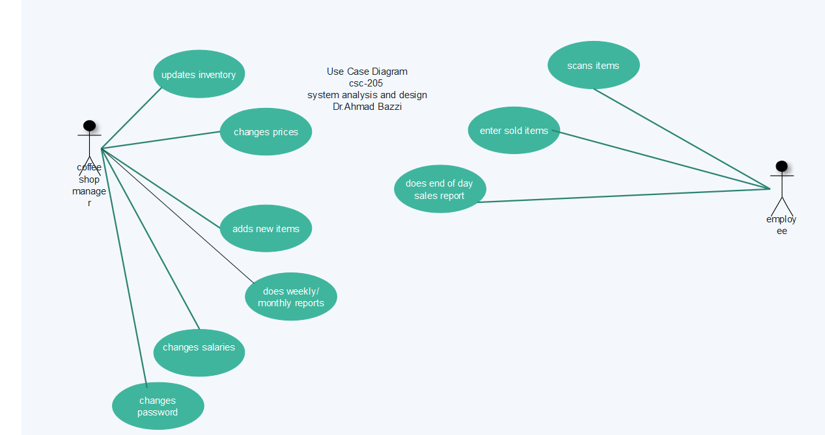

Data flow diagram

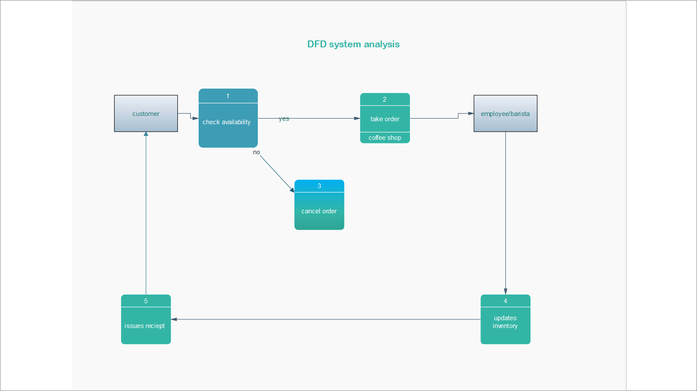

**Sequence diagram**

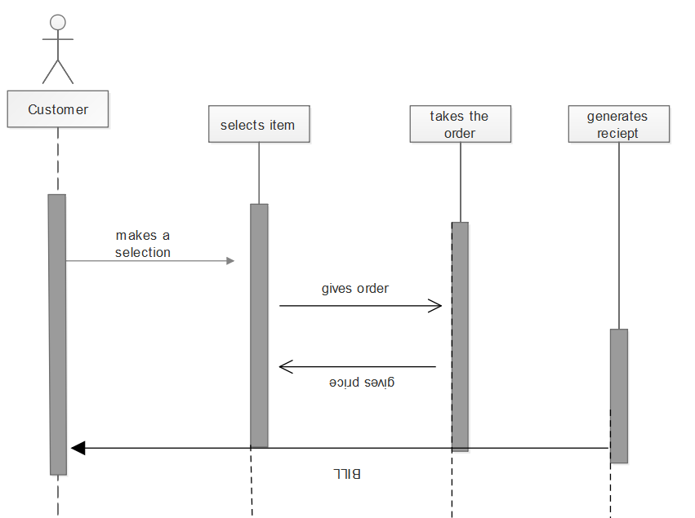

**Class diagram**

