CCTV CAMERA SETUP


Sheen, Alen T (Student)

Purpose:

The purpose of this lab is to set up camera coverage for my IT classroom. This setup is needed so the classroom can be approved as a testing site for IT certifications and to help create a focused, fair, and ethical learning environment. It also helps with accountability in case valuable equipment is lost or damaged.

Definitions:
CCTV:

Closed-Circuit Television. This is a type of security camera system that only allows video to be viewed by specific, authorized monitoring stations.

DVR:
Digital Video Recorder. A device used with CCTV cameras to store video footage so past recordings can be reviewed if needed.

UPS:

Uninterruptible Power Supply. A device that provides backup power to important equipment during power outages. Most UPS systems use batteries, but some can also work with generators for longer backup time.

Background Information:

CCTV:
CCTV surveillance was invented in 1927 by Russian physicist Leon Theremin and was later used by Josef Stalin to monitor people entering and leaving the Kremlin. While the technology has improved a lot over the past 98 years, the main purpose has stayed the same. Today, CCTV is commonly used in places like schools, workplaces, and public transportation systems. It is mainly used for three reasons: to provide evidence if a crime or incident happens, to allow 24/7 monitoring without needing someone present, and to monitor areas where people cannot safely be, such as hazardous environments.

In this classroom setup, CCTV cameras are used to monitor activity to help maintain academic integrity and a productive learning space. Camera coverage is also required for the classroom to be approved as an official testing site for IT certification exams.

DVRs:
Digital Video Recording is an important part of modern CCTV systems. DVRs allow video footage to be stored so it does not need to be constantly watched live. This makes it possible to review footage later if an incident occurs. DVRs help reduce costs and make surveillance systems more useful.
In this deployment, all camera footage is saved to a 5.4 terabyte server. This allows for a long history of recordings so footage can be reviewed or backed up if necessary.
Why Wired Connections Are Better:
For this setup, wired CCTV cameras are used instead of wireless ones for several reasons. First, since this is an IT classroom, there is a higher chance of students attempting to interfere with or attack Wi-Fi based systems. Wireless cameras are generally easier to tamper with, making them less secure.
Another reason is reliability. Wired cameras are more stable and have fewer points of failure compared to wireless cameras. They also require fewer devices to be connected to a UPS, which helps ensure the cameras keep working during power outages. Because of this, wired connections are the best choice for maintaining consistent and secure camera coverage in the classroom.
Summary:

In this lab, I installed 14 wired CCTV cameras to provide full coverage of two connected classrooms. I also set up a central monitoring and recording station so all cameras could be managed and viewed from one location that is easily accessible to teachers.

Setup:
We started by looking at possible locations for each camera. We quickly realized that there were not many good surfaces to mount them on, so conduit mounts were needed. After finding a mount that worked, I made a list of the equipment we already had and what was still needed. We already had all the cameras and most of the required wiring.
Next, we estimated the cable lengths needed for each camera. During this step, I found that one camera location required a 150-foot cable. Once the cable arrived, we began installing the cameras. I first mounted all 14 cameras in their planned locations without running any wires. After that was finished, we started wiring from the camera farthest away from the monitoring station and worked my way back toward it. Each camera was connected one at a time using a new cable run.
Once all the cameras were connected, I added the monitor and power supply. After everything was powered on, the system was fully functional and ready for use.
Pictures:
A complete view of the 14 installed cameras on a 16 camera view, note the two rooms.
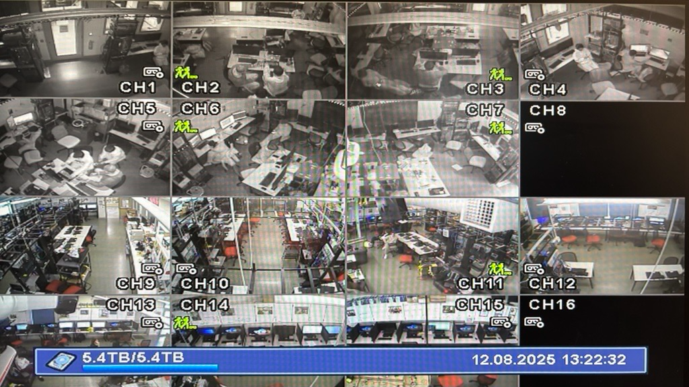
A close-up view of one of the camera views looking at a row of computers used in testing.
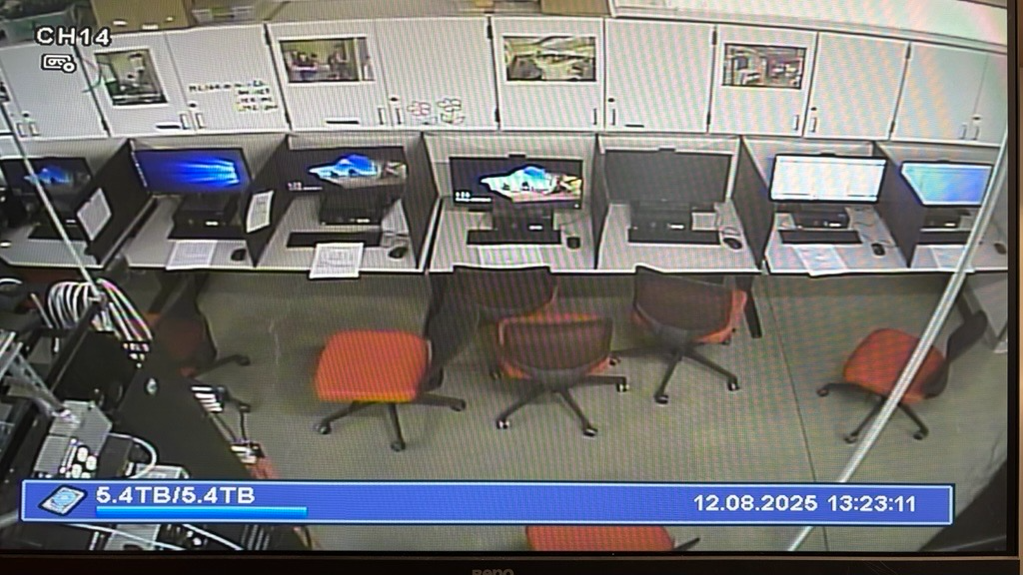

Problems:
The first problem I ran into was installing a few of the cameras upside down. I wasn’t completely sure which direction they were supposed to face, so a couple were mounted incorrectly. Luckily, fixing this was simple and only required unscrewing the cameras and reinstalling them the correct way.
Another issue was extra length on the hose clamps that were holding the mounts to the conduits, along with sagging wires that partially blocked some camera views. I used tin snips to shorten the clamps, and by pulling the wires tighter and rerouting them, I was able to fix the sagging and clear the camera views.
The final major issue was that one of the cameras had a fogged lens, which made the video unusable. To fix this, the camera was replaced with a spare. The replacement camera worked properly and solved the problem.
While not exactly a problem, I also needed to rearrange which ports the cameras were plugged into. This was done so the camera order made sense and could be viewed sequentially in a way that was easier to remember and manage.

