Minka Metrics

Observations metrics
The following graph shows the number of observations in the last 30 days.
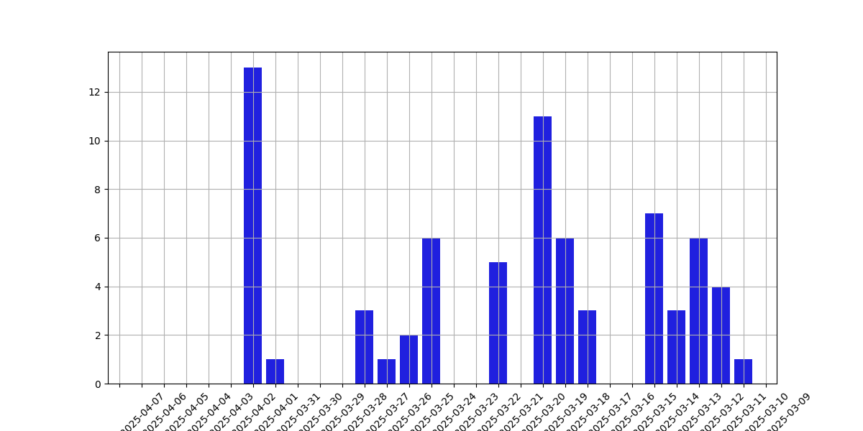

Observers metrics
The following graph shows the number of observers in the last 30 days.
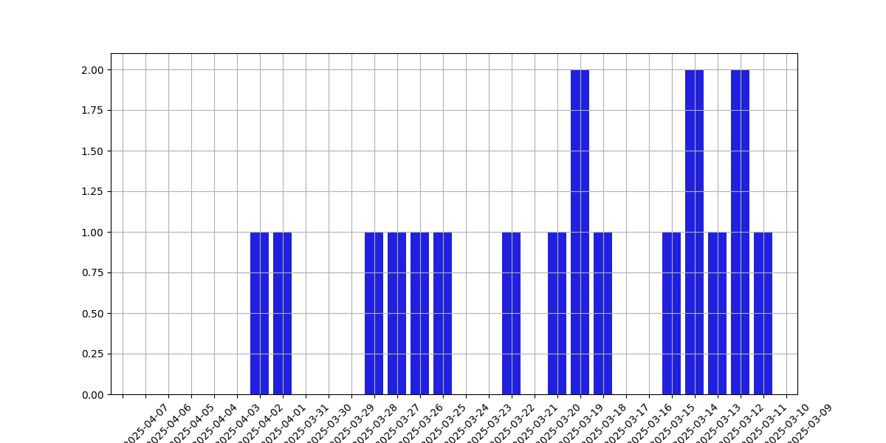

Identifiers metrics
The following graph shows the number of identifiers in the last 30 days.


Species metrics
The following graph shows the number of species in the last 30 days.
