Minka Project
This document contains the results of the analysis of your Minka project.
Comparation of observations between years
This section contains the comparation of observations between years.
The first plot shows the distribution of observations in 2024 and the second one shows the distribution of observations in 2025.
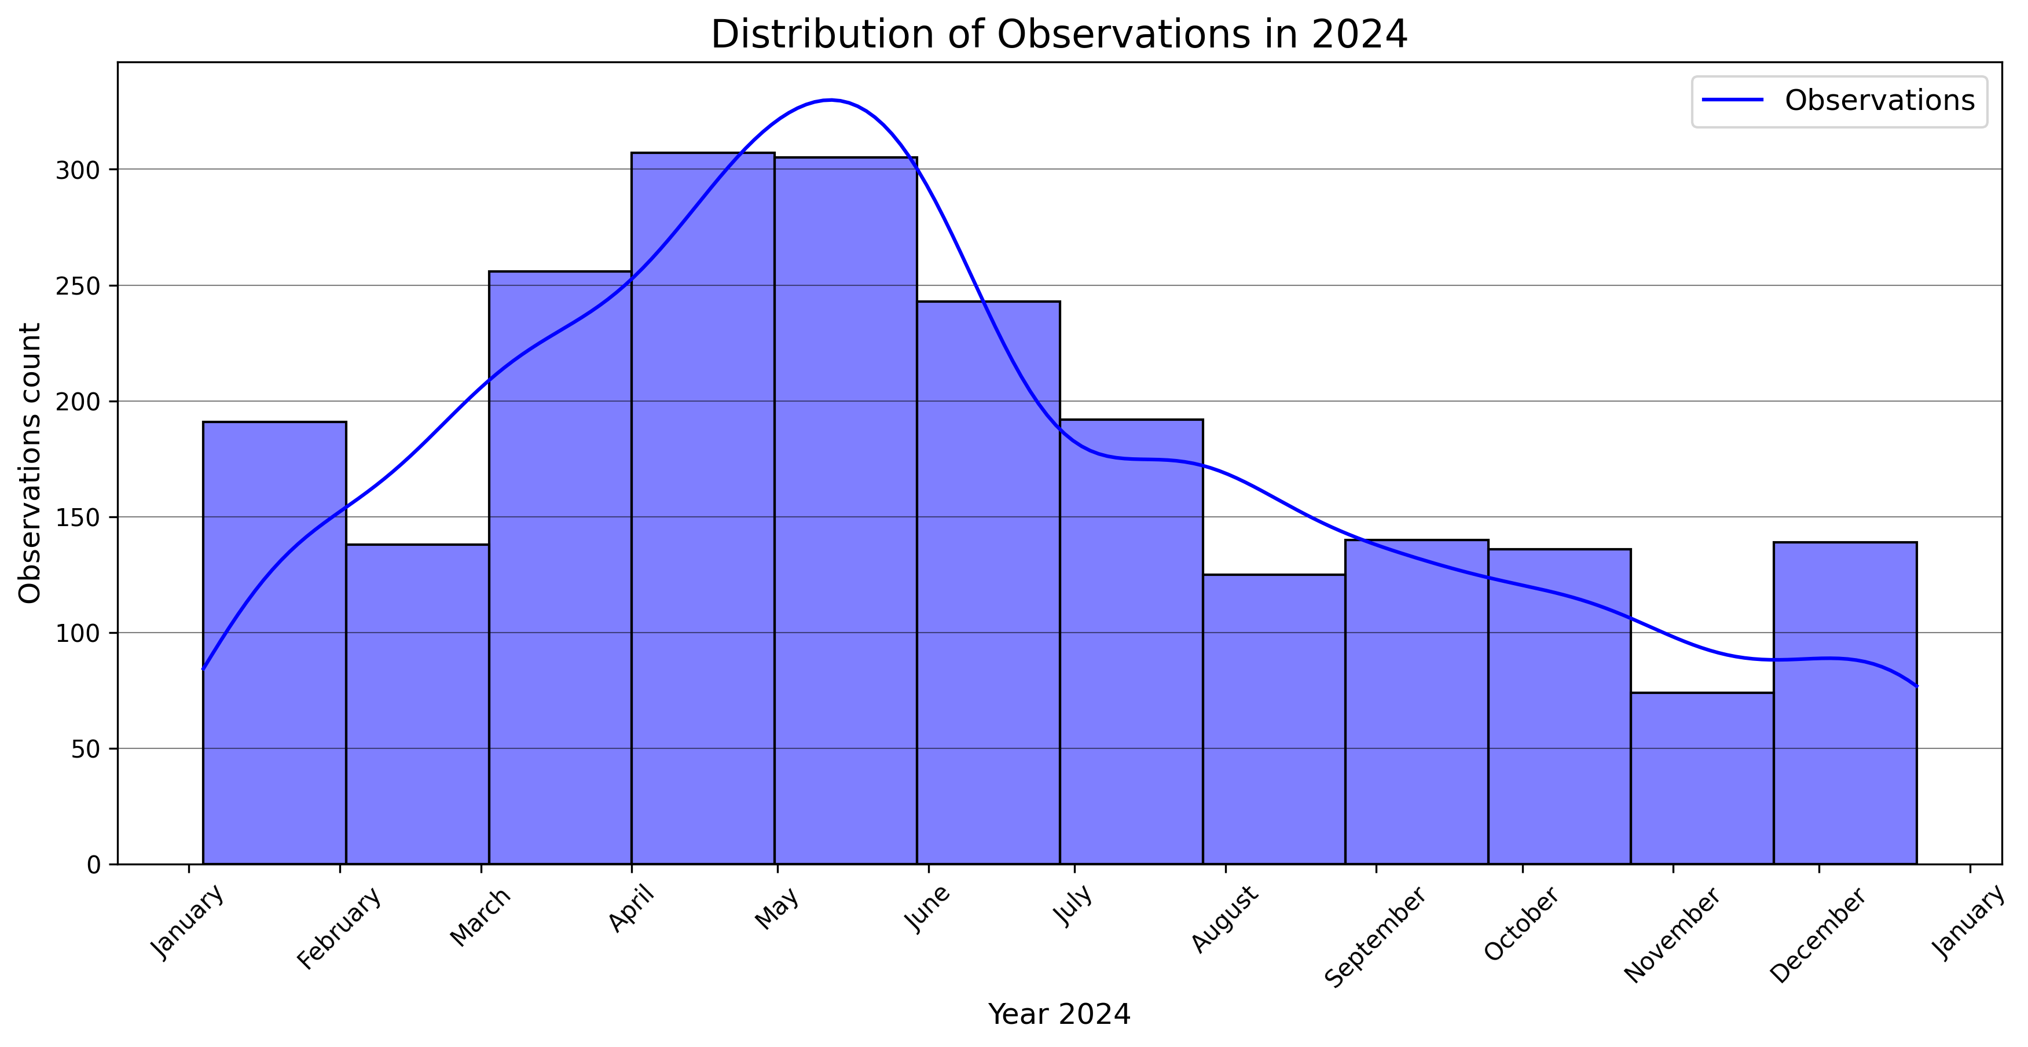
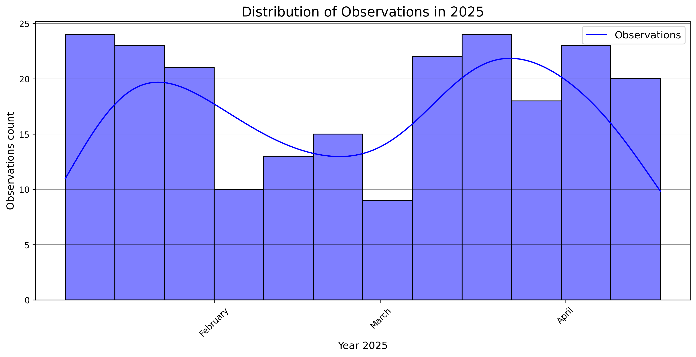

This section contains the comparation of species between months.
The first plot shows the distribution of species in 2024 and the second one shows the distribution of species in 2025.
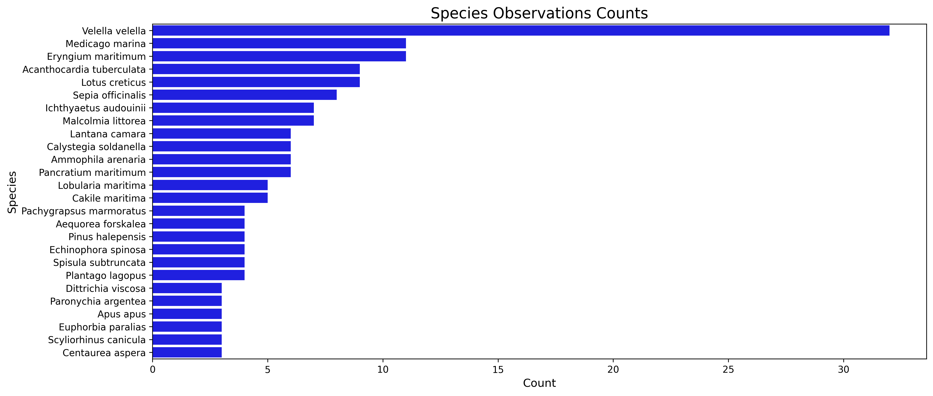
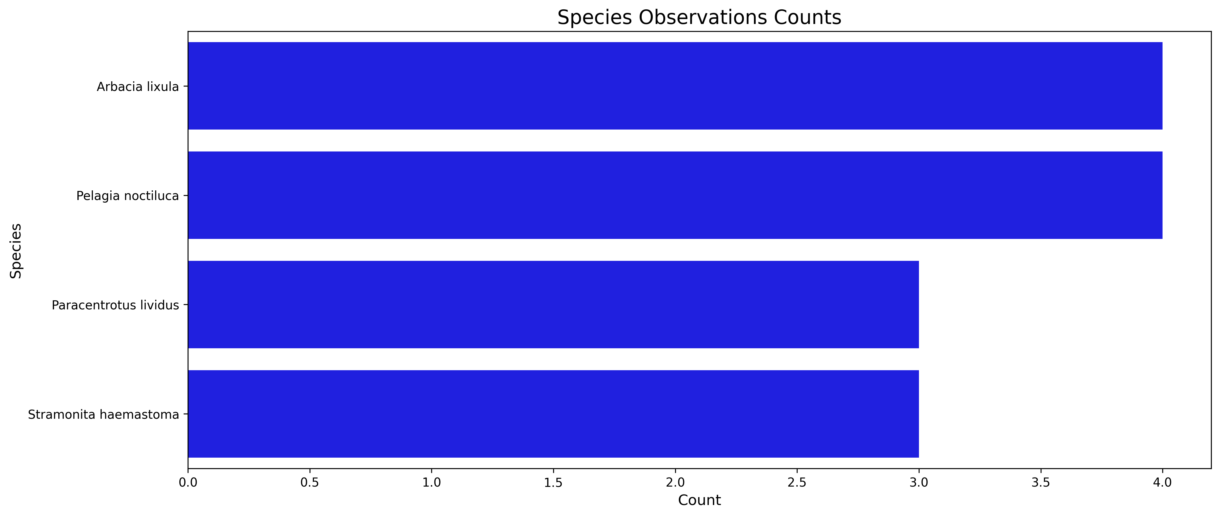
This section contains the comparation of top species between years.
The first plot shows top species in 2024 and the second one shows the distribution of top species in 2025.
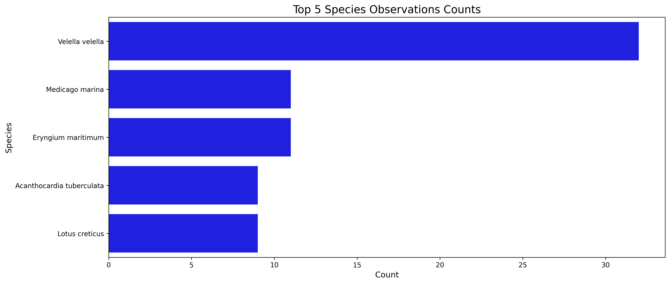
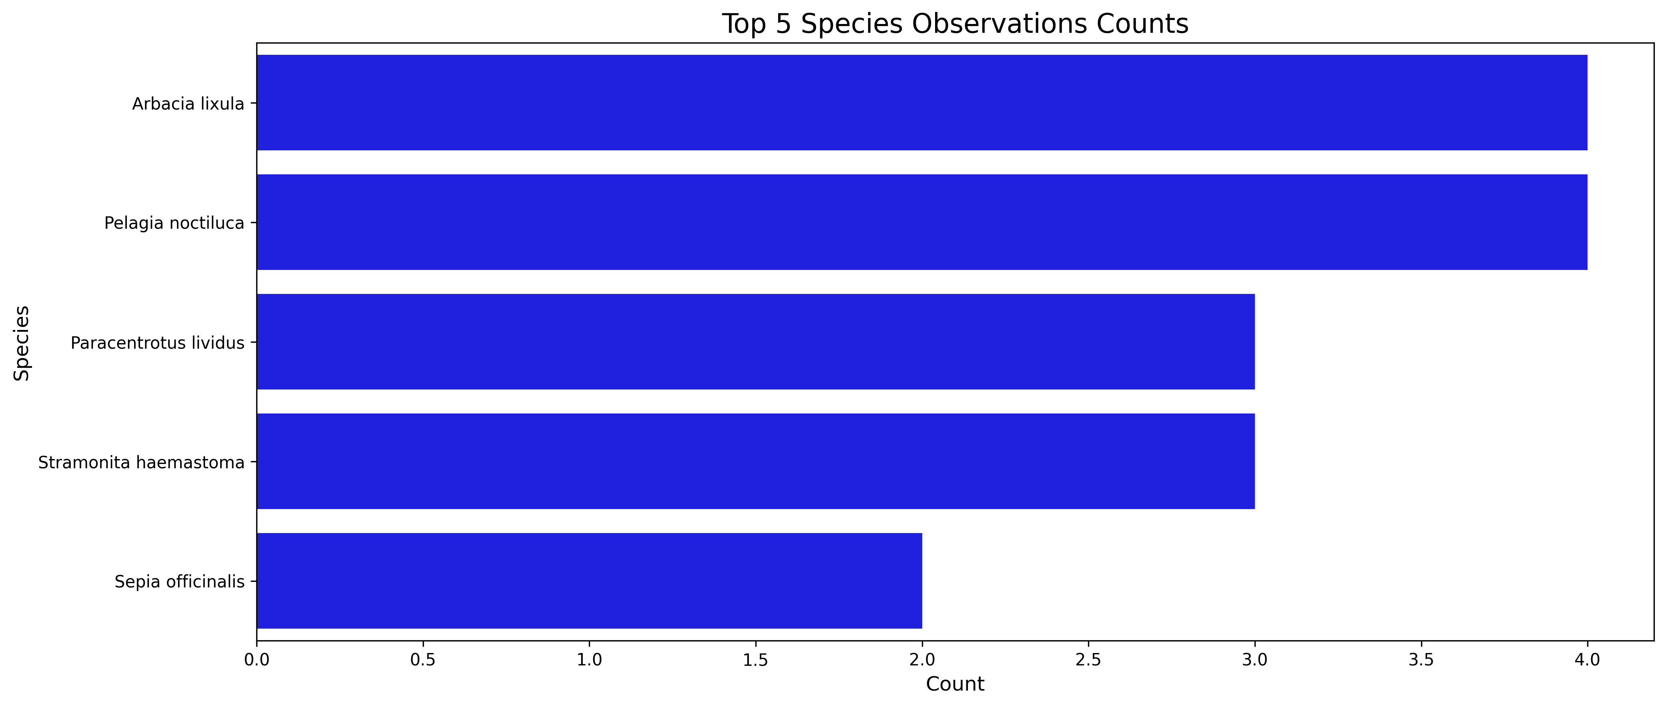

This section contains the comparation of identifiers between months.
The first plot shows the distribution of identifiers in 2024 and the second one shows the distribution of identifiers in 2025.
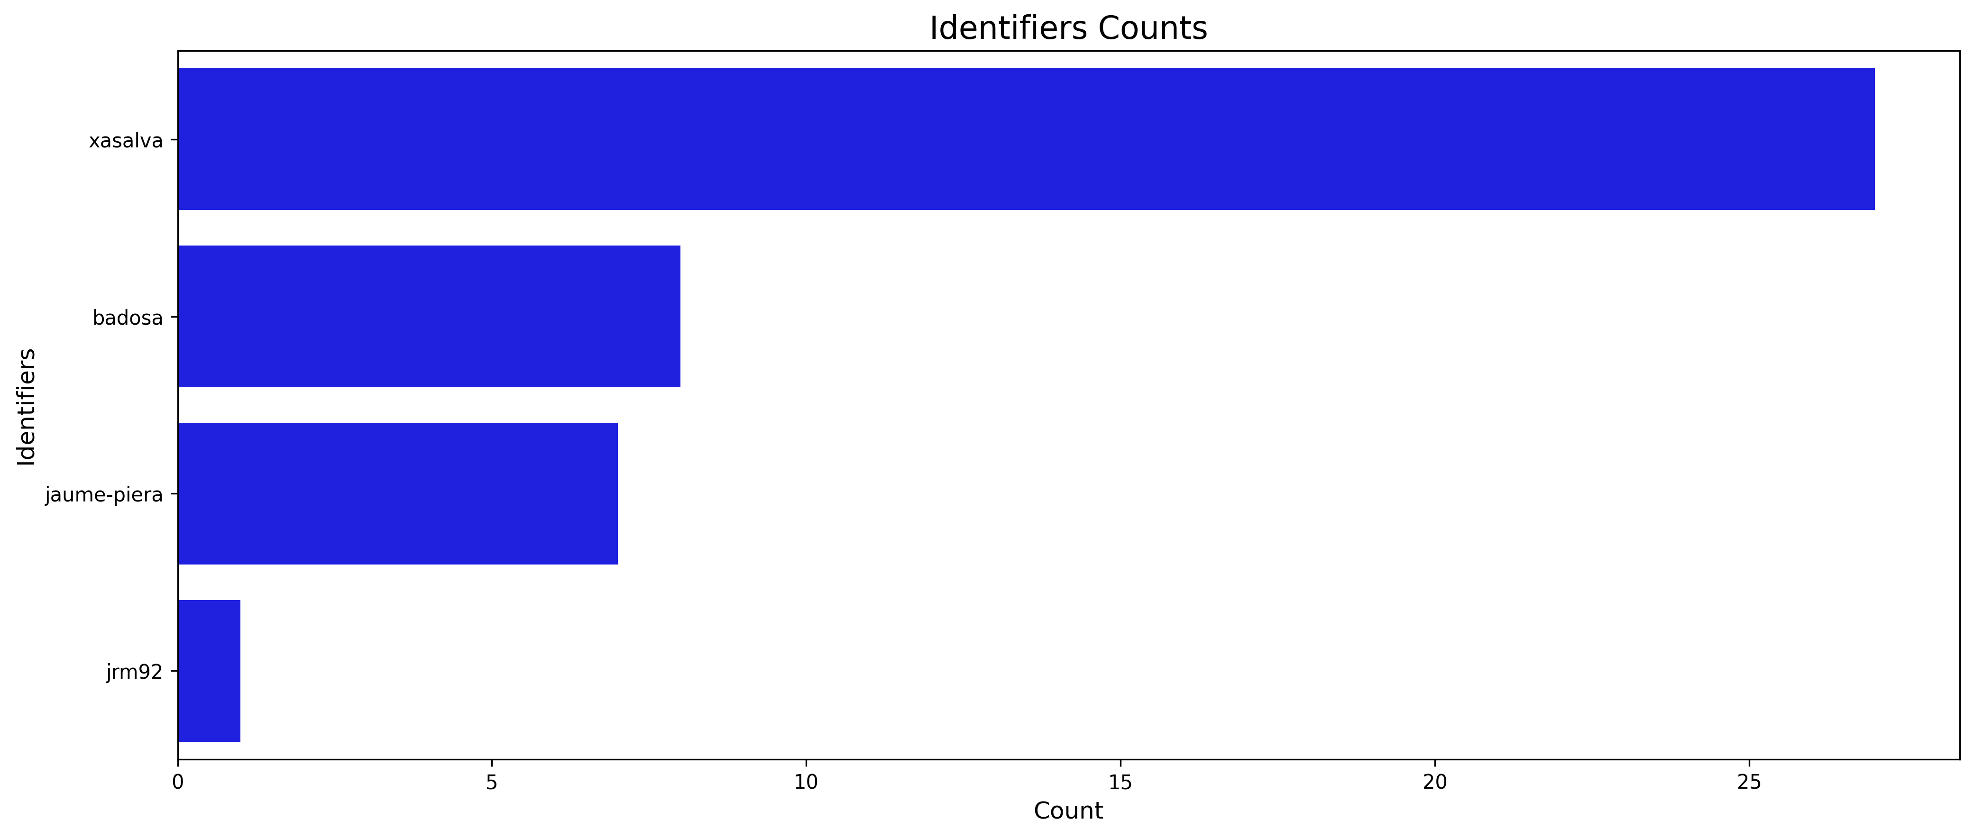
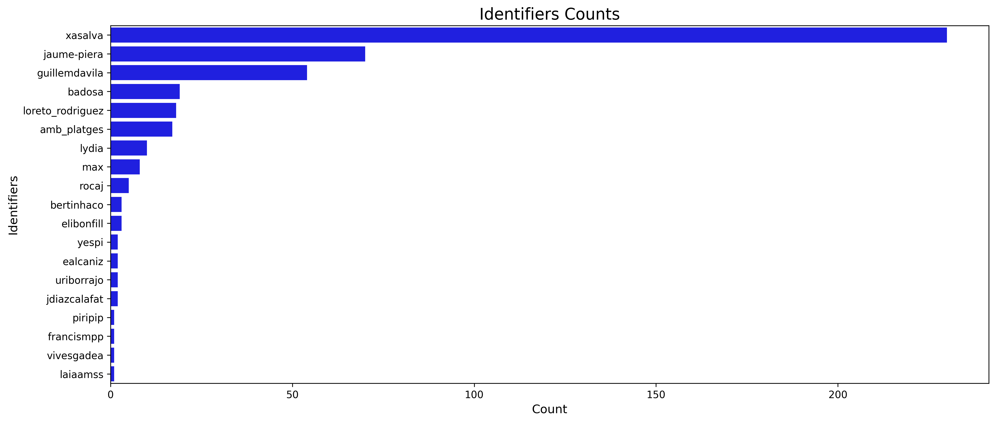
This section contains the comparation of top identifiers between years.
The first plot shows top identifiers in 2024 and the second one shows the distribution of top identifiers in 2025.
