Criterion B: Design

Basic Design
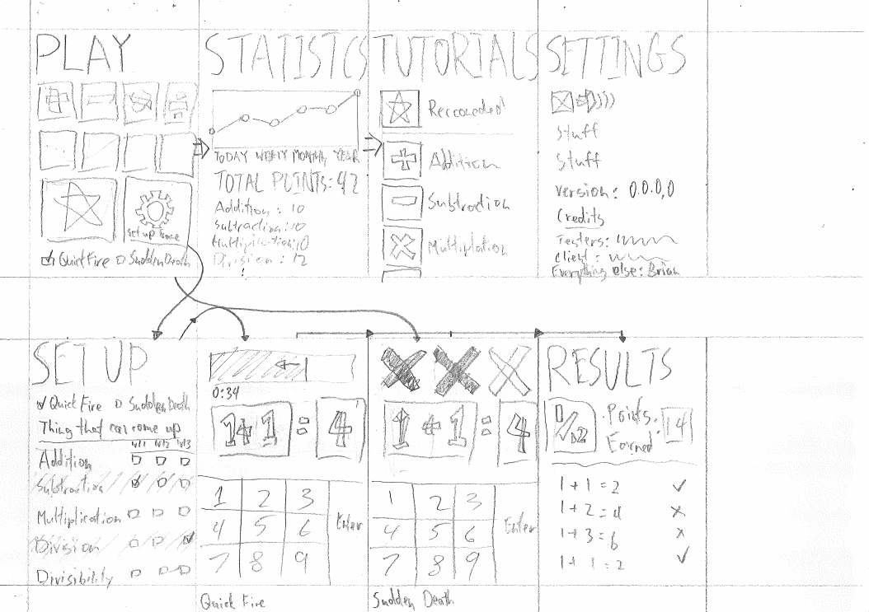

Development Plan

Basic HTML Interface (4 days)
All buttons and interface elements created.

Question mixture creator (3 days)
Takes input from HTML buttons, outputs question mixture file.

Question generator for each of the question types and difficulty. (7 days)
Inputs difficulty, output questions

Topic | Difficulty 1 | Difficulty 2 | Difficulty 3
 | Examples
Addition | 2+3=5 | 22+33=55 | 222+333=555
Subtraction | 3-2=1 | 33-22=11 | 333-222=111
Multiplication | 2*3=6 | 2*33*66 | 22*33=726
Division | 6/2=3 | 44/11=4 | 3/2=1.5
Factors | 6=2,3 | 24=2,3,4,6,8 | 100=2,5,10,20,50

Main Quiz Page (5 days)
Must take in input from question generator, display it, take in user answer, and output Boolean correct or incorrect.

CSS Style-sheets (5 days)
Good aesthetic design.

PhoneGap interface (7 days)
Runnable on mobile devices.

Testing Plan

Test | Expected result
Input from Keypad | Correct numbers displays properly
Links correct | Buttons lead to correct places
Get 3 questions wrong in ‘3 Wrongs’ | Go to results page
Input non-number character | No change and input ignored
Timer runs out in ‘Quick Fire’ | Go to results page
Change Settings from ‘settings’ | Visible changes
Leave ‘3 Wrongs’ for a long time | Auto time-out if no input detected

Data storage plan

 | Question Mixtures | Score Statistics
Format | Question type, Difficulty(1-3) | Year, Month, Day, Correct, Gamemode, Difficulty, Question type
Example | Multiplication, 3  Division, 1  Addition, 2 | 1598, 11, 12, TRUE, A, 3, Multiplication  1598, 11, 12, TRUE, A, 1, Division  1599, 03, 04, FALSE, B, 2, Addition

