Homework 0: Environment Setup

COMS W4111: Introduction to Databases  
Sections 001  
Spring 2025  
  
(v 1.0; 2025-JAN-18)

# Introduction and Overview

*Homework 0* provides step-by-step instructions on how to install and set up necessary tools for this course/section. HW 0 also contains tests to verify successful installation. We start the semester with a HW 0 environment setup prior to HW 1. This allows us to resolve configuration and set up issues before students begin working on graded assignments.

Completing the HW requires using a [Jupyter](https://jupyter.org/install) notebook, running tests and providing screenshots. Students run the tests and include the screenshots in a copy of the Jupyter notebook S25-W4111-HW0.ipynb that they create. The notebook is in the root folder of the HW 0 GitHub repository.

This assignment is for both Programming and Non-Programming tracks.

Total points for homework assignments and exams determine final grade. The final point total is between 0 and 100. HW 0 is not worth any points, i.e. the points earned for submission is 0. Failing to submit HW 0 **on time will result in a 2 points deduction from HW 1,** however. You **may not use late days for HW 0.**

**Due date: 2025-Feb-02, 11:59 PM EDT on GradeScope.**

Please note:

* You may **NOT** use late days.
* You submit on Gradescope.
* There is a [post/mega-thread](https://edstem.org/us/courses/73023/discussion/5989016) on Ed Discussions that contains submission instructions. We will use this thread to answer questions and clarify the assignment.

The following tools will need to be installed and or setup, and tested:

1. MySQL Server Community Edition.
2. PyCharm.
3. DataGrip.

# HW 0 Project

There are two ways to get the project you use for HW0:

* Clone the GitHub repository (<https://github.com/donald-f-ferguson/S25-W4111-HW0>).
* There is also an option to download a zip file that contains the project files. The zip file is on Ed Stem in the HW0 post.

We recommend using Git. There are online [instructions for installation and use.](https://git-scm.com/) Some of the tools that you install will contain Git support.

We will hold an online, recorded recitations TBA to demo installation and use of the software. We will publish the exact time and Zoom URL when we can.

# PyCharm

## Download and Installation

PyCharm is an [integrated development environment](https://en.wikipedia.org/wiki/Integrated_development_environment) for Python programming. **Students must install and use PyCharm.** There are many developer tools for Python. Visual Studio Code is a commonly used IDE. Requiring all students to use the same IDE:

* Simplifies documenting instructions for homework assignments. We do not have to produce instructions for several different IDEs.
* The TAs are experienced with PyCharm. While extremely talented, the TAs do not necessarily know how to use every conceivable IDE.
* Simplifies discussion, answering questions and problem resolution.

Download the *professional* version of [PyCharm](https://www.jetbrains.com/pycharm/). You need to [apply](https://www.jetbrains.com/community/education/#students) for a free education license. Registering with JetBrains and applying for the free education license gives you a one year free license to all JetBrains tools.

Please install PyCharm Professional. You can install the trial version and apply for the license later if necessary.

## HW 0 Project

Use Git to clone the HW 0 project. Alternatively, you can download the zip file from Ed Discussions and unzip into a directory. Start PyCharm and use the file open dialog to open the HW 0 folder.

PyCharm requires configuration for each project. In the test for this section, you will practice configuring a Python Environment.

If you get a message about missing an interpreter or virtual environment, please follow [online instructions](https://docs.anaconda.com/anaconda/user-guide/tasks/pycharm/) to configure a Python interpreter for the project.

Select the file *HW0PyCharmTest.py.* Double click on the file. This will open the python editor on the file. Replace “abc123” with your uni. For example, Professor Ferguson’s file would look like:

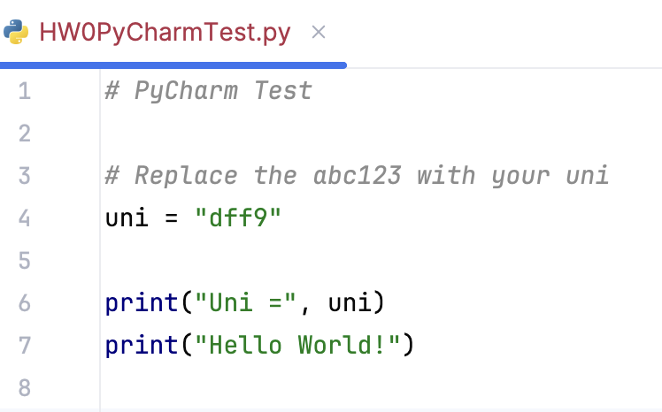

Right click on *HW0PyCharmTest.py* and select run. This should execute the program and PyCharm will look something like

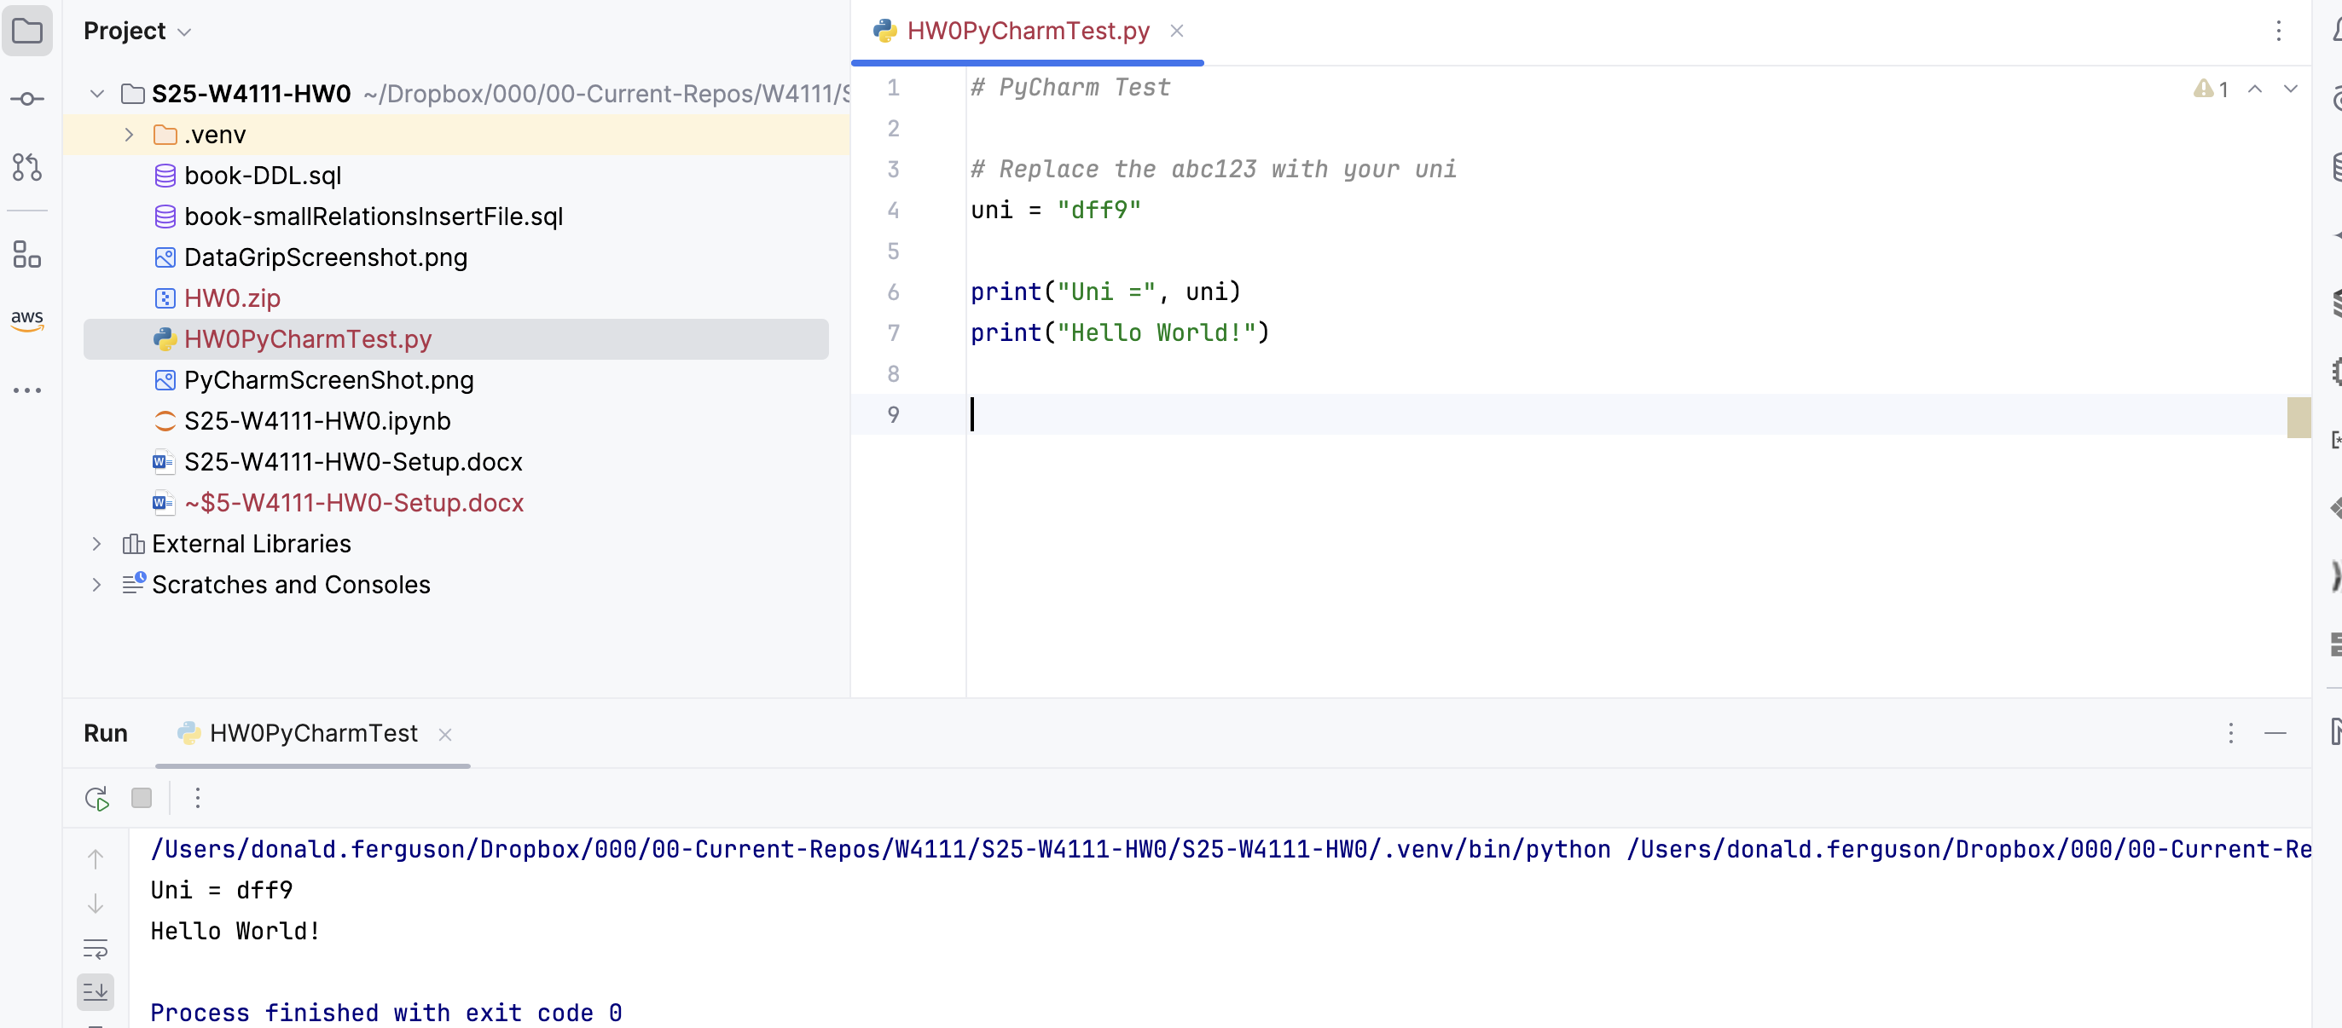

Take and save a screen capture. You will need this to submit the HW assignment.

## Jupyter

Open a terminal window *inside PyCharm* using the button.

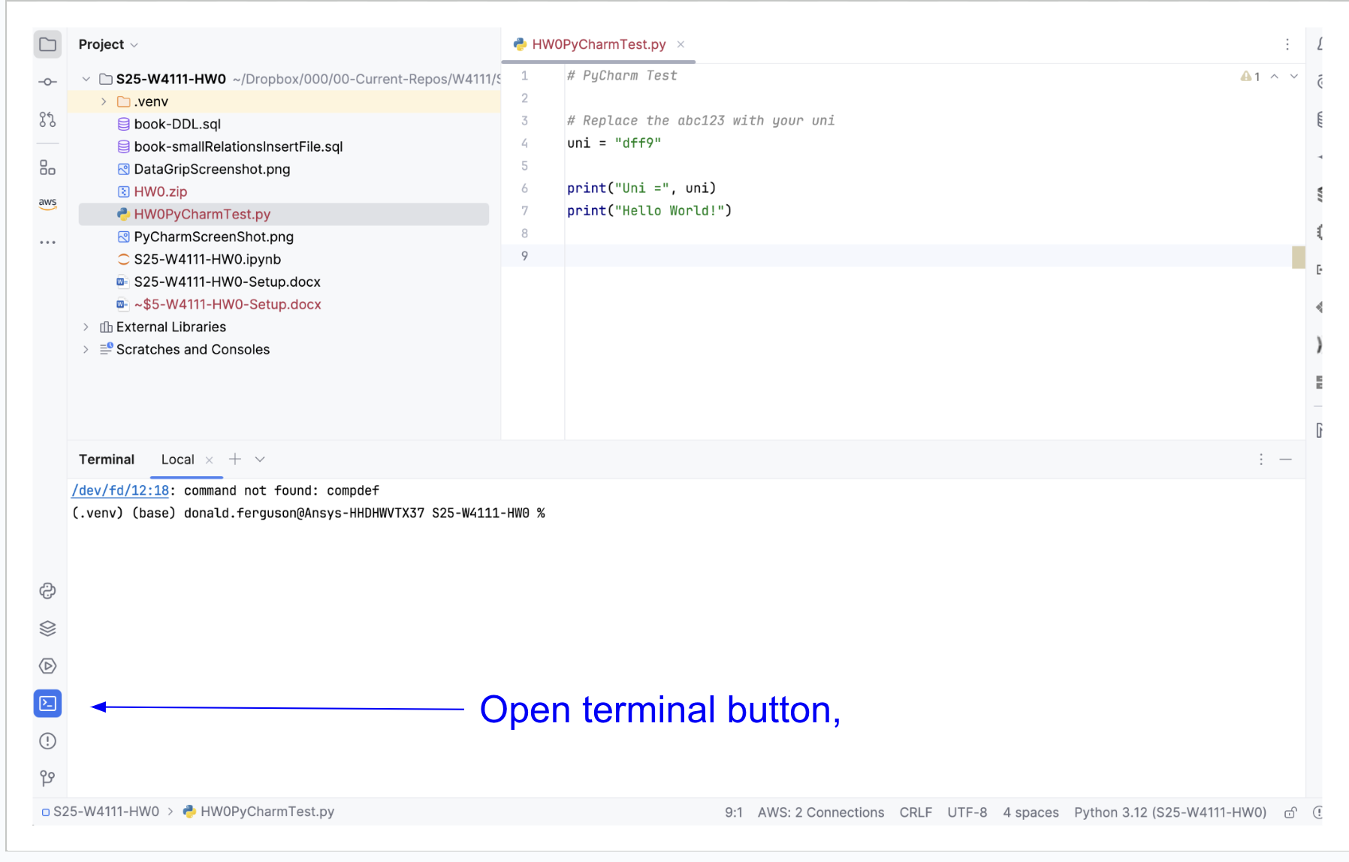

Click on the terminal window. At the command prompt, enter

pip install jupyter notebook

This command will execute and install Jupyter Notebook into the project. Once the installation completes, in the terminal window enter

jupyter notebook

This will execute a few statements and then open a browser window. You will see something that looks like the image below. Once you get the browser window, you are done with Jupyter for now.

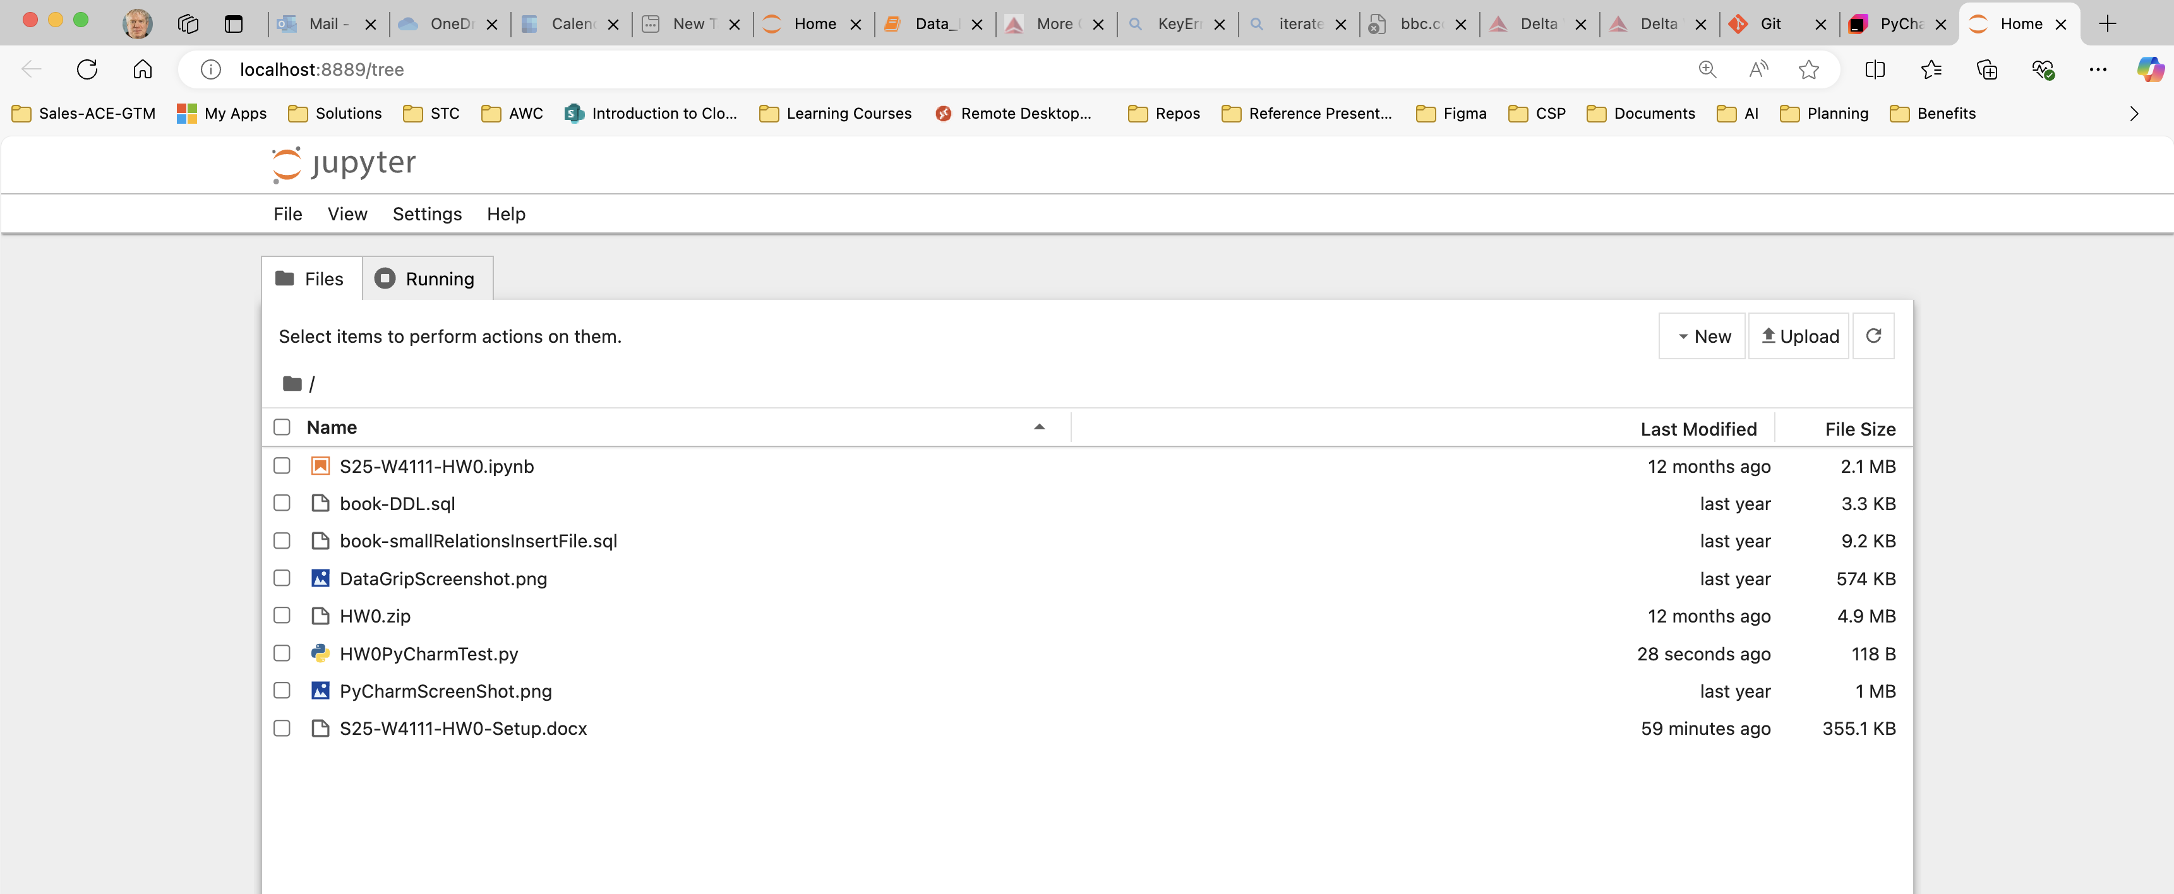

# MySQL Server Community Edition

You must install MySQL (Server) Community. There is a [download link](https://dev.mysql.com/downloads/mysql/) and you can select your operating system. For Mac, you need to install the correct version for your chipset (ARM, Intel).

The installation is relatively easy. There are

* [Instruction for Windows](https://dev.mysql.com/doc/refman/8.0/en/windows-installation.html). Use the MySQL Installer method and choose the Developer Default.
* [Instructions for Mac.](https://dev.mysql.com/doc/refman/5.7/en/macos-installation-pkg.html)
* [Linux](https://dev.mysql.com/doc/refman/8.0/en/linux-installation.html).

**Note:** If you have an old version of MacOS or Windows, you may have to go into the [MySQL Community](https://downloads.mysql.com/archives/community/) archive to find a version compatible with your operating system. Choose a version of MySQL Community Server 8.x that is compatible with your OS version.

At some point, you will be promoted for/have to set login/authentication options.

* **Choose the Legacy Authentication method.**
* Write down and remember the *root* user ID and *password.* You are installing on a local machine with no sensitive data. A simple password is OK. We recommend the password *dbuserdbuser.* Using a common password solves problems due to your forgetting your password.

Installing MySQL registers MySQL Server as a service. It should start automatically. If you are ever unsure if MySQL Server is running, there are online OS specific instructions for determining status, starting and stopping the server.

# DataGrip

DataGrip will be the GUI (Graphical User Interface)/integrated development environment (IDE) and tool that allows you to visualize and edit data table definitions and data on your MySQL server. You need to [apply](https://www.jetbrains.com/community/education/#students) for an education license from JetBrains if you didn’t already do so in the PyCharm setup.

Download [DataGrip](https://www.jetbrains.com/datagrip/) and setup. You will need the education license so you can use DataGrip beyond your free trial period. You can start with the trial version of professional and apply the credit later.

You will need to set up a connection in DataGrip to your local MySQL Sever. There are [online instructions](https://www.jetbrains.com/help/datagrip/connecting-to-a-database.html) for configuring a connection. In addition to the general instructions, there are [MySQL specific](https://www.jetbrains.com/help/datagrip/mysql.html) instructions.

Once DataGrip is installed, you need to install two databases. You do this by running 2 SQL scripts that are in the HW 0 folder:

1. book-DDL.sql
2. book-smallRelationsInsertFile.sql

Start DataGrip. You will run the SQL scripts in the order above. The DataGrip documentation [provides instructions](https://www.jetbrains.com/help/datagrip/run-sql-files.html#run_sql_file) on how to run an SQL script from a file (hard drive). Follow the instructions for each of the SQL files.

Right click on the folder “db_book” in the left navigation menu. Choose “new query console.” In the new window area, enter *select * from student.* Click the green arrowhead to run the query. You will take a screenshot and include it in your Jupyter notebook submission. Your screen will look like … … The left-hand panel will not have as many folders.

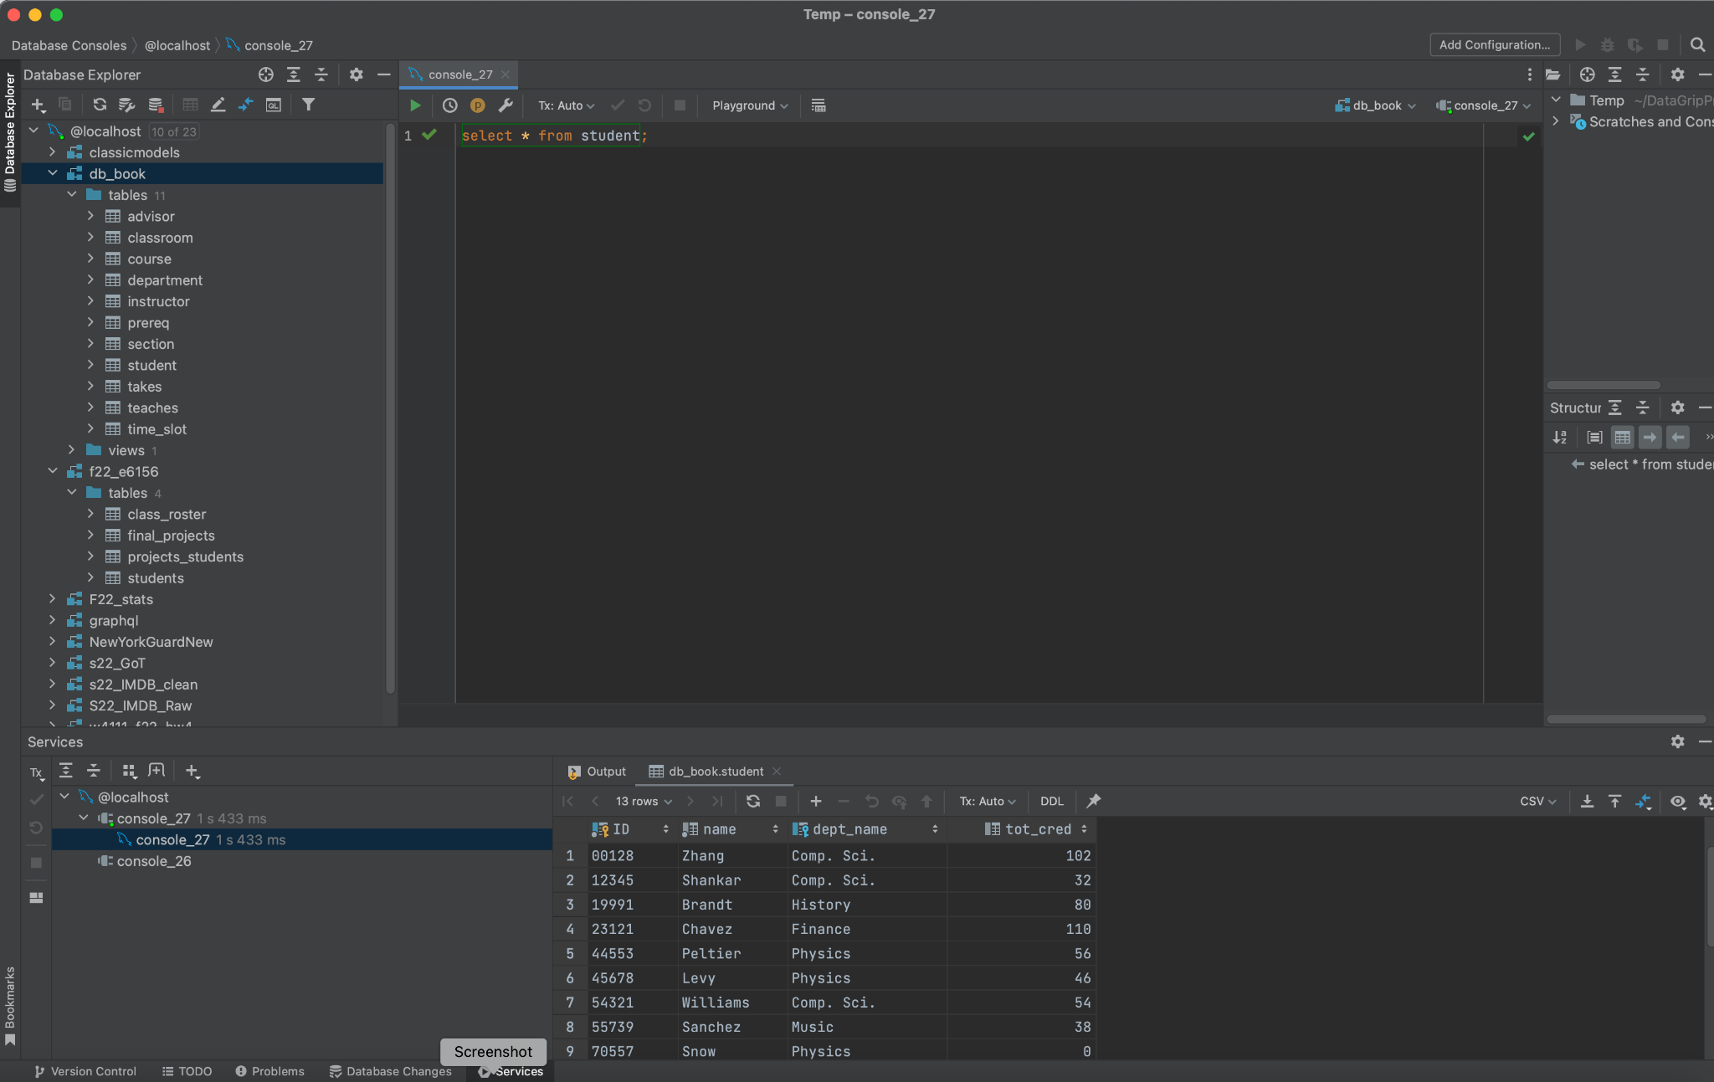

# Using the Jupyter Notebook

Go back to the browser that opened when you started Jupyter Notebook. Double click on the file S25-W4111-HW0.ipynb to open the notebook. Start following the instructions in the notebook.