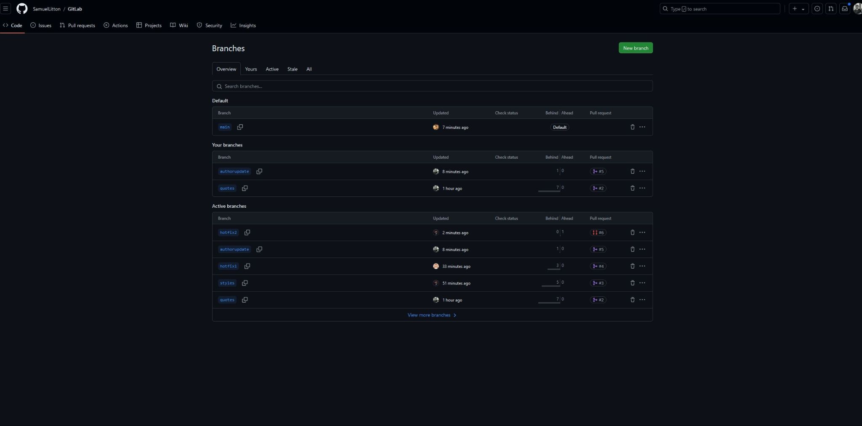

Alejandro Quezada

<https://github.com/SamuelLitton/GitLab.git>

<https://github.com/Aleque2023>

7/21/2024

Module 10.2 Assignment: Shared Code Repository - Git Exercise