Colours to include

black
white
gold
silver
grey
pink
purple
brown

red
orange
yellow
green
cyan
blue
magenta
pink

What is the psychology of colour?

Color psychology is the study of hues as a determinant of human behavior. Color influences perceptions that are not obvious, such as the taste of food. Colors can also enhance the effectiveness of placebos. For example, red or orange pills are generally used as stimulants. Color can indeed influence a person; however, it is important to remember that these effects differ between people. Factors such as gender, age, and culture can influence how an individual perceives color. For example, males reported that red colored outfits made women seem more attractive, while women answered that the color of a male's outfit did not affect his attractiveness.
Color psychology is also widely used in marketing and branding. Many marketers see color as an important part of marketing because color can be used to influence consumers' emotions and perceptions of goods and services. Companies also use color when deciding on brand logos. These logos seem to attract more customers when the color of the brand logo matches the personality of the goods or services, such as the color pink being heavily used on Victoria's Secret branding. However, colors are not only important for logos and products, but also for window displays in stores. Research shows that warm colors tended to attract spontaneous purchasers, despite cooler colors being more favorable.
Perceptions not obviously related to color, such as the palatability of food, may in fact be partially determined by color. Not only the color of the food itself but also that of everything in the eater's field of vision can affect this. (Alcaide, J. et al., 2012). Josef Albers' role in the understanding of color perception was through his research of how colors interact with each other. He also studied the optical illusions of color and how different hues looked the same. This was during his tenure at Yale University.[1]

The color of placebo pills is reported to be a factor in their effectiveness, with "hot-colored" pills working better as stimulants and "cool-colored" pills working better as depressants. This relationship is believed to be a consequence of the patient's expectations and not a direct effect of the color itself.[2] Consequently, these effects appear to be culture-dependent.[3]

In 2000, Glasgow installed blue street lighting in certain neighborhoods and subsequently reported the anecdotal finding of reduced crime in these areas. This report was picked up by several news outlets.[4][5] A railroad company in Japan installed blue lighting on its stations in October 2009 in an effort to reduce the number of suicide attempts,[6] although the effect of this technique has been questioned.[7]

A few studies have shown that cultural background has a strong influence on color preference. These studies have shown that people from the same region regardless of race will have the same color preferences. Also, one region may have different preferences than another region (i.e., a different country or a different area of the same country), regardless of race.[10]

Common associations connecting a color to a particular mood may differ cross-culturally. For instance, one study examined color associations and moods using participants from Germany, Mexico, Poland, Russia, and the United States. The researchers did find some consistencies, including the fact that all nations associated red and black with anger. However, only Poles associated purple with both anger and jealousy and only Germans associated jealousy with yellow.[12] These differences highlight how culture influences peoples' perceptions of color and color's relationship to mood.
Despite cross-cultural differences regarding what different colors meant there were cross-cultural similarities regarding what emotional states people associated with different colors in one study. For example, the color red was perceived as strong and active.[13]
Color can carry a specific meaning.
- Color meaning is either based in learned meaning or biologically innate meaning.
- The perception of a color causes evaluation automatically by the person perceiving.
- The evaluation process forces color-motivated behavior.
- Color usually exerts its influence automatically.
- Color meaning and effect has to do with context as well.[10]

Red | Yellow | Green | Blue | Pink
Lust (S)[24] | Jealousy (S)[24] | Good Taste (F)[24] | Masculine (S)[24] | Sophistication (S)[22]
Power (S)[25] | Competence (S)[22] | Envy (S)[24] | Competence (S)[22] | Sincerity (S)[22]
Excitement (S)[22] | Happiness (S)[24] |  | High quality (F)[24] | Feminine (S)[24]
Love (S)[24] |  |  | Corporate (F)[24]

Violet/Purple | Brown | Black | White
Authority (S)[24] | Ruggedness (S)[22] | Grief (S)[24] | Happiness (S)[24]
Sophistication (S)[22] |  | Sophistication (S)[22] | Sincerity (S)[22]
Power (S)[24] |  | Expensive (F)[24] | Purity (S)[24]
 |  | Fear (S)[24]

https://en.wikipedia.org/wiki/Color_psychology
Changizi et al. (2006) and Changizi (2009) contend that trichromatic vision evolved to enable primates, including humans, to detect subtle changes in blood flow beneath the skin that carry important information about the emotional state of the conspecific. Increased red can convey anger, embarrassment, or sexual arousal, whereas increased bluish or greenish tint can convey illness or poor physiological condition. Thus, visual sensitivity to these color modulations facilitates various forms of social interaction. In similar fashion, Stephen et al. (2009) and Stephen and McKeegan (2010) propose that perceivers use information about skin coloration (perhaps particularly from the face, Tan and Stephen, 2012) to make inferences about the attractiveness, health, and dominance of conspecifics.

Elliot and Maier (2012) have proposed color-in-context theory, which draws on social learning, as well as biology. Some responses to color stimuli are presumed to be solely due to the repeated pairing of color and particular concepts, messages, and experiences. Others, however, are presumed to represent a biologically engrained predisposition that is reinforced and shaped by social learning. Through this social learning, color associations can be extended beyond natural bodily processes (e.g., blood flow modulations) to objects in close proximity to the body (e.g., clothes, accessories). Thus, for example, red may not only increase attractiveness evaluations when viewed on the face, but also when viewed on a shirt or dress.
As implied by the name of the theory, the physical and psychological context in which color is perceived is thought to influence its meaning and, accordingly, responses to it. Thus, blue on a ribbon is positive (indicating first place), but blue on a piece of meat is negative (indicating rotten), and a red shirt may enhance the attractiveness of a potential mate (red = sex/romance), but not of a person evaluating one’s competence (red = failure/danger).
Blue light, in particular, is posited to activate the melanopsin photoreceptor system which, in turn, activates the brain structures involved in sub-cortical arousal and higher-order attentional processing (Cajochen et al., 2005; Lockley et al., 2006). As such, exposure to blue light is expected to facilitate alertness and enhance performance on tasks requiring sustained attention.

The hue of a colour is imortant but the brightness and the chroma (intesity / vidvidness) also play a role.
http://www.nickkolenda.com/color-psychology/
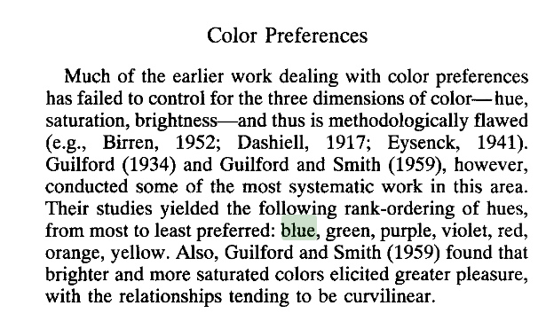
http://crystalkwok.github.io/images/timeline/effect%20of%20colors%20on%20emotions.pdf

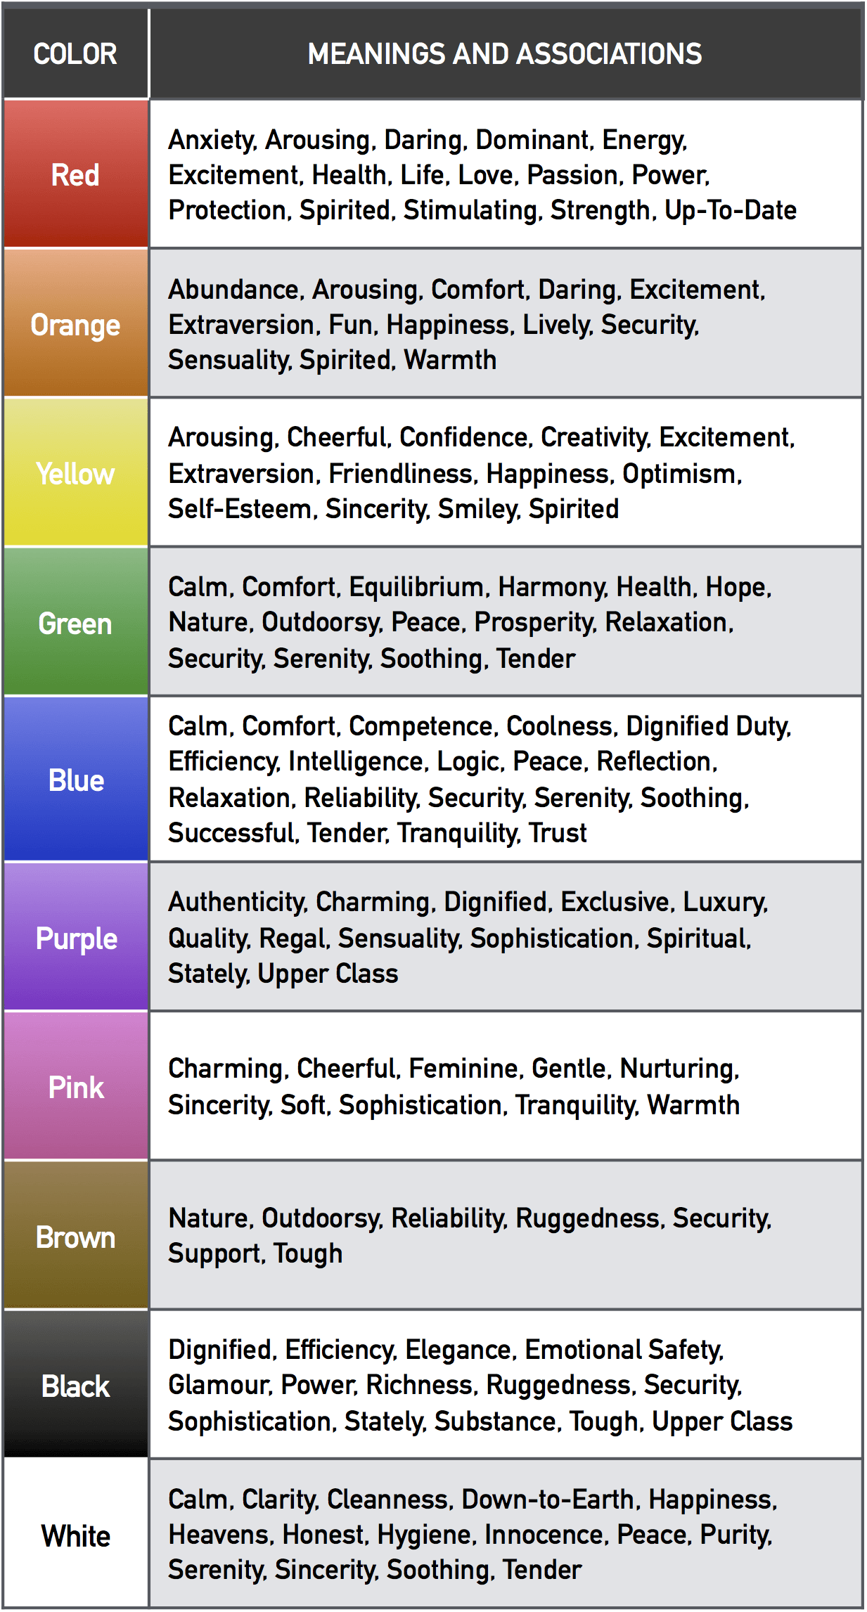

RED
Artificial red (e.g., on leg bands) has likewise been shown to signal dominance in non-human animals, mimicking the natural physiological process (Cuthill et al., 1997).

Associated with energy, war, danger, strength, power, determination as well as passion, desire, and love.
Enhances human metabolism, increases respiration rate, and raises blood pressure.
It attracts attention more than any other color, at times signifying danger.

Energy and Aggression
It is the color associated with energy and aggression. Red has an effect on our physiological state, since it increases heart rate and makes us breathe faster. Red is very noticeable, so an overuse can be irritating or provoke aggression. A red accent on a neutral background can help draw attention to a single element.
Dominance
It has been found that athletes wearing a red kit in combat sports had a bigger chance of winning than those who wore a blue kit. Red makes the person feel more aggressive and more powerful, boosting testosterone, but it also changes the perception others have.
Passion
Red is also the color linked to sexuality and desire. People wearing red are consistently rated as more attractive by others. For example, waitresses in red usually get higher tips than those wearing a differently colored uniform.
Danger
Considering that it draws attention, it’s easy to see why it’s so often used in warning signs. Red has to do with the body’s fight-or-flight response, so too much red leaves the person feeling not just alert, but also stressed out.
Life and Love
Symbolically, red can be linked to life and passion, as well as to bonds of romantic and familiar love. It’s often used in romantic presents, like Valentine’s Day, and to express love, for example, by giving red roses.
(It is often used to express love, as in Valentine’s Day, however it relates more to sexuality and lust, rather than love – love is expressed with pink.
In Eastern cultures such as China red is the color for good luck
it is assosiated with mourning in south africa
http://www.empower-yourself-with-color-psychology.com/color-red.html)

Variations of Red
Its variations include colors such as scarlet, crimson and others. The connotations of each variation may vary. Darker colors, like maroon or burgundy represent an action that is more restrained and sophisticated. Brighter shades, like scarlet, imply more energy and less dominance.
Positive and Negative Aspects of Red
In general, red has both positive and negative connotations. The positive aspects are that it represents love, activity, energy, attention and power. The negative aspects refer to aggression, dominance that instills fear, danger and stress. It’s a very basic and important color, but it’s one that needs to be used with moderation.
http://www.colorpsychology.org/red/

BLACK
Associated with power, elegance, formality, death, evil, and mystery.
A mysterious color associated with fear and the unknown (black holes).
Usually has a negative connotation (blacklist, black humor, ‘black death’)
Denotes strength and authority; it is considered to be a very formal, elegant, and prestigious color.
Mystery
The first association black has is with mystery, the unknown and the hidden. Black is a color linked to secret knowledge and even has a lot of association with magic or esoteric ideas. On a more practical scale, black is the color that hides. It can be used to hide feelings, to separate oneself from the world, even to hide weight, as it is a slimming color.
Power
Black is linked to power. It’s an intimidating color that shows that the person wearing is setting themselves apart from others. It’s a color that indicates strength and discipline. Black doesn’t usually express many emotions, rather, it conceals them, giving the person in black an air of superiority.
Elegance
This is a color that is considered to be quite elegant and simple at the same time. A black outfit can be seen as more fancy than a colorful one. It’s a color used for special occasions.
Evil
Black is certainly a color linked with evil. It is often used to show that someone is the villain in shows and films, and it is the stereotypical color that people who are lonely or antisocial wear.
Mourning
In the Western culture, black is the color related to death and mourning. Black is seen as a grim color that reflects the severity of a loss and the pain people are feeling. It’s a very serious color that expresses grief.
Positive and Negative Aspects of Black
Black is a color to be used with caution, as it’s positive aspects often are closely linked to it’s negative aspects. Black suggests power, elegance and style, but also intimidation, aloofness and limited emotion. It is a color often linked with the idea of evil. Black is related to mystery and concealment. It is also a serious color traditionally used to show one’s grief.

http://www.colorpsychology.org/black/

In color psychology this color gives protection from external emotional stress.
It creates a barrier between itself and the outside world, providing comfort while protecting its emotions and feelings, and hiding its vulnerabilities, insecurities and lack of self confidence.
http://www.empower-yourself-with-color-psychology.com/color-black.html

CYAN
it is cold and direct to the point without distraction. Articulate color
etc.edu.cn/eet/articles/wadecolor/start.htm
In color psychology, turquoise controls and heals the emotions creating emotional balance and stability. In the process it can appear to be on an emotional roller coaster, up and down, until it balances itself.
A combination of blue and a small amount of yellow, it fits in on the color scale between green and blue. It radiates the peace, calm and tranquility of blue and the balance and growth of green with the uplifting energy of yellow.
http://www.empower-yourself-with-color-psychology.com/color-turquoise.html

