**Investors**

**Join Us in Restoring Mexico’s Coral Reefs!**

*Our mission is to rehabilitate Mexico’s vital coral reefs through innovative restoration techniques and sustainable business models. We collaborate with local authorities, marine biologists, and community stakeholders to ensure the longevity and health of these essential ecosystems. Your investment can help us turn this vision into reality.*Note: Image below full width

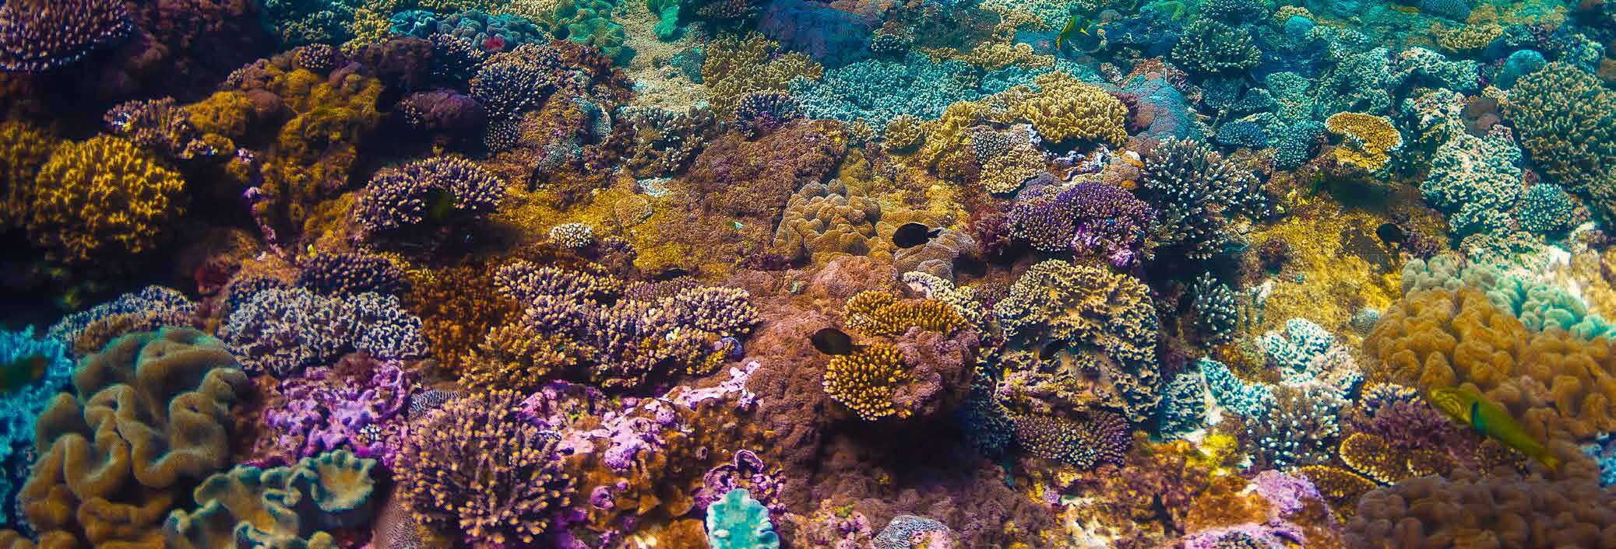

**Seed Capital and Financing Requirements:**

To kickstart our coral reef restoration projects, we require significant seed capital. This initial funding is crucial to cover the costs of research, planning, and the initial phases of reef restoration. Based on similar successful projects globally, we estimate the following funding needs:

**Initial Funding Breakdown**:

*Research and Development: $200,000*

* Baseline surveys
* Genetic studies
* Environmental impact assessments

*Restoration Infrastructure: $500,000*

* Construction of coral nurseries
* Reef structure materials
* Specialized equipment and technology

*Operational Costs: $300,000*

* Salaries for marine biologists and divers
* Training programs for local communities
* Transportation and logistics

*Monitoring & Maintenance: $100,000*

* Long-term monitoring systems
* Regular maintenance of restored reefs
* Data collection and analysis

**Note for text above:**

Note Above for intital funding breakdown there have to be 2 columns of each bullet point . *Research and Development: $200,000 and Restoration Infrastructure: $500,000* should be on the right column taking 50% of the screen .

Note Below there have to be 2 columns of each bullet point *Operational Costs: $300,000* ***and*** *Monitoring & Maintenance: $100,000* should be on the left column taking 50% of the screen .

**Total Initial Investment Needed: $1.1 million**

**Financing Options**

We understand that a successful project requires diverse and sustainable financing streams. Here are the primary financing options we offer for investors:

**1. Equity Investment:** By investing equity, you become a part-owner of our company, sharing in both the risks and rewards of our venture. Equity investments provide the capital needed for large-scale restoration projects and offer potential returns through company growth and profitability.

**2. Debt Financing:** We offer structured debt financing options with competitive interest rates and clear repayment schedules. This allows investors to support our projects while receiving regular interest payments.

**3. Grants and Donations:** Non-profit organizations, foundations, and individual philanthropists can support our mission through grants and donations. These funds are crucial for specific projects or for covering unforeseen expenses.

**4. Biodiversity Credits:** Similar to carbon credits, biodiversity credits represent a quantified positive environmental impact. By purchasing biodiversity credits, investors can directly support the restoration of coral reefs and potentially benefit from future trading of these credits as the market develops.

**5. Revenue Sharing:** Invest in our revenue-generating activities such as eco-tourism, diving expeditions, and educational programs. Revenue-sharing agreements provide a steady income stream while promoting sustainable tourism and local economic growth.

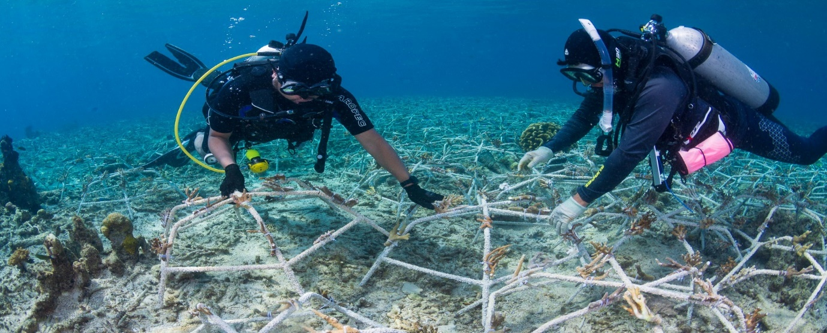

Note: Image below full width

**Expected Returns on Investment**

Investing in coral reef restoration not only yields environmental benefits but also offers attractive financial returns. Here’s what investors can expect:

* Environmental Impact: Contribute to the recovery of coral reefs, enhance biodiversity, and improve coastal resilience against climate change.
* Economic Returns: Generate revenue through eco-tourism, diving, and educational activities. Investors benefit from revenue-sharing agreements and the potential appreciation of reef credits.
* Social Benefits: Support local communities by creating jobs, providing training, and fostering sustainable economic development.

**Join Our Mission Now!!!**