**Note: left 50% need to be the paragraph that starts with reefstore restoration and 50% needs to be image on the right**

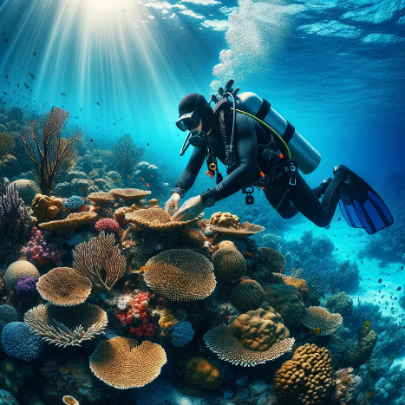**Reefstore Restoration Education**

At Coral Reef Restoration Education, we offer high-quality, scientifically backed video content designed to enhance Scuba Diving Certification programs, covering topics in marine biology, environmental science, and conservation. Our videos provide in-depth knowledge and practical skills essential for understanding and implementing coral reef restoration projects.

#### **Video Content Offerings**

1. **Introduction to Coral Reef Ecosystems**
   * Overview of coral reef biology and ecology.
   * Importance of coral reefs to marine life and human communities.
   * Current threats to coral reefs and their global impact.

NOTE: Left 60% need to be the bullet point starting with 2. Coral reef restoration techniques , and on the righy image,

1. A coral reef under water

   Description automatically generated**Coral Reef Restoration Techniques**
   * Detailed explanations of various restoration methods:
     + **Coral Gardening:** Steps to cultivate and transplant corals.
     + **Artificial Reefs:** Design and implementation of man-made reef structures.
     + **Coral Propagation:** Techniques for fragmenting and growing corals.
     + **Microfragmentation:** Cutting-edge methods to accelerate coral growth.
   * Case studies showcasing successful restoration projects.
2. **Fieldwork and Monitoring**
   * Practical skills for conducting field surveys and monitoring coral health.
   * Techniques for assessing coral reef recovery and biodiversity.
   * Data collection and analysis methods.
3. **Sustainable Practices and Community Engagement**
   * Best practices for minimizing human impact on coral reefs.
   * Strategies for engaging local communities in conservation efforts.
   * Sustainable tourism guidelines to protect reef ecosystems.

#### **Benefits of the Certification**

* **Enhance Learning Outcomes:** Our videos provide comprehensive, up-to-date information from leading experts, ensuring your certification programs are robust and credible.
* **Flexible Integration:** Easily incorporate our video content into your existing curriculum or use them as standalone modules.
* **Engaging and Interactive:** High-quality visuals and clear explanations make complex scientific concepts accessible and engaging for learners.
* **Support Continuing Education:** Offer advanced training for professionals seeking to expand their knowledge and skills in coral reef restoration.

NOTE: IMAGE BELOW FULL WIDTH

#### **How to Collaborate**

**Customized Solutions:** We can tailor our video content to meet the specific needs of your certification programs, ensuring alignment with your educational goals.

**Subscription Packages:** Choose from a range of subscription options to access our full library of videos, including regular updates and new releases.

**Exclusive Access:** Provide your learners with exclusive access to cutting-edge restoration techniques and the latest scientific research.

#### **Get Started**

Enhance your certification programs today with our expert-led coral reef restoration videos. Contact us to learn more about our offerings, customization options, and pricing.

**Email:** [partnerships@coralreefrestoration.org](mailto:partnerships@coralreefrestoration.org)**Phone:** +1 (123) 456-7890

**Together, we can educate and empower the next generation of marine conservationists.**