NewsGenie: An AI-Powered Information and News Assistant
Author: Alessandra Hershey-Zagrans
Repository: https://github.com/Alessandrarye/newsgenie

1. Problem and approach
News consumption is fragmented. People bounce between apps for headlines, a search engine for background, and a chatbot for quick answers, and none of them tell you much about whether a source is trustworthy. NewsGenie puts those jobs in one chat window. It answers general questions, delivers category or topic news on demand, rates each story’s source reliability, and remembers the conversation so follow-ups work naturally.
The system has four layers:
Layer | Technology | Job
Interface | Streamlit | Chat, category buttons, options, service status, per-session memory
Orchestration | LangGraph | Routes each message through classify → retrieve → filter → respond
Intelligence | OpenAI via LangChain | Intent classification (structured output) and grounded answers
Data | NewsAPI, GNews, DuckDuckGo | Real-time headlines and web search, in a fallback chain
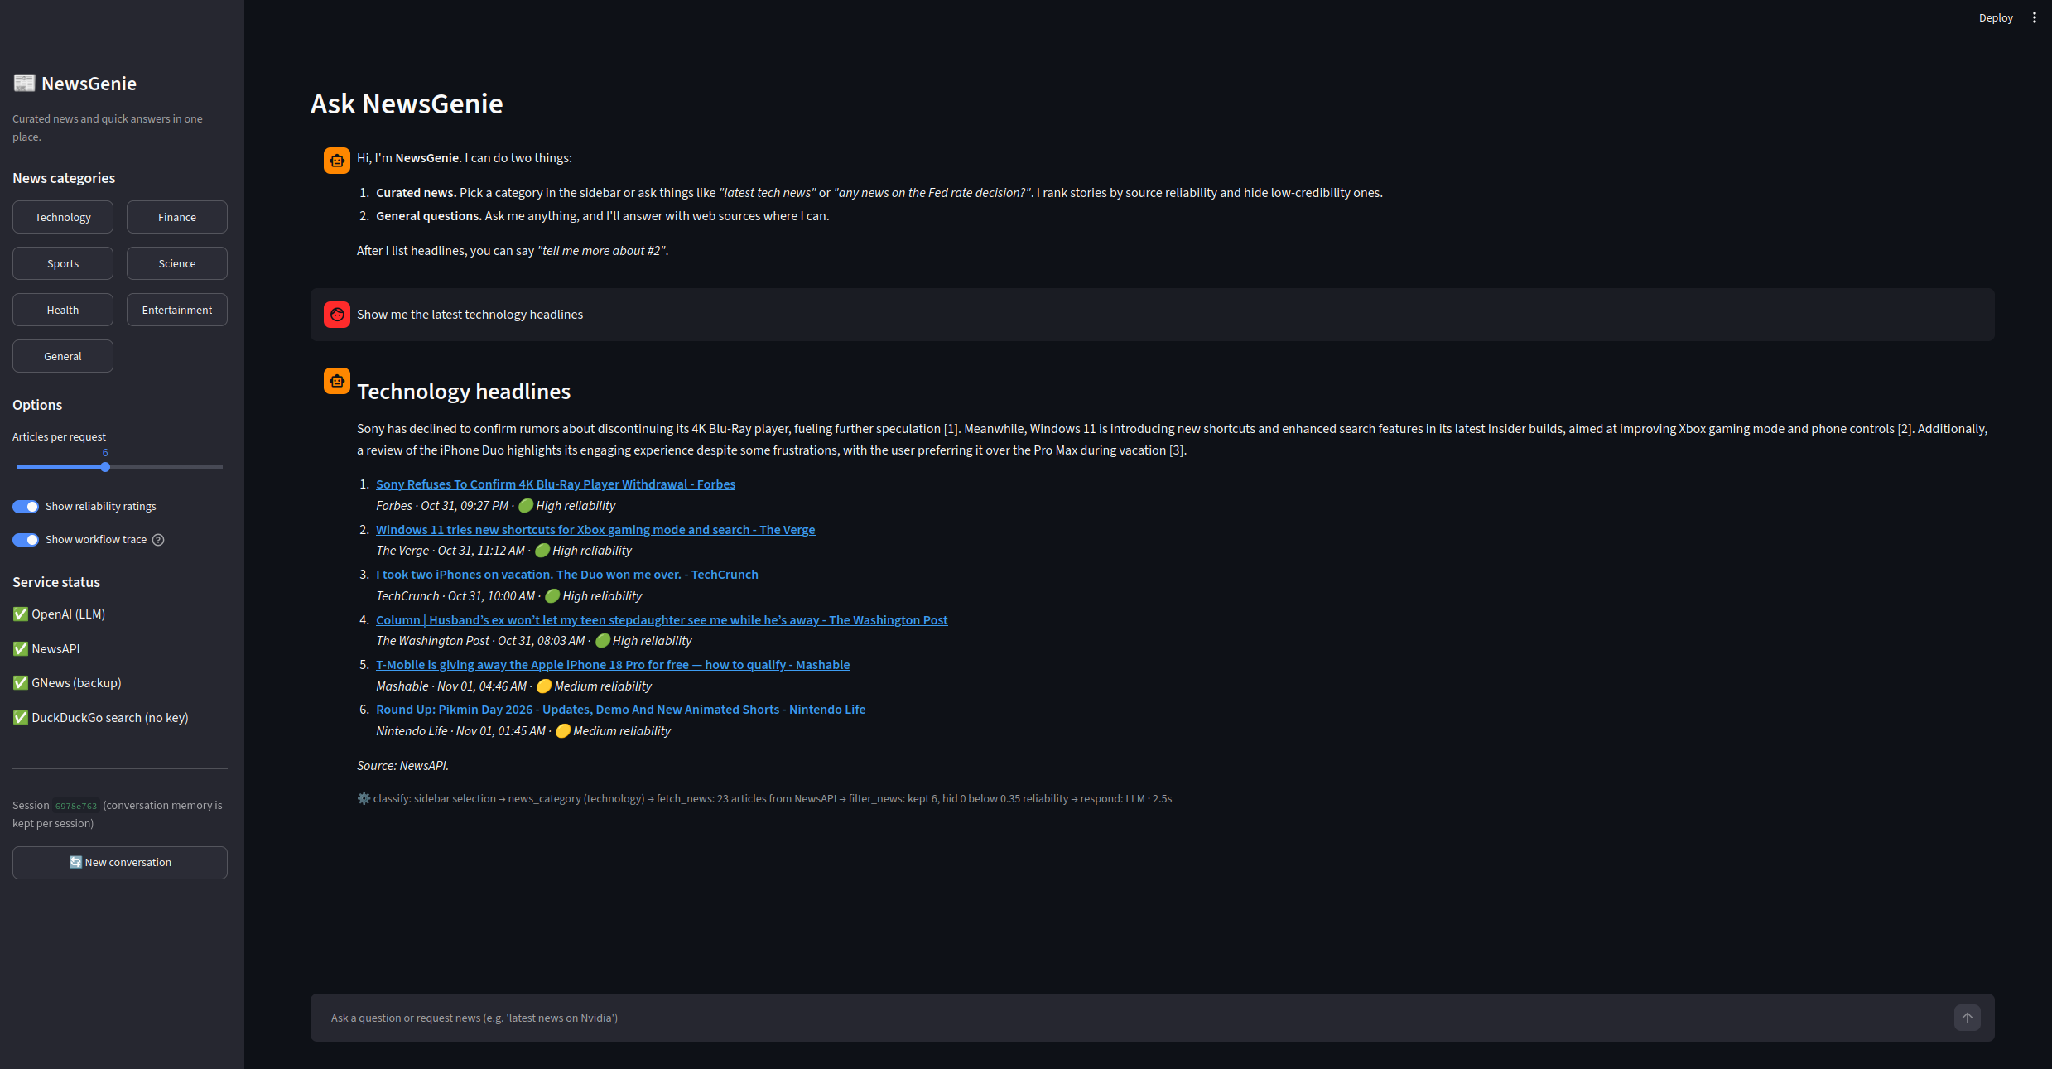
NewsGenie interface with category news, reliability ratings, and workflow trace
Full source code, tests, and setup instructions are available at https://github.com/Alessandrarye/newsgenie.

2. AI chatbot design

2.1 Query differentiation
Every message is classified into one of five intents before any tool runs. Classification decides which APIs get called, so a general question never burns news API quota and a news request never gets a stale answer from the model’s training data.
Intent | Example | Route
greeting | “hi”, “what can you do” | Canned help text, no tools
news_category | “latest tech news”, sidebar button | News providers by category
news_topic | “any news about Nvidia earnings?” | News providers by keyword + web background
follow_up | “tell me more about #2” | Remembered article + web search
general | “what’s the difference between a stock and a bond?” | Web search + LLM answer
Classification runs in two layers:
- Rules (always on, instant). Regular expressions catch greetings, follow-up references (“#2”, “the second article”), and news cue words (“latest”, “headlines”, “breaking”). Keyword lists map words to categories (for example “stocks”, “Fed”, “earnings” → finance). After removing filler words, anything left over becomes the topic, so “latest news on the Fed rate cut” yields topic Fed rate cut.
- LLM with structured output (when a key is set). For anything the rules did not settle, the model returns a typed Classification object (intent, category, topic, article index, standalone search query). It sees the last six messages, which lets it resolve references like “what about him?” into a full search query.
Greetings and follow-ups skip the LLM entirely because the rules handle them reliably. If the LLM call fails or returns something inconsistent (a follow-up when no articles exist), the rule result is used. The UI trace shows which method decided.

2.2 Conversation management
- Session isolation. Each browser session gets a UUID thread_id. The compiled graph is shared across sessions, but LangGraph’s checkpointer stores state per thread, so conversations never mix.
- What persists between turns. messages (full chat history, appended through the add_messages reducer) and last_articles (the most recent ranked list, which makes “tell me more about #3” work).
- What resets each turn. Intent, retrieved articles, web results, errors, and the trace are cleared in the first node so nothing from the previous request leaks into the next.
- Context window control. The classifier sees the last 6 messages and the answer generator the last 8. That keeps latency and cost flat as conversations grow.
- New conversation. A sidebar button issues a new thread_id and clears the visible chat.
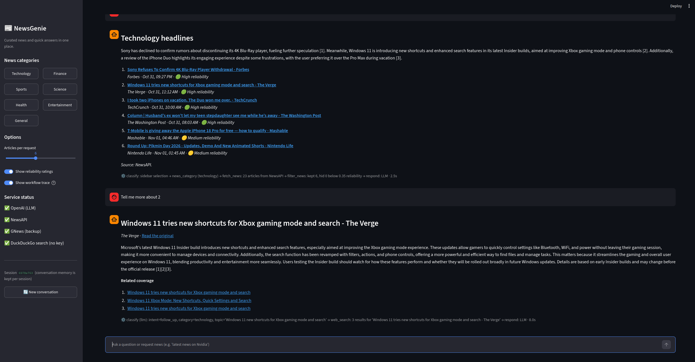
Follow-up “Tell me more about 2” resolved by the LLM classifier using conversation memory

2.3 Response guidelines
- Ground answers in retrieved material and cite it as [n] with links.
- News briefings are 2 to 3 neutral sentences that only restate what the headlines say.
- General answers stay under about 200 words unless the user asks for more, and say so when no web results were available.
- Every news item shows source, time, and a reliability badge so users can judge for themselves.

2.4 Misinformation filtering
NewsGenie does not claim to fact-check. It applies a transparent, auditable reliability score to each article:
score = 0.55 × source reputation + 0.25 × headline quality + 0.20 × corroboration
- Source reputation: curated domain lists. Wire services and established outlets score 1.0, unknown domains 0.5, repeatedly low-rated sites 0.05, satire 0.0.
- Headline quality: penalties for clickbait patterns (“you won’t believe”, “!!!”) and mostly-capitals headlines.
- Corroboration: credit when other independent outlets in the same batch carry a similar headline (word-overlap similarity).
Near-duplicate headlines (syndicated or lightly reworded copies of the same story) are collapsed into one entry, keeping the most reliable copy and crediting the others in its “also reported by” count. Stories below the threshold (default 0.35) and all satire are hidden from the main list, but the UI lists them in an expander with the reason, so filtering is visible rather than silent.

3. Real-time news integration

3.1 Providers and categories
Order | Provider | Key needed | Notes
0 | In-memory cache | No | 10-minute TTL; repeated clicks are instant
1 | NewsAPI | Yes | top-headlines for categories, everything for topics
2 | GNews | Yes | Same interface, used if NewsAPI fails
3 | DuckDuckGo News | No | Last live source; widens from 1 day to 1 week if empty
4 | Last good result | No | Shown with a clear “cached copy from N min ago” warning
UI categories map to provider categories: Technology → technology, Finance → business, Sports → sports, plus Science, Health, Entertainment, and General.

3.2 Sample outputs
Technology
User: Show me the latest technology headlines
Workflow trace: classify: sidebar selection -> news_category (technology) → fetch_news: 23 articles from NewsAPI → filter_news: kept 6, hid 0 below 0.35 reliability → respond: LLM (2.6s)
NewsGenie:
Technology headlines
Sony has declined to confirm rumors about discontinuing its 4K Blu-Ray player, fueling further speculation [1]. Windows 11 is introducing new shortcuts and enhanced search features in its latest Insider builds, aimed at improving Xbox gaming mode and phone controls [2]. Meanwhile, a TechCrunch review highlights the engaging experience of using the iPhone Duo during a vacation, despite some frustrations [3].
- Sony Refuses To Confirm 4K Blu-Ray Player Withdrawal - Forbes
Forbes · Oct 31, 09:27 PM · 🟢 High reliability
- Windows 11 tries new shortcuts for Xbox gaming mode and search - The Verge
The Verge · Oct 31, 11:12 AM · 🟢 High reliability
- I took two iPhones on vacation. The Duo won me over. - TechCrunch
TechCrunch · Oct 31, 10:00 AM · 🟢 High reliability
- Column | Husband’s ex won’t let my teen stepdaughter see me while he’s away - The Washington Post
The Washington Post · Oct 31, 08:03 AM · 🟢 High reliability
- T-Mobile is giving away the Apple iPhone 18 Pro for free — how to qualify - Mashable
Mashable · Nov 01, 04:46 AM · 🟡 Medium reliability
- Round Up: Pikmin Day 2026 - Updates, Demo And New Animated Shorts - Nintendo Life
Nintendo Life · Nov 01, 01:45 AM · 🟡 Medium reliability
Source: NewsAPI.
Finance
User: Show me the latest finance headlines
Workflow trace: classify: sidebar selection -> news_category (business) → fetch_news: 21 articles from NewsAPI → filter_news: kept 6, hid 0 below 0.35 reliability → respond: LLM (1.4s)
NewsGenie:
Finance headlines
Binance has resumed withdrawals for some major cryptocurrencies in phases following a $6 billion heist, pending security checks [1]. Meanwhile, a family affected by Sanfilippo syndrome raised millions for gene therapy research, contributing to the FDA’s recent approval of a related treatment [2]. In other news, bond investors are cautious ahead of the US midterm elections, and a judge has allowed a class-action lawsuit against McDonald’s over its McRib sandwich to proceed [3][4].
- Binance resumes withdrawals for some major cryptocurrencies after $6 billion heist - CBS News
CBS News · Nov 01, 05:35 AM · 🟢 High reliability
- How one family gave a critical boost to gene therapy research - NPR
NPR · Nov 01, 05:00 AM · 🟢 High reliability
- Bond investors sit out ‘most consequential’ US midterm elections in years - Financial Times
Financial Times · Nov 01, 01:01 AM · 🟢 High reliability
- Judge won’t dismiss McRib class-action lawsuit against McDonald’s - USA Today
USA Today · Oct 31, 10:47 PM · 🟢 High reliability
- South Korea’s Chip-Led Exports Accelerate, Bringing $1 Trln Annual Target Closer - WSJ
The Wall Street Journal · Oct 31, 09:42 PM · 🟢 High reliability
- We’re Living in the Age of the Imperial CEO - WSJ
The Wall Street Journal · Oct 31, 09:00 PM · 🟢 High reliability
Source: NewsAPI.
Sports
User: Show me the latest sports headlines
Workflow trace: classify: sidebar selection -> news_category (sports) → fetch_news: 24 articles from NewsAPI → filter_news: kept 6, hid 0 below 0.35 reliability → respond: LLM (1.4s)
NewsGenie:
Sports headlines
Harriet Dart secured her first WTA title by defeating Lilli Tagger at the Guangzhou Open, marking a career highlight [1]. In college football, Week 9 saw notable performances with Nebraska and USC among the winners and losers, while projections for the College Football Playoff top 12 were updated [3][6]. Additionally, the Golden State Valkyries won the WNBA championship in their second season, led by Gabby Williams’ 30 points in a close Game 7 victory over the Atlanta Dream [4].
- Harriet Dart wins first WTA title by beating Lilli Tagger at Guangzhou Open - BBC
BBC News · Nov 01, 06:27 AM · 🟢 High reliability
- The Patriots are 18-43 all time in Miami. Here are keys to a Week 8 victory - ESPN
ESPN · Nov 01, 06:00 AM · 🟢 High reliability
- Nebraska, USC headline college football winners, losers in Week 9 - USA Today
USA Today · Nov 01, 05:07 AM · 🟢 High reliability
- Gabby Williams leads Valkyries to WNBA championship in second season, beating Dream 68-63 in Game 7 - AP News
Associated Press · Nov 01, 04:12 AM · 🟢 High reliability
- Fletcher’s go-ahead score, Lightfoot’s defensive play help No. 1 Miami rally past UNC 38-35 - AP News
Associated Press · Nov 01, 01:05 AM · 🟢 High reliability
- College Football Playoff top 12 projection after Week 9 - ESPN
ESPN · Nov 01, 12:25 AM · 🟢 High reliability
Source: NewsAPI.
docs/failure_mode_demo.md shows the same script run with every external service unreachable. The app still returned a clear message for each request instead of an error.

4. Workflow and error handling

4.1 LangGraph workflow
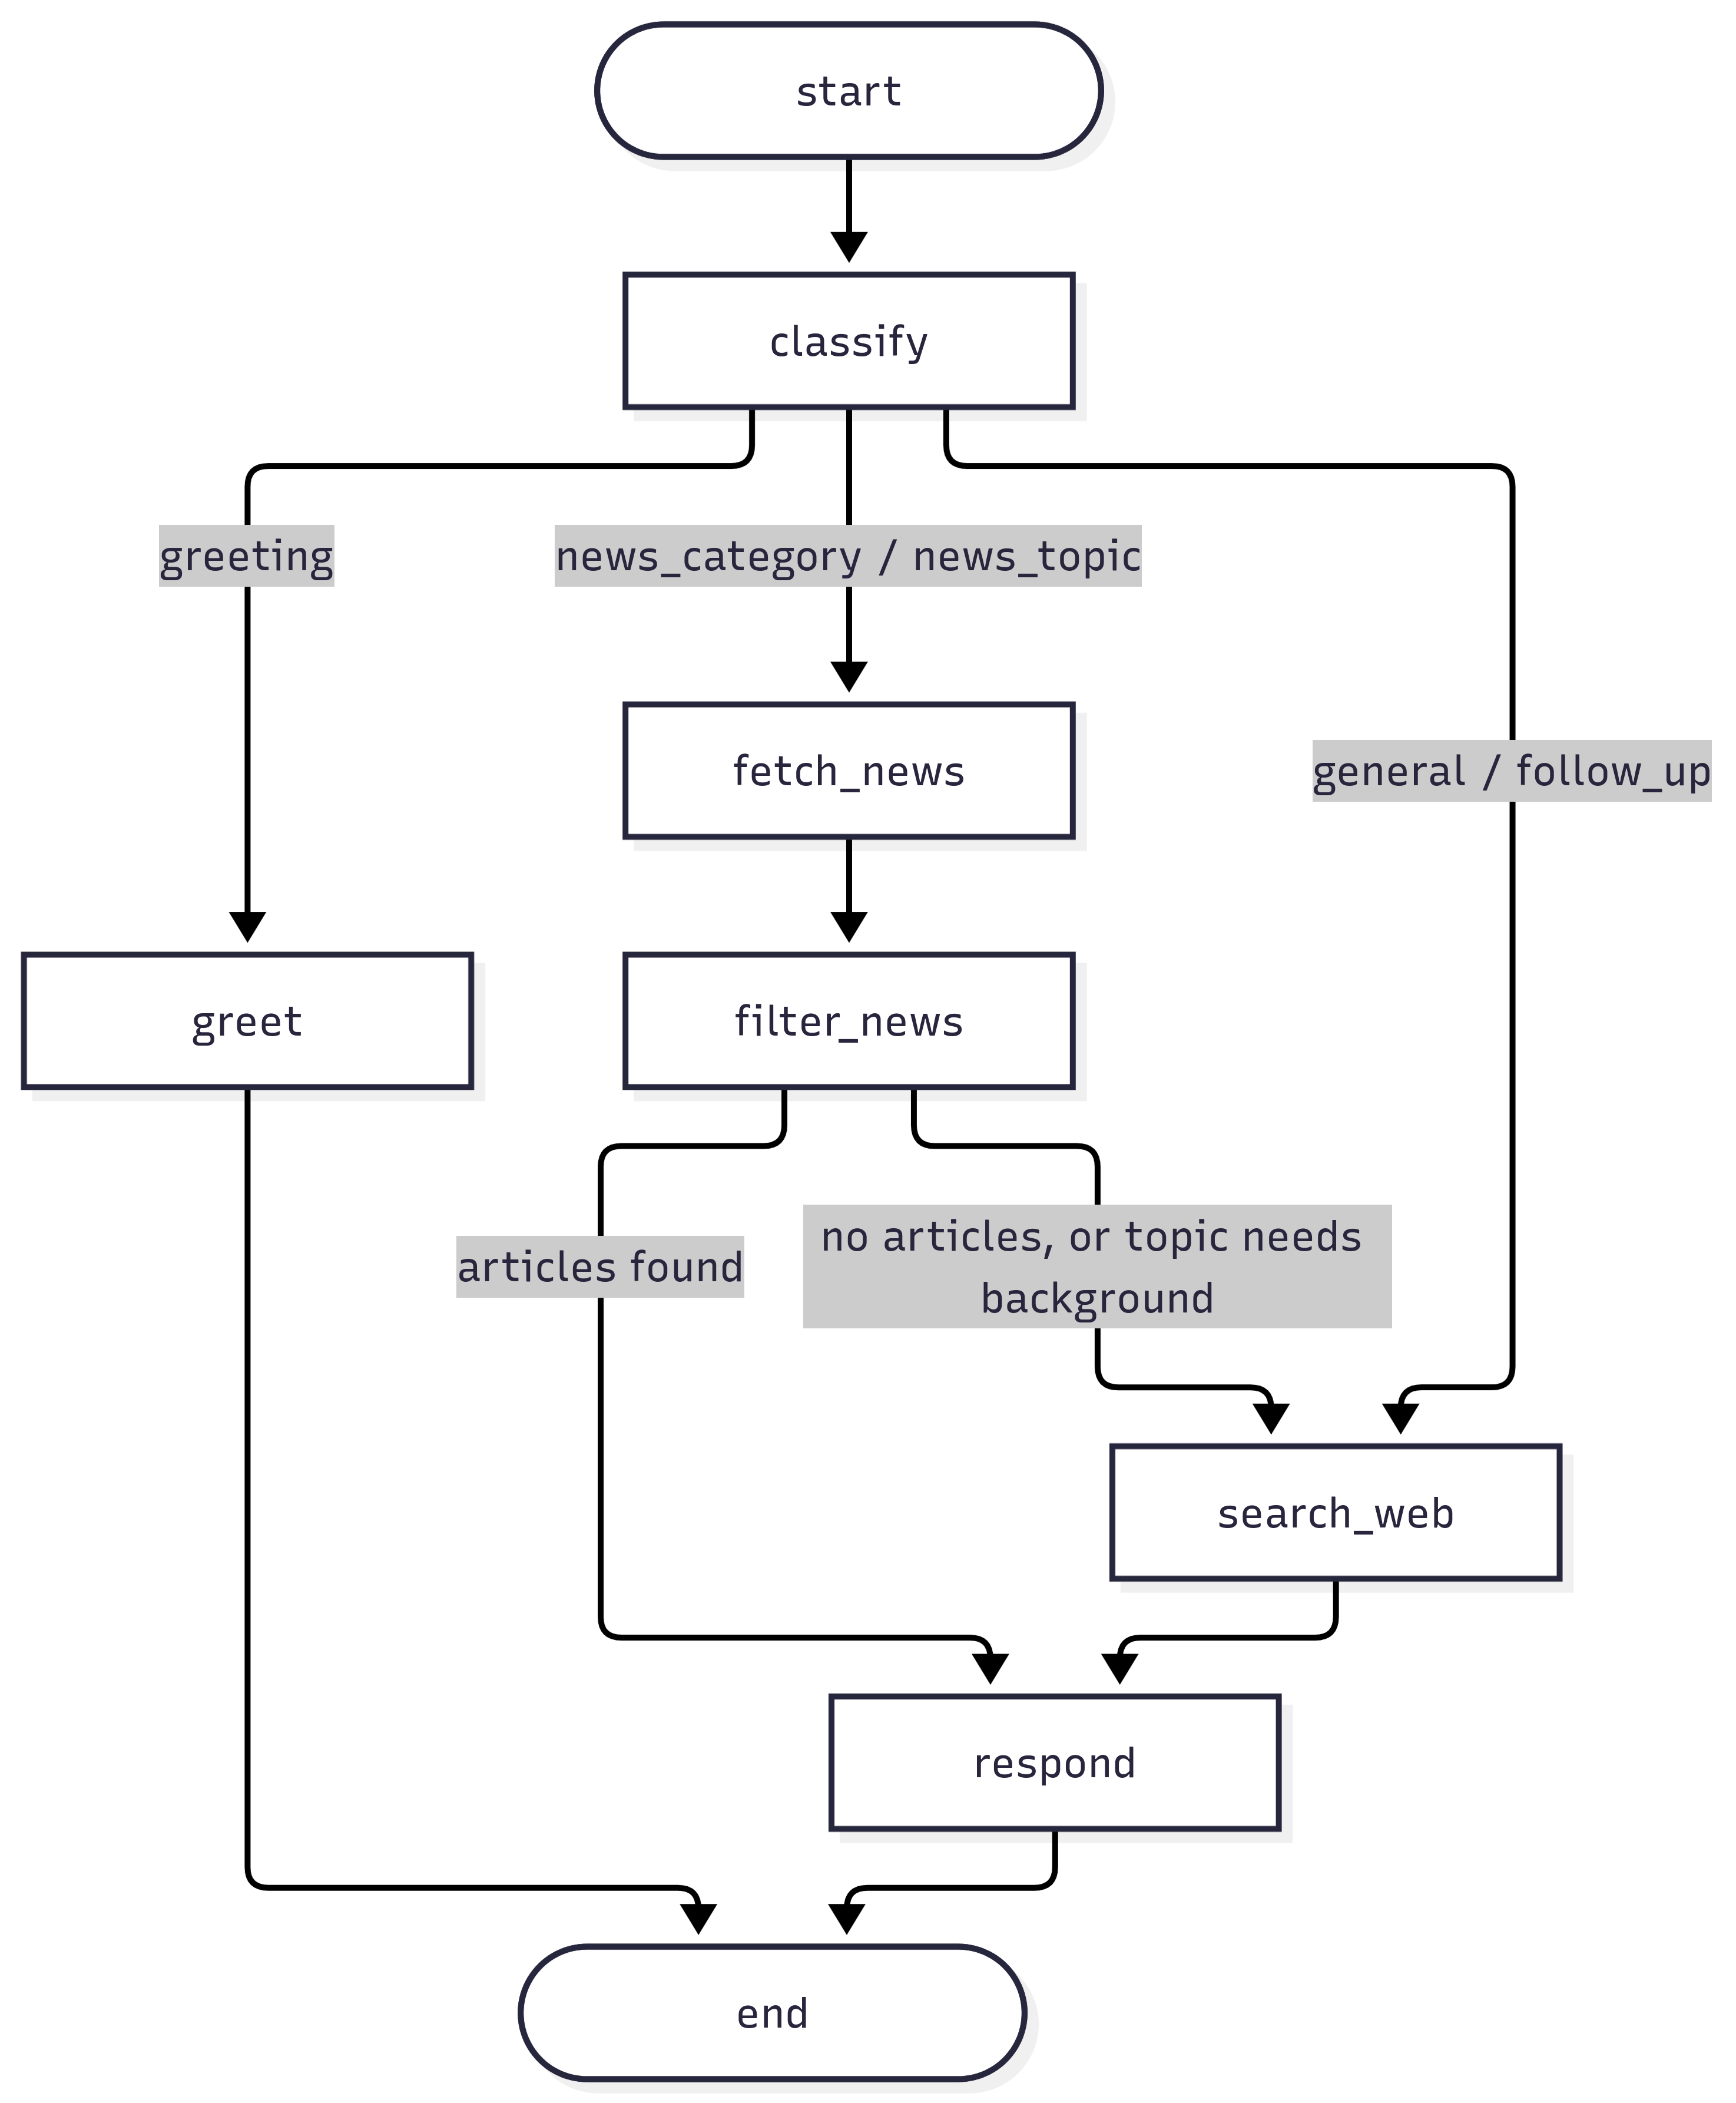
NewsGenie LangGraph workflow with routing conditions
Node | What it does
classify | Resets per-turn state, records the user message, determines intent (or takes the sidebar category directly)
greet | Returns help text with no API calls
fetch_news | Walks the provider chain and records every fallback event
filter_news | Scores, filters, and ranks articles; keeps the top N
search_web | DuckDuckGo search; query depends on intent (question, topic background, or article title)
respond | Builds the reply with the LLM, or with templates when the LLM is unavailable; saves last_articles
The two conditional edges are where fallback logic lives. After filter_news, an empty result sends the request to web search instead of ending with nothing.

4.2 Fallback matrix
Failure | Detected by | Behavior the user sees
OPENAI_API_KEY missing | Settings.has_llm | Rule-based routing and template replies; sidebar notice
LLM call errors or times out | try/except in classifier and responder | Rule classification / template reply for that turn; trace says “LLM failed”
NEWSAPI_KEY / GNEWS_API_KEY missing | Provider raises ProviderError("... not set") | Next provider in the chain; listed under “Fallback details”
HTTP 429 / 5xx | urllib3 Retry (2 retries, 0.5s backoff) | Retried automatically, then next provider
Timeout or network error | requests timeout (8s default) | Next provider
Provider returns no articles | Empty-list check | Next provider
Every live provider fails | End of chain | Last good result with stale warning, or web results, or a clear “try again” message
All articles fail reliability filter | filter_news returns empty | Routed to web search for alternatives
Follow-up number out of range | Bounds check | “I only have N articles from the last list”
Any unexpected exception | Top-level try/except in app.py | Friendly message; conversation is preserved
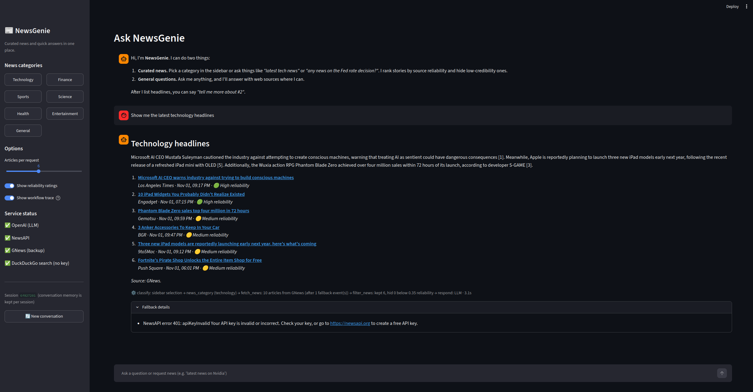
NewsAPI rejected an invalid key (401); the workflow fell back to GNews and still delivered headlines

4.3 Performance
- Caching. News results cache for 10 minutes per category or topic, and web results for 15 minutes, which cuts both latency and API quota use.
- Skipping work. Greetings and sidebar category clicks skip LLM classification. Category news skips web search unless news retrieval came back empty.
- Bounded context. History is truncated before LLM calls.
- Shared resources. The graph and HTTP session are built once per server process (st.cache_resource) instead of on every rerun.
- Visibility. Each reply shows the nodes that ran, the provider used, and elapsed seconds.

4.4 Testing
The tests/ folder has 32 pytest tests that run offline by replacing network calls with fakes. They cover intent classification, topic extraction, reliability scoring, every step of the provider fallback chain (including stale cache and total failure), session isolation, follow-up memory, and the LLM path through a stub model.

5. Limitations and next steps
- The reliability score is a heuristic. A next step is pulling ratings from a published media-bias dataset instead of hand-maintained lists, and adding claim-level checks against fact-check APIs.
- NewsAPI’s free plan only works from localhost, so a public deployment would need a paid plan or GNews as primary.
- NewsAPI assigns categories by outlet rather than by article, so category feeds occasionally include off-topic stories (for example, an advice column under Technology). A per-headline relevance check would tighten this.
- InMemorySaver loses history when the server restarts. A SQLite or Postgres checkpointer would make sessions durable.
- Personalization (saved favorite categories, topic alerts) would build naturally on the existing session state.

References
GNews. (n.d.). GNews API documentation (v4). Retrieved October 28, 2026, from https://gnews.io/docs/v4
LangChain. (n.d.). LangGraph documentation. Retrieved October 28, 2026, from https://langchain-ai.github.io/langgraph/
NewsAPI. (n.d.). Documentation. Retrieved October 28, 2026, from https://newsapi.org/docs
Streamlit. (n.d.). Streamlit documentation. Retrieved October 28, 2026, from https://docs.streamlit.io/

