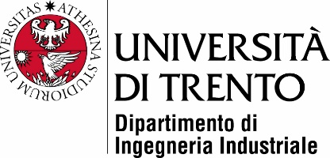

Master’s Degree in

Mechatronics Engineering

FINAL DISSERTATION

[TITLE]

Subtitle (optional)

|  |  |
| --- | --- |
| SupervisorUniTrento |  |
| Davide Brunelli |  |
|  |  |
|  |  |
| Student |  |
| Alessandro Avi 214580 |  |
|  |  |
|  | |

ACADEMIC YEAR 2020/2021