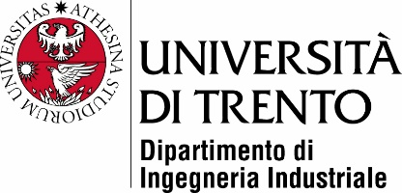

Master’s Degree in

Mechatronics engineering

FINAL DISSERTATION

Continual learning applied on cameras

Subtitle (optional)

|  |  |
| --- | --- |
| SupervisorUniTrento |  |
| Davide Brunelli and signature |  |
|  |  |
|  |  |
| Student |  |
| Alessandro Avi - 214579 |  |
|  |  |
|  | |

ACADEMIC YEAR 2020/2021