MONETARY THEORY AND POLICY: TAKEHOME ASSIGNMENT 3

1. The New Keynesian Supply Side
In this exercise you will work out the supply side of the New Keynesian model. The economy is populated by a large number N of firms producing a differentiated good. Each firm i produces a variety of the good, label it i as well, according to a linear production function: Y (i) = AN(i) (1)
where Y (i) is the output of variety i, N (i) is the labor it uses and A is a common productivity term. These producers are monopolistically competitive, hence they take demand for their variety as given and choose the optimal price level P (i). Varieties are imperfect substitutes in the preferences of the consumer.

Question 1
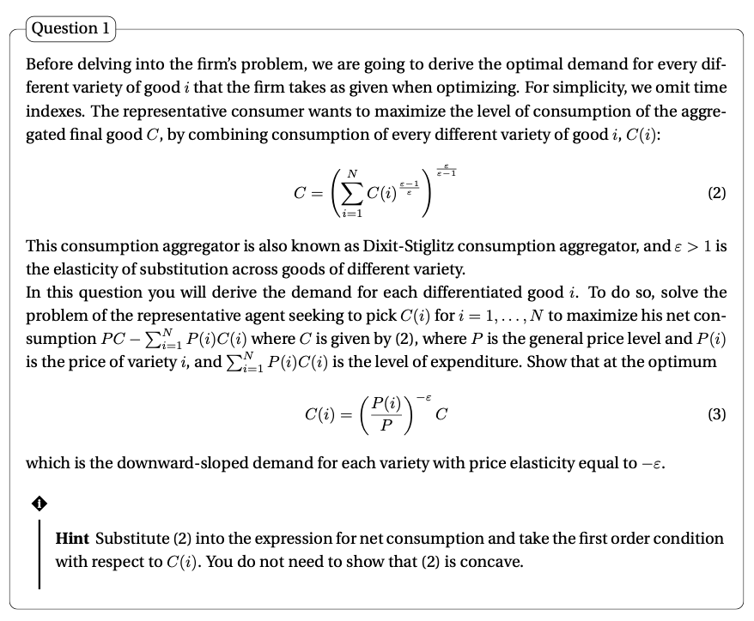
We maximize net consumption by putting $C= {\left(\sum_{i=1}^{N}{{C(i)}^{\frac{ε-1}{ε}}}\right)}^{\frac{ε-1}{ε}}$ into PC - $\sum_{i=1}^{N}{P\left(i\right)C(i)}$
Hence we get: P ${\left(\sum_{i=1}^{N}{{C(i)}^{\frac{ε-1}{ε}}}\right)}^{\frac{ε-1}{ε}}$ - $\sum_{i=1}^{N}{P\left(i\right)C(i)}$
We take FOC wrt C(i) : P $\frac{ε}{ε-1 } {\left(\sum_{i=1}^{N}{{C(i)}^{\frac{ε-1}{ε}}}\right)}^{\frac{ε}{ε-1}-1} \frac{ε-1}{ε} {C_{i}}^{\frac{ε-1}{ε}-1}$ – P(i)

P${\left(\sum_{i=1}^{N}{{C(i)}^{\frac{ε-1}{ε}}}\right)}^{\frac{ε}{ε-1}-1 } {C_{i}}^{\frac{ε-1}{ε}-1}$ – P(i) P${\left(\sum_{i=1}^{N}{{C(i)}^{\frac{ε-1}{ε}}}\right)}^{\frac{ε}{ε-1}-\frac{ε- 1}{ε- 1} } {C_{i}}^{\frac{ε-1}{ε}-\frac{ε}{ε}}$ – P(i)
P${\left(\sum_{i=1}^{N}{{C(i)}^{\frac{ε-1}{ε}}}\right)}^{\frac{1}{ε-1} } {C_{i}}^{\frac{-1}{ε}}$ – P(i) P${\left(\sum_{i=1}^{N}{{C(i)}^{\frac{1}{ε}}}\right)}^{ } {C_{i}}^{\frac{-1}{ε}}$ – P(i)

${\left(C^{\frac{1}{ε}}\right)}^{ } {C_{i}}^{\frac{-1}{ε}}$ = $\frac{P(i)}{P}$ $C^{ } C_{i}^{-1}$= ${\left(\frac{P(i)}{P}\right)}^{ε}$

$\frac{1}{C_{i}}$= ${\left(\frac{P(i)}{P}\right)}^{ε}$ $\frac{1}{C}$

$C_{i}= {\left(\frac{P(i)}{P}\right)}^{-ε}C$

The consumption of good Ci will be clearly affected by the average price for all products, the price of the good considered, and the elasticity of consumers. Elasticity will determine how reactive consumers are to differences in prices. The more the consumers are reactive the more a low Pi price relative to P will increase demand.

Question 2
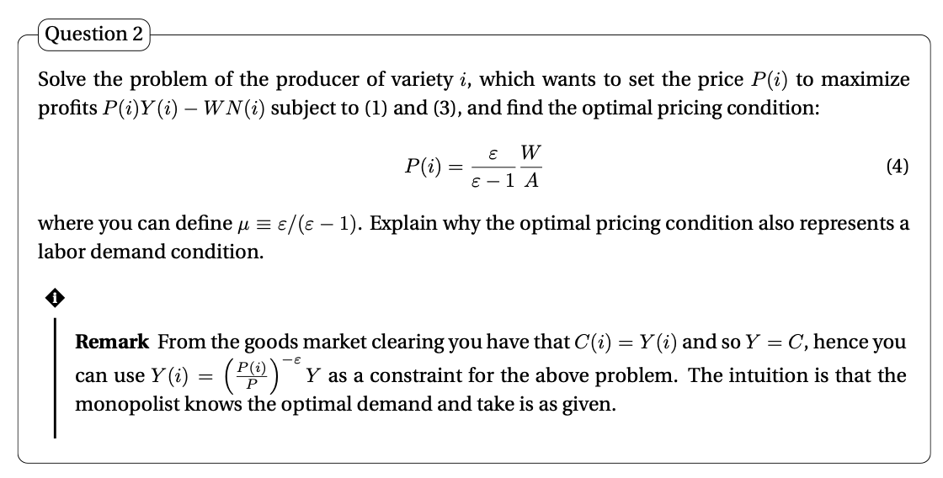

We can rewrite $C_{i}= {\left(\frac{P(i)}{P}\right)}^{-ε}C$ as $Y\left(i\right)= {\left(\frac{P(i)}{P}\right)}^{- ε}$Y

Max. [1] P(i)Y (i) − WN(i) under [2] Y(i) = AN(i) and [3] $Y\left(i\right)= {\left(\frac{P(i)}{P}\right)}^{- ε}Y$

put 2 into 1: P(i)Y (i) − W$\frac{Y(i)}{A}$ [4]

put 3 into 4: P(i) ${\left(\frac{P(i)}{P}\right)}^{- ε}Y$ − W $\frac{1}{A} {\left(\frac{P(i)}{P}\right)}^{- ε}Y$ (P(i) - W $\frac{1}{A}$) ${\left(\frac{P(i)}{P}\right)}^{- ε}$ Y [5]

FOC of [5] wrt Pi: $- \frac{ ε- 1 }{{\left(\frac{P(i)}{P}\right)}^{ε}}$ Y - ε ${\left(\frac{P(i)}{P}\right)}^{-ε-1}\frac{1}{P} \frac{W}{A}$ Y

$- \left(ε-1\right){\left(\frac{P\left(i\right)}{P}\right)}^{-ε}Y$ - ε ${\left(\frac{P(i)}{P}\right)}^{-ε-1}\frac{1}{P} \frac{W}{A}$ Y $- \left(ε-1\right)$ - ε ${\left(\frac{P(i)}{P}\right)}^{-1}\frac{1}{P} \frac{W}{A}$ $- \left(ε-1\right)$ - ε $\frac{1}{P(i)} \frac{W}{A}$

$\frac{1}{P(i)}$ = $\left(\frac{ε-1}{ε}\right)$ $\frac{A}{W}$ $P\left(i\right)= \frac{ε}{ε - 1}\frac{W}{A}$ [6]

This pricing condition also represents a labor demand condition. The $\frac{W}{A}$ ratio ties the price to the labor cost. When a firm sets its optimal price, it automatically sets the amount of labor (considering a given productivity) required to produce a defined quantity of the good (up until the desired price is realized). Basically the amount of labor required is a result of the price-cost optimization.

Question 3
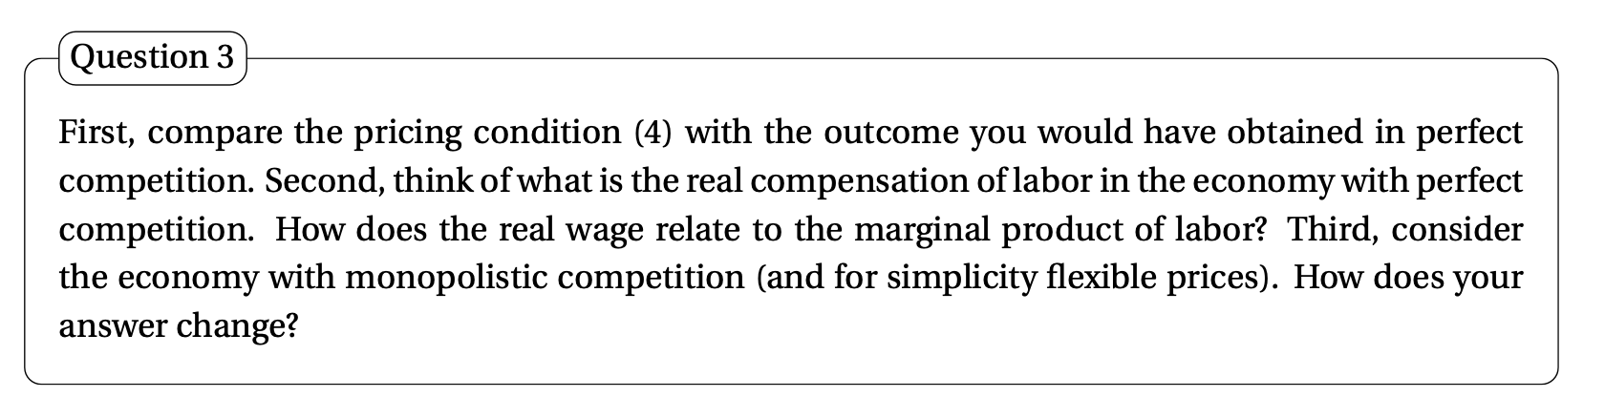

A. Perfect competition scenario
1. ε in perf comp is +inf Lerner index: $\frac{ε}{ε - 1}$ = 1 $P\left(i\right)= \frac{ε}{ε - 1}\frac{W}{A}$ [6] becomes: P(i) = $\frac{W}{A}$
Hence, in the perfect competition scenario the price charged is equal to the nominal marginal cost
2. If we now consider the real compensation of labor:
we take $P\left(i\right)= \frac{ε}{ε - 1}\frac{W}{A}$ [6] and we divide and multiply by Pt: $P\left(i\right)= \frac{ε}{ε - 1}\frac{\frac{W}{Pt}}{A} Pt$
If the markup is equal to 1 we deduce that $\frac{W}{Pt}=A \frac{Pi}{Pt}$
since the market is perfectly competitive Pi/Pt = 1, hence: $\frac{W}{Pt}=A$
real wage is equal to productivity

3. Since the production function is Y (i) = AN(i) (1)
Marginal product of labor (the derivative of Y wrt N) is equal to A.
hence, the higher the marginal product of labor the higher the real wage $\frac{W}{Pt}=A$

B. Monopolistically competitive market scenario:
1. ε is < +inf 1 Lerner Index: > 1 $P\left(i\right)> \frac{W}{A}$
Hence, in the monopolistically competitive market scenario the price charged is higher than the nominal marginal cost
2. If we now consider the real compensation of labor:
$P\left(i\right)= \frac{ε}{ε - 1}\frac{\frac{W}{Pt}}{A} Pt$ $P\left(i\right)= \frac{ε}{ε - 1} \frac{\frac{W}{Pt}}{A} Pt$ $\frac{W}{Pt}= \frac{ε}{ε - 1} \frac{AP(i)}{Pt}$ $\frac{W}{Pt}> \frac{AP(i)}{Pt}$

Since we assume all firms set flexible prices $\frac{W}{Pt}> A$
real wage is higher than productivity, and it is equal to: $\frac{W}{Pt}= \frac{ε}{ε - 1} A$

3. Since the production function is Y (i) = AN(i) (1)
the derivative of Y wrt N (marginal product of labor) is A.
Now:
$\frac{W}{Pt}= \frac{ε}{ε - 1} A$
Ceteris paribus (assuming markup is fixed), an increase in productivity will raise real wages

Question 4
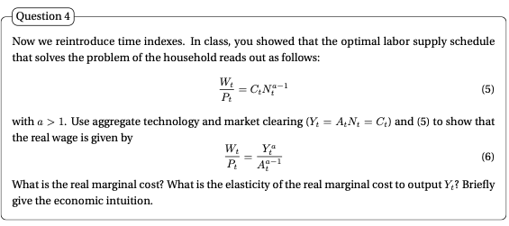

From: $\frac{W_{t}}{P_{t}} = C_{t} N_{t}^{α-1}$. If we substitute in $N_{t}= \frac{Y_{t}}{A_{t}}$ and we consider $Yt =C_{t}$ $\frac{W_{t}}{P_{t}} = Y_{t} {\left(\frac{Y_{t}}{A_{t}}\right)}^{α-1}$ $\frac{W_{t}}{P_{t}} = \frac{Y_{t}^{α}}{A_{t}^{α – 1}}$

The real marginal cost is equal to the real wage divided by productivity A, Hence:
MC = $\frac{Y_{t}^{α}}{A_{t}^{α }}$
If we now want to compute the elasticity of the real marginal cost to output, we compute $\frac{ Δ MC}{ Δ Y}$ * $\frac{Y}{MC}$

elasticity = $\frac{αY^{α-1}}{A_{t}^{α}}* \frac{Y}{\frac{Y_{t}^{α}}{A_{t}^{α }}}=α$

Hence, the elasticity of the real marginal cost to output is equal to a. As Output increases by 1% the real marginal cost will increase by a%. This is a typical result (increasing costs at the margin) in models where we do not have internal economics of scale.

Question 5
Combine the optimal conditions for labor demand and labor supply to write the firm’s optimal price as a function of the mark-up μ, aggregate output Yt, labor productivity At, and the aggregate price level Pt. Then, define the natural level of output Ytn and derive its expression. Briefly comment on the determinants of the natural level of output. Finally, use the expression of Ytn to obtain the firm’s optimal price as a function of Yt, Ytn, and Pt.

Demand: $P\left(i\right)= μ\frac{W}{A}$

Supply: $\frac{W_{t}}{P_{t}} = \frac{Y_{t}^{α}}{A_{t}^{α - 1}}$

We merge by substituting W from supply into demand:

$P_{t}\left(i\right)= μ\frac{1}{A} \frac{Y_{t}^{α}}{A_{t}^{α - 1}} P_{t }$ $P_{t}\left(i\right)= μ {\left(\frac{Y_{t}}{A_{t}}\right)}^{α}P_{t }$

If we assume all prices are flexible all firms will set prices: $P_{t}\left(i\right)= P_{t }$

Hence: $1= μ {\left(\frac{Y_{t}}{A_{t}}\right)}^{α}$ $Y_{t}^{n}= \frac{A_{t}}{μ^{\frac{1}{α}}}$
Τhe Natural level of output is level of output ($Y_{t}^{n}$) arising when prices are flexible (firms can quickly adjust their prices).
It is determined by
(i) technology At : the higher the technology level the higher workers’ productivity, hence the higher the aggregate level of output
and (ii) monopolistic competition in good markets μ: the lower the markup the more competitive the market thus the higher the aggregate level of output

if we now want the firm’s optimal price as a function of Yt, Ytn, and Pt, we write:
$P_{t}(i)=μ {\left(\frac{Y_{t}}{A_{t}}\right)}^{α}P_{t }=({\frac{{ Y}_{t }}{\frac{{ A}_{t }}{μ^{\frac{1}{α}}} })}^{α}P_{t}=({\frac{Y_{t}}{Y_{t}^{n}})}^{α} P_{t}$

Question 6
Assume that a fraction s ∈ (0, 1) of firms has sticky prices, whereas the remaining (1 − s) fraction sets its price flexibly. Write the last pricing condition you derived in the previous question in loglinear terms. Then, characterize the loglinear price set by flexible and sticky price firms. For sticky price firms assume for simplicity $y_{t}^{n,ε}= y_{t}^{ε}$ Finally, aggregate those prices to derive the loglinear expression for the aggregate price level.

Now, if we take logs:
$\log{P_{t}\left(i\right)}=a\left(\log{Y_{t}-\log{Y_{t}^{n}}}\right)+\log{P_{t}} -→ P_{t}\left(i\right)=a\left(y_{t}- y_{t}^{n}\right)+ P_{t}$

If we assume there are two types of firms:
1. flexible price firms (1-s)
$p_{t}\left(i\right)$ = a$\left(y_{t}- y_{t}^{n}\right)+ p_{t}$
2. Sticky firms:
these firms’ prices are the result of yesterdays’ expectations:
$p_{t}\left(i\right)$ = a$\left(y_{t}^{e}- y_{t}^{n,e}\right)+ p_{t}^{e}$ given that $y_{t}^{n,ε}= y_{t}^{ε}$ $p_{t}\left(i\right)$ = $p_{t}^{e}$

I we now aggregate these results, we get: $p_{t}=sp_{t}^{e}+\left(1-s\right)[a(y_{t}-y_{t}^{n}$)+ $p_{t}]$

Hence: ${p_{t}=p}_{t}^{e}+[ \frac{\left(1-s\right)α}{s} ](y_{t}-y_{t}^{n}$)

Question 7
Derive the Phillips curve. Then, explain how a deviation of inflation from expected inflation causes a deviation of output from its natural level, and provide an intuition for this result.

${p_{t}=p}_{t}^{e}+[ \frac{\left(1-s\right)a}{s} ](y_{t}-y_{t}^{n}$), where we can call $\frac{1}{α}$ = $[ \frac{\left(1-s\right)a}{s} ]$

Hence, we write the Phillips curve:

$p= p^{e}+[ \frac{1}{α} ](y- y^{n}$),

recall the variables are in log, if we now subtract $p_{-1}$ from both sides

$p-p_{-1}= p^{e}- p_{-1}+[ \frac{1}{α} ](y- y^{n}$),

And now we can rewrite the difference in prices as inflation:
$π = π^{ε}+[ \frac{1}{α} ](y- y^{n}$)

We add ν to represent exogenous events:
$π = π^{ε}+[ \frac{1}{α} ](y- y^{n}$) + ν

or we can also write:

$π = π^{ε}+λx$ + ν
where λ = $\frac{1}{α}$ and x = $(y- y^{n}$)

According to this equation, deviation of output yt from the natural level ytn are related to deviation of the price level pt from the expected price level pte. As we can see from the formula higher than expected inflation means a greater output gap.
Intuitively: if the actual inflation rate is higher than the expected one some firms(sticky firms) are stuck with lower prices than optimal; these firms face higher demand for their products than the firms using flexible prices; sticky firms hence raise their production to meet the higher demand and aggregate output rises above the natural level.

The higher the number of sticky firms the higher the effect of inflation on the output gap and, consequently the higher the reduction in unemployment. Eventually, when all prices will be adjusted upwards, demand will be back to the original level.

If all firms are flexible the price increase is immediately internalized, production is reduced and no gap, no employment is created, there is no excess demand. Inflation raises immediately. This would mean that monetary policy works perfectly to raise inflation without altering output.

In summary:
The more sticky firm we have the greater the effect of a price increase to the output gap
Vice versa: the more sticky firm we have the smaller the effect of an output increase to prices

Let’s define an example. Consider the equation: $P_{t}- P_{t}^{e}=[ \frac{\left(1-s\right)a}{s} ](y_{t}-y_{t}^{n}$),

A. low proportion of sticky firms
If s = 0.1 $[ \frac{\left(1-s\right)a}{s} ]$ = 9a
Dp = 9a Dx
if Dx up by 1% Dp up by 9a% high effect of output increase to inflation
flexible firms will immediately adjust prices after demand shocks high effect of inflation in the SR

however Dx = Dp / 9a
an increase in prices will determine a weak effect on demand, being the firms flexible they will , and will immediately adjust their prices, hence avoiding any significant increase in demand

B. high proportion of sticky firms
If s = 0.9 $[ \frac{\left(1-s\right)a}{s} ]$ = 0.11a
Dp = 0.11a Dx
if Dx up by 1% Dp up by 0.11a%
sticky firms are very slow at adjusting prices after demand shocks low effect on inflation in the SR
however Dx = Dp / 0.11a
an increase in prices will determine a strong effect on demand, being the firms sticky they cannot raise their prices, and will receive an higher than expected demand

2 The Phillips Curve
The focus of the original Phillips curve was the correlation between wage inflation and unemployment (wage Phillips curve). In the previous exercise, you derived the New Keynesian Phillips curve, which links deviations of output from its natural level to unexpected movements in the inflation rate (price Phillips curve). Economists have looked at both versions of the Phillips curve, as the two types of correlation may reflect different behavior in the structural factors driving the economy.
In the first part of this empirical exercise, you are going to explore the historical behavior of the “classical” Phillips curve, that is the price Phillips curve (although we will use unemployment rate as a measure of slackness, rather than the output gap). In the second part of the assignment, you will study alternative definition of the Phillips curve, using different measures of labor market slackness as predictor for both price inflation rate and wage inflation rate. For the first part, you have to download the following quarterly series from FRED:
1. Unemployment Rate, Seasonally Adjusted (Unit: Percent. Aggregation Method: Average)
2. Consumer Price Index for All Urban Consumers: All Items in U.S. City Average,Index1982-1984=100, Seasonally Adjusted
(Unit: Percent Change from Year Ago. Aggregation Method: Average)
These two series should be downloaded from 1951Q1 up to the latest available observation

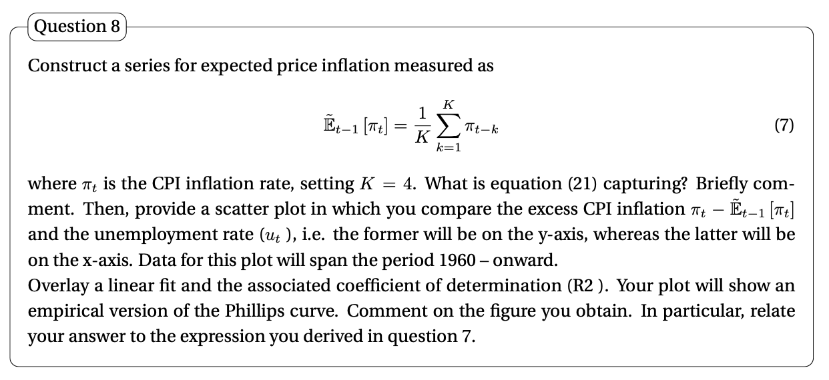
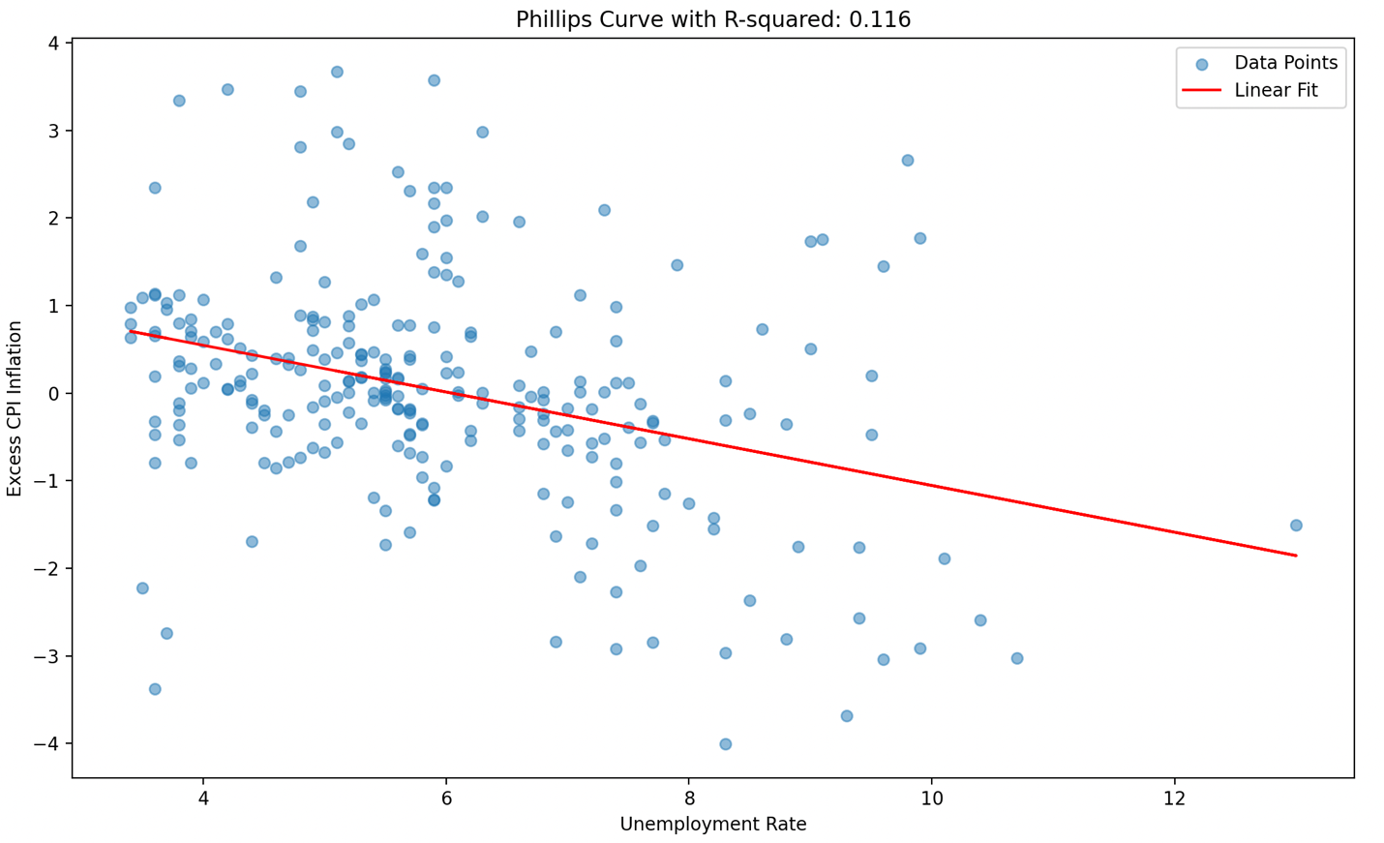

We can see that there is a negative relationship between excess CPI and the unemployment rate. As the unemployment rate increases the excess CPI decreases. The concept that we are representing is perfectly in line with what we defined in question 7, but in this case we are considering unemployment, and not the output gap. . Actually if we had plotted the output gap on the x axis we would have had a positive slope relationship. However these two measures are referring to the same concept: when output is high unemployment is low, and vice-versa. In fact, if $\left(y- y^{n}\right)$ is positive, so output is higher than its natural level then the actual employment rate will be lower than the natural level, and $π- π^{ε}$ will also be positive, therefore inflation will be higher than expected.

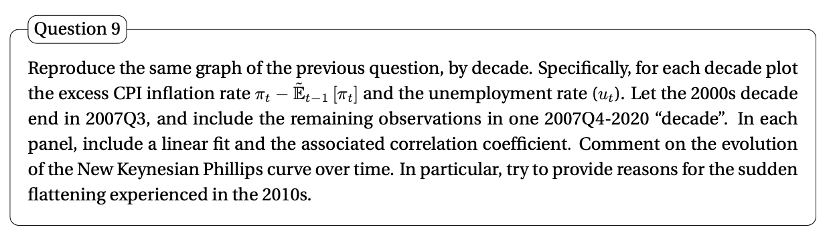

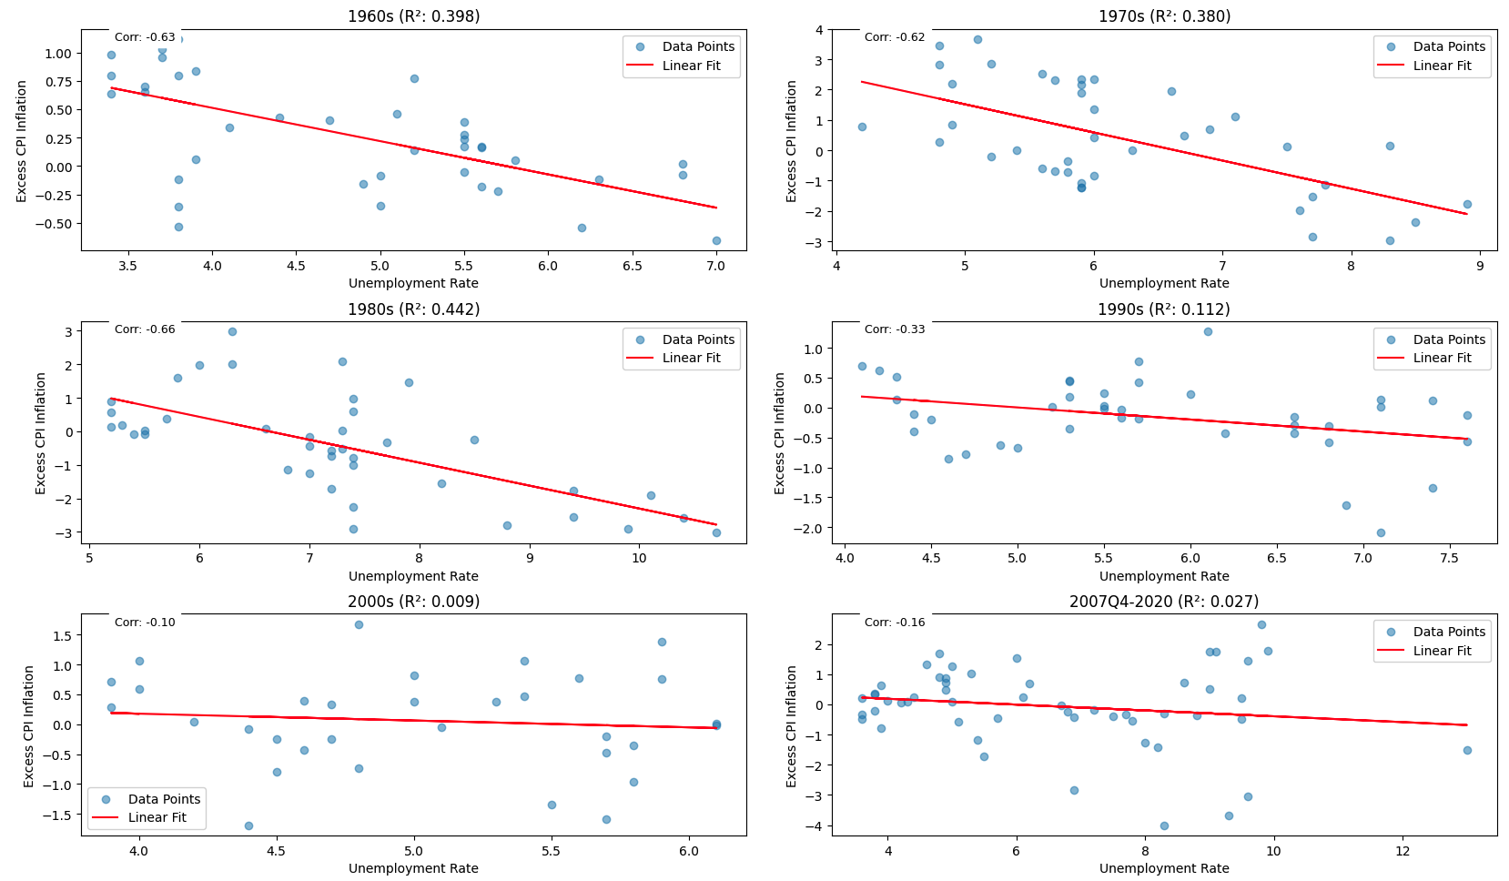

As we can see, starting from the 90s the unemployment-CPI relationship started to become less evident: both the R^2 and the correlation coefficients (top left of the graphs) plummeted. In looks like the trade-off between inflation and employment has disappeared.
Now, we can see the slope of the relationship is flatter, if we apply the reasoning from the examples in question 7, we may be tempted to assume firms have become more sticky, as the slope of the relationship is more flatter. This could be reasonable, as lower levels of inflation may lead firms not to feel the necessity of updating frequently their prices. However, both the R^2 and the correlation coefficient decreased very abruptly and it could be that the relationship simply faded due to the effect of central banks.
An explanation could be the following:
In the past central banks were really bad at controlling inflation, which was similar to some endogenous variable: it was determined by the real forces of the economy, hence, mainly the job market.
Today, central banks target inflation, and apply their instruments in order to keep it stable. In a certain way we could consider it a variable that is now exogenous to the market, it is no longer determined by its forces, rather, it is the result of central banks’ policies.
Moreover, there is a related reason (always intertwined with central banks intervention):
As written in MCLEAY, M. and S. TENREYRO (2020). “Optimal inflation and the identification of the Phillips curve”:
“if monetary policy is set with the goal of minimizing welfare losses (measured as the sum of deviations of inflation from its target and output from its potential), subject to a Phillips curve, a central bank will seek to increase inflation when output is below potential. This targeting rule will impart a negative correlation between inflation and the output gap, blurring the identification of the (positively sloped) Phillips curve.” Thus central banks interventions create may be creating a confounding effect with respect to the identification of the Phillips curve.

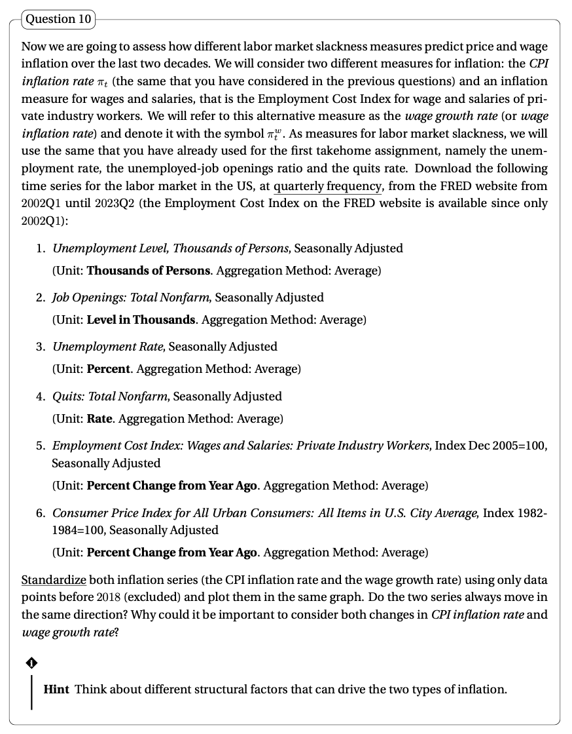

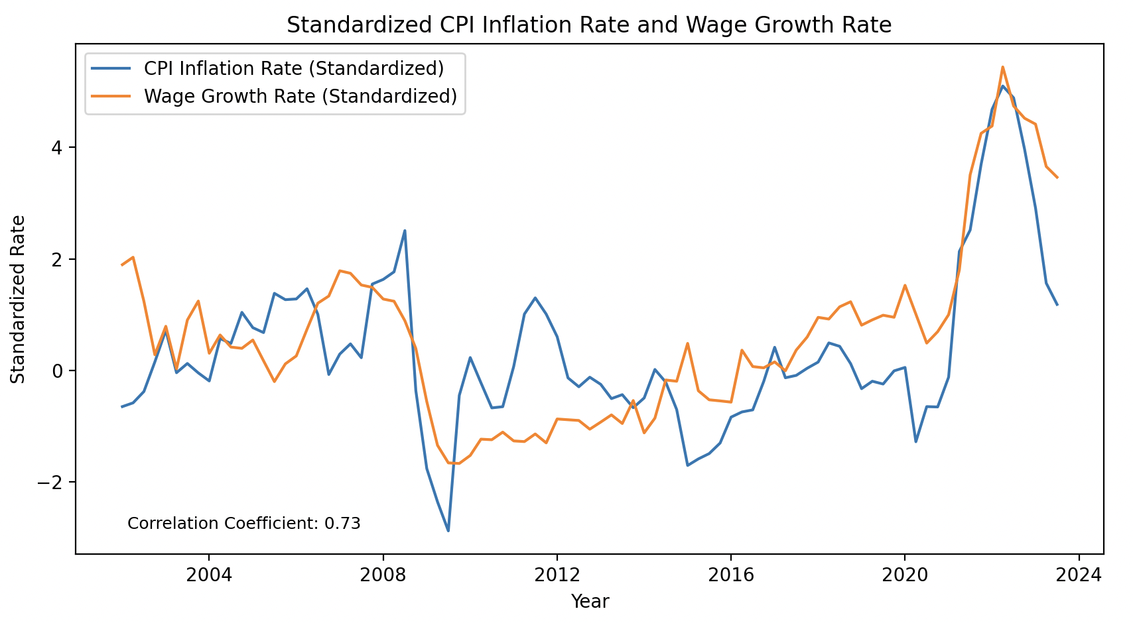

It's common to see the two rates moving together because as the cost of living increases (CPI), wages might also increase to compensate for the higher costs. This is proven by the correlation coefficient. However, the relationship is not always perfect due to various economic factors, such as productivity, unemployment, and labor market conditions.
Considering both CPI inflation rate and wage growth rate is important because if wages grow at a slower rate than CPI, it means that people's purchasing power is decreasing, leading to a potential decrease in living standards.
I suppose wage inflation is mainly linked to job market conditions. If we follow the intuition of the Phillips curve: high inflation means high output, high employment. If employment is high employers will need to pay workers more in order to convince them to work for their businesses. In this scenario wage inflation would be a consequence of CPI. CPI instead should be determined by more volatile features: gas, oil and commodity prices (in parallel to supply-demand dynamics), in fact in the graph it is more unstable (I assume the recent peak of wage growth was due to the very strong labor market we had and the high number of quit rates).

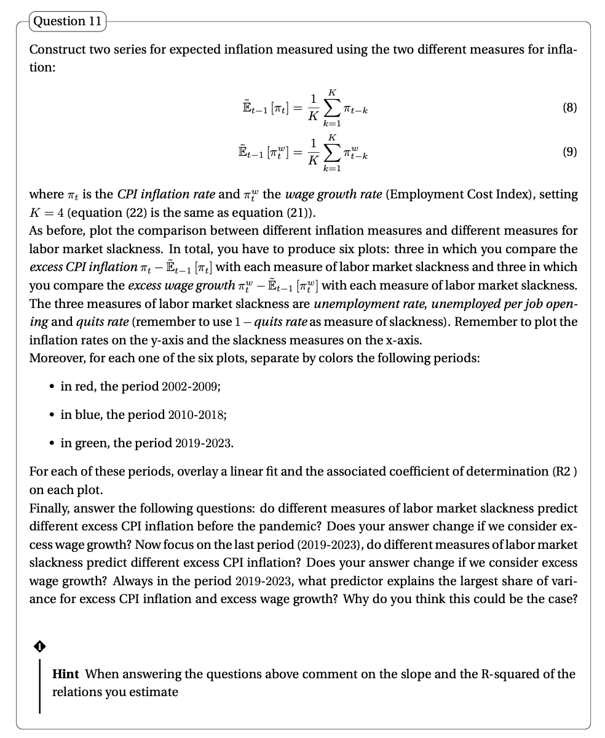

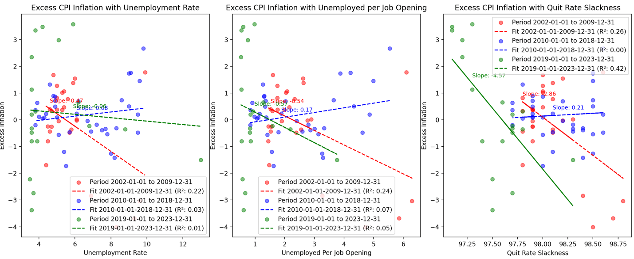

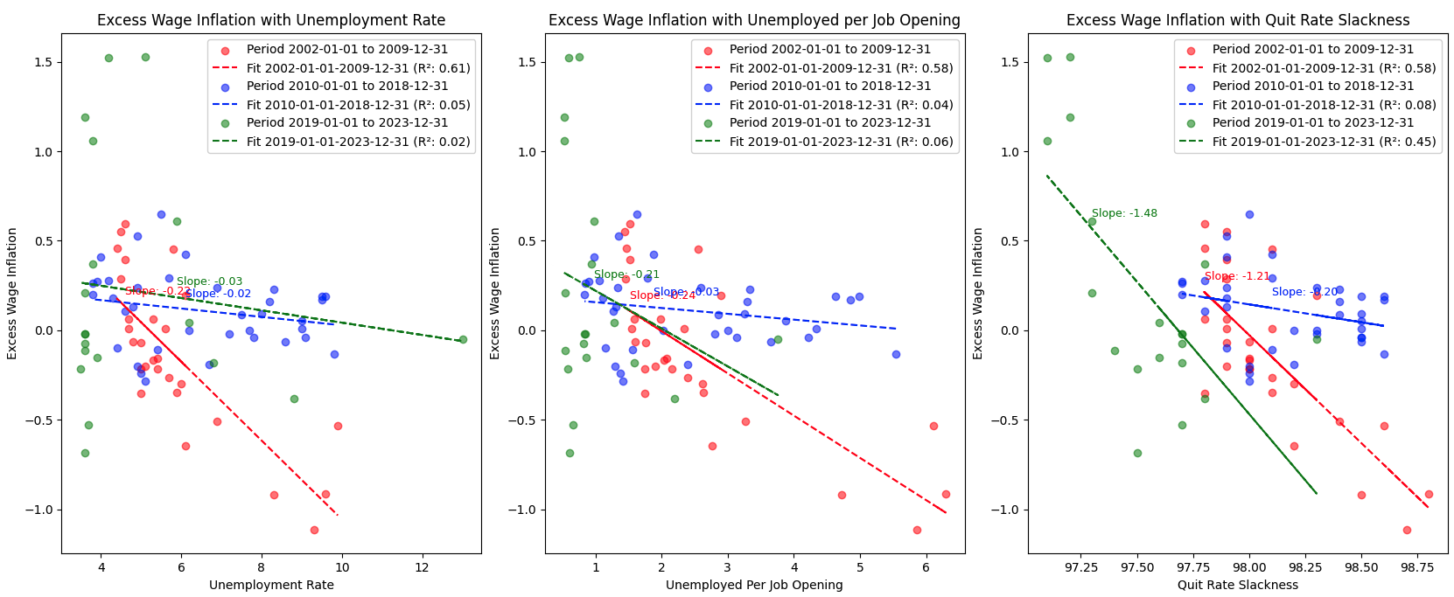

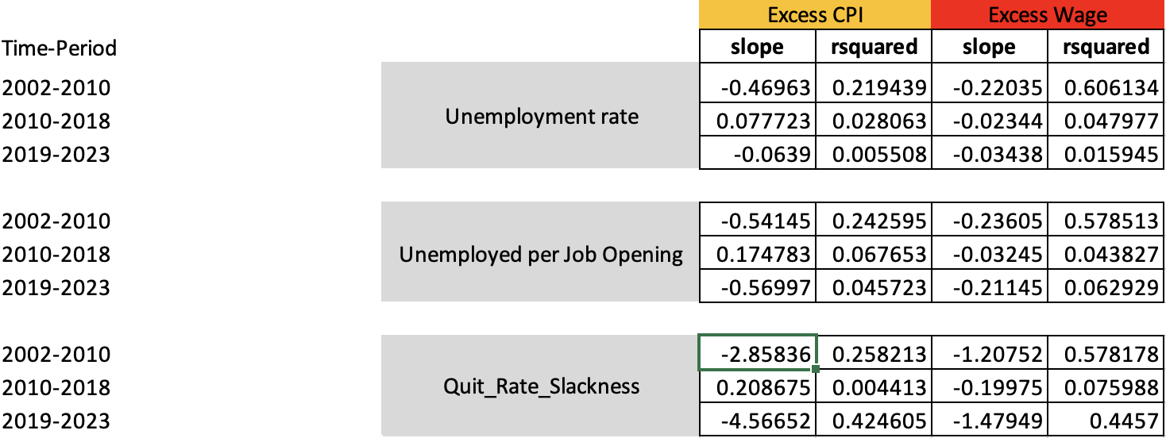

Finally, answer the following questions: do different measures of labor market slackness predict different excess CPI inflation before the pandemic?
If we consider the R^2 we can see that the different measures of labor market slackness are more or less equally efficient in predicting the model. However we can also see that quit rate slackness indicator predicted a considerable more negative slope.
2. Does your answer change if we consider excess wage growth?
No, as can be seen from the table results are coherent with what described by the CPI. The three indicators provide similar R^2 estimations, but the slope of the quits rate is far higher than the others. More generally, Excess wages seem way better than excess CPI at predicting the model.
3. Now focus on the last period (2019-2023), do different measures of labor market slackness predict different excess CPI inflation?
Yes. While the R^2 for the Unemployment rate and Unemployed per job opening are very low, the R^2 for the quit rate slackness is very high. Moreover, the slope of the quits rate slackness is also extremely higher than the others.
4. Does your answer change if we consider excess wage growth?
No, except from the fact that using excess wages provides slightly more reliable models.
5. Always in the period 2019-2023, what predictor explains the largest share of variance for excess CPI inflation and excess wage growth?
The quit rate slackness is the best predictor for the 2019-2023 period both for excess CPI inflation and excess wage growth.
6. Why do you think this could be the case?
Quit rate has been the best measure to explain inflation. In the last two years quit rates have been extremely high, thus signaling the presence of a very strong job market. At the same time, inflation has been very high. If we then regress 1-quit rates on inflation, we see a very strong correlation. This could simply be a coincidence: the quit rate is the measure that more than any other one has signaled a strong labor market, and this happened exactly in this period of high inflation. While inflation was probably very high due to a strong fiscal stimulus (thus maybe due to the output gap), for sure a significant part of it was related to war and covid, so external shocks, not a job market effect (I suppose there is huge bias in the coefficient).

We can make some other side considerations:
1. The 2010-2018 period has been almost in all graphs the one with higher positive / smallest negative slope (flatter relationship).
2. Except the 2010-2018 period all other periods exhibited always a negative relationship.
3. the quit rate slackness measure always exhibited the highest slopes

