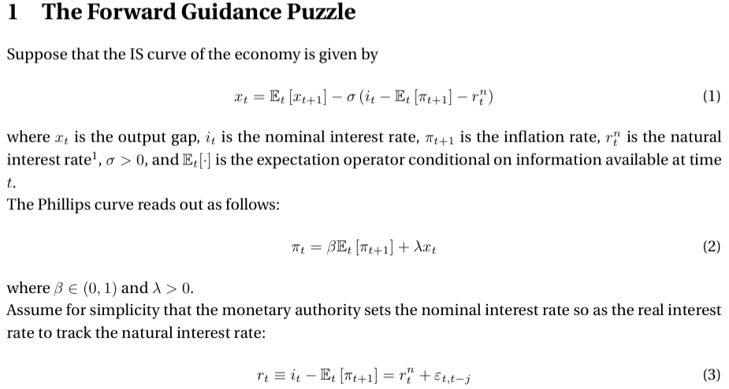
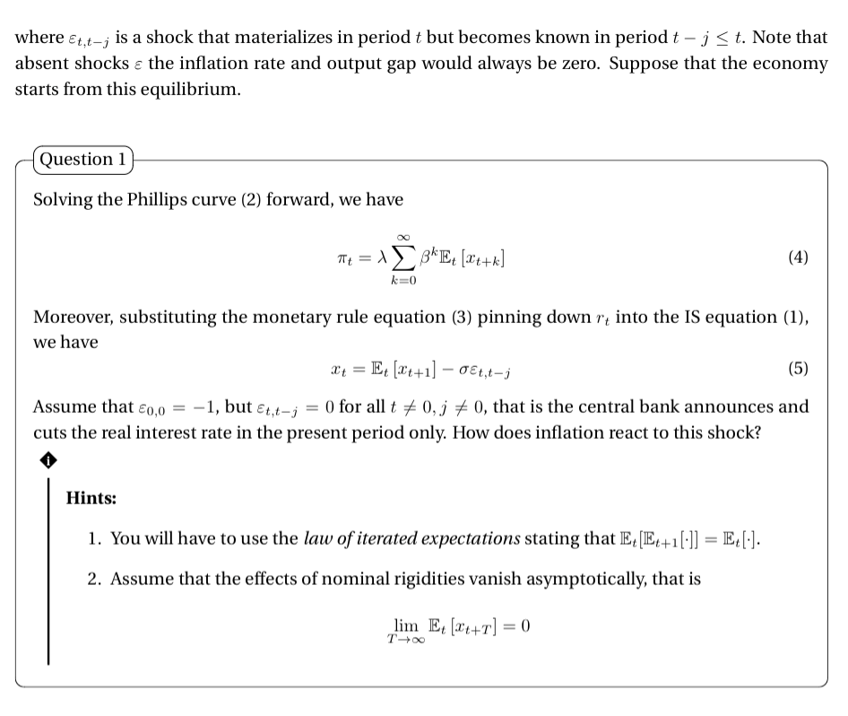

We now substitute xt from (5) into (4):

$π_{t}= λ\sum_{k=0}^{+inf}{β^{k} E_{t}[ E_{t+k}\left[x_{t+k+1 }\right]-σε_{t+k, t+k-j}]}$

Thanks to law of iterated inflation we can simplify:

$π_{t}= λ\sum_{k=0}^{+inf}{β^{k} E_{t}[ x_{t+1+k }-σε_{t+k, t+k-j}]}$ [6]

If we now consider ε_{0,0} = -1 and ε_{t,t-j} = 0 for all $t ≠0, j≠0$

$π_{0}= λσ+ λ\sum_{k=0}^{+inf}{β^{k} E_{0}[ x_{1+k }]}$

But we know also that the effects of nominal rigidities will vanish asymptotically, hence:

$π_{0}= λσ$ [8]

Inflationary response in t₀ will be determined by both the slope of the PC and the slope of the IS curve

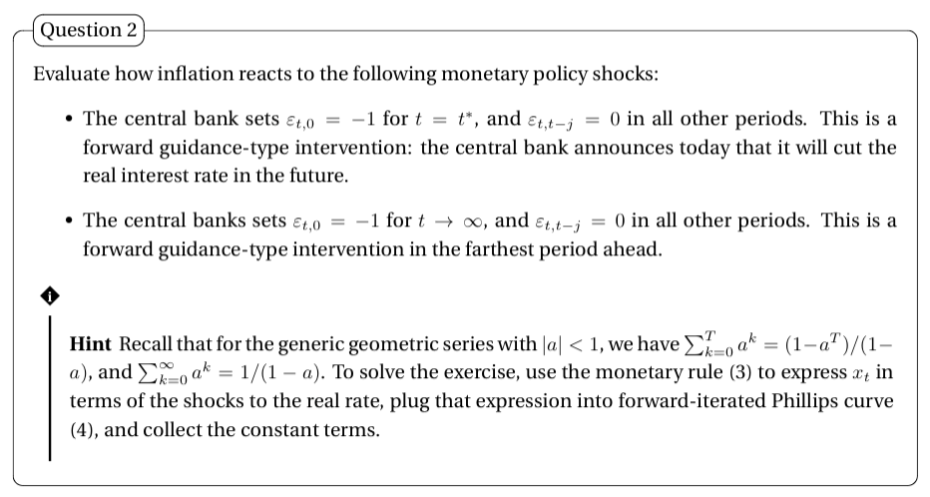
Filling (3) into (1) we get (5):

$x_{t}=E_{t}\left[x_{t+1}\right]-{σε}_{t, t-j}$

Filling (5) into (4) and simplifying we get:

$π_{t}= λ\sum_{k=0}^{+inf}{β^{k} E_{t}[ x_{t+1+k }-σε_{t+k, t+k-j}]}$

If we now decompose the sum, we have

--> ${ π}_{t}= λ\sum_{k=0}^{+inf}{β^{k} E_{t}\left[ x_{t+1+k }\right] - λσ\sum_{k=0}^{+inf}{β^{k} E_{t}[σε_{t+k, t+k-j}}}]$

--> and again: ${ π}_{t}=- λσ\sum_{k=0}^{+inf}{β^{k} E_{t}[σε_{t+k, t+k-j}}]$

Scenario 1- Forward guidance in T*

-->${ π}_{t}= -λσ\sum_{k=0}^{T^{*}}{β^{k} E_{t}[σε_{t+k, t+k-j}}]$ with T* = t + k*

--> applying the geometric series: ${ π}_{t}= - λσ (\frac{{1- β}^{T*}}{1-β})\sum_{k=0}^{T^{*}}{ E_{t}[σε_{t+k, t+k-j}}]$

--> Considering $ε_{t+k, t+k-j}$ will be equal to 1 only at t + k* = T* we will have just a non zero number in the series and it will be equal to -1

--> Hence: ${ π}_{0}= \frac{{1- β}^{T*}}{1-β}$ $λσ$

Scenario 2 - Forward guidance in t $→inf$

-->${ π}_{t}= -λσ\sum_{k=0}^{+inf}{β^{k} E_{t}[σε_{t+k, t+k-j}}]$

--> applying the geometric series: ${ π}_{t}= - λσ (\frac{1}{1-β})\sum_{k=0}^{T^{*}}{ E_{t}[σε_{t+k, t+k-j}}]$

--> Considering $ε_{t+k, t+k-j}$ will be equal to 1 only at t $→inf$ we will have just a non-zero number in the series and it will be equal to -1

--> Hence: ${ π}_{0}= \frac{1}{1-β}$ $λσ$



Recalling that in our example the shock considered (ε = -1) is an expansionary monetary policy shock.

${ π}_{0}= \frac{{1- β}^{T*}}{1-β}$ $λσ$ < ${ π}_{0}= \frac{1}{1-β}$ $λσ$

and this is true as long as ${ β}^{T*}$ > 0, with ${ β}^{T*}$ the smaller the greater T*. Eventually T* --> +inf --> ${ β}^{T*}$ = 0

So in scenario 1 inflation in t₀ is always lower than in scenario 2. This means that agents are ‘discounting’ more heavily the positive effect of the future expansionary shock of scenario 2.

The forward guidance puzzle refers to the empirical observation that long-term interest rates do not respond to monetary policy announcements as strongly as standard New Keynesian models would predict. In these models, central bank announcements about future policy should significantly affect long-term interest rates and, thus, the economy, because agents are assumed to form their expectations rationally and take into account all available information.
A famous paper by M. Del Negro, M. Giannoni and Christina Patterson, ‘The Forward Guidance Puzzle’ estimates that “Using data from a panel of Blue Chip survey expectations, accommodative forward guidance had effects on output and inflation expectations that were positive and nontrivial, but still 28 and 8 times smaller, respectively, than implied by standard models”. Crucially, this divergence is probably driven by two possible features: 1. The basic models assume rational agents and 2.The models do not consider that the life of the agents is finite. At the same time they show that it is possible to improve the traditional model by discounting more heavily thanks to the introduction of a perpetual youth structure.

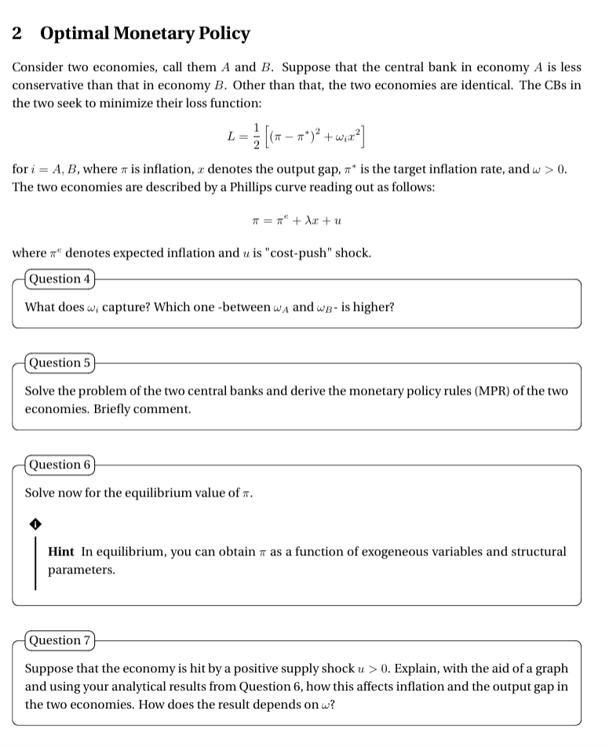
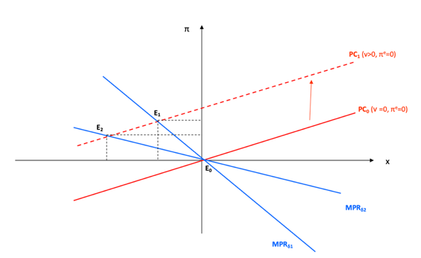
ωi represents the relative weight that the CB assigns to output in the economy. Since we know generally that δ = $\frac{ω}{λ}$ $π- π^{*}$ = - δx the higher ω, the higher δ, hence, the lower the optimal decrease in output. The higher ω the more stabilizing the output gap is a priority for the CB, thus the smaller is the optimal change in x. A less conservative CB will have an higher ω, thus a higher δ1 --> the MPR curve will be steeper

CB chooses i to minimize L = $\frac{1}{2} [{\left(π- π^{*}\right)}^{2} + ω{i\left(x\right)}^{2}]$ subject to PC: $π= π^{e}+λx+ ν$

We can first minimize L = $\frac{1}{2} [{\left(π- π^{*}\right)}^{2} + ω{\left({x- x}^{*}\right)}^{2}]$ subject to PC: $π= π^{e}+λx+ ν$ and then fill the results in IS to deduce i

x from PC into L: L = $\frac{1}{2} [{\left(π- π^{*}\right)}^{2} + ω{\left(\frac{π- π^{e}+v}{λ}\right)}^{2}]$ , we call ${f= π}^{e}+v$

maximize, FOC wrt π: $[\left(π- π^{*}\right) + ω\left(\frac{π-f}{λ}\right)\frac{1}{λ}]$ since from PC $\frac{π-f}{λ}=x$

$[\left( π- π^{*}\right) + ω\left( \frac{x}{λ} \right)]$ this is called the MPR (monetary policy rule) curve (optimal monetary policy)

--> $π- π^{*}=- ω\left( \frac{x}{λ} \right)$

Left side: MC of inflation (note dL/dπ = $π- π^{*}$)
Right side: MB of inflation (in PC: if $π$increases by 1 unit 1/λ additional unit of output gap is generated, now, since the Marginal cost of higher output gap is dL/dx = ωx the marginal cost of higher inflation in terms of higher output hap is 1/λ (ωx). Hence MB: -1/λ (ωx)
if you can call δ = $\frac{ω}{λ}$ $π- π^{*}$ = - δx if left term is positive optimal monetary policy rule wants right term (output gap, Y_{CURRENT} – Y_{LT}) to be set negative (‘leaning against the wind’)

For country A: $π- π^{*}=- ω_{A}\left( \frac{x}{λ} \right)$
For country B: $π- π^{*}=- ω_{B}\left( \frac{x}{λ} \right)$

About the slope
Assume $π- π^{*}=1$ x must be set = $- \frac{1}{δ}$
ω: the higher ω, the higher δ, hence, the lower the optimal decrease in output. Idea: the higher ω the higher the more stabilizing the output gap is a priority for the CB, thus the smaller is the optimal change in x.
λ: the lower λ, the higher δ, hence the lower the optimal decrease in output. Idea: λ is the slope of the PC. The lower λ the higher is the amount of output that must be sacrificed to reduce inflation, thus the smaller is the optimal change in x. Low λ: many sticky firms, these firms are slow in adjusting prices, if inflation goes down Demand plummets, hence output.

Note: $δ$ is also called the sacrifice ratio: how costly it is to disinflate by reducing x

By merging MPR and PC by x :

MPC: $π- π^{*}=-δx$ --> $x=\frac{\left(π^{*}-π\right)}{δ}$

PC: $π= π^{e}+λx+ ν$

--> $π= π^{e}+ λ\frac{\left(π^{*}-π\right)}{δ}+ ν$

--> $π= \frac{{\frac{δ}{λ}π}^{e}+ \frac{δ}{λ}ν+π^{*}}{\frac{δ}{λ} + 1}$

--> simplify further: $π=\frac{{δπ}^{e}+ δν+ {λπ}^{*}}{δ + λ}$

Given $π=\frac{{δπ}^{e}+ {λπ}^{*}}{δ + λ}+ \frac{δν}{δ + λ}$ ,

if we assume in the first place that the economy was at π = π* = π^{e} , now the positive shock will make the PC shifts up.
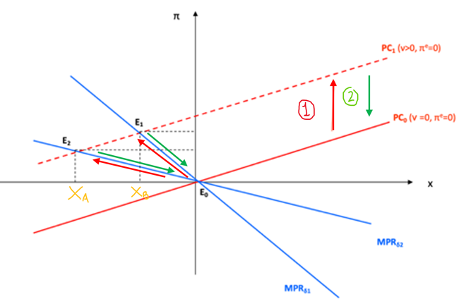
After the supply shock (assuming it is temporary):
1. PC shifts up, π1 >π* so current inflation goes above target and CB immediately responds to the shock: it tries to limit the inflationary pressures through a reduction in the output gap. In presence of a supply shock the CB is unable to achieve the opt combination of inflation and output gap, given by π = π* and x = x* = 0. This happens even though expected inflation equals target inflation
2. Targeted inflation (MPR) stays fixed. Thus expected inflation starts moving down shifting at the same time the PC curve gradually toward its initial position.
--> To sum up, an increase in expected inflation determines, with inflation targeting, a temporary phase of negative output gap.
The result clearly depends on omega, as it is possible to see on the provided graph. The more the CB cares about output (steepest slope in the graph) the lower the desired output gap (x0). Instead, the more conservative central bank, in order to keep inflation lower, will seek a greater reduction in the output gap.

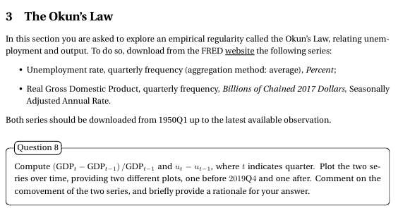

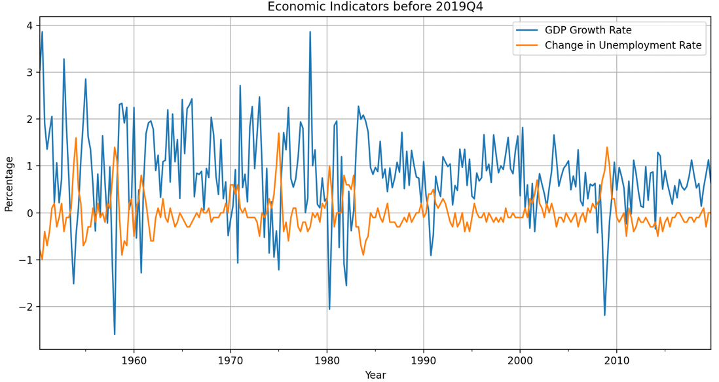

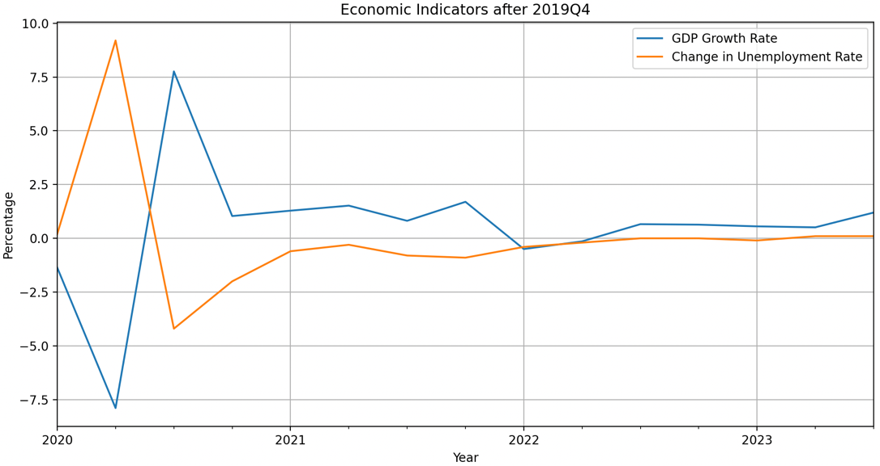

As expects, as unemployment rate increases GDP decreases. This is rational as we can describe GDP ad a function of the factor of production employed. As more and more productive forces are unused (unemployment) less aggregate GDP will be produced.

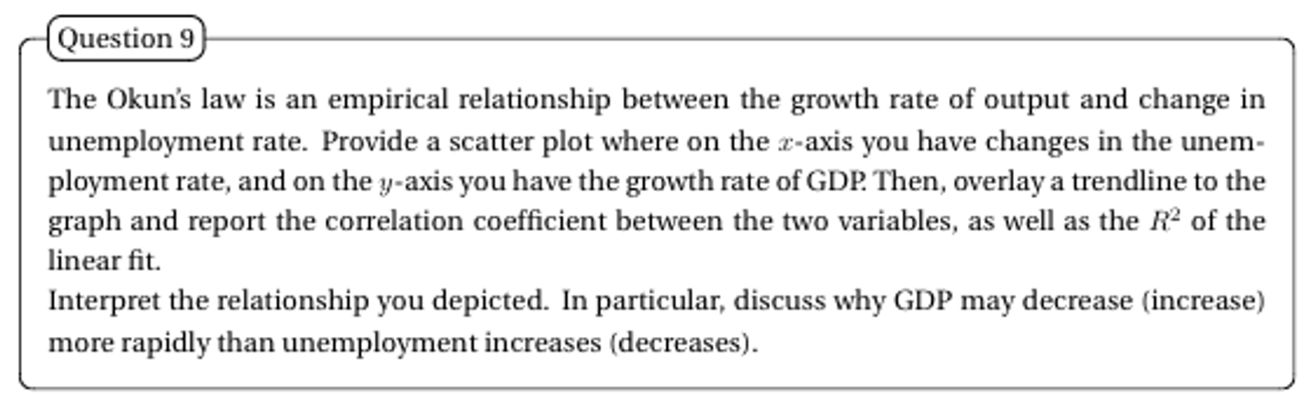

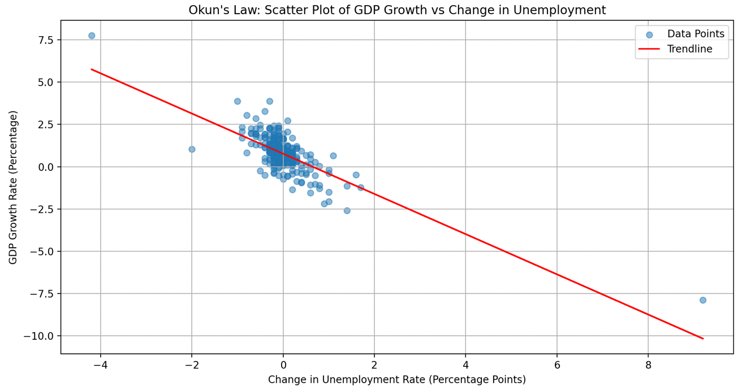

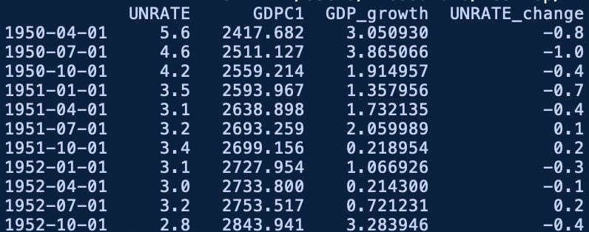
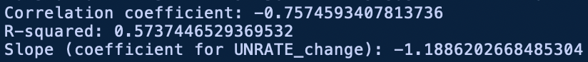

The correlation coefficient is very significant and negative (-0.76) the R^2 is high (0.57) and the slope is negative (-1.19). As unemployment increases by 1 GDP decreases by 1.19. We could expect GDP to decrease more rapidly than unemployment increases for may reasons. One could be that following a period in which firms experiment a sudden decrease in profits (ex. due to macroeconomic shocks), they decide to layoff workers. First arrives the reduction in profits (then a lower aggregate GDP), then the reduction in employees. It would make no sense to reduce the workforce in a period of rising profits.

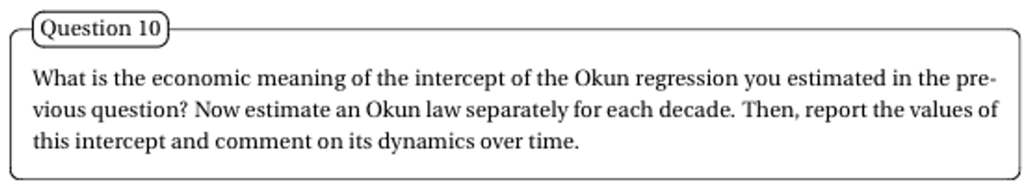

Usually in Linear regression models the intercept has the following interpretation:
The intercept represents the value of y takes when x is equal to 0. This value usually captures the many other factors that are determining the y behavior. In our case this would mean that when the change in unemployment is equal to 0 the GDP nevertheless increases by 0.77%. This value is actually reasonable, in fact, as we know, there are many variables (growing population, growing productivity etc) that determine every year a steady aggregate increase in GDP.

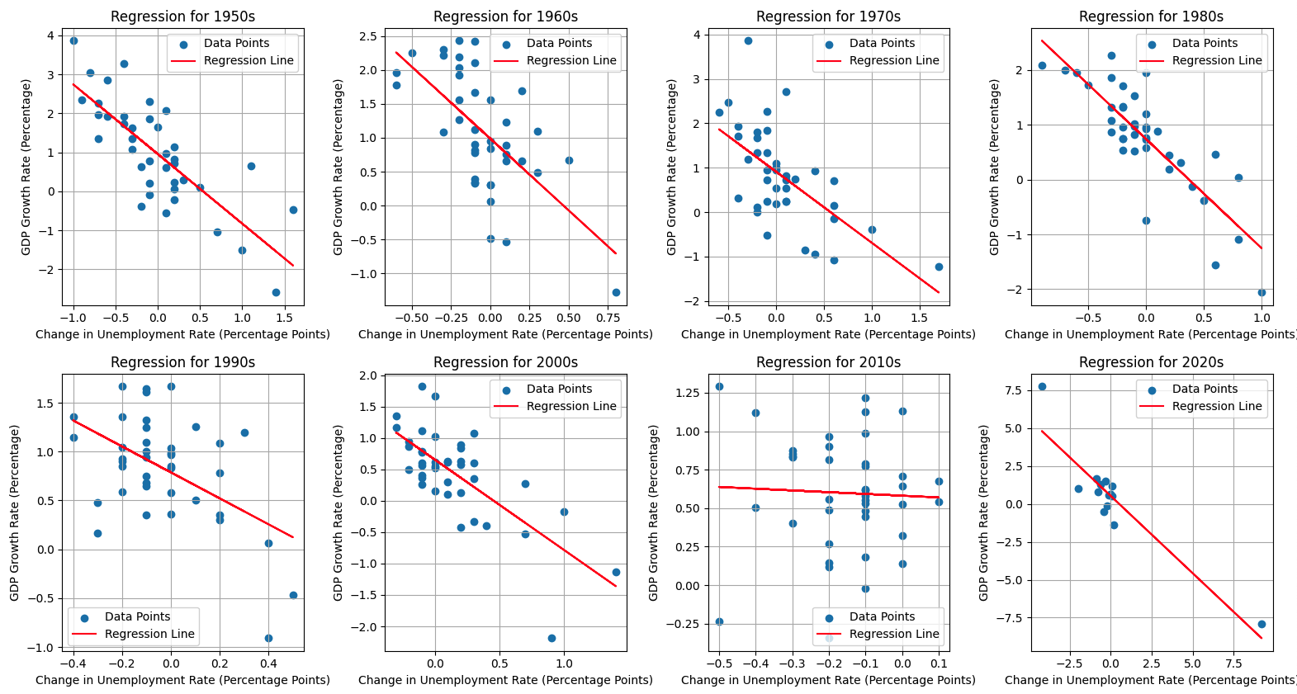

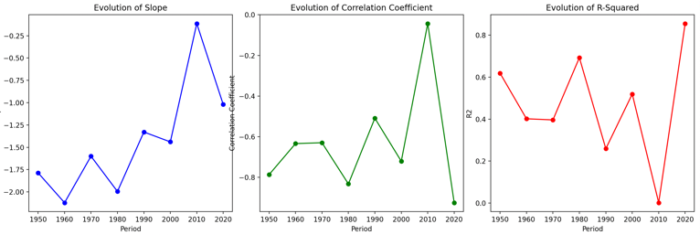
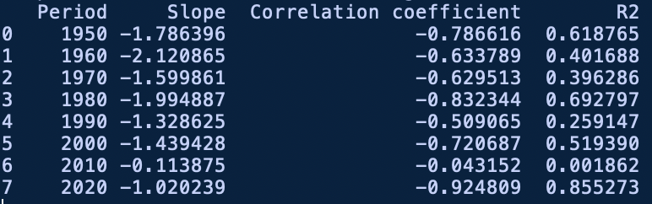

We can see that staring from the 90s there was a progressive flattening of the Slope of the regression. A the same time also the correlation coefficient and the R² plummeted, especially in the 2000-2010 decade. There could be many reasons:
1. I would expect this phenomenon to be related to inflation targeting and the modern approach that central banks have in dealing with monetary policy. This hypothesis is suggested from the fact that the relationship started fading in the 90s, as IT started being introduced. As discussed in the previous assignment when talking about the PC, I imagine that several key labor-market relationships where altered by the strong interference of central banks.
2. I can also imagine that the rise of the service sector may have played a role: I could expect a greater flexibility in the production capabilities of a service firm if we consider the number of workers required to expand/contract the amount of services provided.
3. Maybe there has been a diffusion of flexible work contracts (as for example has happened in Italy) that are allowing a more flexible adjustment process in response to contractions in output.
4. Regulation could also have played a role: maybe more stringent layoff policies have been implemented in the last decade, thus reducing the possibilities for employers to layoff employees.
5. Last, it is interesting to consider the range of the x axis of out 8 plots. It is interesting to see how tight is the range in 2010-2020, and how changes in unemployment are mainly negative. In all the other periods we had several large, positive observations, in this case the maximum is 0.1 this clearly makes us understand how different the 2010 decade was if compared to all the others. It could be that the absence of any huge shock, the low variability of unemployment and the very low levels of unemployment have made the difference. Maybe the relationship is less strong in scenarios with low variability, or when the unemployment rate is particularly low.

