MP IN 2007 AND DURING COVID

1. 2007 US
Both Conventional and unconventional Monetary policy were used
A. Conventional monetary policy:
Rapid and large reduction in the policy rate – essentially to the zero lower bound
B. Unconventional monetary policy:
– Communication and forward guidance (central banks more explicit about future course of monetary policy and the economy)
– Balance sheet policies aimed at altering the composition and the size of central banks’ balance sheet. Huge increase in CB B/S.
But Different Motivations for unconventional MP
a. US: zero-lower bound (as we had seen with the Taylor rule)
Unconventional monetary policy is a continuation of MP easing by “other means” once the lower bound on short term policy rates has been reached (unconventional MP substitute for conventional MP)
b. EU: ensure correct market functioning
Orphanides and Wieland rule (similar to a Taylor rule) did not prescribe strong negative rate in EU (around 0 was enough) --> The lower bound on interest rates may have been less binding in the euro area than in the United States or the United Kingdom.
Eu so applied Unconventional MP to ensure that the selected policy stance (as reflected in the settings of policy rates) passes through to the real economy (unconventional MP complement to conventional MP).

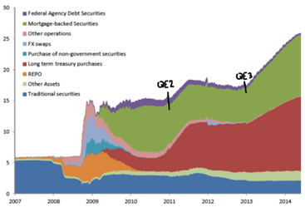
C. Balance sheet policies in deep for US market. Three broad tools:
a. Lending to financial institutions: provision of short-term liquidity to banks and other financial institutions (loans, treasury in exchange for non-liquid assets)
b. Providing liquidity to key credit markets: provision of liquidity, financing, and assistance in seeking assets directly to borrowers and investors in specific nonbank credit markets (money market mutual funds, commercial paper, asset-backed securities).
c. Purchasing longer-term/different securities(Large Scale Asset Purchases programs): They bought agency securities (Freddie mac, Fannie may), asset-backed securities (particularly, MBS) and Gov. Bonds

D. Effect of QE on long-term interest rates
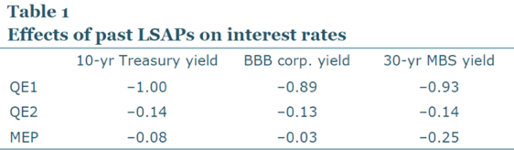
In general, not easy to understand exact channel of how QE affects the economy
Some papers have looked at Fed or ECB statements to see how i reacts to them (event study approach with usual limitation: when to put cutoff?) --> QE1 way more powerful than QE2, there is a sense than QE is becoming less powerful over time.
*note: interesting to see they never bought corporate bonds, but due to portfolio rebalancing effects there are spillovers.

2. Europe crisis in deep, why we cared so much about ensuring market functioning?
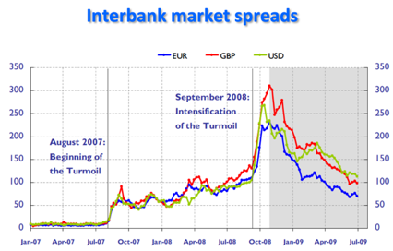
Chronology:
a. Financial turmoil, August 2007 to September 2008 (Lehrman Brother)
b. Financial crisis, mid-September 2008 to May 2010:
i. Key disruption: Freeze of the interbank market (look at graph, spread = Libor* – Overnight indexed swaps (OIS): need for banks to obtain liquidity from other sources (risk of fire price assets liquidation) and Assed backed securities mkt --> credit crunch --> fall in AD, deflation

*Libor: interbank offered rate. ESTR just overnight this is from 1 week to 12 months: Available at different maturities ---> Libor shows also credit and liquidity risk in the banking sector.
OIS: interest rate swaps over some fixed, but no exchanges of principal amount --> no exposure to counterparty risk = OIS accurately reflects expectations of effective policy rates

ii. ECB solution:
Idea: enhance flow of credit in the banking sector (owing to its importance in the financing of the economy in the EU in comparison with the US):
a. Fixed-rate full-allotment (give loans): unlimited provision to central bank liquidity at a fixed rate (MRO). Before was limited.
b. Expansion of collateral: list already very long before the crisis, now even longer.
c. Lengthening of maturities of refinancing operations (LTROs): first six months, then one year, and finally three yrs
d. Liquidity provision in foreign currencies: provision of US dollars to euro area banks and provisions of euro to non-euro area banks
e. Financial market support through purchases of covered bonds: outright purchases of debt securities issued by banks

c. Sovereign debt crisis, May 2010:
i. Key disruption
Persistently elevated sovereign bond yields in some Member States (huge spread); partly driven by self-fulfilling expectations.
Greece, Italy, Spain etc are in a Textbook scenario of “bad expectational equilibrium”, not bad fundamentals, but mkt negative expectations are self-fulfilling. Mkt participants do not lend to the country bc they think others won’t lend in the country in the future --> country cannot roll over its debt --> textbook solution is an announcement that the CB stands ready to purchase an unlimited amount of government debt. In theory such an announcement by itself should eliminate the bad expectational equilibrium, without any actual need of intervention by the CB

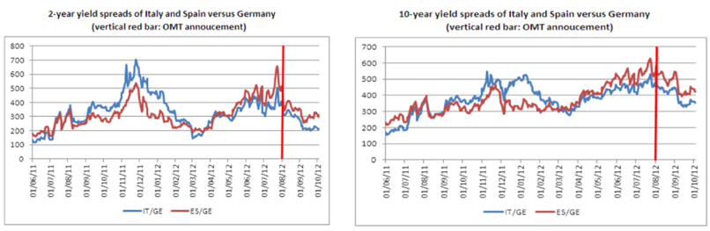
ii. ECB Solution:
Direct intervention in financial markets
i. “Security Markets Programme” (SMP), 2010: direct purchases of government debt in secondary mkt.
ii. “Outright Monetary Transactions” (OMT), 2012 expands SMP: commitment to buy Gov debt with no ex-ante quantitative limits on size

--> Worked in reducing spread (see figure)

Limitations:
i. if you ask for this money you have to follow the European Stability Mechanism (ESM). Necessary to mitigate Eu risk exposure, preserving prudent fiscal policy
ii. Focus on shorter segment of yield curve (up to 3 years). Smaller risk.

Note: Discussion about spread, two different views:
I. Bundesbank: spreads are important to keep alive the incentive to fiscal discipline --> Critic: It is not obvious either that high spreads necessarily provide the appropriate incentives for fiscal adjustment.

II. Spreads are harmful, and their presence in the euro area comes from the ECB’s failure to play its role of “lender of last resort”. Vicious circle in government debt dynamics and market expectations - with high spreads leading to exploding debts, which in turn justifies the expectation of a default.
--> Critic: The proponents of the second view make their lives too easy by simply assuming that government solvency would be ensured by low spreads. A defULT may actually happen. Debt monetization, thus, is not a purely notional out-of-equilibrium risk, it is a real risk that has to be weighed against the benefits from low spreads. Basically, what if CB really has to intervene?

How the financial crise caused the sovereign debt crisis: vicious loop (Sovereign-bank diabolic loop)
1. Fin crisis weakened banks’ B/S + then Lehman bankruptcy further weakened confidence in the healthiness of fin system
2. National banks have a strong bias towards national bonds
3. Fiscal support started to be given to banking systems and significant spending packages
4. Weak Banks B/S ---> Cut lending ---> Less economic activity and tax revenue --> weakens government solvency in these countries -->
the financial crisis worsened public deficits ad debts --> deterioration of sovereign creditworthiness
5. “Bailout loop”
deterioration of sovereign creditworthiness ---> lower market value of banks’ holdings of domestic sovereign debt --> this reduced perceived solvency of domestic banks --> higher risk of need of Gov. bailout --> Higher Sovereign debt risk

c. Prolonged period of low inflation, 2015
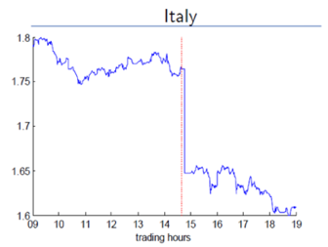
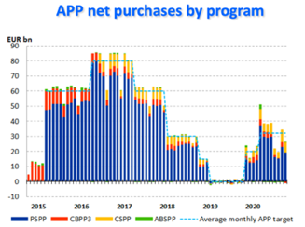
i. ECB Solutions
a. Expanded Asset Purchase Programs
Evidence: APP announcement (Jan 2015) had a strong effect on effect on Ita 10-year yields (figures)

b. Forward guidance, 2013
c. Negative interest rates, 2014
Negative interest on deposit facility. why should banks be willing to deposit ? Alternative: keep in vault (costly) or invest.
Key: deposit rate drives EONIA (you know it), hence negative interest rate policy (NIRP) works

Negative interest rate policy (NIRP): removes the ZLB ---> In US I expectations are always asymmetric, in EU a bit symmetric

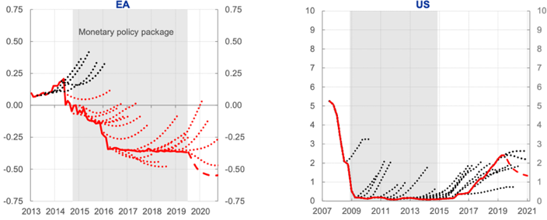
d. Targeted Long-term Refinancing Operations (TLTROs) (2014 -->)
Long-term loans to banks that contain incentive mechanisms to ensure effective pass-through to hhs and firms: amount and cost of borrowing depend on banks loans to business and consumers (ex. TLTROs Il Banks Can borrow up to 30% of their outstanding loans to business and consumers. Cost is super advantageous: can be as low as the negative deposit rate at the time of the loan (banks paid to get these loans))

3. Covid
A. Main measure: Expansion of banks B/S. Pandemic Emergency Purchase Programs (PEPP), as APP but more flexible,
We like flexibility bc:
– Allows to intervene in entire yield curve, preventing financial fragmentation
– Tailored to manage staggered virus progression and uncertainty on when/ where fallout worst

B. Other measures:
– Additional €120 billion in March 2020 to APP
– More favorable terms from June 2020 to June 2021 on TLTROs-III
– Collateral easing measures
etc…

