EDUCATION

Education is mainly public financed (80%), advanced economies spend a lot in education (‘one of the big expenditures’).
Often centralized, exception US: 80% of education spending is done at the state and local level (not often in OECD).
Private expenditure is mainly related to universities.
rival (limited number of seats in classes) and excludable: not a public good. So why governments care?

2. Why Should the Government Be Involved in Education?
Bottomline: 1. Education is long and costly (LT benefit, ST cost) and 2.Education creates huge economic development and Value. 3. Egalitarism
A. Implications of being long and costly
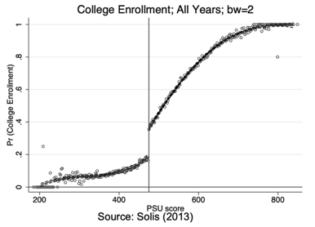
a. Borrowing constraints
poor but talented students may not be able to borrow to get education even if PDV benefits > costs
Thesis: availability of loans do matter = borrowing constraints are an issue
Solis: Chile Guaranteed loan is available if the test score of the student is above 475.
we could expect 476 vs 474 have same ability –> PDV of education is the same, they should have access to university with same probability. However, 474 goes way less frequently.
educational credit market failure:
Sun and Yannelis (2016) found that financial deregulation in the U.S., which made it easier to get bank loans, significantly increased college attendance and completion. And Marx and Turner (2017) showed that notifying students of loan eligibility significantly increased their odds of going to college.

b. Family and individual failures (to conform to standard econ model):
They basically fail at maximizing family utility bc they are myopic
a) Some parents may not take good care of their children
b) Young adults might not do what is in their LR interest due to self-control problems or lack of information
Carrell-Sacerdote: in-field experiment, College students from Dartmouth help senior (randomized) high schoolers apply to college: solve lack of info on Lt benefits Effects: Women (+15% likelihood of enrolling in college), but small effects on men
Note: cash bonus for applying to colleges does not have any impact = Pure economic incentives are not enough

B. How education creates LT value
a. Externalities (e.g., productivity spillovers, crime, citizenship)
a. Education and crime
Imprisonment = α + βEduc + ε <--- problem educ is correlated with ε
Solution: Lochner and Moretti, use compulsory attendance laws as instrument variable. The instrument should influence the y (Imprisonment) only through its effect on the explanatory variable (schooling) Completing high school reduces the probability of incarceration by about .76% for whites and 3.4% for blacks
b. Is there any effect of education on voting? (more broadly a better civic behavior)
Moretti, Mulligan, Oreopoulos (2003) find positive effects, using the same strategy, of education on likelihood of voting
c. positive effect on health
d. less risky behaviors as smoking and drinking

b. Education raises earnings
Earnings = α + β · Education + ε confounders... not working!
I. Control for underlying ability by adding variables (e.g. SAT score)
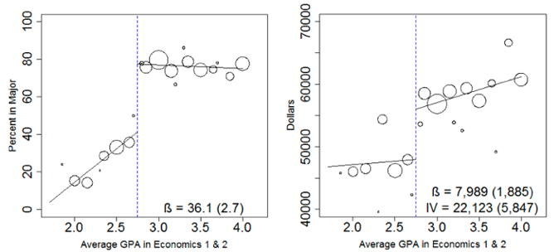
II. Find exogenous quasi-experiments
Economics majors BAs earn more ($90K) than non-econ BAs ($66K) at age 40. Is this causal?
Bleemer and Mehta: use GPA threshold requirement (2.8) to major in economics at UC Santa Cruz. Regression Discontinuity: compare students just below vs. just above 2.8. Just above the threshold:
Econ major acceptance likelihood + 36% (not everyone > 2.8 majors)
wage earnings 5 years after graduation from $47K to $55K
Causal effect of majoring in economics is ($55K-$47K)/.36=$22K
Note: Each circle is a mean of all students with that GPA

--> why education raises earnings? two very different possible explanations
I. Education as Human Capital Accumulation (Moretti, 2004)
Education raises earnings because it improves productivity of the educated person ⇒ Education is economically valuable
II. Education as a Screening Device
Education provides only a means of separating high-ability from low-ability individuals and does not actually improve skills ⇒ they are already high skilled, education did not make them better. Simply screening = their economic value is not enriched

c. Huge factor for innovation
publicly financed research that is carried out at universities is critical for innovation and economic growth.

C. Guarantee equality of opportunity and Intergenerational Mobility
Education is a normal good, higher-income families provide more education the children will be rich. This breaks income mobility: whether low- income people have a chance to raise their incomes. What’s the situation like now?
Chetty et al. ’20 compile college-level statistics on parental income and student earnings outcomes.
a. Access: The poorer you are the less you will study. Forget about Ivy League: Ivy league has more kids from top 1% families than from bottom 50%
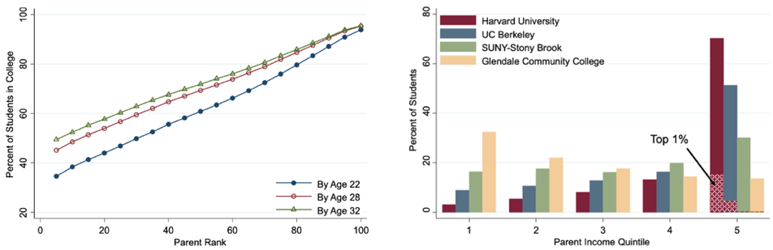
b. Trends: Fraction poor kids stagnated in top schools (in spite of more financial aid) and dropped at best public schools and community colleges
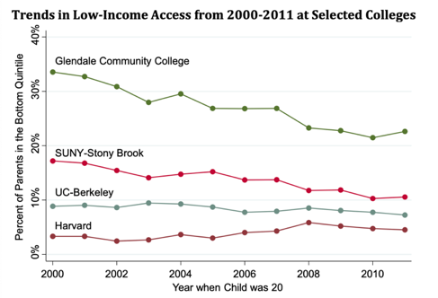
c. Mobility rates: measure of ‘success stories’ = students who enter into college from families in the bottom 20% and get income of top 20%. Fairly small figure.
d. Outcomes: the only nice point, within good colleges, outcomes of poor vs. rich kids are similar
once you get in, no matter what, your future income will not be strongly not affected by your parents

3. What can make schools better?
We cannot simply compare school districts with better and worse schools and look at the resulting implications for students. Districts with better schools (the treatments) probably differ in many ways from districts with worse schools (the controls): richer, more engaged parents etc, better facilities etc.
A. small class size
Experimental example: Tennessee implemented Project STAR in 1985, randomly assigning 11,000 students to small classes (13–17) or regular classes (22–25)
Krueger and Whitmore shows positive effects of small class size on test scores and likelihood of taking a college entrance exam. These effects were largest for poor and minority students. Estimated return: 5.5% per year.
Chetty et al. found small positive effects on college enrollments and adult earnings
*does not work if to have more classes u hire unqualified teachers/ have poor infrastructure
B. Charter schools?
Analyses of what makes charter schools good: more time in class, teachers receiving feedback.
Charter schools not subject to all state regulations for schools (flexibility to recruit teachers / adjust hours / curriculum)
Oversubscribed charter schools use lottery for admissions randomized experiment to estimate the causal effect of charter schools in lottery winners vs. losers
Angrist, Pathak, Walters: Urban charter schools better than urban public, while non-urban charters worse than non-urban public
*key problem: you cannot take the oversubscribed charters (the best) and consider them the standard
C. Preschool (before age 5)
Most advanced countries have universal government-provided preschool. US is a notable exception (with variation across states).
Gray-Lobe, Pathak, Walters ’21 use admissions lotteries to estimate the effects of large-scale public preschool in Boston
Strong positive effects on high-school graduation and college attendance (+ 5%) and reductions in incarceration
D. school spending
Jackson et al. (2018) look at the result of school district spending cuts during the Great Recession lower test scores and lower graduation rates.

4. What we are heading into rn
Private non-profit universities have inelastic supply (fixed). Public schools make the difference (75%).
+ In recent decades, US states have reduced their spending and tuition at public institutions has increased enormously
Student loans have exploded, saddling young people with debt that often cannot be repaid
For-profit schools have mushroomed (⇡ 10% of total enrollment today). They charge a lot, advertise aggressively, and saddle students with debt, provide not great results = individual failures/lack of information exploited by for-profit schools

5. How Gov. intervenes
In the context of education, the price mechanism approach is to offer discounts on private educational costs to students, and the quantity mechanism approach is to mandate that individuals obtain a certain level of education. In practice, the governments of most developed nations pursue neither of these approaches, and instead they provide a fixed level of education for no cost.

