# Assignment 3: Mutual Activation

Two proteins A and B mutually activate their own expression. Their dynamics is described by the

following coupled differential equations:

$\frac{dA}{dt}=\frac{βB^{n}}{k_{b}^{n}+B^{n}}-δA$, $\frac{dB}{dt}=\frac{βA^{n}}{k_{a}^{n}+A^{n}}-δB$

where β is the maximum expression and δ is the decay rate (assumed to be the same for the two

proteins), and ka and kb are the activation thresholds.

1. Assuming that ka = kb = k and n >> 1, represent graphically the nullclines of the system in the plane (A, B), for β / δ > k. Identify the equilibrium points.
2. Determine graphically the stability of all the equilibria for the case of section (a), drawing the slope field of the system in the different regions in which the nullclines divide the phase space.  
   What is the biological meaning of this behaviour?
3. Assume now that ka and kb are different. Fixing ka, show (also graphically) that if kb increases a bifurcation occurs. Draw the bifurcation diagram approximately. What is the type of this bifurcation?

My solution:

1. The nullclines for $\frac{dA}{dt}$ and $\frac{dB}{dt}$ for the given parameter values are two identical *activation curves,* symmetric about the line y = x, representing the points in which the two coupled differential equations are each equal to zero.  
   The equilibrium points are indicated by their three points of intersection: (0, 0), (k, k), (β/δ, β/δ).

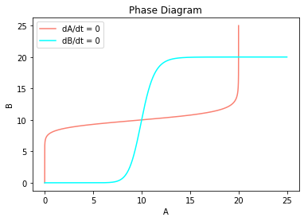

A

B

1. In this system there are *two stable equilibria* and *one unstable equilibrium*, displayed by the two full dots and the empty dot respectively. This is clearly shown by the slope field in the diagram: the arrows cross the dA/dt curve vertically, while pointing towards the dB/dt curve, and vice versa. So, the overall slope field points towards the two stable equilibria of the system, while the unstable equilibrium is at the centre of a *separatrix* which divides the phase plane in two basins of attraction.  
   This means that when the concentration of A and/or B is not sufficiently high (below the separatrix), the degradation term will prevail over the activation loop, the concentrations of our two proteins will both go to zero and the two genes will be in their **OFF state**; on the other hand, when A and/or B are high enough, on the other side of the separatrix in the plane, the activation loop will show its effect, bringing the concentrations of the two proteins to a high steady-state value: the genes are now in their **ON state**.

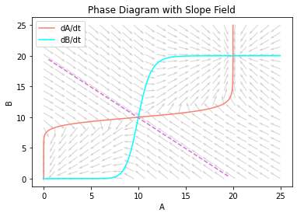

A

B

1. 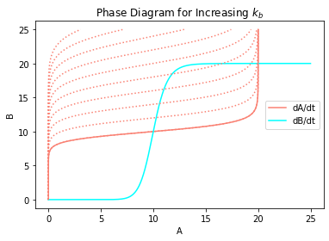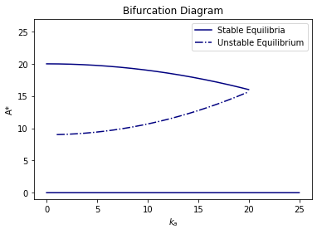 When ka is fixed and kb is increasing, for the dA/dt nullcline we have that *the step region of the curve is shifting upwards*. The concentration of A at which the unstable equilibrium exists starts increasing with the increase in kb while the concentration of A corresponding to the higher fix point starts decreasing, until the two points converge; any further increase in kb will result in the disappearance of both the unstable equilibrium and the higher stable equilibrium: a **saddle node bifurcation** occurs and only the stable equilibrium at zero is remaining, so the genes will be in their OFF states for such high values of kb.

A*

B

kb

A

|  |  |  |  |  |  |  |  |  |  |
| --- | --- | --- | --- | --- | --- | --- | --- | --- | --- |
|  |  |  |  |  |  |  |  |  |  |

Here’s my initial draft for this assignment.

