## Computer practical: time domain ESR in *Spinach*

This practical is about setting up orientation-selective PELDOR simulations on spin systems that may contain more than two electron spins as well as other complicating factors (exchange coupling, ZFS, significant non-secular dipolar terms, *etc.*). You will fund a large number of other examples in *examples/esr_solids* directory, an a number pulse sequences in *experiments* directory.

In the examples below, feel free to modify the various parameters and settings to bring the simulation closer to your actual usage scenarios.

## 1. Installation

If *Spinach* is not installed already, download the latest version from <http://spindynamics.org>, unpack the zip file and follow the installation instructions. It is important to set *Matlab* path correctly.

## 2. Frequency domain ESR spectra and pulse holes

At the first stage of a PELDOR simulation, it is necessary to examine the frequency domain spectrum and to choose pump and probe frequency, as well as to calibrate soft pulses. We start by specifying the magnet field (in pulsed ESR it is constant) and spin system parameters:

**% Isotopes**

**sys.isotopes={'E','14N'};**

**% Magnet field**

**sys.magnet=3.35;**

**% Interactions**

**inter.zeeman.matrix=cell(1,2);**

**inter.zeeman.matrix{1}=[2.01045 0.00000 0.00000**

**0.00000 2.00641 0.00000**

**0.00000 0.00000 2.00211];**

**inter.coupling.matrix=cell(2,2);**

**inter.coupling.matrix{1,2}=[1.2356 0.0000 0.6322**

**0.0000 1.1266 0.0000**

**0.6322 0.0000 8.2230]*1e7;**

Here the magnet is W-band (3.35 Tesla), a standard nitroxide *g*-tensor from the literature, and the standard 14N hyperfine coupling were specified. Quadrupolar interaction on 14N may also be added if necessary – it usually does not influence the results. A full description of how spin systems are specified in *Spinach* is available in the online manual.

Next we specify the formalism and the basis set. Spinach runs most efficiently in Liouville space when the basis operators are irreducible spherical tensors (particular combinations of Pauli matrices with neat rotation properties):

**% Basis set**

**bas.formalism='sphten-liouv';**

**bas.approximation='none';**

We then call the housekeeping functions that perform input data analysis and pre-processing:

**% Spinach housekeeping**

**spin_system=create(sys,inter);**

**spin_system=basis(spin_system,bas);**

Run the file. Both housekeeping functions will print copious output to *Matlab* console. Read it carefully, it contains a detailed summary of what *Spinach* thinks the user has supplied. If the input data is fund to be inconsistent, an informative error message will be printed to the console in red.

At this point, we have supplied the spin system information to the program. It now needs to know the experiment parameters. We will use the *holeburn* experiment (which reports the hole that a particular soft pulse burns in the powder pattern) within the *powder* context (which handles powder averages and rotating frames). Take a good look at the online manual pages for *holeburn.m* and *powder.m* functions. They support a great number of parameters, of which we will only need a few:

**% Sequence parameters**

**parameters.spins={'E'}; % Working spins**

**parameters.rho0=state(spin_system,'Lz','E'); % Initial condition**

**parameters.coil=state(spin_system,'L+','E'); % Detection state**

**parameters.decouple={}; % Decoupling**

**parameters.offset=-2e8; % Transmitter offset, Hz**

**parameters.sweep=8e8; % Sweep width, Hz**

**parameters.npoints=128; % FID point count**

**parameters.zerofill=512; % Zerofilling**

**parameters.axis_units='MHz'; % Axis units**

**parameters.grid='rep_2ang_6400pts_sph'; % Spherical grid**

**parameters.derivative=0; % Plot zeroth derivative**

**parameters.invert_axis=0; % Plot from left to right**

Parameter names are all self-explanatory. Note that any signals that end up outside the sweep width will get reflected back – a simulation cannot impose a frequency bandpass filter of the same kind that the spectrometer does. The offset is with respect to the free electron Zeeman frequency. Note also the huge spherical grid – time domain ESR simulations are expensive.

The next stage is to specify the parameters of the soft pulse. We will run a pulse of duration 100 nanoseconds, at the frequency offset of –300 MHz from the free electron Zeeman frequency, with the initial microwave phase of π/2, and 2*r* + 1 = 5 points in the microwave phase grid:

**% Soft pulse parameters**

**parameters.pulse_rnk=2;**

**parameters.pulse_phi=pi/2;**

**parameters.method='expm';**

**parameters.pulse_dur=100e-9;**

**parameters.pulse_pwr=2*pi*10e6;**

**parameters.pulse_frq=-300e6;**

With all parameters now in place, we can call the holeburn pulse sequence from the powder context, with the rotating frame assumptions set to ‘esr’. We also need a reference spectrum where the amplitude of the soft pulse is set to zero:

**% Soft pulse simulation**

**fid_a=powder(spin_system,@holeburn,parameters,'esr');**

**% Simulation with soft pulse off**

**parameters.pulse_pwr=0;**

**fid_b=powder(spin_system,@holeburn,parameters,'esr');**

We will need to apply apodisation to the free induction decays, to Fourier transform them, and then to plot the resulting spectra:

**% Apodization**

**fid_a=apodization(fid_a,'exp-1d',6);**

**fid_b=apodization(fid_b,'exp-1d',6);**

**% Fourier transform**

**spectrum_a=fftshift(fft(fid_a,parameters.zerofill));**

**spectrum_b=fftshift(fft(fid_b,parameters.zerofill));**

**% Plotting**

**figure(); hold on;**

**plot_1d(spin_system,real(spectrum_a),parameters,'r-');**

**plot_1d(spin_system,real(spectrum_b),parameters,'b-');**

**legend({'soft pulse','reference'});**

The output, for two different offset frequencies (it will take 10 minutes or so, use a smaller spherical grid if you want a quick and dirty result) is shown in Figure 1. Note different excitation efficiencies at different frequencies even though pulse width and power are the same.



**Figure 1.** Holes burned in the nitroxide powder pattern by the pulses with the parameters specified above at the offset frequencies of –300 MHz (left) and 0 MHz (right) relative to the electron Zeeman frequency.

Experiment with pulse frequencies and amplitudes. For quick and dirty estimates, the number of points in the powder averaging grid may be reduced.

## 3. PELDOR simulation

Let us specify a simple system at X-band with two electrons at a distance of 20 Angstrom with non-overlapping signals and g-tensors at a specific orientation relative to one another:

**% Magnet field**

**sys.magnet=0.3451805;**

**% Isotopes**

**sys.isotopes={'E','E'};**

**% Zeeman interactions**

**inter.zeeman.eigs=cell(1,2);**

**inter.zeeman.euler=cell(1,2);**

**inter.zeeman.eigs{1}=[2.284 2.123 2.075];**

**inter.zeeman.euler{1}=[135 90 45]*(pi/180);**

**inter.zeeman.eigs{2}=[2.035 2.013 1.975];**

**inter.zeeman.euler{2}=[30 60 120]*(pi/180);**

**% Coordinates (Angstrom)**

**inter.coordinates=cell(2,1);**

**inter.coordinates{1}=[0.00 0.00 0.00];**

**inter.coordinates{2}=[20.00 0.00 0.00];**

The usual formalism selection and housekeeping commands go next:

**% Basis set**

**bas.formalism='sphten-liouv';**

**bas.approximation='none';**

**% Spinach housekeeping**

**spin_system=create(sys,inter);**

**spin_system=basis(spin_system,bas);**

Spinach has a separate pulse sequence (*deer_3p_soft_hole.m*) that performs pulse hole diagnostics. After looking through the online manual, we conclude that the following parameters are necessary:

**% Sequence parameters**

**parameters.spins={'E'}; % Working spins**

**parameters.rho0=state(spin_system,'Lz','E'); % Initial condition**

**parameters.coil=state(spin_system,'L+','E'); % Detection state**

**parameters.grid='rep_2ang_6400pts_sph'; % Powder grid**

**parameters.method='expm'; % Propagation method**

**% EPR spectrum parameters**

**parameters.offset=-4e8; % Rotating frame offset**

**parameters.sweep=3e9; % Sweep width**

**parameters.npoints=256; % FID point count**

**parameters.zerofill=2048; % Zerofilling**

**parameters.axis_units='GHz-labframe'; % Axis units**

**parameters.derivative=0; % Plotting options**

**parameters.invert_axis=1; % Plotting options**

**% DEER pulse parameters**

**parameters.pulse_rnk=[2 2 2]; % Phase grid ranks**

**parameters.pulse_dur=[20e-9 50e-9 40e-9]; % Durations**

**parameters.pulse_phi=[pi/2 pi/2 pi/2]; % Phases**

**parameters.pulse_pwr=2*pi*[8e6 8e6 8e6]; % Powers (rad/s)**

**parameters.pulse_frq=[9.720e9 10.255e9 9.720e9]; % Frequencies**

The frequencies, powers, and durations of the microwave pulses are obtained from the same kind of analysis as was described in the previous section. We can now launch the pulse hole diagnostics function from the *powder* context:

**% ESR hole burning simulations to locate the holes**

**fids=powder(spin_system,@deer_3p_soft_hole,parameters,'deer');**

The pulse sequence returns four FIDs as columns of a matrix. We need to apodise and Fourier transform them:

**% Apodisation and Fourier transform**

**fids=apodization(fids,'crisp-1d');**

**specs=fftshift(fft(fids,parameters.zerofill,1),1);**

Plot the spectra using the following command (change the matrix column number between 1 and 4) and inspect the pulse holes:

**plot_1d(spin_system,real(specs(:,1)),parameters,'r-');**

The simulation should produce the spectra shown in Figure 2.



**Figure 2.** Pulse hole diagnostics plots. **Top left:** frequency-swept ESR spectrum. **Top right:** the effect of the first probe pulse in the PELDOR sequence. **Bottom left:** the effect of the pump pulse in the PELDOR sequence. **Top right:** the effect of the second probe pulse in the PELDOR sequence.

The next step is to perform the PELDOR simulation and to obtain a stack of spin echoes. The pulse sequence file is called *deer_3p_soft_deer.m*; open it and take a look at the source code. You will see straightforward pulse and evolution commands, as well as code comments and documentation. Further documentation may be obtained by clicking on any of the functions and pressing Ctrl-D.

We now need to specify PELDOR sequence timing parameters:

**% DEER echo timing parameters**

**parameters.p1_p3_gap=1e-6; % Gap between P1 and P3**

**parameters.p2_nsteps=100; % Number of steps in P2 position**

**parameters.echo_time=100e-9; % Time to sample around the echo**

**parameters.echo_npts=100; % Number of points in the echo**

The sequence is also called from the *powder* context; it returns a stack of echo signals:

**% DEER simulation**

**echo=powder(spin_system,@deer_3p_soft_deer,parameters,'deer');**

Full echo signals are returned because subsequent data processing (phasing, integration, *etc.*) are at the user’s discretion – it is not usually possible to predict what the echo is going to look like. We can plot the echo stack (it may be necessary to multiply it by a complex exponential to phase it):

**% Echo stack plot**

**surf(real(exp(-1.7i)*echo));**

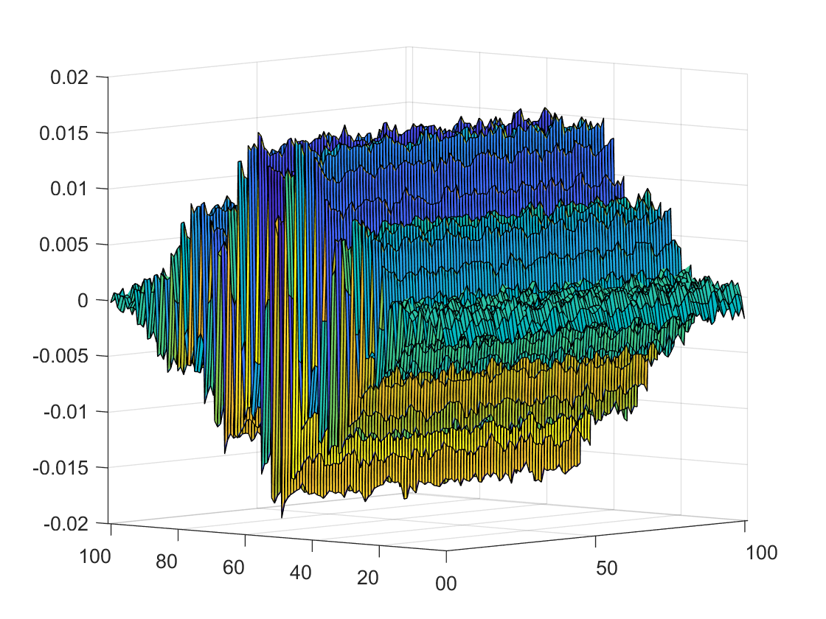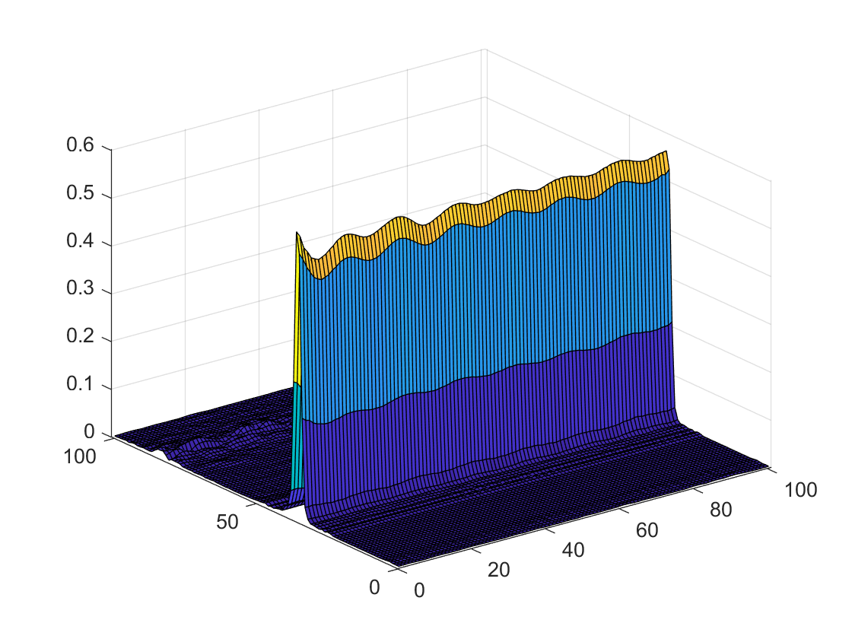

**Figure 3**. A stack of PELDOR echoes (left) and a stack of their amplitude-mode Fourier transforms (right).

Because simulations lack the many heterogeneities that are present in real experiments, they tend to produce long echoes. From this point, further data processing is performed by the user. It is often beneficial to apodise and Fourier transform the echo to improve the modulation depth:

**echo=apodization(echo,'col-sqsb-2d');  
surf(abs(fft(echo,[],1)))**

## 4. Exploration

1. Move the two pulse frequencies close together and observe the interference caused by the flip-flop terms in the dipolar operator. The effect may be suppressed artificially by setting the assumptions to ‘deer-zz’.
2. Reduce the spherical averaging grid size and observe the effect on the echo stack.
3. Add a third electron and observe the effect on the echo stack and the simulation time.