Building calendars for daily seasonal adjustment: lessons from electronic invoicing and electricity demand

Introduction
Daily administrative and transactional data are increasingly used as timely proxies for official monthly indicators. This work examines two daily series for Italy: the taxable amount of electronic invoices (2019–2025) and the national electricity demand (2012–2025). Seasonal adjustment of daily data poses significant challenges due to multiple, non-integer periodicities and a large number of calendar effects [1-3]. At daily frequency, modelling the calendar is a central aspect of the methodological strategy, as high-frequency data highlight every special day that monthly or quarterly aggregations tend to smooth out (e.g., month-end invoicing equals nine ordinary weekdays; a weekday holiday cuts electricity demand by 150 thousand MWh). Assessing short-term changes on these specific dates and their surrounding days is crucial for capturing the true underlying dynamics of daily series. Furthermore, modelling the calendar at a daily frequency can provide significant insights into the calendar specification of official monthly indicators [2]. Finally, we outline the methodological choices made in building the calendars for the two series, introduce a diagnostic toolkit based on the adjusted series, propose a generic building process, and derive lessons for good practice.

Methodology

Model and estimation
Both series are adjusted with the JDemetra+ 3 R packages [3]. A log/level test selects a multiplicative model for e-invoicing and an additive one for electricity demand. The pre-treatment is a RegARIMA model with automatic outlier detection. The linearized series is then decomposed with a sequential ARIMA-model-based approach: the weekly component first, then the annual one.
Calendar effects are modelled with dummy regressors, whose coefficients are fixed for e-invoicing and time-varying for electricity demand. Fixed coefficients are estimated within the RegARIMA pre-treatment. Time-varying coefficients are estimated in a preliminary state-space model, in which the series is the sum of a weekly Airline component and of the calendar regressors with random-walk coefficients $β_{j,t}=β_{j,t-1}+ξ_{j,t}$. This model is estimated through the Kalman filter and its smoothed coefficients give the calendar component, which is removed from the series before the RegARIMA modelling (two-step approach).
Rather than judging the estimated coefficients, we judge the seasonally (and calendar) adjusted series ($y_{t}^{SCA}$) through a Day to Month Ratio (DMR) defined as
$\frac{y_{t}^{SCA}}{median\{y_{m}^{SCA}: m ∈ month(t) \}}$, whose median should be close to 1 for any group of days, with a tolerance of ±5%. Medians of DMR_{t} are computed over the whole sample by day of the week; by day of the month; by number of days to the end of the month (EoM), which avoids mixing months of different lengths; for the periods from three days before to three days after each holiday, stratified by the day of the week of the holiday to reveal bridge effects; and for special periods (Christmas–Epiphany, August, Easter). Each group is then split into weekdays (Monday to Friday), Saturdays and Sundays: misspecified regressors typically produce opposite errors on these different day types. The toolkit is completed by a check on outliers, since their presence on recurring calendar dates indicates missing regressors.

Building process
The calendar building process is iterative. It begins by exploring the raw series to identify the causes of recurring anomalies and specifying a minimal, motivated calendar. The adjusted series are then diagnosed and the calendar refined through economic hypotheses, each verified with a DMR table before adding one regressor at a time and re-running all profiles. Finally, the calendar is simplified by dropping non-significant regressors, and the process stops once all profiles are within ±5%. The time variation of the calendar effects is then tested on the complete calendar.

Results and Practical Application

Electronic invoicing: an administrative calendar
With national holidays and three month-end dummies, the SCA series shows a strong intra-month pattern (Figure): a peak on the 15th (median DMR = 1.27), reflecting the monthly deadline for deferred invoices, a peak on the 1st (1.13), a ramp of up to 1.09 in the week before the EoM and an over-correction of the last days (down to 0.76). The final calendar models the last day of the month and its five preceding days, days 1, 15 and 20, and the last working Friday before a month end falling on a weekend.
The key choice is to split each regressor into weekday (Monday–Friday), Saturday and Sunday versions. With a single dummy, weekdays are over-corrected by 10–15% and weekends under-corrected (day 15: median DMR = 0.89 on weekdays, 2.12 on Sundays), because each effect is relative to a normal day of the same type: a Sunday month end is 69 times a normal Sunday, a weekday month end 8.6 times a normal weekday. This split shows that weekend days display a month-end effect only when no working day follows them within the month.
Dummies modelling holidays falling on weekends are set to zero except for Easter Sunday: before this fix, 11 of the 13 outliers fell on weekend holidays; after it, the outliers are special events like the 2020 lockdown. Non-significant regressors are then dropped (e.g., EoM−2 on Saturdays) and those with similar effects are merged (e.g., Sundays from EoM−5 to EoM−2), resulting in 32 final regressors.
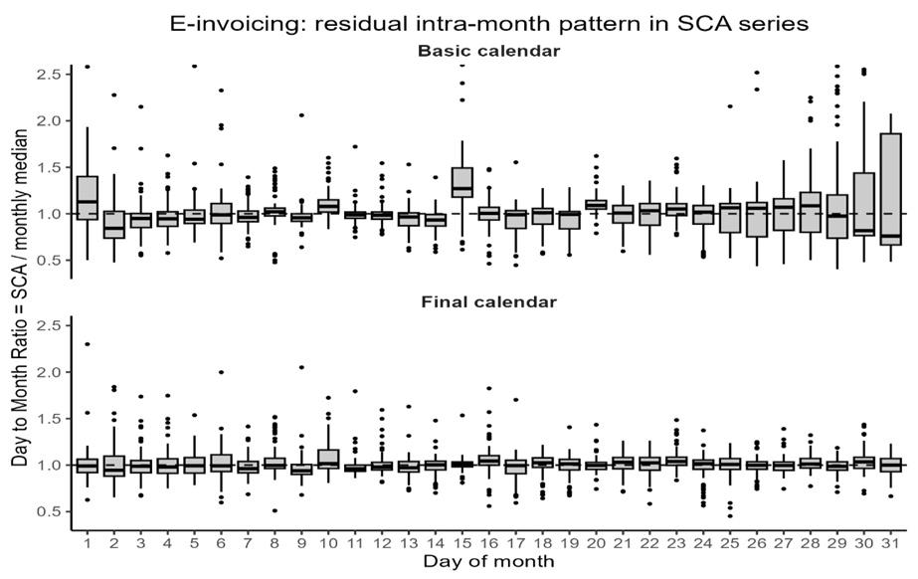
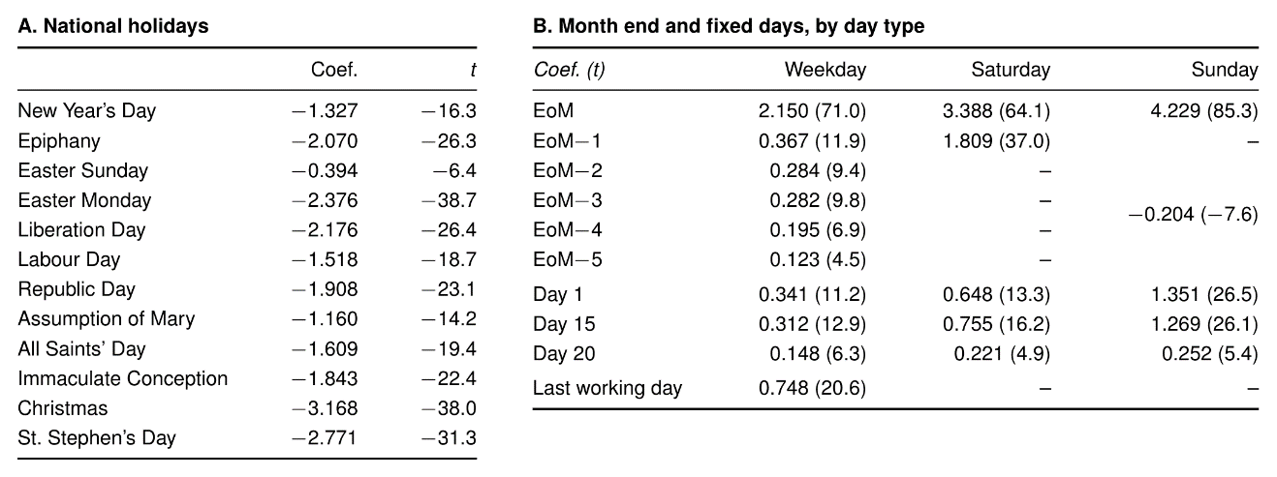

Electricity demand: a production calendar with drifting effects
The final calendar is a production calendar with bridges (before modelling, median DMR = 0.90 on Mondays before a Tuesday holiday and 0.91 on Fridays after a Thursday holiday), semi-closure days (24 and 31 December, working days between Christmas and Epiphany, 14 and 16 August), Saturday holidays and an additional effect for midweek holidays. Semi-closure days have fixed dates but affect only working days: if left to the annual seasonal component, only their average effect would be captured, leaving working days under-corrected and weekends artificially corrected. Modelling the whole Easter window, from Good Friday to the Tuesday after Easter Monday, also improved the DMR of Easter Sunday and Monday, which already had their own regressors.
Calendar effects drift over time in different directions: national holidays weaken, while some days around them, such as Monday bridges and the Tuesday after Easter Monday, strengthen (see the Figure below). Fixed and time-varying coefficients perform similarly on the DMR diagnostics (better bridges and midweek holidays for the latter, a better Easter window for the former); the two SCA series differ by less than 0.2% on most days and by 3–4% on recent holidays. Time-varying coefficients are retained. The remaining outliers include the 2020 lockdown, the 2022 energy crisis and pairs of summer level shifts in cool and hot summers, which point to temperature effects.
The causes of the drift in holiday effects remain an open question: a lower industrial share of consumption and self-generation from rooftop solar are hypotheses that can be investigated.
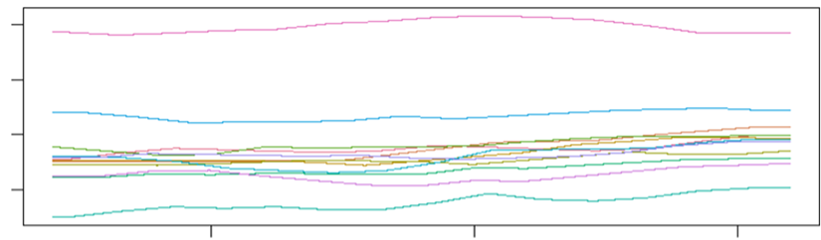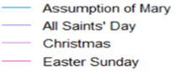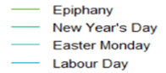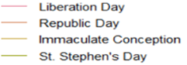
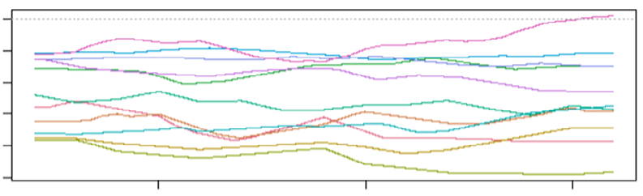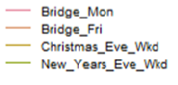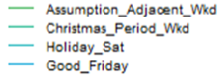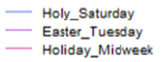

Main Findings
The Table below shows that the same calendar-building process, applied to the two series, led to two very different calendars: an administrative one for e-invoicing, driven by billing rules and fiscal deadlines, and a production calendar for electricity demand, driven by plant activity and closures. Several lessons can be drawn from the two cases. First, the effect of a holiday, or of any other special day, depends on the day of the week it falls on. For the same reason, special days with a fixed date, such as Christmas Eve, cannot be left to the annual seasonal component when their impact depends on the day of the week: the seasonal component can only capture their average effect across years. If left unmodelled, such days also bias the estimated effects of nearby holidays, since multi-day drops are partly absorbed by the local level of the model. Official public holidays are only part of the calendar: bridges and the last working day of the month also have substantial effects. Finally, recurring outliers on calendar dates usually point to missing or misspecified effects.
 | E-invoicing | Electricity demand
Calendar driver | Administrative: billing rules, fiscal deadlines | Production: plant activity, closures
Model | Multiplicative (log), 2019–2025 | Additive (MWh), 2012–2025
Intra-month effects | Strong: month end ×8.6, days 1, 15 and 20, pre-month-end ramp | None
Around special days | Last working day before a weekend month end | Bridges, Easter window, Christmas period
Weekends | Sunday month end: 69 times a normal Sunday | Saturday holidays: -5% on a normal Saturday
Effects over time | Stable | Smooth drift: about -10% to -18% since 2012
Calendar regressors | 32, fixed coefficients | 23, time-varying coefficients

References
- D. Ollech, Seasonal adjustment of daily time series, Journal of Time Series Econometrics 13 (2021), 235-264.
- K. Webel, A review of some recent developments in the modelling and seasonal adjustment of infra-monthly time series, Deutsche Bundesbank Discussion Paper 31/2022 (2022).
- K. Webel and A. Smyk, Seasonal adjustment of infra-monthly time series with JDemetra+, Journal of Official Statistics 40 (2024), 783-828.
ABSTRACT 2000 CARATTERI PER PIATTAFORMA SUBMISSION
(Intro+ Conclusioni)

Daily administrative and transactional data are increasingly used as timely proxies for official monthly indicators. This work examines two daily series for Italy: the taxable amount of electronic invoices (2019–2025) and national electricity demand (2012–2025). Seasonal adjustment of daily data is challenging due to multiple, non-integer periodicities and many calendar effects. At daily frequency, modelling the calendar is central, as daily data expose every special day that monthly aggregates average out (e.g., a month end is worth almost nine ordinary weekdays of invoicing; a weekday holiday cuts electricity demand by about 150 thousand MWh), and assessing short-term changes on these dates is a key added value of daily seasonally adjusted series. We propose an iterative calendar-building process based on a simple diagnostic, the day-to-month ratio, which compares each adjusted day with a typical day of its month. Applied to the two series, the same process led to very different calendars: an administrative one for e-invoicing, driven by billing rules and fiscal deadlines, and a production one for electricity demand, driven by plant activity and closures, with holiday effects drifting over time. Several lessons emerge. The effect of a holiday, or of any other special day, depends on the day of the week it falls on; for the same reason, special days with a fixed date, such as Christmas Eve, cannot be left to the annual seasonal component, which only captures their average effect across years. If left unmodelled, such days also bias the estimated effects of nearby holidays. Official public holidays are only part of the calendar: bridges and the last working day of the month also have substantial effects. Finally, recurring outliers on calendar dates usually point to missing or misspecified effects.

