

An Italian analysis on

healthcare performance

Participants of group B:

*Lorenzo Garcia Condoluci 1808446*

*Camilla Lombardi 1794467*

*Alessandro Taglieri 1890945*

*Clemente Recine 1800656*



# Index

**1. Executive Summary**3

**2. Introduction**3

**3. Literature review**4

**4. Description of the Model developed**4

**5. Description of the Method chosen for empirical analysis on data**5

Cluster analysis 5

Data Envelopment Analysis (DEA) 6

**6. Description of the Data chosen**7

Introduction to the chosen data 7

Detailed description of the features 7

**7.** **Analysis of the data**8

Some analysis about our data 9

*Correlation matrix*9

*Overview of the dataset about Italy regions’ satisfaction*10

*Distribution of the satisfaction over 5 Italy Macro-areas*10

*Distribution of regions’ satisfaction over Italy map*11

*Analysis on Investment Vs Population: a comparison with the satisfaction*12

*Analysis on hospital beds / healthcare personnel Vs Population: a comparison with the satisfaction*13

Clustering analysis 13

Data Envelopment Analysis 16

**8.** **Conclusions**20

**9.** **Appendix**21

Detailed informations about datasets 21

Variables scanned in Systematic Review 22

Systematic review 25

**10.** **Bibliographic References**35

# 1. Executive Summary

The recent Covid-19 pandemic has raised several problems regarding the global health system: lack of healthcare staff and hospital beds, insufficient funds and general dissatisfaction of patients. This situation prompted us to focus our research on the Italian healthcare system. Previous studies have classified the northern regions at the top of the ranking regarding the health care services while the southern regions have always taken the lowest positions.

Using data coming from ISTAT we are going to analyze the correlation between the satisfaction of the patients and the factors that do affect it. Furthermore, we have also collected data on investments in healthcare by region and we have exploited it to make a clustering and a DEA expecting to find some links between regions and the efficiency.

Our findings confirm the statement that the level of satisfaction is generally higher in the north of Italy, but we did also find that the efficiency score is not strictly related to the satisfaction.

# 2. Introduction

Healthcare has always played a primary role in humans everyday life, but particularly in this time period, we must remember how important it is to invest in such aspects in order to strengthen the social system, ensure security and improve life quality.

Due to the Covid-19 pandemic, many of the healthcare system problems have arisen: not enough hospitalized places in intensive care, the urgency to open new temporary structures to guarantee hospitalization for whoever needs it, nerve-racking and stressful work shifts for healthcare workers (as many photographic testimonies have shown us over the last year).

We have seen the devastating effects this pandemic has created both in developed countries such as Italy, Germany, the United States and the United Kingdom and in less developed countries where the situation is even worse given the lack of healthcare facilities in relation to the number of inhabitants and the quality of healthcare provided.

Given all the presented issues, it is important to consider both the patients and the healthcare assistants point of view. In the systematic review, we are going to present as part of this report, we did analyse 10 different papers focused on the performance of hospitals assessing the quality and the social impact of healthcare professionals.

Furthermore, we are going to stress our interest in the Italian healthcare system focusing on finding relationships on the satisfaction of patients' hospitalization, on the investments in and the number of hospitals throughout Italy. This choice is due to the fact that we have read/listened to a lot of news that highlighted a health disparity in our country (especially between north and south), therefore we decided to analyze the data firsthand to verify this.

We have outlined some questions that do represent the main target of our research:

1. Is it true that in Italy there is a disparity of healthcare services depending on the region?
2. Is there a correlation between the fundings each hospital invests in sanity and the satisfaction of the patients?
3. Are we able to assess the efficiency of the number of available beds in Italian hospitals given different inputs, i.e. the population and the investments in the healthcare system?

# 3. Literature review

Our analysis begins with the considerations and the results obtained from a previously executed systematic review “*Systematic Review on the performance of hospitals assessing the quality and the social impact of healthcare professionals*” (see Appendix), where we have examined articles from 2018 to 2021 related to the performance of hospitals and the quality of healthcare providers in developed countries focusing on the impact on society they do have.

Here we observed three main themes that have been analysed and deeply discussed:

1. The importance of relationships in a healthcare system
2. The satisfaction both of patients and nurses
3. Where does healthcare-related quality come from

In our analysis, the point of view is completely changed. While in the articles we found there are feedbacks of healthcare staff through data collected by interviews, we have based our studies on a dataset that collects the information about the patients in Italian hospitals. Nevertheless, we have analyzed the common variables between these two analyses, selecting only those articles which clearly defined the metrics used. *The tables 8 and 9* clearly present the variables scanned in our systematic review.

*In table 9*, the variables “Missed care experience” and “Perception of nurse experience” can be observed. As we said, these features represent the nurses’ point of view, while in our analysis we had the same variable from the patients’ perspective and satisfaction concerning all the aspects of hospitalization. We still believe that we can use these variables to enhance the difference between the two subjects and to compare them. In this article the percentage of “missed care experience” is quite high, maybe highlighting inadequate work skills.

We consider this as our starting point; we want to focus on Italian patients’ point of view by analyzing their satisfaction and healthcare facilities situation and compare it between each and every Italian region.

A couple of other articles we have considered are related to the Italian satisfaction. These newspaper articles (La Repubblica, AGI, Censis) [8] state that the situation of the Italian healthcare system is not the same for every region: the northernmost regions have a better health system than the southern ones. So, one of the objectives of our analysis is to deny or confirm this statement.

# 4. Description of the Model developed

In order to achieve our project objectives, we started by analyzing and describing the data we have chosen (see chapter 6) that collects information about patients and Italian hospitals. Once having examined the most important aspects of the dataset, we started thinking about the methods to use for the analysis.

Given that we have a database with different regions, one of the first thoughts was to implement a cluster analysis in order to see if the Italian regions can be grouped according to different factors. The other analysis we wanted to show is a DEA based on the fact that we have many variables on which to compute the efficiency of Italian hospitals. After these three steps, the last step is to compare these different approaches in terms of what they have in common and in what they differ and then draw the conclusion of our study.

# 5. Description of the Method chosen for empirical analysis on data

### *Cluster analysis*

Cluster analysis or clustering is the task of grouping a set of objects in such a way that objects in the same group (called a cluster) are more similar (in some sense) to each other than to those in other groups (clusters). It is the main task of exploratory data analysis, and a common technique for statistical data analysis, used in many fields, including pattern recognition, image analysis, information retrieval, bioinformatics, data compression, computer graphics and machine learning.

Cluster analysis itself is not one specific algorithm, but the general task to be solved. It can be achieved by various algorithms that differ significantly in their understanding of what constitutes a cluster and how to efficiently find them. Popular notions of clusters include groups with small distances between cluster members, dense areas of the data space, intervals or particular statistical distributions. Clustering can therefore be formulated as a multi-objective optimization problem. The appropriate clustering algorithm and parameter settings (including parameters such as the distance function to use, a density threshold or the number of expected clusters) depend on the individual data set and intended use of the results. Cluster analysis as such is not an automatic task, but an iterative process of knowledge discovery or interactive multi-objective optimization that involves trial and failure. It is often necessary to modify data preprocessing and model parameters until the result achieves the desired properties.

Clustering analysis will be used to spot similarities between locations in Italy, as it is of common opinion that between North and South Italy there are huge differences. With this type of analysis, we also verify in which Italian regions people are more satisfied with the nurses’ service offered during the hospitalization, the number of beds and the number of caregivers’ for each region. It is also possible to observe which is the trend of this feature by computing the analysis per year. Moreover, we believe that it is a good tool to visualize the data by inserting them in a map and colour the cluster that we obtain.

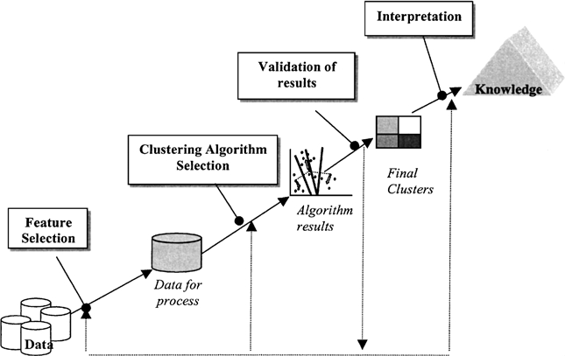

*Figure 1- Clustering*

### *Data Envelopment Analysis (DEA)*

We are going to perform a Data Envelopment Analysis (DEA) to measure the productive efficiency of decision-making units. In contrast to parametric methods that require the ex-ante specification of a production or cost function, non-parametric approaches compare feasible input and output combinations based on the available data only. DEA, as one of the most commonly used non-parametric methods, owes its name to its enveloping property of the dataset's efficient DMUs, where the empirically observed, most efficient decision-making units (DMU) constitute the production frontier against which all DMUs are compared. DEA's popularity stems from its relative lack of assumptions, ability to benchmark multi-dimensional inputs and outputs as well as computational ease owing to it being expressible as a linear program, despite aiming to calculate efficiency ratios. We could argue that benchmarking our DEA will form a sort of “best-practice frontier” and not a “production frontier” (Charnes A., W. W. Cooper and E. Rhodes (1978)). The output of our analysis will consider the number of beds in a hospital given in input the investments in the healthcare system and the population we must serve.

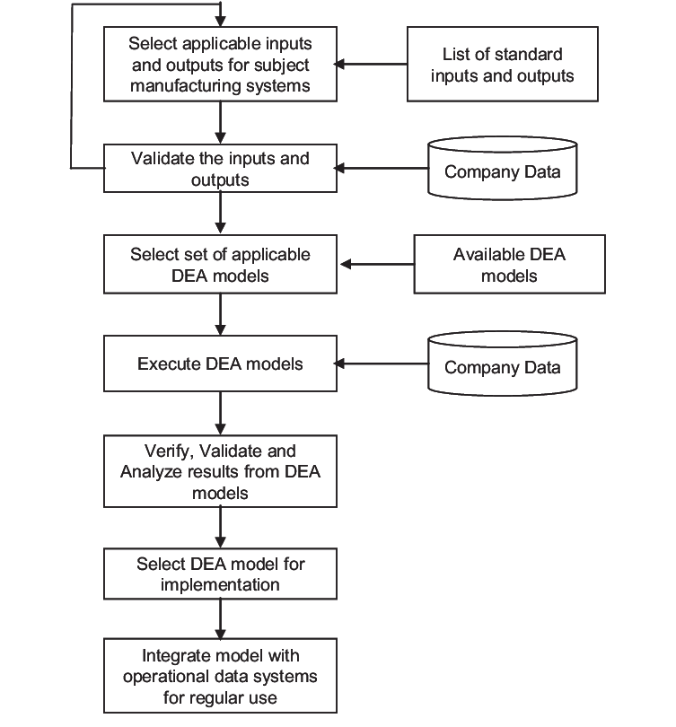

*Figure 2 - DEA*

# 6. Description of the Data chosen

## *Introduction to the chosen data*

The data we are going to use comes from the sample survey named “Aspetti della vita quotidiana” done by ISTAT (National Institute of Statistics) [0]. This survey covers many aspects that statisticians might want to analyse related to everyday’s life. The data gathered is then splitted into different datasets in order to cover different dimensions. We are going to work with some datasets coming from dati.istat.it, same resource and the same type of data.

Specifically, we used five different datasets:

* The satisfaction dataset measures the quality of the healthcare system [1];
* The population dataset will give us information about the population for each region [2];
* The third dataset will tell us the number of hospitals per region [3];
* The dataset that contains information about numbers of healthcare personnel [4];
* Finally, the dataset about the number of hospital beds [5];

We used these datasets to obtain a final and complete dataset that contains information about each and every Italian region in order to perform the different analysis described in the following chapter - Analysis of the data.

To challenge ourselves with interesting and practical analysis, we noticed that we missed an economic feature that we did retrieve from “Agenzia Coesione” (government website [6]) where for each region we have information about the investments in the healthcare system over the years.

Notice that for all the datasets we are considering, we have each feature for each Italian region in the time frame between 2014 and 2019.

## *Detailed description of the features*

To better understand and analyse all the aspects we are willing to touch, we are going to merge these datasets based on necessity. So, let us give a brief overview of the main features we are going to consider in our analysis. These factors could both be coming from the original datasets or could be computed by us for the purpose of the analysis we are going to implement (if so it will be clearly stated). More information about the features of all the datasets and how we pre-process them can be found in the appendix.

*The final dataset* that we gathered from different sources in Istat site [0], contains for every Italy region and for every year, from 2014 to 2019, the following information:

* Level of healthcare Satisfaction;
* Population;
* Beds hospital;
* Healthcare personnel;
* Number of Hospitals.

We work with this dataset mainly using the following features (that we will use to perform different analysis). More details about this main dataset are reported in the appendix.

***Territory***- this feature will tell us the region we are considering. Often we can also find aggregates based on different aspects; for example for the geographic position of the regions (“North”, “South”, etc..), the type of the city (“Urban city”, “Countryside”) or a total aggregate like “Italy”. We are going to use only different Italy regions and some aggregates based on the geographic position of the regions;

***Time*** - the year we are considering. We considered only from 2014 to 2019;

***Population*** - The population of Italy regions;

***Hospitals*** - the number of healthcare structures;

***Hospital_beds*** - the number of hospital beds;

**Healthcare_personnel** - the number of people that work in public healthcare structures;

*Satisfaction* - this concept refers to three different features. This data is gathered from several surveys where people could give their opinion with three different categories of grade: *very much, quite and little/poo*r. So in the dataset are present the following features:

* ***Value_veryMuch***: percentage of people that gave the higher grade for their satisfaction about hospitals.
* ***Value_quite***: percentage of people that gave a good grade for their satisfaction about hospitals.
* ***Value_little-poor***: percentage of people that gave a bad grade for their satisfaction about hospitals.

***Aspect*** - The three previously stated features are given for many different aspects (more info in the appendix). We take into consideration only satisfaction about the “Nurses aspect”.

*The second main dataset* allows us to get an overview of an economic perspective on public health. This dataset contains the following main features that we used to perform several analysis:

***Region***: it identifies all different Italy regions;

***Time***: the year we are considering. We considered only from 2014 to 2019;

***Investment***: the investment for public healthcare structures in Italy (for different regions). This value is expressed in millions of Euros.

More details about this second dataset are reported in the appendix.

# Analysis of the data

We perform the following analyses in different ways. First, we preprocessed the dataset that we have chosen to get only useful information and features that we are actually going to use. Then, we did some descriptive analysis to have a better understanding of the dataset and the data that we are exploring. With the numerous types of analysis we are going to perform, we will try to understand some aspects of the level of satisfaction and how it changes over the different Italian regions during the years from 2014 to 2019.

Two types of detailed analysis, Clustering and DEA, to explore the efficiency of the healthcare system based on the satisfaction level will be the main aspects of our report.

Data preprocessing and the following descriptive analysis have been done with Python language. The code needed to perform the various types of analysis and the preprocessing of the data is allocated in a public Github repository [7]. Clustering and DEA analysis have been done with R language and these scripts are stored also in the same Github repo. Here you can also find the report itself and all datasets that we have used.

## *Some analysis about our data*

### **Correlation matrix**

First, we represent thecorrelation coefficients between variables with a correlation matrix. Each cell in the table shows the correlation between two features. We use it to summarize and introduce data, as an input into and as a diagnostic for advanced analyses.

In this way, we can have a first summary of the data and the correlation among all features. As we can see in the following figure, the satisfaction feature is not correlated with any other feature, while all other variables are strictly correlated among them.

We believe that this high correlation is a good point to discuss both exploring better the correlation among these variables and finding how they changed over time. Further analyses will help us understand in a more detailed way how Italian institutions decide to invest money in healthcare by adding more hospital beds, hiring more care assistants and building hospitals. This topic has always been debated in this country and now, due to the pandemic, it has even more importance.

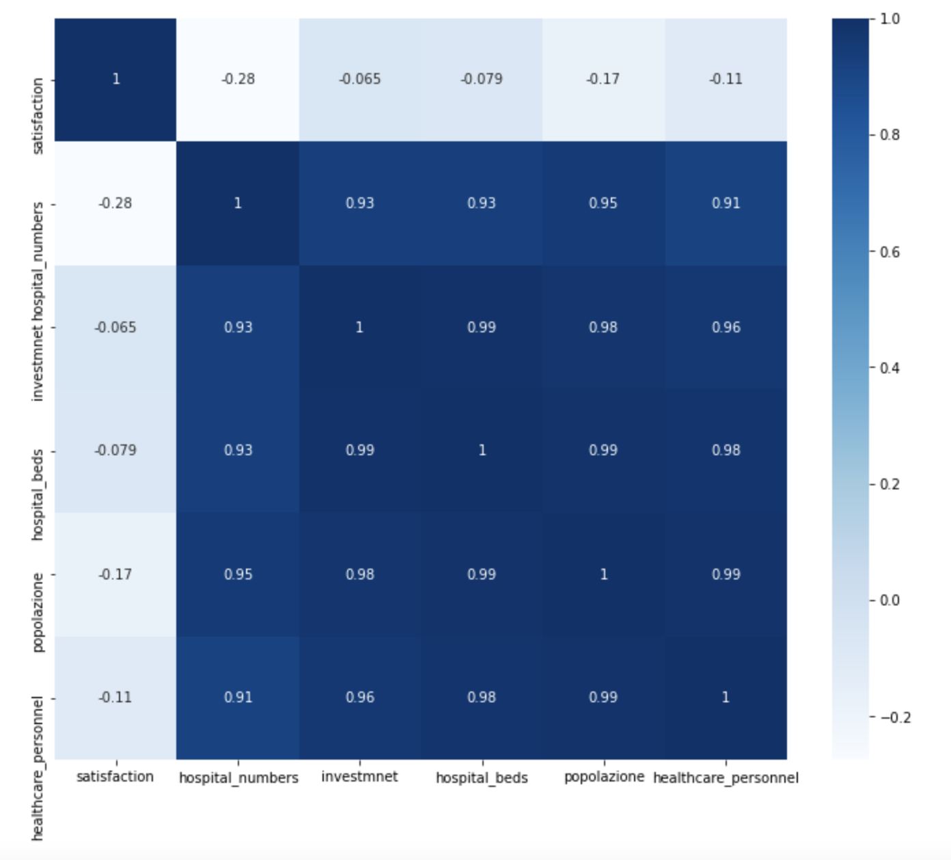

*Figure 3 – Correlation matrix*

### **Overview of the dataset about Italy regions’ satisfaction**

This analysis allows us to understand better the distribution of the satisfaction and how it is reported in the dataset. In the *Figure 4*, data about 2019 is reported.

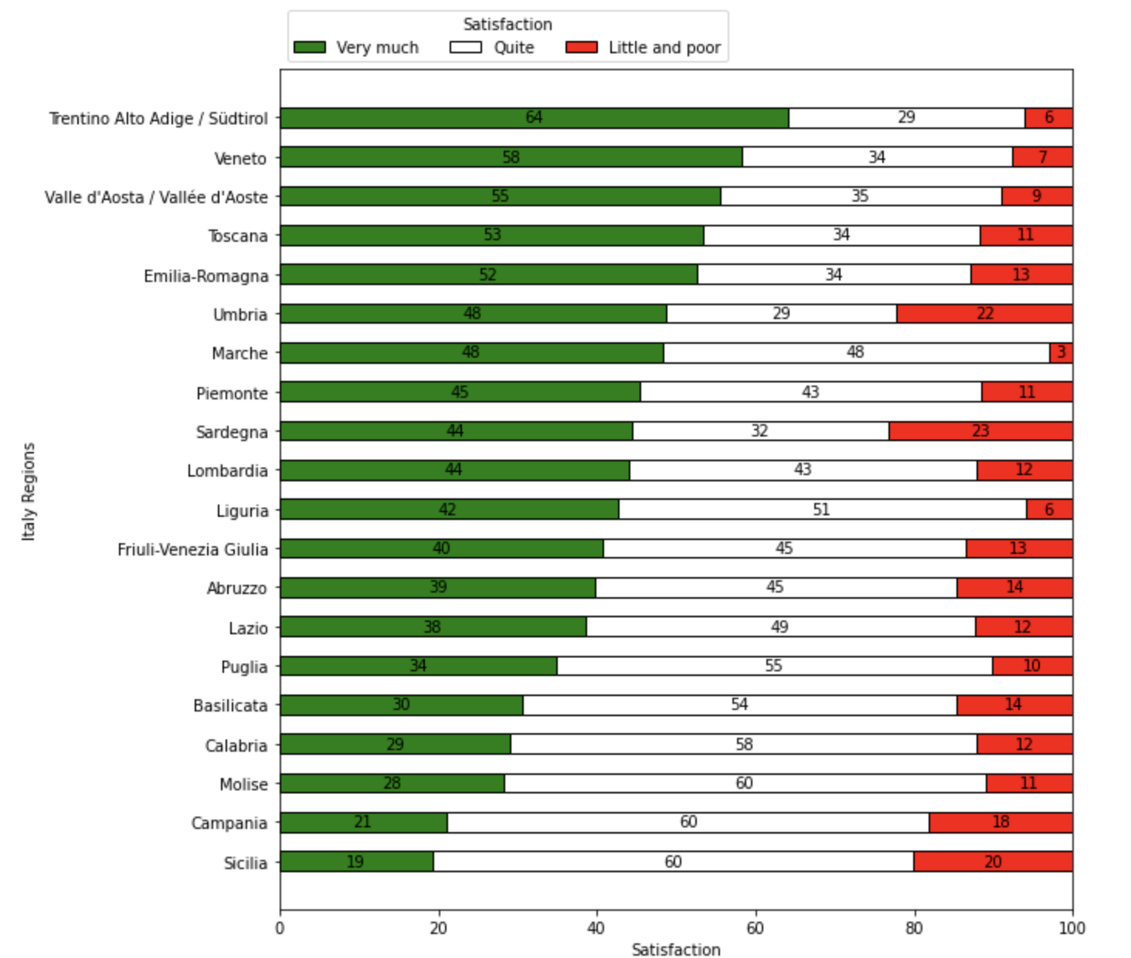

*Figure 4 – Distribution of the satisfaction in 2019*

The satisfaction is shown for every Italian region and for each grade of satisfaction (as previously described). In the horizontal axis, we find the percentage for these grades sorted in descending order, from the highest satisfaction level to the worst one. Trentino Alto Adige is the best region where 64% of people state a *very good* satisfaction level in the hospitals in the region, while Sicilia is where the smallest number of people have this level of satisfaction. We can also notice that the region that has the least grade of satisfaction at level *little/poor* is Marche, although it is not the region with the highest level of satisfaction. From this last point of view, we can see that Sardegna is the region where more people gave the worst grade of satisfaction.

### **Distribution of the satisfaction over 5 Italy Macro-areas**

With the following multi-line chart, we show the distribution of the satisfaction for five different macro-areas (North-West, North-East, Center, South, Islands) in Italy. We grouped 21 Italian regions in these five areas based on their geographic position. We consider data from 2014 to 2019 and we consider the value of the satisfaction from the input dataset.

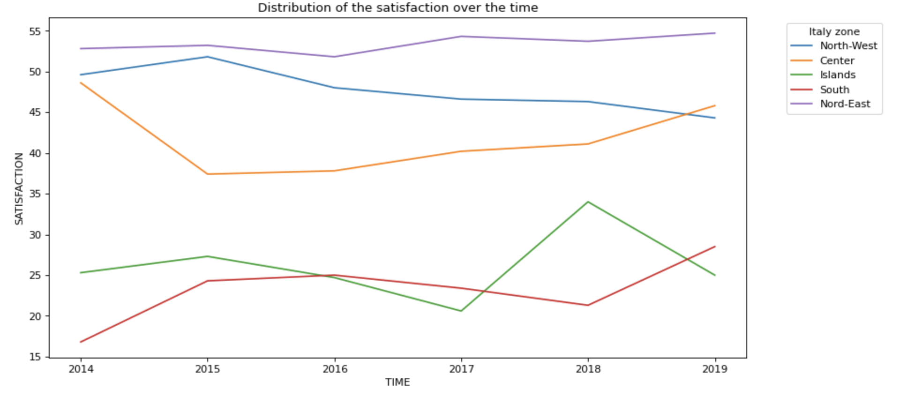

*Figure 5 – Distribution of the satisfaction*

By observing the plot we can see that for every macro-area all data are linear enough and we detect that the South-Italy is the area with the worst satisfaction during each and every year, except in 2019 where the islands-area have the worst score. Finally, the North-East area is the zone that has the best satisfaction over all years.

### **Distribution of regions’ satisfaction over Italy map**

We made another analysis focusing on a more clear geographical distribution of the satisfaction level for each Italian region. We built it with a custom heat map. As we can see in the following figure we assign a specific colour to each region based on the scale reported on the right side of the picture. Colours go from black - bad satisfaction - to a light yellow which indicates a very good satisfaction. We considered the mean of the level of satisfaction (*value_veryMuch* in the dataset) for all the years between 2014 and 2019.

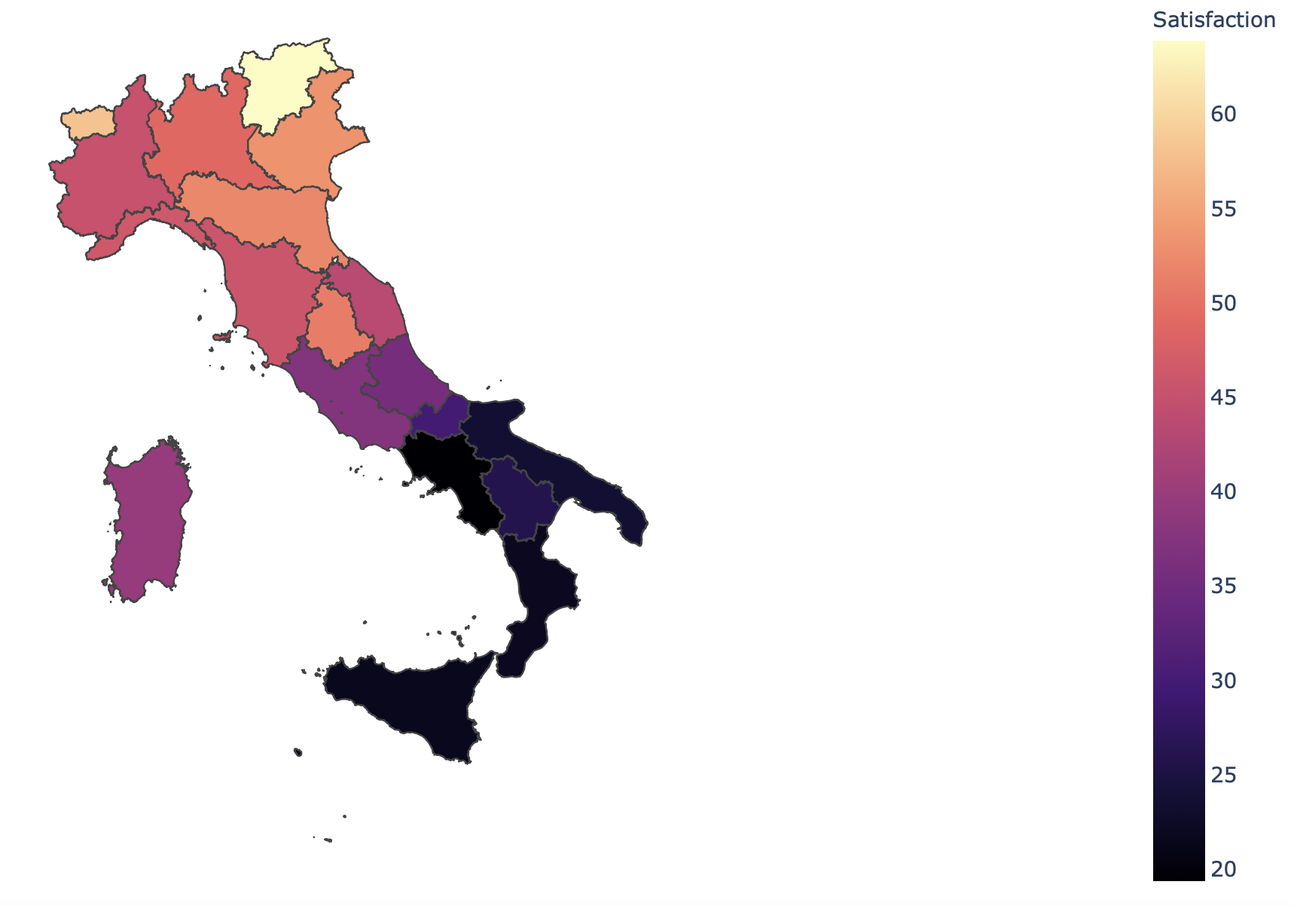

*Figure 6 – Satisfaction on heat map*

From this figure, we can notice that North Italy is the zone with the best level of satisfaction. This level decreases from North to South, so the southern regions of Italy are the worst, especially ‘Puglia’, ‘Campania’, ‘Calabria’ and the island ‘Sicilia’ that are coloured with black colour. Meanwhile, the centre regions have a level that goes from 30 to 45, same as ‘Sardegna’. The best regions are allocated in the North-East, for example, ‘Trentino alto-Adige’ presents the highest value, closely followed by Veneto.

The results we can infer are definitely similar to what we have found in the previous analysis. So, this heatmap confirms that there is a higher level of satisfaction regarding the nurses’ performances in hospitals in North Italy across all the years we are considering.

### **Analysis on Investment Vs Population: a comparison with the satisfaction**

From the above plot, we notice that healthcare satisfaction is distributed clearly in a specific way in all of Italy. To verify this behaviour we decided to show in the same heat map the investments for every region. We scaled this feature based on regions’ population and so we show the rate of investments over population in every region. This was computed adding to our dataset a specific indicator: (investments / population). This indicator was then normalized searching for values between 0 and 100 in order to confront the results on the same scale. The value we then used to colour the map is the mean of the values between 2014 and 2019. On the right side of the image, we can see the resulting scale.

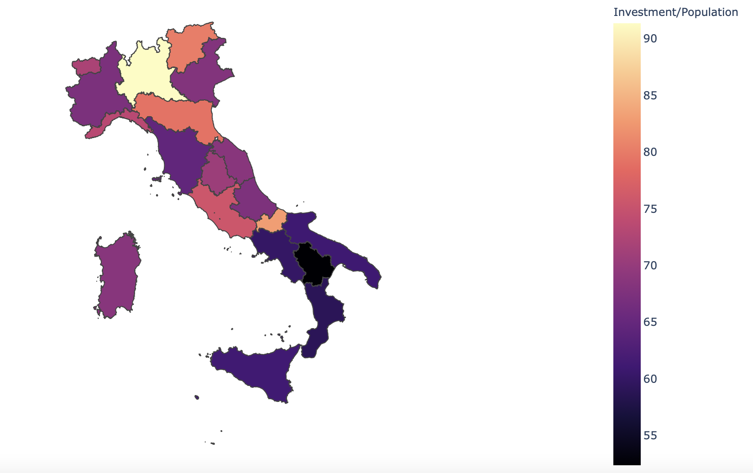

*Figure 7 – Investment on heat map*

It can be clearly seen that the southern regions are doing the worst. This result might also be the reason why the level of satisfaction in that same part of Italy is at such a low level (as we have seen with the previous map). It might be interesting to notice that the Italian regions whose satisfaction levels are the highest (like Trentino Alto Adige and Valle d’Aosta) are not those with the highest value of the indicator we computed. This supports the fact that having more money per patient does not necessarily mean that you can provide him better services; maybe the equipment you use for example in Lombardia is more sophisticated, but a strong and healthy human interaction between patient-nurse (which contributes greatly to the satisfaction level of the patient) is and must be a critical factor in healthcare-related environments. Furthermore, by making a comparison between the two maps, we can see that while in the satisfaction map we could easily group the regions together given the different colours, for the latter map it is not at all straightforward.

### **Analysis on hospital beds / healthcare personnel Vs Population: a comparison with the satisfaction**

We decided to compare the distribution of satisfaction in Italy with the Hospital beds and healthcare personnel. As we did before for the investments we showed the ratio of bed_hospitals over population (left figure) and the ratio of healthcare personnel over population (right figure), both for every Italian region.

|  |  |
| --- | --- |
| *Figure 8 – hospital beds in heat map* | *Figure 9 – healthcare personnel in heat map* |

From the left figure, we can see that the distribution of bed hospitals is similar to the distribution of satisfaction: this could justify the inequality among all regions. Then we can notice that North-Italy has a higher ratio of beds hospitals with respect to the population, whereas the South has the worst results from this point of view. Only “Toscana” looks to be the only region with a big difference in the distribution of the satisfaction level.

The same process has been done for healthcare personnel: we can see the resulting map in the right figure. Here the distribution is very different from satisfaction because the Italian zones (North, South, Center) are not very different among them. The only thing that is the same, regards “Trentino-Alto-Adige”, which is the best region for both points of view (healthcare personnel and satisfaction).

## *Clustering analysis*

We conducted a cluster analysis because it is known that in Italy there are geographical barriers and opinions which state differences between Northern, Central and Southern Italy.   
To verify this statement we ran a cluster analysis based on the value of high satisfaction for the nurse service during the hospitalization, the number of nurses and the number of hospital beds. Of course, data was shown for each Italian region and they were referred both to the year 2014 and 2019. This choice originates from the curiosity to assert if the level of satisfaction has changed during the years in the different regions.

Computing these analyses, 4 clusters are obtained for both years. By observing the groups’ composition we detect some differences in the two years and that the clusters do not represent Italy’s geographical distribution. In fact, we find some southern or central regions together with northern ones.

In 2014 we can observe that the clusters are organized as:

|  |  |  |  |  |  |  |  |  |  |  |  |  |  |  |  |  |  |  |  |  |  |  |  |  |  |  |  |  |  |
| --- | --- | --- | --- | --- | --- | --- | --- | --- | --- | --- | --- | --- | --- | --- | --- | --- | --- | --- | --- | --- | --- | --- | --- | --- | --- | --- | --- | --- | --- |
| |  |  |  |  | | --- | --- | --- | --- | | **YELLOW** | **ORANGE** | **PINK** | **PURPLE** | | Friuli-Venezia Giulia | Lombardia | Marche | Sicilia | | Liguria | Toscana | Sardegna | Campania | | Trentino Alto Adige | Piemonte | Abruzzo | Puglia | | Umbria | Veneto | Calabria |  | | Valle d’Aosta | Emilia - Romagna | Basilicata |  | |  | Lazio | Molise |  |   *Figure 10 – Cluster analysis in 2014 – Table and heat map* |  |

The first is the “yellow” group composed of the regions whose satisfaction for the nurses assistance is very high and in a range between 52% (Friuli Venezia Giulia) and 70% (Trentino Alto Adige). In this group, 4 of the regions are located in North Italy and just one in the center, but it still maintains a high percentage of satisfaction with respect to caregivers .  
It follows the “orange” group in which there are both regions of North and Center Italy and it is possible to notice that here the percentage of satisfaction is a bit lower but still high and in between a range of 46.2% (Lazio) and 54.4% (Toscana and Veneto).   
The “pink” group is characterized by regions of Center and South Italy and the values regarding the satisfaction start to decrease drastically. In fact here we observe values that go from 15.3% (Abruzzo) to 38.6% (Marche).   
At the bottom levels of satisfaction we find the “purple” group. These three regions are all located in southern Italy and we have very low values, which are in a range of 13.9% (Campania) and 21.7% (Sicilia).

It is interesting to show that in 2019 the situation slightly changed, as shown below:

|  |  |  |  |  |  |  |  |  |  |  |  |  |  |  |  |  |  |  |  |  |  |  |  |  |  |  |  |  |  |  |  |  |  |  |  |  |  |
| --- | --- | --- | --- | --- | --- | --- | --- | --- | --- | --- | --- | --- | --- | --- | --- | --- | --- | --- | --- | --- | --- | --- | --- | --- | --- | --- | --- | --- | --- | --- | --- | --- | --- | --- | --- | --- | --- |
| |  |  |  |  | | --- | --- | --- | --- | | **YELLOW** | **ORANGE** | **PINK** | **PURPLE** | | Emilia-Romagna | Trentino Alto Adige | Lombardia | Calabria | | Veneto | Valle d’Aosta | Campania | Basilicata | | Piemonte | Marche | Sicilia | Molise | | Toscana | Umbria | Lazio |  | |  | Abruzzo | Puglia |  | |  | Friuli Venezia Giulia |  |  | |  | Liguria |  |  | |  | Sardegna |  |  |   *Figure 12 – Cluster analysis in 2019 – table and heat map* |  |

From the table and the figure, we observe that the groups’ components have changed. Some regions have lost percentage points in the 5 years and some have gained high levels of satisfaction, while others are on the same level as 2014.   
The “actual yellow” group is composed of four regions that were already in the same cluster in 2014 but now have a higher percentage, with the exception of Toscana which has lost 0.9%. With respect to the other groups, this is the one with the tightest range: between 45.4% (Piemonte) and 58.2% (Veneto). Piemonte in this cluster is the region which has the lowest value because all the others are over 50%.   
Further on, we find a big group with 8 regions in it. We notice that here there are regions that in 2014 had a very high value of satisfaction and have lost some points (Trentino Alto Adige whose value in 2014 was 70% and in 2019 is 64%) but also other regions which performed very badly in 2014 like Abruzzo whose value was of 15,3% and in 2019 it is equal to 39.8%. Despite this extraordinary growth, Abruzzo’s value of satisfaction is the lowest in this group, and the highest is still the one of Trentino Alto Adige.   
The “pink” cluster groups regions that are situated in the North, Center and South of Italy. What happens here is very similar to what occured in the previous cluster. There are both regions that had a higher level of nurse satisfaction in 2014 and it has decreased (Lazio and Lombardia) and regions that, on the other hand, have improved their performance such as Campania, Sicilia and Puglia. We can also notice that Campania in 2014 was one of the worst regarding the satisfaction while Lazio and Lombardia were in a good position. By the way, the range of this group is between 19.2% (Sicilia) and 44.1% (Lombardia).

In the last group we find Calabria, Molise and Basilicata. They were already in the same cluster in 2014, but the situation has changed. The first two have improved their satisfaction score reaching and passing the 20%, while the last has lost 3.6% percentage points. We have that the scores are very close, between 28% and 30%.

These cluster analyses also depend on the number of nurses and number of hospital beds that are in each region. In most of the cases, these values are proportional to the amount of inhabitants of the regions. In particular, we have seen through previous analysis *(Figure 8)* in that the distribution of hospital beds with respect to the population is similar to the one of satisfaction, while the one regarding the number of hospital care assistants is very different. We believe that this difference has affected the results obtained in the cluster analysis.

Moreover, in the correlation matrix *(Figure 3)*, it is possible to observe that the investments, the number of hospital beds, the number of nurses, and the number of inhabitants are very related. This point also justifies the results that we have obtained performing the cluster analysis.

## *Data Envelopment Analysis*

The DEA we are going to perform will have the following variables:

*Table 3 – DEA variables*

|  |  |  |
| --- | --- | --- |
| **INPUT 1** | **INPUT 2** | **OUTPUT** |
| Population | Investments | # available beds |

Given also the challenges faced by the Italian healthcare system at the initial stages of the Coronavirus pandemic where it was more than clear that the available beds in hospitals were not nearly enough, we thought it might be interesting to analyse the number of beds with the population and the investments for each region. To do this, firstly we averaged the values over the 5 year time period we are considering and then we performed the Data Envelopment Analysis using the software R.

In the beginning, it is necessary to test the constant vs variable return to scale, then test the convexity of the production set using the relevant functions from the package FEAR:

*Table 4 – FEAR functions*

|  |  |
| --- | --- |
| test.rts | pval = 0.2384081 |
| test.convexity | pval = 0.0001756659 |

Knowing that the null hypothesis of constant returns to scale (CRS) is rejected if the p-value of **test.rts** is less than 0.05. The same for the null hypothesis of convexity, which should be rejected if the p-value of **test.convexity** is less than 0.05. Looking at our results, we can state that the null hypothesis of CRS is accepted, but the null hypothesis of convexity can not be accepted. From the latter it follows that only the Free Disposal Hull estimator is consistent.

The following is the resulting graph considering every region in the dataset:

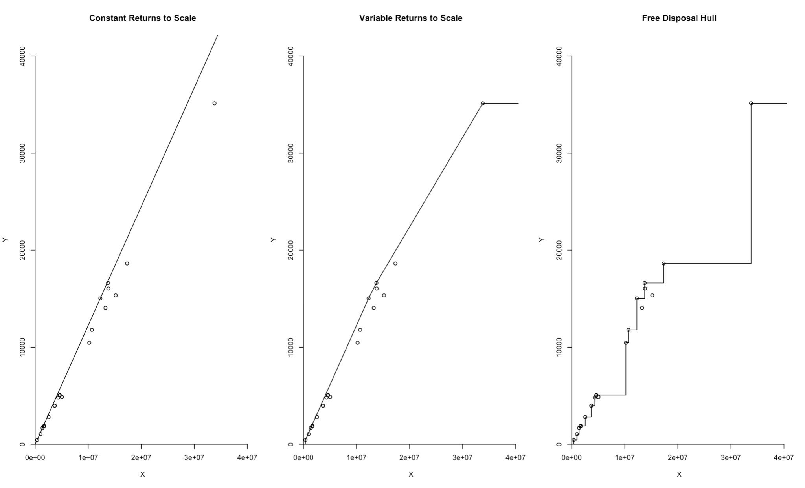

*Figure 12 – resulting graphs from DEA*

We can clearly see that there is only one outlier in the graphs which corresponds to information about Lombardia. Therefore, we deemed it necessary to filter it out in order to get a better look at the other values we are considering.

Because we are working on a “different” dataset, we need to re-compute the following:

*Table 5 – pval values*

|  |  |
| --- | --- |
| test.rts | pval = 0.7416665 |
| test.convexity | pval = 0.9408096 |

Both values of p-val for the different tests are now greater than 0.05, which means we must accept both the null hypothesis. Accepting the null hypothesis of **test.rts** implies that we do accept CRS, while under the null hypothesis of **test.convexity** both the FDH and VRS-DEA estimators are consistent.

Let us graphically see how the graph without the region Lombardia differs from the original one:

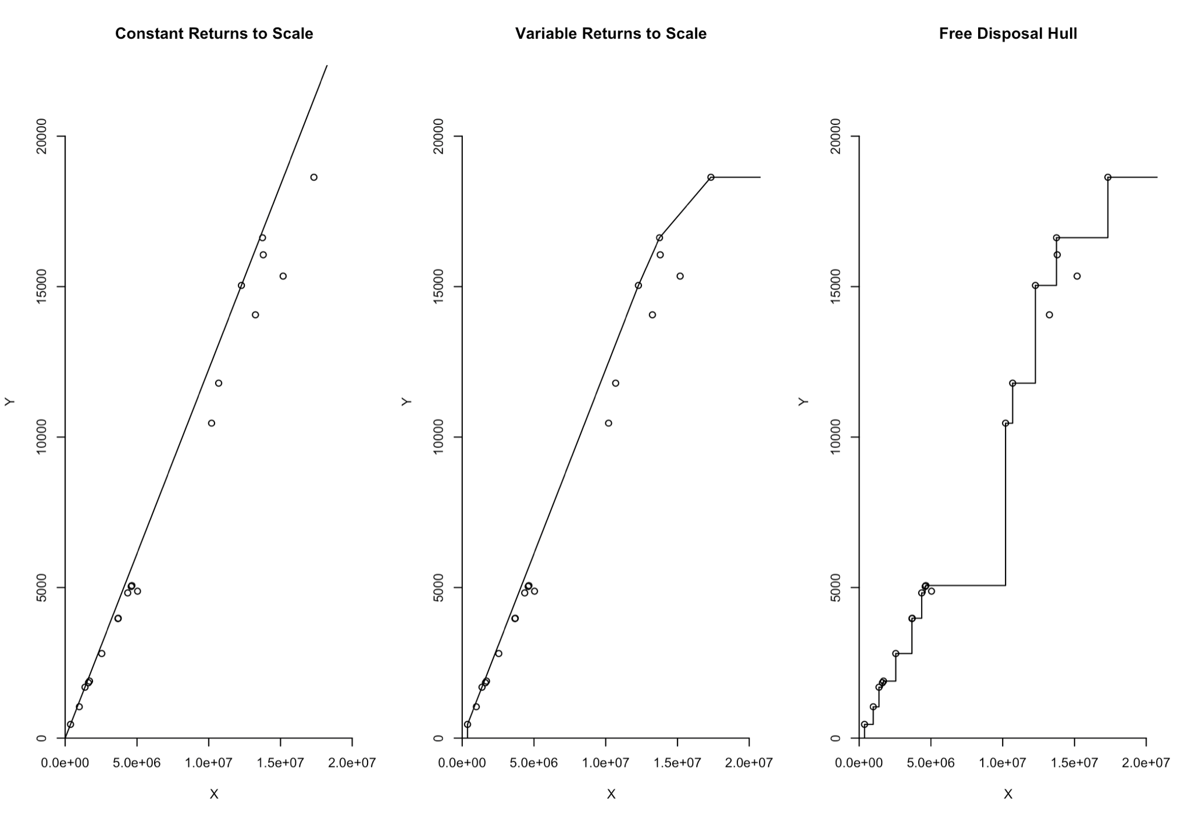

*Figure 13 - resulting graphs from DEA*

What we thought would be extremely interesting to see are the summary statistics on efficiencies for these two distributions:

|  |  |
| --- | --- |
|  |  |

*Figure 14 – summary statistics on efficiencies*

By comparing these summaries we can notice that there is not a big difference between the case with and without Lombardia. Even if Lombardia is an outlier, its efficiency is located between 0.9 and 1. By considering the case with Lombardia, the mean efficiency is slightly higher than the other case. Overall the efficiency is quite high: just 1 region has a smaller efficiency than the rest (between 0.7 and 0.8); 9 regions have an efficiency between 0.8 and 0.9; 7 regions have an efficiency between 0.9 and 1 and there are 4 regions with the maximum score of efficiency.

Finally, we clustered the different regions based on the efficiency score we have computed:

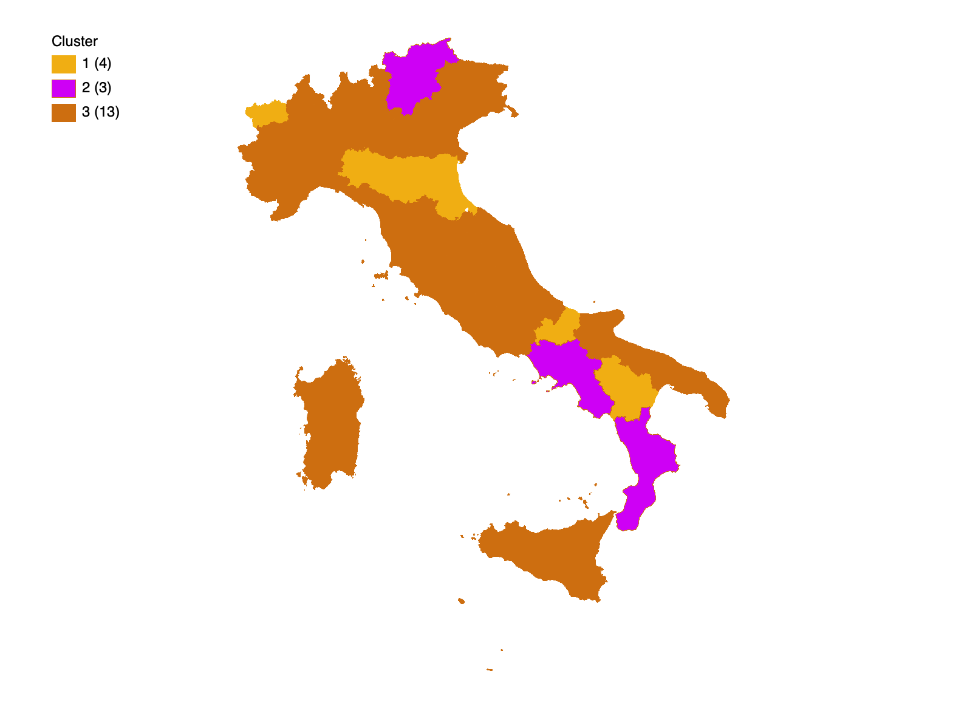

*Figure 15 – Efficiency score in heat map*

As we can see from the map, we have 3 different groups: 2 quite small ( Group 1: Trentino Alto Adige, Campania, Calabria and Group 2: Valle d’Aosta, Emilia Romagna, Molise, Basilicata ) and one ( Group 3 ) that comprises 13 regions spanning indiscriminately from North to South.

It can be interesting to note that, following what has been already described in previous analyses, we can clearly notice how the level of satisfaction is almost not at all correlated with these efficiency scores (which, as we know, are related to investments, population and # beds). Regions like “Calabria” and “Basilicata” that are clustered together respectively with “Trentino Alto Adige” and “Valle d’Aosta” are the same parts of Italy that are at opposite ends of the various satisfaction related comparisons we have shown *(Figure 6 and Figure 7)*.

Again, we can notice that external factors like, most probably, the relationship between patients and nurses are of uttermost importance in order to increase the level of satisfaction. Money and the availability of free beds do not necessarily mean that the population we must serve is at ease with the services we can provide.

# Conclusions

At the beginning of this paper, we clearly stated three questions we were willing to address specifically. Our focus was on stating whether it is true or not that geographical barriers affect satisfaction regarding healthcare services. We were also interested in analyzing relationships between investments and performance, and in assessing the quality of healthcare services.

Through the various analyses we performed, we tried to tackle these questions from different perspectives in order to really understand what we were facing and be able to provide meaningful answers (otherwise all the effort the team has put into developing this project and the effort the reader has done to get to these conclusions would not be repaid). Of course, we decided to focus our research on three specific questions because we thought them to be the most interesting ones to answer, but there are a variety of other possible interrogations one could pose. We are only hoping that our analysis will be the starting point for the answer to those other questions. It is (tacitly) understood that further research on the matter is definitely needed.

The final question we would like to answer is the following: how are the results we obtained both through the exploratory analysis of the datasets (correlation matrix, distribution maps, etc.) and through the more specific analysis we have chosen (the clustering and the data envelopment analysis) useful for the problem we have addressed?

Well, the numerous analyses we have initially performed on our dataset were necessary to understand its distribution and to be able to give valuable insights on the data we gathered, while both the clustering and the DEA were needed in order to inform the reader on some type of “behaviour” we might not at all expect from such data.

The results obtained with our analyses highlight, most surprisingly, that higher efficiency scores do not necessarily imply higher satisfaction levels.

On one hand, the outcomes from the cluster analysis and from the numerous initial descriptions of the dataset point out that the northern regions of Italy present a higher level of satisfaction than the southern ones, but in recent years the latter has reached important levels, improving in a more impactful way. On the other hand, the DEA shows that some regions in the south of Italy are among the most efficient regions (given the declared input and output).

One explanation could be that the satisfaction score is related to many factors that might not be considered in the survey from ISTAT, e.g. human behaviour as well as hygiene, organization and reliability. All of these are variables that are not taken into account when we compute the efficiency score of the healthcare system.

# Appendix

## *Detailed informations about datasets*

*Table 6 - Final dataset about healthcare satisfaction*

|  |  |  |  |  |
| --- | --- | --- | --- | --- |
| **Name** | **Type** | **Description** | **Values (range)** | **Note** |
| ITTER107 | String | Identifier of Territory |  |  |
| Territory | String | It identifies for which territory (zone, region, aggregate) the satisfaction is expressed |  | It can be some aggregate (Italy, different geographical zones or different type of city) or all Italy regions |
| TIPO_DATO_AVQ | String | Aspect for which satisfaction is expressed | * 0_NURS_Q * 0_HFOOD_V * 0_SANFAC_V * 0_MED_CAREV | There are four different types of aspects: Nurses, hygiene. food and medical care aspects. We considered only the nurses aspect |
| MISURA_AVQ | String | Identifier of type of measure of the satisfaction | * THV; * HSC. | THV stays for a thousand values and HSC stays for 100 people with the same characteristics. We considered this last measure to get different values in percentage |
| Measure | String | Type of measure of satisfaction level | * thousands value * per 100 people with the same characteristics |  |
| TIME | String | Year | From 2014 to 2019 |  |
| Value_veryMuch | Integer | percentage value of people that give a higher grade about healthcare satisfaction. | from 0 to 100 | It stays for the highest level of satisfaction |
| Value_quite | integer | percentage value of people that give a good (medium) grade about healthcare satisfaction | from 0 to 100 | It stays for the medium level of satisfaction |
| Value_little-poor | Integer | percentage value of people that give a lower grade about healthcare satisfaction. | from 0 to 100 | It stays for the lower level of satisfaction |
| Hospital_beds | Integer | Number of hospital beds for every region in every year |  |  |
| Healthcare Personnel | Integer | Number of nurses on healthcare structures |  |  |
| Hospitals | Integer | Number of hospitals |  |  |
| Population | integer | Population for every region in a specific year |  |  |

*Table 7 – second dataset about investment on healthcare structures:*

|  |  |  |  |  |
| --- | --- | --- | --- | --- |
| **Name** | **Type** | **Description** | **Values (range)** | **Note** |
| Territory | String | Territory: it identifies for which territory (zone, region, aggregate) the satisfaction is expressed |  | It can be some aggregate (Italy, different geographical zones or different type of city) or all Italy regions |
| TIME | String | Year | From 2014 to 2019 |  |
| Investment | Float | It identifies the investment on healthcare structure in a territory for a specific year |  |  |

## *Variables scanned in Systematic Review*

*Table 8 – variables scanned in “Self-assesed competence among nurses working in municipal health-care services in Norway” paper*

|  |  |  |  |  |  |
| --- | --- | --- | --- | --- | --- |
| **Paper** | **Authors** | **Variables** | | **Number** | **SD(%)** |
| Self-assesed competence among nurses working in municipal  health-care services in Norway | Hovland G., Kyrkjebø D., Andersen J.R., Råholm M.-B. | Age | 25-30 | 12 | 13.5% |
| 31-50 | 57 | 64.0% |
| 51-65 | 20 | 22.5% |
| Sex | Female | 85 | 95.5% |
| Male | 4 | 4.5% |
| Workplace | Home health care | 39 | 43.3% |
| Nursing home | 34 | 38.6% |
| Other | 15 | 17.0% |
| Missing | 1 | 1.1% |
| Work experience | 7 months to 9 years | 20 | 22.5% |
| 10 to 19 years | 30 | 33.7% |
| 21 to 29 years | 24 | 27.0% |
| >30 years | 13 | 14.6% |
| Further education | <30 credits | 14 | 15.7% |
| 30-60 credits | 23 | 25.8% |
| 61-90 credits | 6 | 6.7% |
| >90 credits | 14 | 15.7% |
| None | 28 | 31.5% |

*Table 9 – variables scanned in second paper*

|  |  |  |  |  |  |
| --- | --- | --- | --- | --- | --- |
| **Paper** | **Authors** | **Variables** | | **Number** | **%** |
| A cross-sectional study of the determinants of missed nursing care  in the private sector: Hospital/unit/staff characteristics, professional quality of life and work alienation | (Eskin Bacaksiz F., Alan H., Taskiran Eskici G., Gumus E.) | Age groups | ≤25 years | 662 | 73.8 |
| ≥26 years | 235 | 26.2 |
| Gender | Female | 753 | 83.9 |
| Male | 144 | 16.1 |
| Educational level | Medical vocational high school | 557 | 62.1 |
| Associate degree | 173 | 19.3 |
| Graduate and postgraduate | 167 | 18.6 |
| Tenure in profession | ≤1 year | 206 | 23.0 |
| 2-5 years | 413 | 46.0 |
| ≥6 years | 278 | 31.0 |
| Tenure in hospital | ≤1 year | 363 | 40.5 |
| 2-5 years | 410 | 45.7 |
| ≥6 years | 124 | 13.8 |
| Tenure in unit | ≤1 year | 405 | 45.2 |
| 2-5 years | 388 | 43.3 |
| ≥6 years | 104 | 11.6 |
| Unit | Inpatient units | 490 | 54.6 |
| Intensive care units | 407 | 45.4 |
| Position | Staff | 754 | 84.1 |
| Front-line manager | 143 | 15.9 |
| Work schedule | Shifts | 712 | 79.4 |
| Only daytime | 185 | 20.6 |
| Weekly working time | ≤45 hr | 261 | 29.1 |
| 46-59 hr | 433 | 48.3 |
| ≥60 hr | 203 | 22.6 |
| Overtime work | Yes | 783 | 87.3 |
| No | 114 | 12.7 |
| Overtime work hours | ≤8 hr | 350 | 44.7 |
| ≥9 hr | 433 | 55.3 |
| Nurse/patient ratio | ≤5 patients | 502 | 56.2 |
| 6-10 patients | 370 | 41.4 |
| ≥11 patients | 21 | 2.4 |
| Hospitalization days | ≤7 days | 466 | 55.8 |
| 8-15 days | 170 | 20.4 |
| ≥16 days | 199 | 23.8 |
| Missed care experience | Yes | 262 | 29.2 |
| No | 365 | 70.8 |
| Perception of nurse experience | Not enough | 422 | 47.0 |
| %25 | 139 | 15.5 |
| %50 | 177 | 19.7 |
| %75 | 120 | 13.4 |
| %100 | 39 | 4.3 |

## *Systematic review*

*Abstract*

**AIM:** The aim of this systematic review is to identify the factors through which we can assess the quality of healthcare assistants and how this reflects on the hospitals.

**BACKGROUND:** The worldwide health condition prompted us to analyze the importance of the quality of nurses and how much patients are satisfied with it.

**METHOD:** Relevant articles were found using the literature database SCOPUS. A systematic review, based on the PRISMA Model, was conducted. We visualized the main features thanks to VOSViewer software.   
**RESULTS:** Three main themes were identified: *the importance of relationships*, *where does quality come from*, *both patients and nurses satisfaction*.

**CONCLUSIONS:** Research provided insight on the main aspects in order to improve the quality of hospitals.

*Introduction*

As the COVID-19 induced world pandemic continues, hospitals and healthcare professionals struggle to keep up with the increasing difficulties posed by the ongoing situation. This systematic review presents itself as an analysis of how hospitals and healthcare professionals adjourned and evolved themselves from 2018 to today in order to observe the main factors that influence the quality and the social impact of healthcare professionals. Hospitals are definitely a perfect framework of analysis where the general performance is directly connected to the performance of each human being working in it.

The reason why we worked on such a topic is that we wanted to research the positive impact that nurses do have on patients and on their recovery. We decided to focus on the time period between 2018 and nowadays and to consider only the more developed countries (like United States, Canada, European countries, etc.) to have a similar framework of hospital structures and nurses education.

*Method*

*Design*

This systematic review is based on the totality of information gained during the course of Quantitative Models for Economic Analysis and Management held at Sapienza University of Rome (Data Science MSc) by Cinzia Daraio (A.Y. 2020-2021):

1. Provided slides specifically on how to structure a systematic review;
2. Seminar of the 08 April 2021 held by Thyago C. Nepomuceno “Methodological Tools For Network and Mapping of Bibliometric Landscapes”;
3. Seminar of the 15 April 2021 held by Simone Di Leo “PRISMA Model In Action - Systematic review of university performance using intellectual capital”;

*Literature Search*

The literature search was conducted on SCOPUS using the following query:

TITLE-ABS-KEY( (hospital*) OR (clinic) )

AND TITLE-ABS-KEY ( (assess* AND qualit*) AND (human AND action) )

AND TITLE-ABS-KEY ( (perform*) OR (reliabilit*) OR (value*) OR (suppl*)

OR (facilit*) OR (fornitur*) OR (innovat*) OR (research*)

OR (universit*) OR (surger*) )

AND PUBYEAR > 2017 AND ( LIMIT-TO ( LANGUAGE, “ENGLISH”) )

Let us see some statistics on the 649 articles we retrieved from scopus.com:

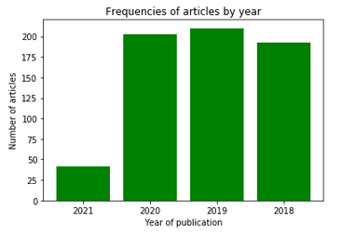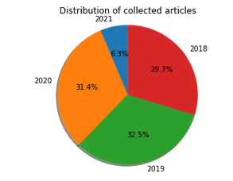

It can be clearly seen that the number of the articles published per year is evenly distributed between 2018 - 2021, while (quite obviously given that we are writing this systematic review in April 2021) the articles dated 2021 are a minority.

We then use VOSviewer to analyse some interesting characteristics.

Given that we decided to focus our analysis on more developed countries, we thought it would be interesting to see the geographical distribution using the following parameters:

* type of analysis: co-authorship
* unit of analysis: countries
* counting method: fractional counting
* max_number_countries = 25
* min_number_documents = 5

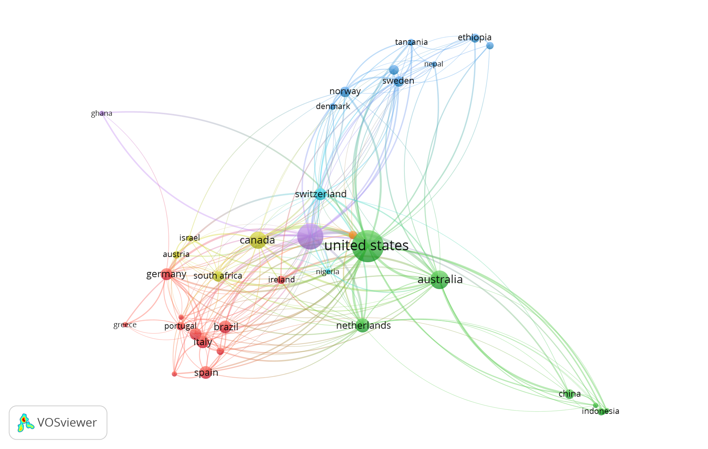

Furthermore, we decided the analyse the keywords in the 649 retrieved articles using the following parameters:

* type of analysis co-occurrence
* unit of analysis: author keywords
* counting method: fractional counting
* min_number_occurrences_keyword = 5

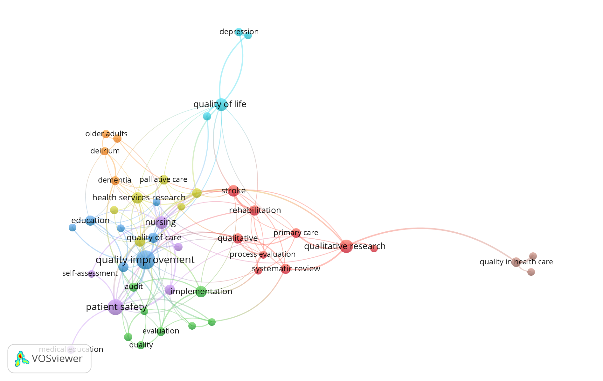

After having deeply analysed the structure of the relationship between the given keywords, the participants decided to give a more specific focus to the systematic review. In fact, we decided to prioritize aspects like “nursing”, “quality improvement”, “patient-safety”.

We will better see in the chapter on eligibility criteria the specific considerations we made to decide whether a paper is or is not eligible for the purpose of this systematic review.

As anticipated, our review will focus on developed countries. The following is a graph showing the relationship between the countries that were considered developed countries. This decision was based on “The 2019 Human Development Report by the United Nations Development Programme” which was released on 9 December 2019 and calculates HDI (Human Development Index) values based on estimates for 2018.

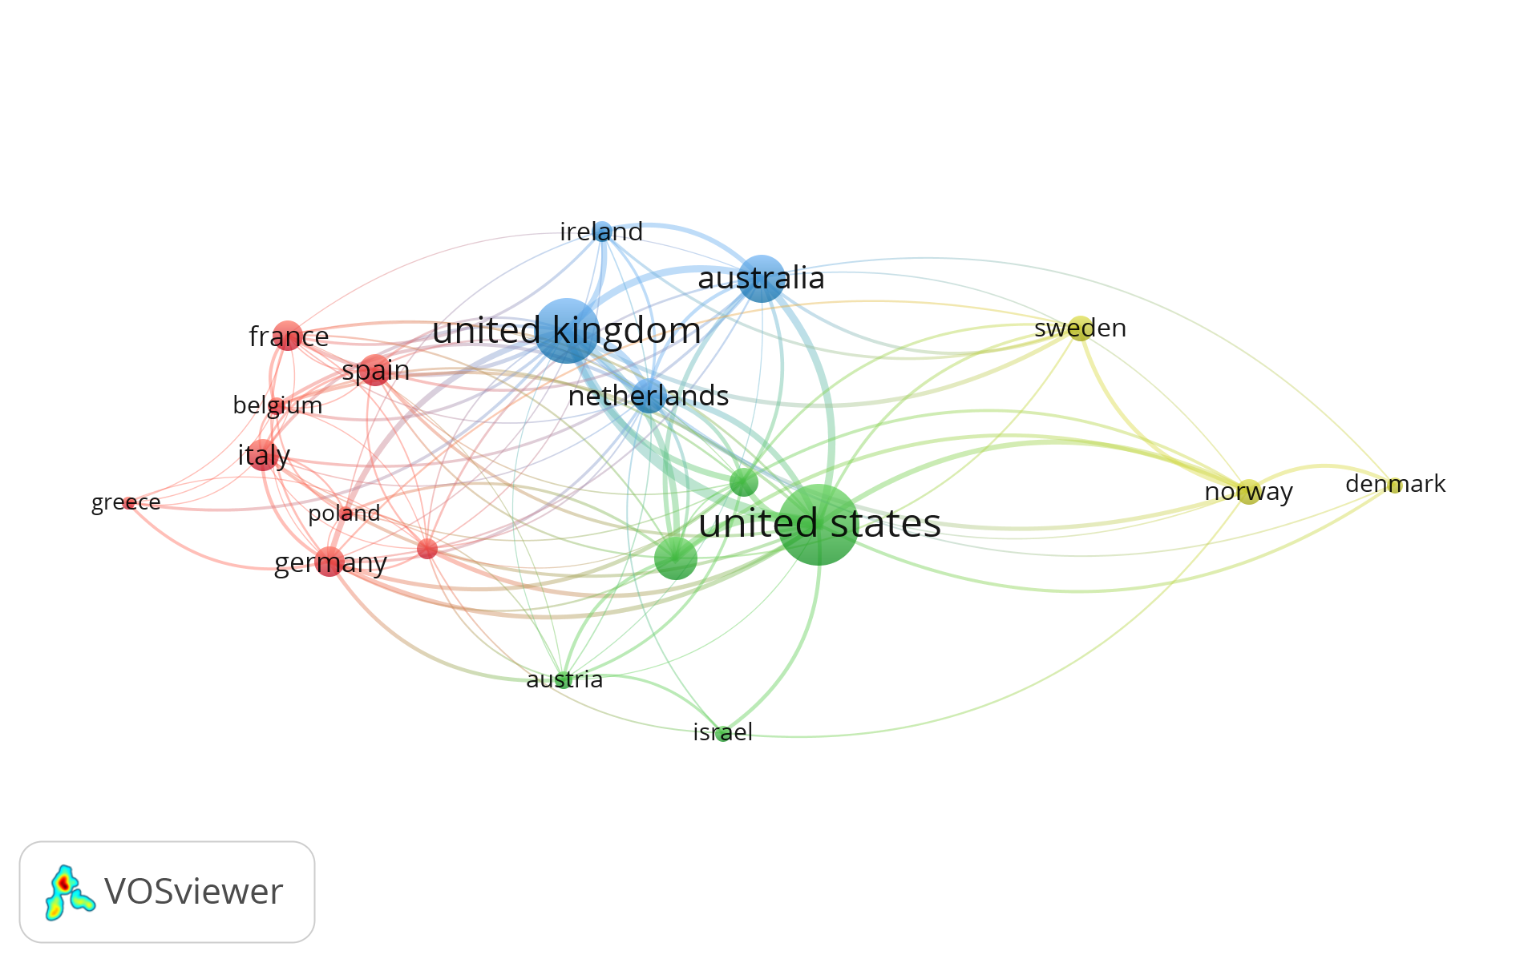

We are going to consider 20 countries that can be clustered into 4 clusters. It is interesting to notice how the United States and the United Kingdom are the most relevant and more strongly related nodes in the graph.

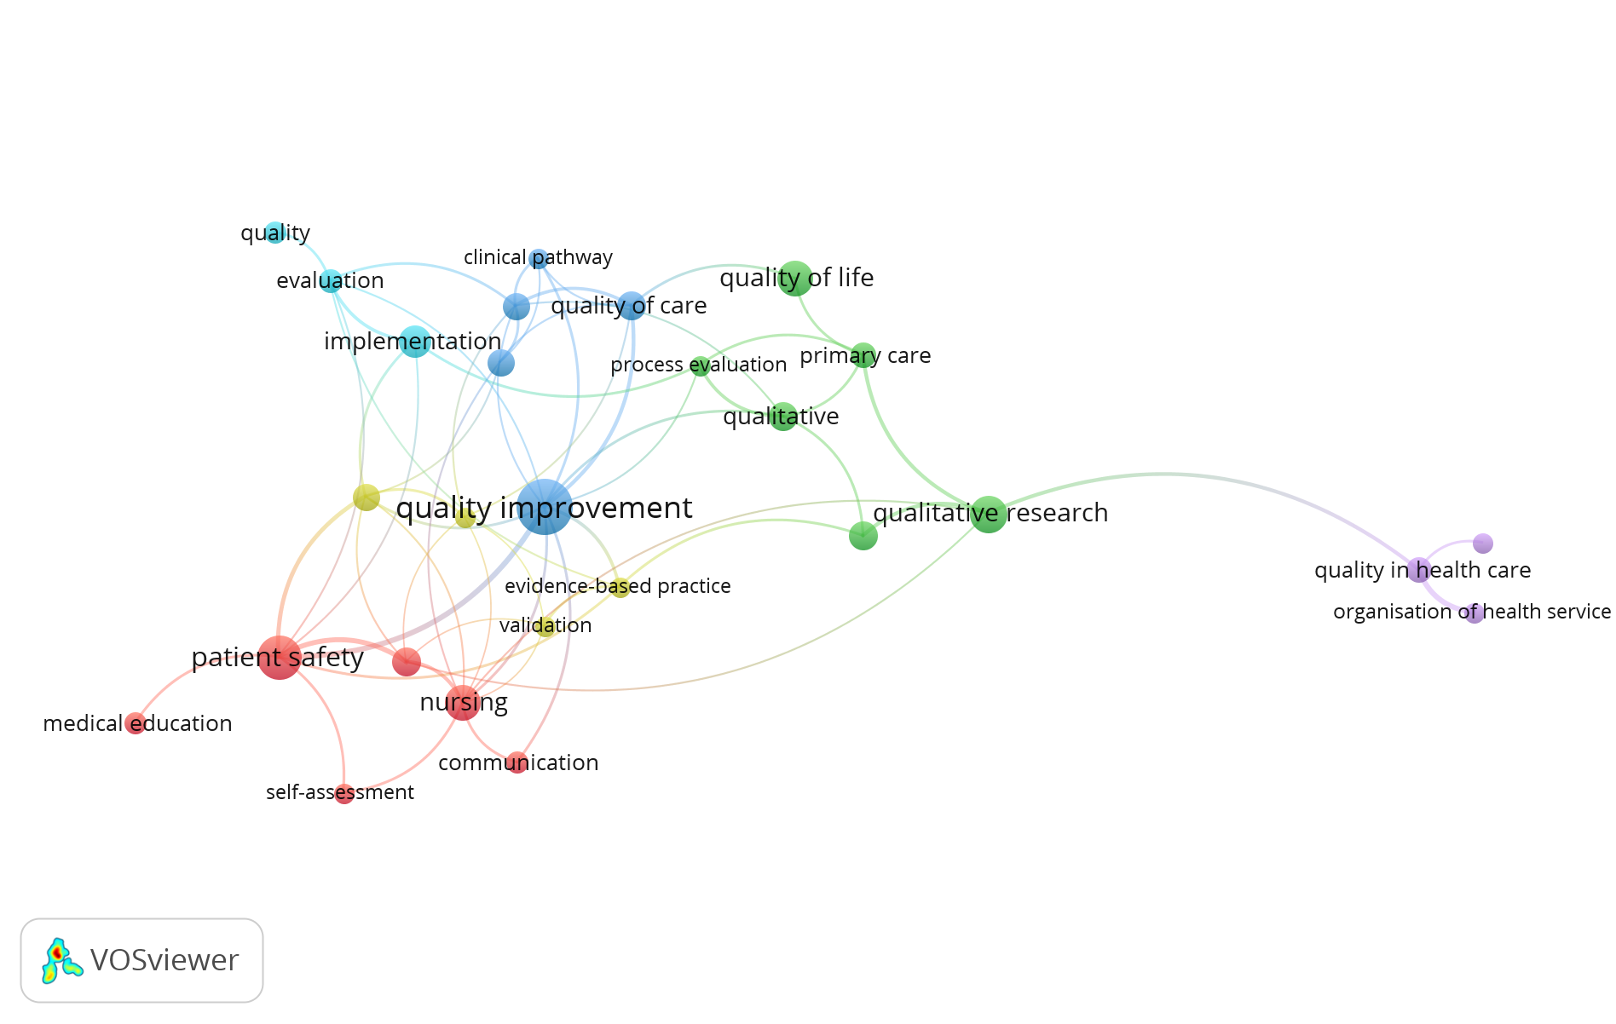

This graph highlights the keywords we are going to take into account due to the fact that they do possess the qualifying criteria to be considered in the systematic review.

*Search Outcome*

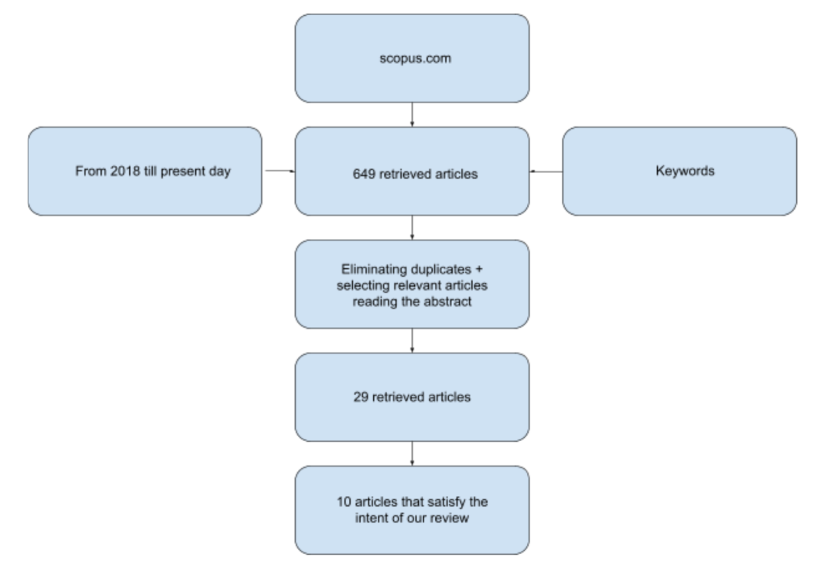

The initially retrieved articles were 649. We then used Raynann to select all those articles that presented either in the title or in the abstract the selected keywords and that were relevant to the topic. Each paper needed to be labelled giving both reasons for the inclusion and the exclusion. Notice that we decided to focus only on those articles that were relevant to more developed countries. This decision was supported by the whole group because we believe that considering the quality of healthcare provided in both third-world countries and in rapidly emerging countries would have needed a different study design because they are not comparable to hospitals in developed countries.

This type of selection was made in a collaborative manner by dividing equally the workload between the team members (around 160 articles each). Once everyone had read the assigned papers, each one of us reviewed (1) the ones that were classified as a “maybe”, (2) the ones that were classified as ”relevant” from one of the team members. At the end of this process, the returned pool of papers counted 29 articles. All the abstracts of the considered essays were then read by at least one member to check that the content of the articles was not equal or similar.

*Eligibility criteria*

The following are the eligibility criteria the participants used to determine whether an article is qualified to be included in the systematic review. In order to assess their eligibility, each one of the 29 articles has been read and discussed by the entire group.

Some of the papers had as main topic how nurses dealt with specific diseases or patients with particular conditions. We decided to not consider them as they were too specifically inherent to such diseases and therefore not coherent with our aim. Other papers were found to reference either countries that we did not include in our analysis (but it was not explicitly declared in the abstract) or that they focused on a population coming from such countries. Just one paper was not eligible because it did not present any results and was just an introduction to a specific framework of analysis that the authors would like to assess in the near future.

The PRISMA Flow Diagram we can find on this page summarizes the most important steps that were undertaken in order to decide the articles that needed to be included in the systematic review.

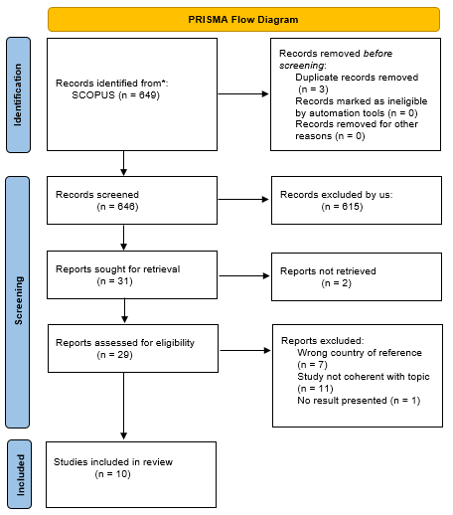

*Table of Included Studies*

This table does contain the most important information about the articles that have met the eligibility criteria set by the group.

|  |  |  |  |  |  |  |
| --- | --- | --- | --- | --- | --- | --- |
| **Articles** | **Author(s) (year) and location** | **Aim** | **Type of article** | **Methodology** | **Sample size** | **Findings** |
| **#1** | Pleh D.N., Rosted E., Thomsen T.G.  (2021), Denmark | Identify key competence of outpatients nurses as perceived by patients | Systematic review | Integrative review inspired by Whittermore and Knafl's methodology. |  | Main key competences found were providing access, sharing knowledge and establishing relationships. |
| **#2** | Eskin Bacaksiz F., Alan H., Taskiran Eskici G., Gumus E.  *(2020), Turkey* | To analyze missed nursing care in a sample of private hospitals. | Paper | Survey coming from 897 nurses. | 897 | Measurements of the missed nursing care statistically differed in terms of nurses’ gender, weekly work hours, overtime work and perception of nurse adequacy, and the hospital's accreditation status. |
| **#3** | Stotts J.R., Lyndon A., Chan G.K., Bekmezian A., Rehm R.S.  *(2020)* | The purpose of this integrative review was to synthesize the findings of studies that examined factors that influence in-hospital pediatric nurses in non-ICU environments when confronted by clinical deterioration. | Systematic review | A search of the CINAHL, PubMed, and Web of Science databases was conducted in January 2019 by JRS for English-language research published up to December 31, 2018 that was filtered for human and child, birth to 18 years |  | All of the studies reviewed used non-experimental designs. Six themes associated with the aims of this research were derived through iterative and constant comparison: Assessing and documenting, Decision making, Communicating changes in patient conditions, Intervening, Relationships between team members, Parents as partners in surveillance. |
| **#4** | Fassarella C.S., da Silva L.D., Camerini F.G., Barbieri-Figueiredo M.D.C.  *(2019), Portugal* | Evaluate the organizational safety culture of a Portuguese university hospital on the basis of nurses’ perceptions | Paper | Survey on Patient Safety Culture instrument | 567 | Teamwork between units and supervisor expectations and actions promoting patient safety lead to better;  Manager should aim to a safety culture based on transparency, trust, organizational learning and communication of errors instead of a punitive culture |
| **#5** | Colldén Benneck J., Bremer A  *(2019), Sweden* | To explore registered nurses' experiences and behaviours associated with near misses where patient safety in the ambulance service was jeopardized | Paper | Based on critical incident technique, a retrospective and descriptive design with individual qualitative interviews was used. |  | Seventy-three critical incidents of near misses constituted four main areas: Drug management; Human-technology interactions; Assessment and care and Patient protection actions |
| **#6** | Barbara King, Kristen Pecanac, Anna Krupp, Daniel Liebzeit, Jane Mahoney  *(2018), Wisconsin US* | Explore nurses' experience with fall prevention and impact of those experiences on how nurses provide care to fall risk patients (zero falls). | Paper | Grounded Dimensional Analysis, 22 interviews, focus group (5) | 22 | Restricting fall risk patients as a way to stop messages and meet the hospital goal |
| **#7** | Gro Hovland, Dagrun Kyrkjebo, John roger Andersen, Maj Britt Raholm  *(2018), West part of Norway* | Nursing competence in Norway | Paper | Norwegian version of the Nurse Competence Scale (NCS) instrument, describes the quality of action on this scale with values 0-25, 26-50, 51-75, 76-100 low, moderate, good and very good quality. | 89 | Competence is situationally and socially related, with educational level |
| **#8** | Janet Phillips, Ann Stalter, Sherri Winegardner, Carol Wiggs, Amy Jauch  *(2018), USA* | *What ST evidence fosters the effect of workplace civility in practice settings?* | Systematic review | Five stage method (Whittemore and Knafl) |  | Five categories emerged revealing themes surrounding incivility in practice. The categories include (1) general incivility, (2) workplace incivility, (3) incivility in nursing practice, (4) suggestions to improve civility for nurses in practice, and (5) systems/ST and incivility in nursing practice. |
| **#9** | Patricia S. Groves | Jacinda L. Bunch  *(2018), Iowa* | The aim of this paper is discussion of a new middle‐range theory of patient safety goal priming via safety culture communication. | Paper | Discussion |  | Given the complex healthcare environment, continual staffing challenges, and limited fiscal resources of healthcare organizations, hospitals must be open to new methods of promoting patient safety and increasing the quality of healthcare encounters. |
| **#10** | Sarah Sims, mary Leamy,Nigel Davies, Katy Schnitzler, Ros Levenson, Felicity mayer, Robert Grant, Sally Brearley, Stephen Gourlay, Fiona Ross,6 Ruth Harris1  *(2018), UK* | Synthesis of the evidence on IR to develop IR programme theories of what works better | Systematic review | A three-stage literature search and a stakeholder consultation event was completed. |  | The synthesis identified a number of discrepan- cies between how IR is purported to work and how it operates in practice, as well as international differ- ences in how the intervention has been implemented. |

*Results*

Given the focus of our systematic review, ten papers met the declared eligibility criteria. Five studies were systematic reviews, three were cross-sectional studies, all using interviews and surveys for data collection, and finally, we had a GDA (Grounded Dimensional Analysis) and a discussion paper. Due to the fact that we decided to consider just developed countries, all the studies we analyzed were conducted in European countries (Norway, Sweden, Denmark, Portugal, Italy), UK, Turkey, Canada, the US, Australia. In the table of included studies, we summarized all the main information about the papers taken into account.

In this systematic review, three main themes were found: *the importance of relationships*, *where does quality come from*, *both patients and nurses satisfaction*. All these arguments are strongly related to both the topic of human action and the assessment of quality.

The included papers highlighted how much the relationship between patients and nurses is important to improve quality in caregiving and in the outcome of patients. We could see this focus both from the patients and the nurses perspective.   
However, relationships should also be established between nurses and hospital staff. The former has to meet the hospital’s goal, and this is not always so simple from the nurses’ point of view. The key point in this theme is that there has to be a very good communication between the hospital staff and nurses in order to ensure high quality, patient satisfaction and not too much stress for healthcare providers.

The papers also focus on where quality comes from. This theme is present in almost all the studies we have considered to be eligible and is linked with the topics of competences, “civility”, the feeling at ease of nurses. Competences not only come from the educational level, but also from the teamwork between units and supervisors and on the fact that there should be a safety culture based on trust, organizational learning and communication of errors instead of a punitive culture (Fassarella C.S., da Silva L.D., Camerini F.G., Barbieri-Figueiredo M.D.C., 2019).

These two main topics are strongly related to each other and they conduct to both patients and nurses satisfaction. In a non-stressful situation, nurses work better and improve health care safety and high-quality performances which can lead to good outcomes for patients.

*Discussion*

The aim of this analysis was to show how hospitals and healthcare professionals adjourned and evolved themselves from 2018 to today in order to observe the main factors that influence the quality and the social impact of healthcare professionals.

*Common points*

The three main highlighted themes identify the importance of competences both as a personal ability to perform well and as the result of cooperation between hospital staff and nurses. Common to all papers was that not only the quantitative data was important but also the environmental variables had a strong impact on health care professionals and on their performance.

Another aspect that has been emphasized by all studies is the fact that one of the most important key points is communication. Communication both between nurses and patients and nurses and hospital staff is fundamental as this idea leads to a quality improvement in nurses' jobs. We can observe that this aspect has been stressed by all eligible papers even if the geographical and social context the original analysis was performed in differs.

*Differences*

While the papers we analysed for this systematic review mostly concern themselves with surveys handed to nurses, where the focus was to assess their satisfaction with hospital policies and how working in a safe environment affects their work, in some of the systematic reviews we do consider (Pleh D.N., Rosted E., Thomsen T.G., 2021), surveys were addressed to patients in order to assess the quality of their healthcare providers.

Moreover, the aim of the analysis conducted might differ between different papers. Some of the articles analyze technical aspects of nurses’ daily work which could improve their efficiency, optimizing aspects like the roundings and surveillance measures, while others do focus on interpersonal relationships between nurses and hospital staff or between nurses and patients.

*Limitations of our study*

Our choices of including only very recent studies (from 2018 to 2021) and the geographical limitations we imposed, may have affected our analysis. It is not ensured that developed countries, even if they have very similar health systems, have a higher quality than less developed countries.

Furthermore, cultural and social phenomena may influence the health care that a country provides, also in the cluster of developed countries.

*Conclusions*

This systematic review is a qualitative analysis. We can clearly infer that communication is a fundamental aspect in a hospital framework to better both the performances and the social impact of nurses, but it is not clear how communication should be implemented.

The participants have found interesting the fact that academic education of healthcare professionals was only considered in one of the articles while they do believe that it is an important aspect that might positively influence the quality assessment.

Furthermore, we are aware that, given the limitations we imposed, we might not have considered many features that could be relevant to the purpose of this systematic review.

Further research is needed to better understand this topic and to assess how to effectively improve the quality and the performances of healthcare providers. It would also be interesting to actually consider what we have categorized as “less developed countries” and actually see how they do perform on the topics this systematic review is centred on.

# Bibliographic References

*[0] ISTAT (National Institute of Statistics) website:*

[*http://dati.istat.it*](http://dati.istat.it)

*[1] Satisfaction Dataset:*

[*http://dati.istat.it/Index.aspx?lang=en&SubSessionId=1afcaafb-c045-4444-b2a7-f5b833f937ef*](http://dati.istat.it/Index.aspx?lang=en&SubSessionId=1afcaafb-c045-4444-b2a7-f5b833f937ef)

*[2] Population Dataset:*

[*http://dati.istat.it/Index.aspx?lang=en&SubSessionId=33d90912-3e16-4020-be5b-a9da7ac2735c*](http://dati.istat.it/Index.aspx?lang=en&SubSessionId=33d90912-3e16-4020-be5b-a9da7ac2735c)

*[3] Number of Hospitals Dataset:*

*<http://dati.istat.it/Index.aspx?lang=en&SubSessionId=22147533-4e06-4b8c-8d1a-d7506f40701d>*

*[4] Healthcare personnel Dataset:*

*<http://dati.istat.it/Index.aspx?lang=en&SubSessionId=bf29824c-02d7-4178-835f-f46139870089>*

*[5] Bed hospitals Dataset:*

[*http://dati.istat.it/Index.aspx?lang=en&SubSessionId=c3e021f6-c3fc-464e-9894-e9a8156e23cc*](http://dati.istat.it/Index.aspx?lang=en&SubSessionId=c3e021f6-c3fc-464e-9894-e9a8156e23cc)

*[6] Investment Dataset:*

[*https://www.agenziacoesione.gov.it/wp-content/uploads/2020/09/CPT_Informa_Sanitax.pdf*](https://www.agenziacoesione.gov.it/wp-content/uploads/2020/09/CPT_Informa_Sanitax.pdf)

*[7] Repository Github:*

[*https://github.com/AlessandroTaglieri/QME_project*](https://github.com/AlessandroTaglieri/QME_project)

*[8] Newspaper articles read:*

[*https://www.repubblica.it/salute/medicina-e-ricerca/2019/10/26/news/sanita_ecco_la_classifica_delle_regioni_veneto_al_top-239523688/*](https://www.repubblica.it/salute/medicina-e-ricerca/2019/10/26/news/sanita_ecco_la_classifica_delle_regioni_veneto_al_top-239523688/)

[*https://www.agi.it/salute/ecco_dove_funziona_la_sanit_italiana-1346614/news/2017-01-04/*](https://www.agi.it/salute/ecco_dove_funziona_la_sanit_italiana-1346614/news/2017-01-04/)

[*http://www.quotidianosanita.it/studi-e-analisi/articolo.php?articolo_id=13993*](http://www.quotidianosanita.it/studi-e-analisi/articolo.php?articolo_id=13993)

Systematic review references:

(Pleh D.N., Rosted E., Thomsen T.G.) *Key competences of outpatient nurses, as perceived by patients attending nurse-led clinics – An integrative review;* 2021

(Eskin Bacaksiz F., Alan H., Taskiran Eskici G., Gumus E.) *A cross-sectional study of the determinants of missed nursing care in the private sector: Hospital/unit/staff characteristics, professional quality of life and work alienation;* 2020

(Subramani S. ) *The Social Construction of Incompetency: Moving Beyond Embedded Paternalism Toward the Practice of Respect;* 2020

(Geerligs L., Shepherd H.L., Rankin N.M., Masya L., Shaw J.M., Price M.A., Dhillon H., Dolan C., Prest G., Andrews G., Baychek K., Beale P., Allison K., Clayton J., Coll J., Cuddy J., Girgis A., Grimison P., Hack T., Kelly B., Kirsten L., Lindsay T., Lovell M., Luckett T., Murphy M., Newby J., Orr F., Pearce A., Piro D., Shaw T., Stubbs J., Viney R., White F., Yim J., Butow P.) *The value of real-world testing: A qualitative feasibility study to explore staff and organisational barriers and strategies to support implementation of a clinical pathway for the management of anxiety and depression in adult cancer patients;* 2020

(Liou S.-R., Liu H.-C., Tsai S.-L., Chu T.-P., Cheng C.-Y.) *Performance competence of pregraduate nursing students and hospital nurses: A comparison study;* 2020

(Fowler S.B.) *Critical-care nurses' perceptions of hope: Original qualitative research;* 2020

(Bakhtiari S., Rakhshan M., Shahriari M., Sharif F.) *Perspective and experience of operating room personnel on ethical behaviours;* 2020

(Stotts J.R., Lyndon A., Chan G.K., Bekmezian A., Rehm R.S.) *Nursing surveillance for deterioration in pediatric patients: An integrative review;* 2020

(Quaye A.A., Coyne I., Söderbäck M., Hallström I.K.) *Children's active participation in decision-making processes during hospitalisation: An observational study;* 2019

(Kakemam E., Kalhor R., Khakdel Z., Khezri A., West S., Visentin D., Cleary M.) *Occupational stress and cognitive failure of nurses and associations with self-reported adverse events: A national cross-sectional survey [护士的职业压力和认知障碍以及与自我报告不良事件的关系:一项全国性的横断面调查];* 2019

(Colldén Benneck J., Bremer A.) *Registered nurses’ experiences of near misses in ambulance care – A critical incident technique study;* 2019

( Manoppo I.A., Banna T.) *The completeness of nursing care documentation in Fakfak hospital;* 2019

(Maessen K., van Vught A., Gerritsen D.L., Lovink M.H., Vermeulen H., Persoon A.) *Development and Validation of the Dutch EBPAS-ve and EBPQ-ve for Nursing Assistants and Nurses with a Vocational Education;* 2019

(Ratsch A., Sewell F., Pennington A.) *Developing and testing a matrix to achieve ready-everyday nursing standards (RENS): An observational study protocol;* 2019

(Wood C., Chaboyer W., Carr P.) *How do nurses use early warning scoring systems to detect and act on patient deterioration to ensure patient safety? A scoping review;* 2019

( Birgand G., Haudebourg T., Grammatico-Guillon L., Ferrand L., Moret L., Gouin F., Mauduit N., Leux C., Le Manach Y., Lepelletier D., Tavernier E., Lucet J.-C., Giraudeau B.) *Improvement in staff behaviour during surgical procedures to prevent post-operative complications (ARIBO2): Study protocol for a cluster randomised trial;* 2019

(Been-Dahmen J.M.J., Beck D.K., Peeters M.A.C., Van Der Stege H., Tielen M., Van Buren M.C., Ista E., Van Staa A., Massey E.K.) *Evaluating the feasibility of a nurse-led self-management support intervention for kidney transplant recipients: A pilot study;* 2019

(Patrone C., Cassettari L., Giovannini F., Cremonesi P., Cevasco I.) *Study and implementation of a performance set of indicators for the nurse manager in a frailty hospital;* 2019

(Fassarella C.S., da Silva L.D., Camerini F.G., Barbieri-Figueiredo M.D.C.) *Organizational indicator of safety culture in a university hospital [Indicador organizacional da cultura de segurança em um hospital universitário] [Indicador organizacional de la cultura de seguridad en un hospital universitario];* 2019

(Drach-Zahavy A., Leonenko M., Srulovici E.) *Towards a measure of accountability in nursing: A three-stage validation study [实现护理责任的衡量标准:分三阶段验证研究];* 2018

(Groves P.S., Bunch J.L.) *Priming patient safety: A middle-range theory of safety goal priming via safety culture communication;* 2018

(Kouatly I.A., Nassar N., Nizam M., Badr L.K.) *Evidence on Nurse Staffing Ratios and Patient Outcomes in a Low-Income Country: Implications for Future Research and Practice;* 2018

(Sims S., Leamy M., Davies N., Schnitzler K., Levenson R., Mayer F., Grant R., Brearley S., Gourlay S., Ross F., Harris R.) *Realist synthesis of intentional rounding in hospital wards: Exploring the evidence of what works, for whom, in what circumstances and why;* 2018

(Travers C., Henderson A., Graham F., Beattie E.) *CogChamps: Impact of a project to educate nurses about delirium and improve the quality of care for hospitalized patients with cognitive impairment;* 2018

(Bloodworth L.C., Parenti K., Fralix J., Smith M.) *Using Quality Measures for Performance Improvement in the Skilled Nursing Facility/Long-Term Care Setting;* 2018

(Phillips J.M., Stalter A.M., Winegardner S., Wiggs C., Jauch A.) *Systems thinking and incivility in nursing practice: An integrative review;* 2018

(Hovland G., Kyrkjebø D., Andersen J.R., Råholm M.-B.) *Self-assessed competence among nurses working in municipal health-care services in Norway;* 2018

(Mohanaruban A., Flanders L., Rees H.) *Case-based discussion: perceptions of feedback;* 2018

(King B., Pecanac K., Krupp A., Liebzeit D., Mahoney J.) *Impact of Fall Prevention on Nurses and Care of Fall Risk Patients;* 2018

(Parsons K., Gaudine A., Swab M.) *Older nurses' experiences of providing direct care in hospital nursing units: a qualitative systematic review;* 2018

Page MJ, McKenzie JE, Bossuyt PM, Boutron I, Hoffmann TC, Mulrow CD, et al. The PRISMA 2020 statement: an updated guideline for reporting systematic reviews. BMJ 2021;372:n71. doi: 10.1136/bmj.n71

https://www.repubblica.it/salute/medicina-e-ricerca/2019/10/26/news/sanita_ecco_la_classifica_delle_regioni_veneto_al_top-239523688/

https://www.agi.it/salute/ecco_dove_funziona_la_sanit_italiana-1346614/news/2017-01-04/

http://www.quotidianosanita.it/studi-e-analisi/articolo.php?articolo_id=13993