**A Few Good Hits in Pittsburgh**

*Written by Zilio Alessandro*

Most markets follow the concept of equilibrium between demand and offer.

This is something you learn in Economics I as soon as you enter university, and that you already grasped if you tried to look for a particular pair of shoes, baseball cap or that evasive rookie Mickey Mantle card just to find out that their price is between two bucks too much and some million dollars too much.

That’s how it works though: if you have a rare commodity, that nobody has and everybody wants, you are bound to be heavily paid for it, and that’s how baseball works too.

Think about Mike Trout: every single franchise would love to have the future GOAT rostered but only the Angels can, making him extremely valuable, so much that he has no actual trade value as it goes far beyond human imagination.

What the 2020 free agent market doesn’t lack for a chance is outfielders of the lefty-swinging variety: to the group headed by former Astro Michael Brantley the nontender deadline recently contributed to add another trio of lefty corner bats in former “Cubs legend” Kyle Schwarber, eternal star to-be Nomar Mazara and inside pitch hitting machine Eddie Rosario.

Therefore a team in need of a left/right fielder that can hit righties shouldn’t have trouble choosing, and at good deals likely: both Schwarber and Rosario were nontendered on projected salaries around $9M, even less than that for Mazara, and while pandemic and whatnot are leading many teams to payroll cuts, see the Reds shipping away their closer for peanuts, there’s also to say that maybe the reason those players were let go has to do with how they performed in 2020:

*Figure 1: 2020 statistics, left-swinging free agent outfielders*

As you can see, apart from Brantley, every other batter had some issues: Rosario put the ball in the air more than the others and at a good launch angle but he lacked punch and couldn’t compensate for it with contact as Brantley; Schwarber hit the ball hard and barreled at a good rate but he grounded too many balls and run on a fairy-tale like HR/FB% that screams regression; Mazara….just more of his usual hard groundballs and light-hitting infielder-like LA, a trait that has hit his shares hard in the last couple of seasons.

You may wonder about the variety of chosen statistics, and for good reason as there’s a little bit of everything but the focus lies on hard contact: where am I going? Look at this line and you’ll get it:



This is the definition of a mixed bag: X hits the ball in the air more than Rosario, leads the group in EV, LA, Barrel% and HardHit%, maximizes his contact spectrum avoiding the soft part better than anyone while displaying Brantley’s ISO and Rosario’s HR/FB ratio all adding to get…one of the worst qualified batters in the 2020 shortened season as per a horrid -0.7 WAR!

If you got the hint from the title it shouldn’t be hard to guess who X is: he plays for the Pirates, he patrols the outfield and wields his bat lefty, the owner of a last percentile 2020 WAR is none other than El Cafè, **Gregory Polanco**.

You are excused if you didn’t know Polanco was that bad in 2020, nobody but Pirates fans knew anyway as the team went out of contention quickly and resorted to yet another mediocre season, one too many after Andrew McCutchen’s departure and the owner’s decision to spend as little as possible, not to mention that Archer trade…these are not good times for Pittsburgh baseball to say the least.

What you may remember Polanco as is a good RF with light tower power and some strikeout issues and so did I, because that’s who he was not so far back in time:

*Figure 2: Gregory Polanco’s statline, 2018 to 2020*

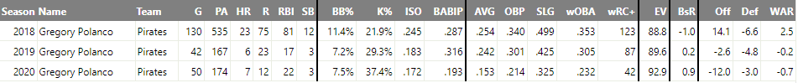

In his last full season Polanco was pretty solid, walking at more than a 10% clip while mashing for power without getting too many K’s and delivering a solid contribution, 23% better than league average, slightly hindered by defensive shortcomings.

His problems started early in 2019 when he went first to the 10-day DL and then to the 60-day DL for left shoulder issues that cut his season short and came back biting him in 2020 for yet another small stint on the disabled list.

So that’s it right?! Guy gets hurt, comes back but maybe too soon and his performance pays the price…but is it? Not on this case I’m afraid: in 2019’s cup of coffee, pardon, and 2020 pandemic season he actually seemed fine, raising his EV of 4 mph while showing some improvements both on the defensive side and on the bases, so what is Polanco’s issue?

Yes, when he hits the ball it’s hard contact and barrels but…he just doesn’t hit the ball!

*Figure 3: Gregory Polanco’s swing and contact profiles and tendencies, 2018 to 2020*

To summarize the plate (in)discipline of Polanco: he swung more than ever but less on pitches in the zone and more on offerings outside the strike zone; moreover while doing so he proceeded to post the *second worst* Contact% in the league (min 80 PAs) behind the sole Bobby Dalbec, *fifth worst* Z-Contact% although a “mere” outside top 20 O-Contact%. For good measure, he saw the *11th lowest* amount of pitches in the zone and answered with a *fourth* position in the SwStr% category.

Put everything together and you’ll get why Polanco’s -0.7 WAR was *eight worst* in the league along with Michael Chavis, Eric Thames and Justin Smoak: swing more, hit less and miss more both on balls and strikes is taking the recipe for success and doing the exact opposite of what’s written.

Why did El Cafè miss so many pitches? Rather, what was his kryptonite?

*Figure 4: Gregory Polanco’s value per pitch type, 2018 to 2020*

As everyone would have thought, it’s the fastball: Polanco saw an average rate of average speed fastballs with respect to league averages, around 53% four-seamers at a 93.3 mph, and he was the ABSOLUTE WORST HITTER on heaters as per pitch value while also setting *eight worst* in the slider department. So, he was despicable on straight gas and wrinkles alike, but where was he challenged? Where are his swing’s holes?

*Figure 5: Gregory Polanco’s Swing%, Contact% and ISO/p on FBs, 2020 season*

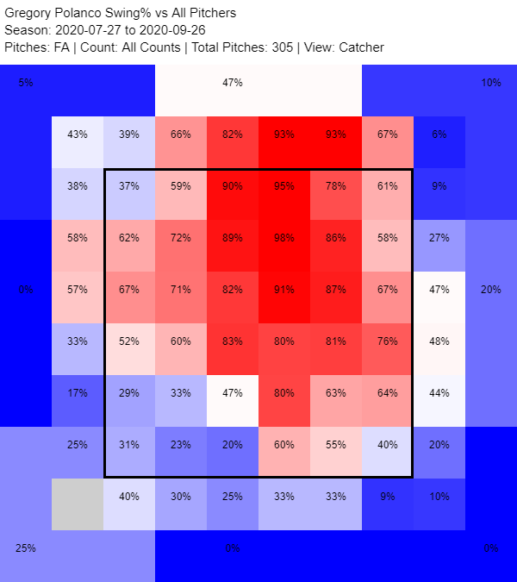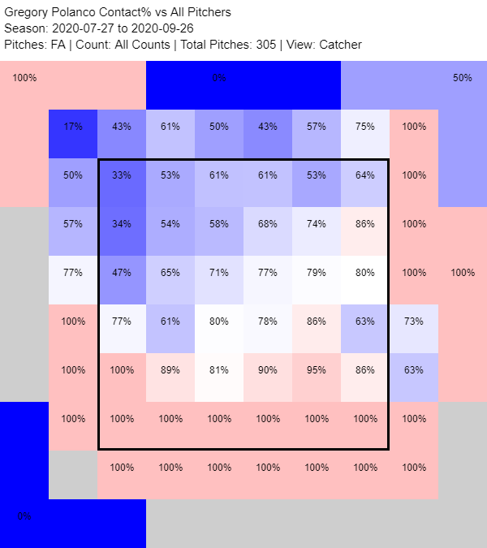

Polanco is yet another victim of the pitching trend in the last three years: fastball up in the zone. Heatmaps don’t lie: Polanco swung a lot on FBs high and over the strike zone, made abysmal contact and, when he actually hit the high heat, he wasn’t really hurting anybody with those sub 0.100 ISOs.

One terrifying aspect of Polanco’s swing and contact display in 2020 against the heater was his inability to crush the middle-middle offerings as a slugger would do, but why is that? Here is where Polanco tricked himself: he decided to focus on pitches middle to low in, a plan that cost him a lot considering his poor job at letting fastballs up go by instead of flailing at them helplessly.

While each player goes at the plate with a plan, although there are those who’ll say that they adhere to the “see ball, hit ball” mantra, Polanco went looking for locations where he could unleash his raw power, and with some effect, but that made him susceptible both to gas up high and straight down the pipe, a sign that maybe his swing was too long and levered to react and adapt accordingly.

A confirmation of this flawed plan can be found when looking for Polanco’s misadventures against sliders:

*Figure 6: Gregory Polanco’s Swing%, Contact% and ISO/p on SLs, 2020 season*

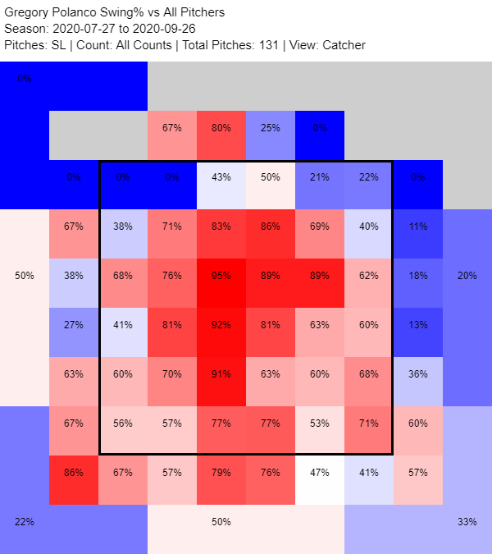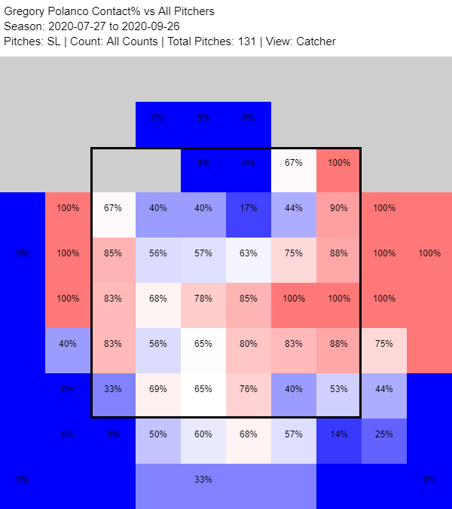

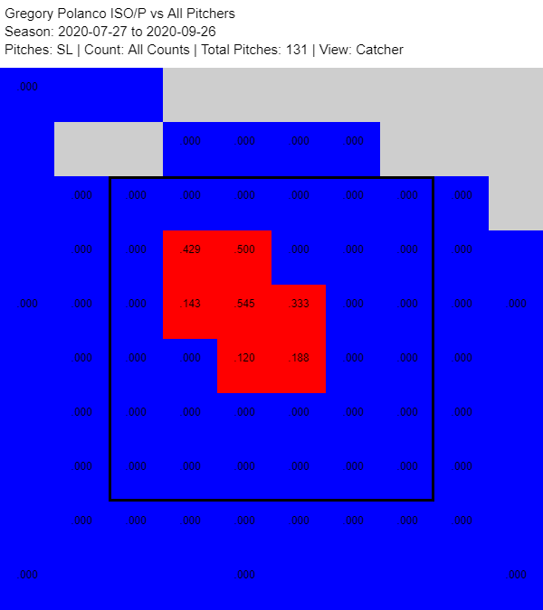

There he is: he swung at a lot of those slider in the zone, and also low and outside with no avail as a lefty platoon bat does in the L-L matchup, and made contact with almost everything down and in but he had no gratification doing so, finding some juicy result only on the proverbial cement mixers, the hanging sliders right there to be crushed.

Setting his sights down and in slowed Polanco’s bat, one that past shoulder troubles did maybe already dent on pure bat speed but not in thump, and made him a feast (few) and famine (lot) hitter that didn’t walk enough to get into Joey Gallo territory.

So, why did I choose Polanco as a sleeper pick, albeit one to provide adequate and not superstar-like contributions?

Let’s start by saying that, coming back from a long injury as he did, the 2020 season with its scattered calendar and preparation issues was the worst scenario to set foot back in the game. Consider also that the sample size in 60 games is not that great and you’ll understand why I think this was the worst possible version of Polanco and the only way is up.

Borrowing Baseball Savant’s expected metrics, you’ll see that Polanco was the same (bad) player as he was in 2019 in terms of xBA, xSLG and xwOBA not the walking disaster he seemed to be in 2020, although he went skyrocketing in Whiffs (+10.3%) and yet has found no answer to the shift (almost 0.100 wOBA differential with or without it).

Another interesting tidbit is that, while being dreadful at the plate, Polanco set some personal marks on the other facets of the game:

*Figure 7: Gregory Polanco’s WAR values, 2018 to 2020*

That batting will forgive no one, but seeing an adequate baserunning (27.4 ft/s sprint speed, 0.6 more than 2019) and good defense in RF (1 DRS and 3 OAA with great routes and bad reactions) is a bright light in Polanco’s nightmarish 2020, one that makes you wonder what he could actually be if his batting was even decent, not spectacular.

Then, what to do with this splits?

*Figure 8: Gregory Polanco’s wOBA home/away split, 2020 season*



Both slashlines are awful, and that’s being kind, but a 0.150 wOBA away is nothing short of inexplicably bad, the sort of anomaly you tend to get when dealing with low sample sizes.

Finally, his contract: Polanco has a $11M salary for the upcoming season, more than what Schwarber and Rosario were let go for, not to mention Mazara, and a pair of upscaling club options for 2022 and 2023 with $3M and $1M buyouts respectively, that is to say he’ll need to provide at least a couple of wins to be cost-effective.

On the other side he’ll cost you short of nothing: the Pirates would be happy to pack his contract and some cash for a lottery ticket or a PTBNL knowing their love for low payrolls.

Would I take Polanco over the other lefty outfield bats mentioned at the beginning? Well, I’d surely rather have Brantley although he’ll cost around $12-14M being low (consider the $7M of Eaton’s contract with the White Sox and things could be worse), but after him things get murkier: Rosario is much more solid with the bat but not on the field and going away from Minnesota could hurt his power production; Schwarber is alike with a little more flexibility and worse splits against lefties than Rosario; Mazara is another buy low candidate, albeit one with red flags since far too long to bet on even an average bat.

This is to say that, if he has time to prepare his swing and look at the data as in a normal season, Polanco could be a gamble worth taking, one that will come almost free of charge with some money in the bag, a risk that can be almost null in the sole season but a profit in the long run if the bat ever comes back thanks to the club options.

Hitting a baseball is incredibly hard, barreling it is ever harder and Polanco can hit it as hard as anyone, he just needs to hit it more…enough said!

*All graphs and tables can be found in the Leaderboards section on Fangraphs, while expected statistics, sprint speed and OAA are available on Baseball Savant*