SUPERPY:

**WHAT IS SUPERPY**

Superpy is a command-line tool that employees can use in the supermarket on a daily bases to keep track, update and producing reports of its inventory. By using Superpy you can for example:

* Check which are the products available in the supermarket on a specific date
* The amounts of products available in specific date in the supermarket
* Keeping track of different types of prices of a product (bought price, selling price etc)
* Keeping track of the status (bought, sold, expired) of a product
* Reporting revenue and profit in specific time periods.
* Updating the list of bought products

The guide will provide examples on how to achieve the desired results.

**Requirements on your computer**

In order to run correctly the command-line tool. The user needs to have installed on its computer:

* Version of Python above 3.7 (you can download it from here [Download Python | Python.org](https://www.python.org/downloads/))
* The following modules that are used in the command line:
* Csv (to import-export format for databases, included in the Python intstallation )
* Argparse (to build user interface)
* Datetime (to introduce the concept of time in the program, included in the Python intstallation)
* The following extra package (and show how we install it):
* Matplotlib
* Rich.

In order to install the modules you can run in you command prompt:

* Argparse: pip install argparse
* Matplotlib: python -m pip install -U pip
* Rich: python -m pip install rich

HOW TO USE SUPERPY

HOW TO RUN A COMMAND:

In order to use the software you need first to open your commandpromp:

1. You need to set the correct folder where the file is saved. To do so re-direct the commandpropt to the folder where Superpy is saved using “cd ..” command
2. Once you are in the folder where Superpy is saved, you have to access it. To do so write “cd Superpy”
3. Now you can start to write the command that you want to have. Each command needs ALWAYS to be placed after the following text :“py main.py “write here the command”

**REPORTS**

**Product available on a specific date (-la)**

This command allows you to have an overview of the products history (and its properties) available in the supermarket in a specified date. For example, we want to know the products status at the supermarket on the 2023-11-20. Once this date is set, if you write the following command you will have an overview table of this list

**Command:** *“py main.py -la”*

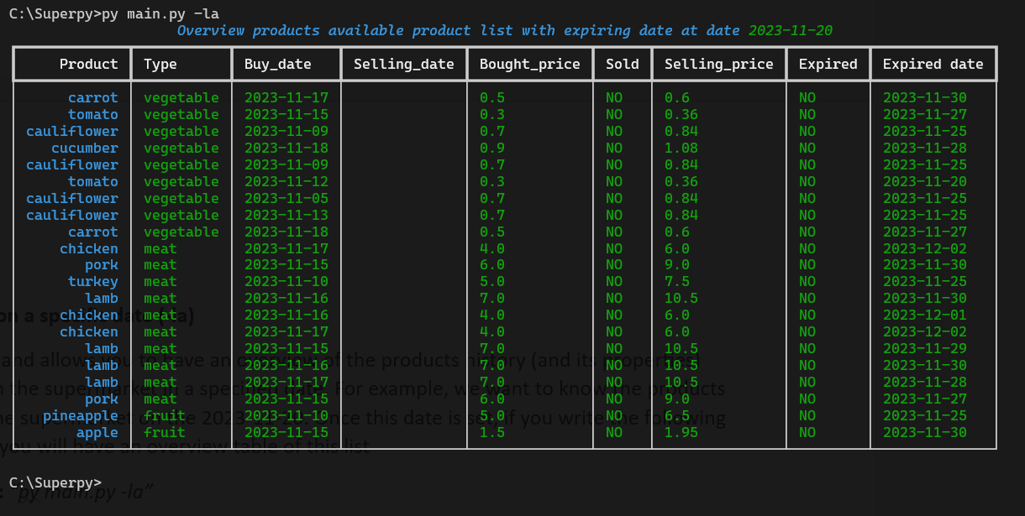

**List of bought product in a time range (-lbd)** *(to adjust print date)*

This command allows you to have an overview of the bought products in the supermarket in a specified time range. For example, we want to know the bought products list from the supermarket on the time range 2023-10-01/2023-11-30. Once this date is set, if you write the following command you will have an overview table of this list:

**Command:** *“py main.py -lbd 2023-10-01/2023-11-30 ”*

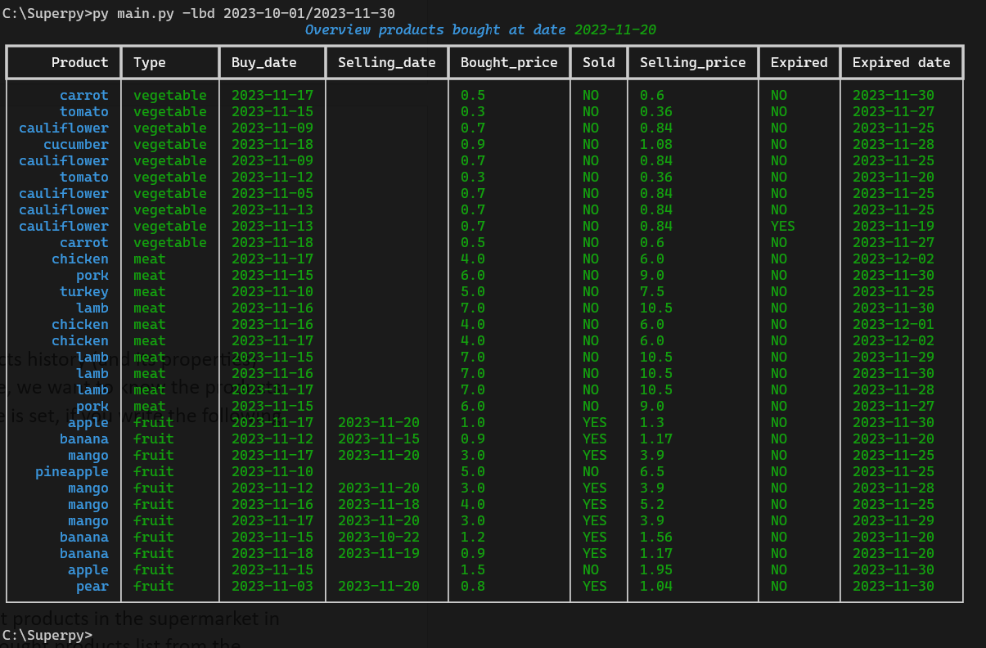

**List of sold product on in a time range (-lsd)** *(to adjust print date)*

This command allows you to have an overview of the sold products in the supermarket in a specified time range. For example, we want to know the sold products list from the supermarket on the time range 2023-10-01/2023-11-30. Once this date is set, if you write the following command you will have an overview table of this list:

**Command:** *“py main.py -lbd 2023-10-01/2023-11-30 ”*

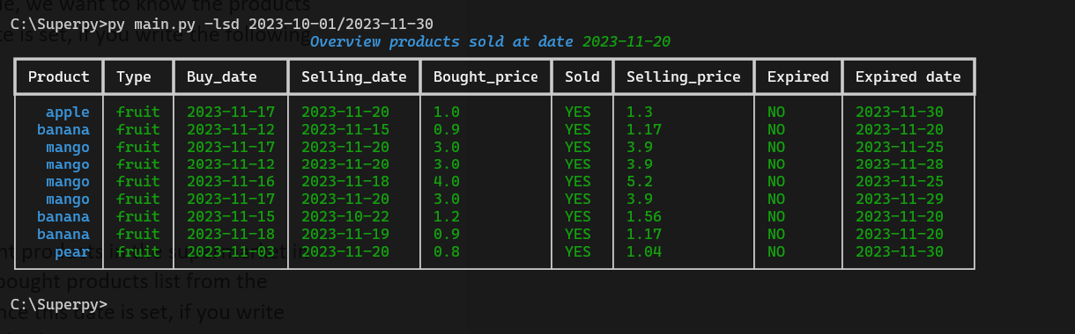

**List of sold product on a specified date (.ls)**

This command allows you to have an overview of the sold products in the supermarket in a specified date. For example, we want to know the sold products list at the supermarket on the 2023-11-20. Once this date is set, if you write the following command you will have an overview table of this list

**Command:** *“py main.py -ls”*

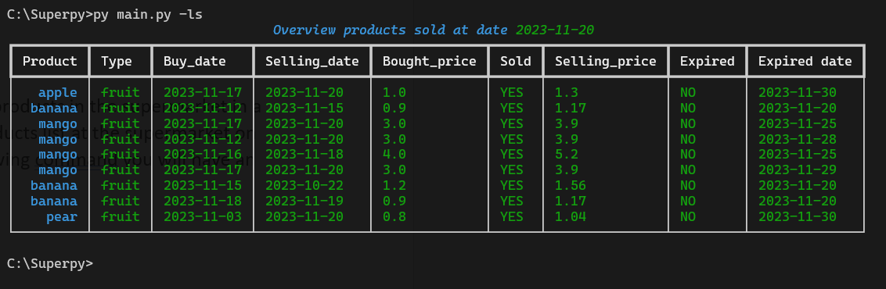

**List of amount products in the supermarket on specified date (-lnp)**

This command allows you to have an overview of the amount of products (by product name) in the supermarket in a specified date. For example, we want to know at the end of the day (2023-11-20) the amount of mango at the supermarket. Once this date is set, if you write the following command you will have an overview table of this list.

**Command:** *“py main.py -lnp mango”*

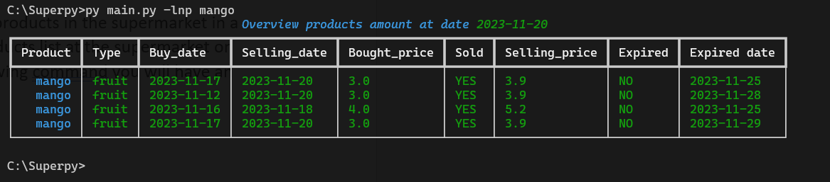

**List of products and its data: bought price - expired date - sold price and expired status on a specified date (.l)**

This command allows you to have an overview of supermarket products and its most important data in a specified date. For example, we want to know at the end of the day (2023-11-20) the current status of the products in the supermarket. Once this date is set, if you write the following command you will have an overview table of this list.

**Command:** *“py main.py -l”*

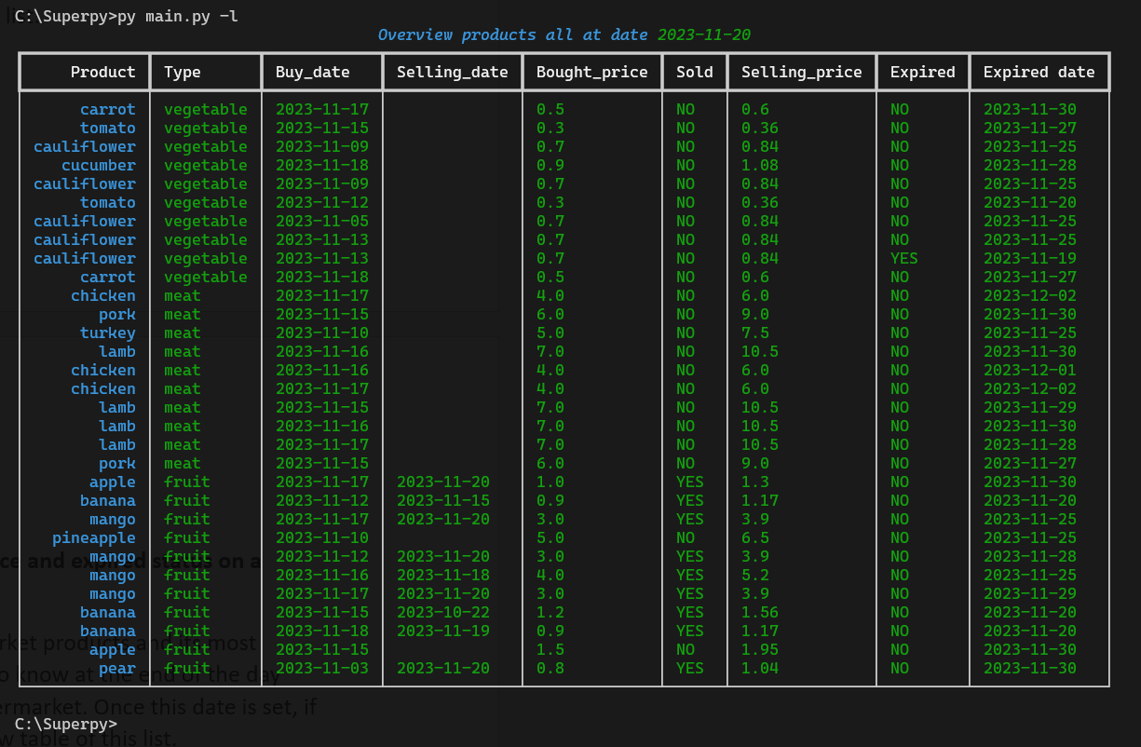

**List of products expired in a specific date (.e)**

This command allows you to have an overview of the expired product in a specified date. For example, we want to know at the end of the day (2023-11-20) which product are expired. Once this date is set, if you write the following command you will have an overview table of the product expired that day

**Command:** *“py main.py -e” ”*

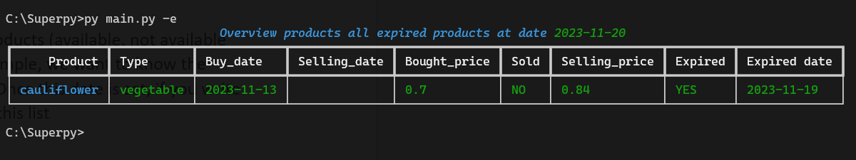

**General overview of the products: check (.pt)**

This command allows you to have an overview of all the products (available, not available and expired) in the supermarket in a specified date. For example, we want to know the products overview at the supermarket on the 2023-11-20. Once this date is set, if you write the following command you will have an overview table of this list

**Command:** *“py main.py -pt”*

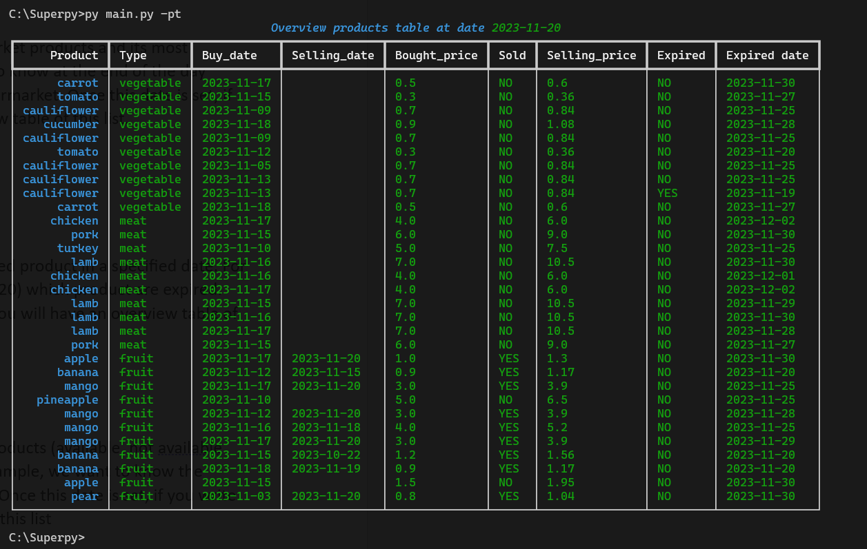

***List of on sale product: (-os)***

*This command allows you to have an overview of all the products which are on sale in the supermarket in a specified date. A product goes on sale 3 days before its expiring date, and its price will be 50% discounted. For example, we want to know the products on sale at the supermarket on the 2023-11-20. Once this date is set, if you write the following command you will have an overview table of this list*

***Command:*** *“py main.py -os”*

**Profit and revenue in a specific period of time (.pr)**

This command allows you to have a the total profit and revenue of the supermarket in a specific time frame. For example, we want to know in the month of November what is the profit and revenue of the supermarket. To do so we need to run the following command followed by the time range desired

**Command:** *“py main.py -pr 2023-11-01/2023-11-30”*

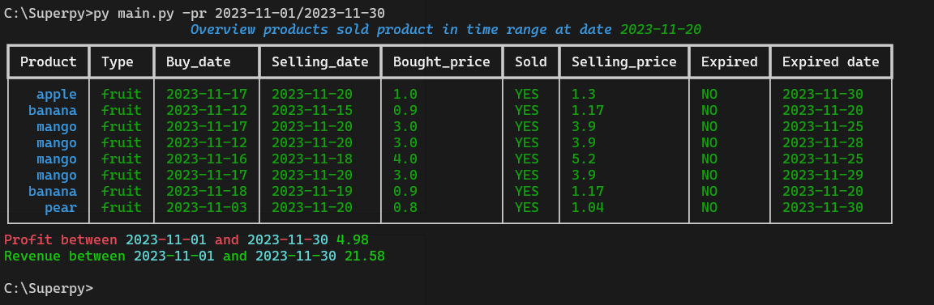

Or in the period of October-November

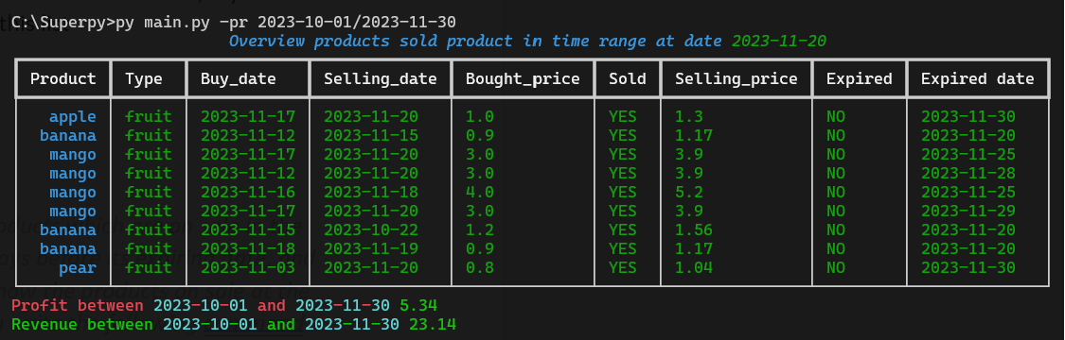

**TIME:**

Time play an important role in the Superpyprogram. Through a series of command you can:

* check the current date in use in the program or
* advance in time,
* retreat in time
* reset the time to the current date

**Advance in time (-ad)**

This command allows you to “add” an amount of days to the current date set in the program. Remember, once the new date is set, you need to “run” again all the reports commands in order to get an updated overview. For example, we want to move 5 days in advance to our current date (date of today is 2023-11-20). If you write the following command you will have displayed the new date of the supermarket

**Command:** *“py main.py -ad”*

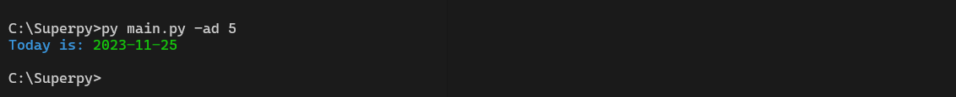

**Retreat days (-rd)**

This command allows you to “remove” an amount of days to the current date set in the program. Remember, once the new date is set, you need to “run” again all the reports commands in order to get an updated overview. For example, we want to move 5 days in backwords to our current date (date of today is 2023-11-20). If you write the following command you will have displayed the new date of the supermarket

**Command:** *“py main.py -rd”*

**

**Reset date to current date (-rt)**

This command allows you to “reset” the date of the program to the current date. Remember, once the new date is set, you need to “run” again all the reports commands in order to get an updated overview. For example, we want to set the current date of today in the program. If you write the following command you will have displayed the new date of the supermarket corresponding to today.

**Command:** *“py main.py -rt”*

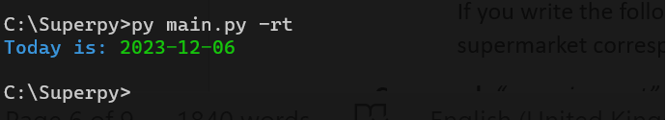

**UPDATE REPORTS**

The user can add information to the database available in the supermarket. For example the following commands are supported:

* Add available product that is possible to buy in the supermarket
* Record which new products has been sold

**Add new available product possible to buy now in the supermarket (-bp) and its profit (-ip)** *(to adjust print date)*

This command allows you to “add” a new item-product, to the list of products available in the supermarket. For example, from now on in the supermarket we can sell a “pear” to do so we need to run the below command and insert the specific data of that product in the following order: Name – Type – Selling price – expiration date.

**Command:** *“py main.py -bp pear fruit 0.6 2023-11-20”*

Once the product is added, you need to assign also a profit to it. To do so you can run the following:

**Command:** *“py main.py -ip pear 2”*

To check that the item has been added we can run the list of product to check if has been added.

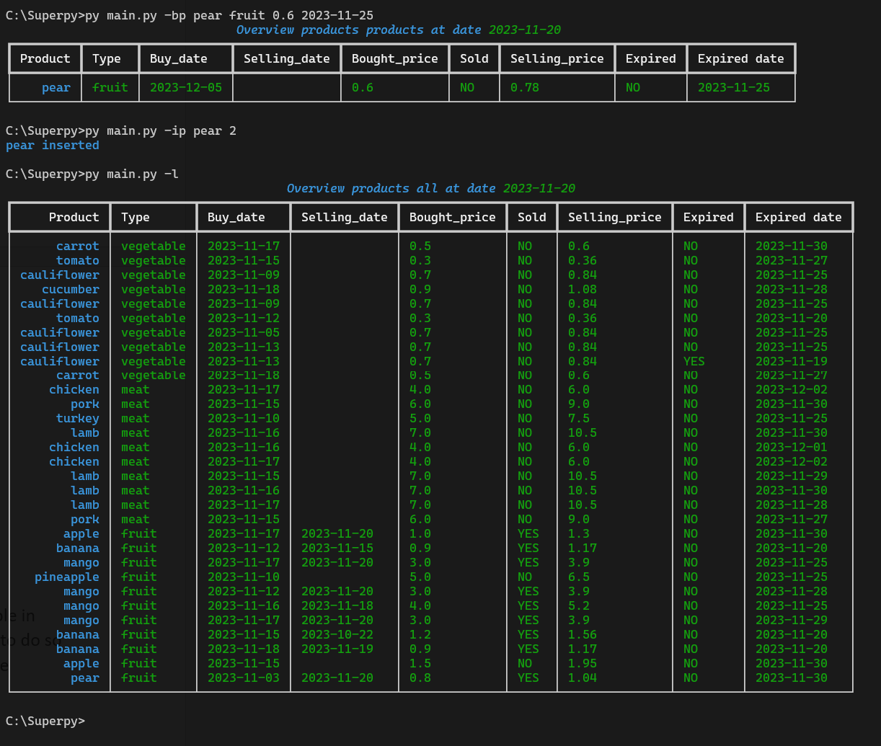

**Record which new product has been sold (-sp):**

This command allows you to “record” if a product has been sold. In this way the list of available product of the supermarket can be updated. For example, we want to record that the pineapple item has been sold. To do so we need to run the below command and insert the name of the product sold

**Command:** *“py main.py -sp pineapple”*

By printing again the list of product, we can see that the pineapple has been sold

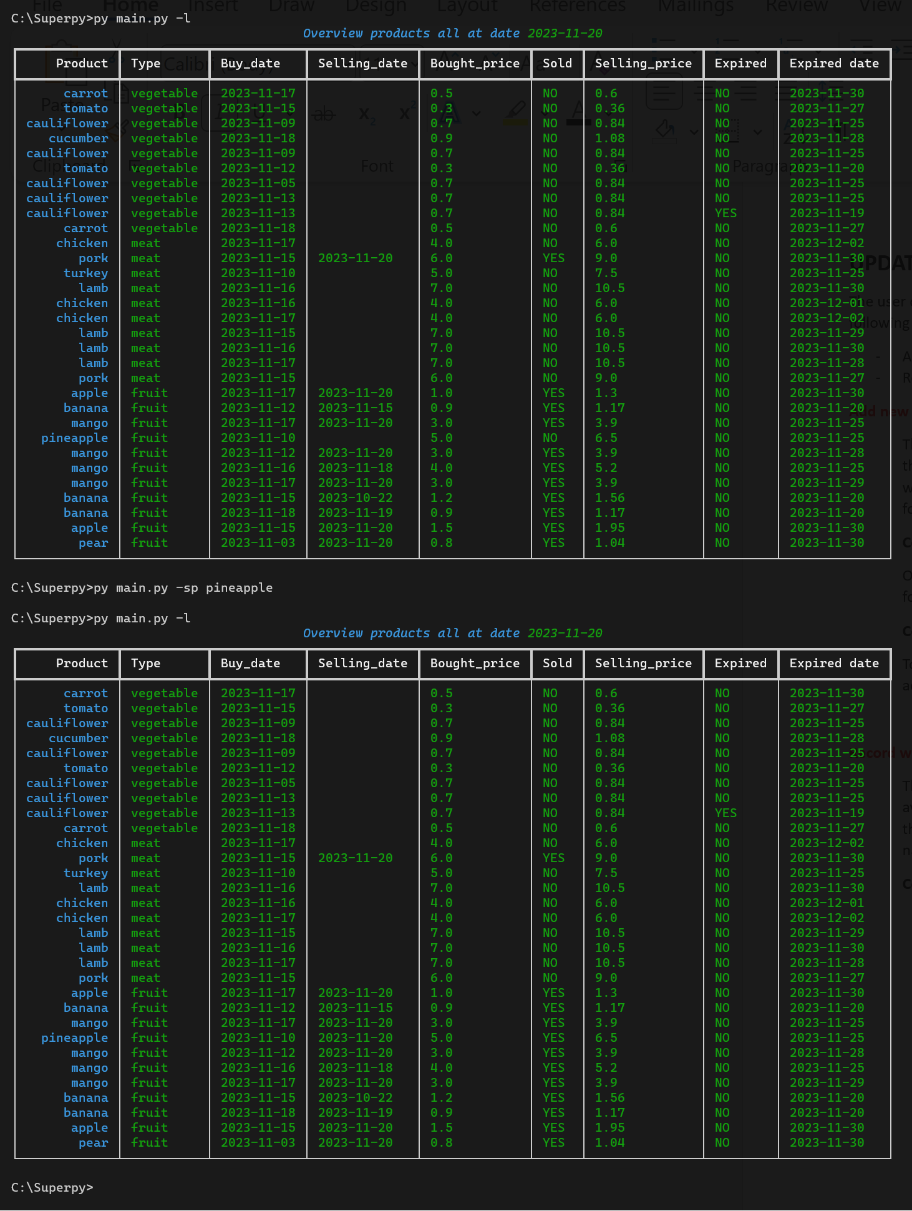

**EXPORT CSV FILE - PLOT:**

**Export csv files, (-ex ..)**

The program allows you to export data in csv format, on a specific date.To do so we need to run the below command and indicate at the end which type of list we want to export. The program will generate automatically a csv file with the requested information and save it in the export folder.

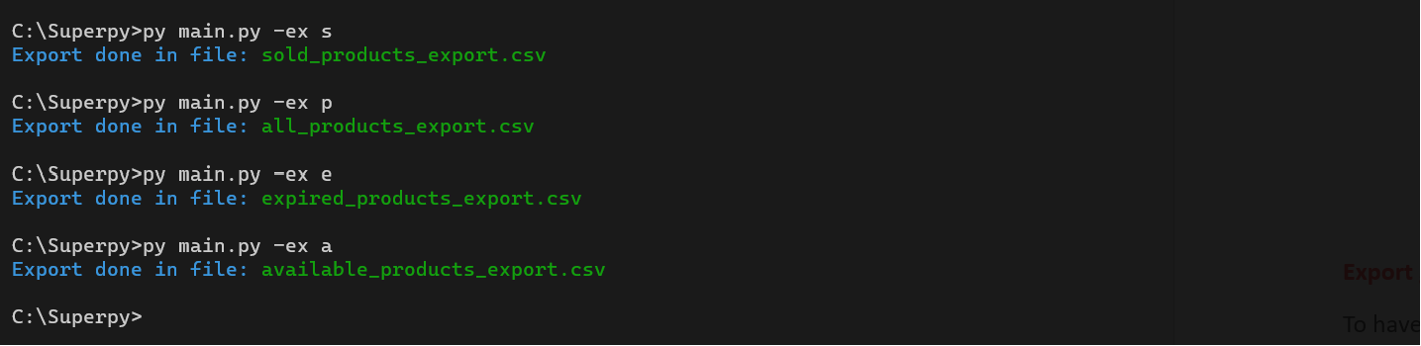

**SOLD PRODUCTS – Command:** *“py main.py -ex s”*

**ALL PRODUCTS – Command:** *“py main.py -ex p”*

**EXPIRED PRODUCTS – Command:** *“py main.py -ex e”*

**AVAILABLE PRODUCTS – Command:** *“py main.py -ex a”*

**Export graphic – plot sold (-ps)**

To have a graphic overview of the product sold in a specific time frame, you can run the following command:

**Command:** *“py main.py -ps 2023-10-01/2023-11-30”*

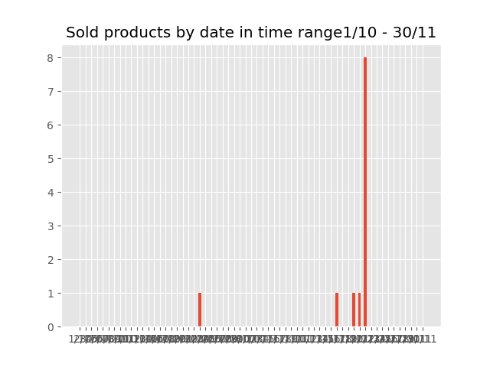

**Export graphic – plot bought (-pb)**

To have a graphic overview of the product bought in a specific time frame, you can run the following command:

**Command:** *“py main.py -pb 2023-10-01/2023-11-30”*

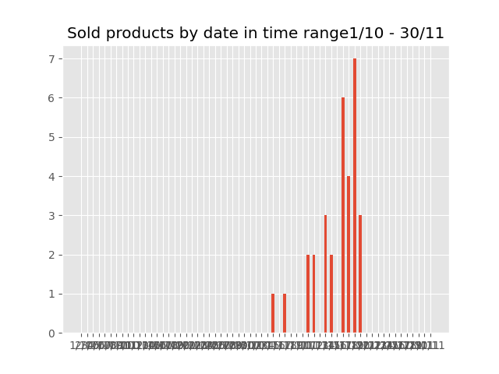

**DICTIONARY** *(to print again)*

In this section you can find all the available command that the user can do

**Command:** *“py main.py -h”*

