## Exercises - GEO4902-03 - Ensemble prediction

**The assignment is due by Friday, Oct. 15, 2021**

***[Save google-collab as jupyter notebook, with your name in the filename, and upload on canvas]***

### Exercise 1 - Forecast of a convective extreme precipitation event

**Use:**

<https://github.com/franzihe/GEO4902_2021/blob/main/03/Ensemble_Prediction_Part1.ipynb>

The script gives you a framework to assess ensemble forecasts from the Scandinavian ensemble forecasting system. All 10 ensemble members are within one forecast file.

The extreme precipitation event (Telemark, Agder, Vestfold) occurred on 13th July 2019.

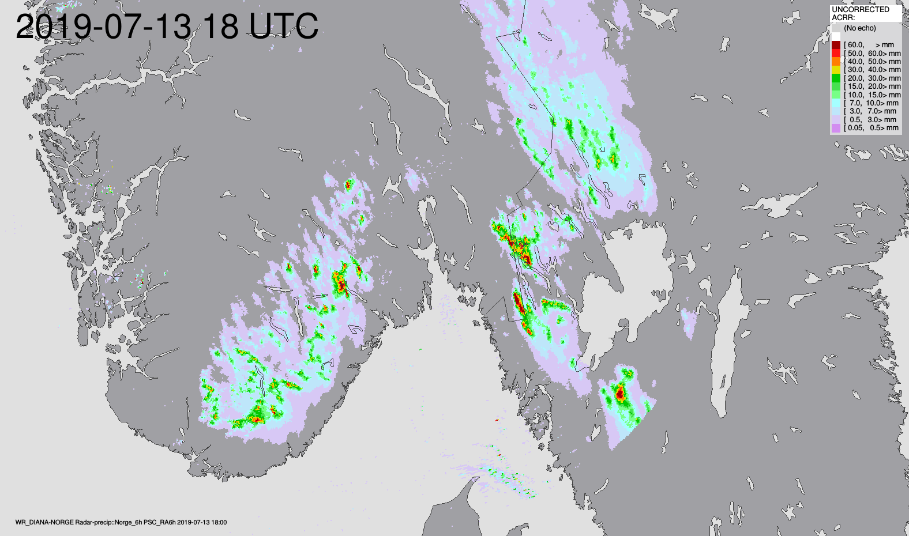

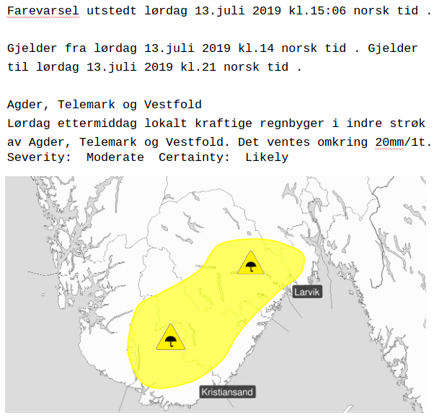

The Figure (top) shows the 6-hour accumulated precipitation from 2019-07-13 12UTC until 2019-07-13 18UTC obtained from radar reflectivity observations. (bottom) shows the forecast by the meteorologists.

1. You can decide on an initial time you want to use to assess the ensemble forecasts. In total, use two different initial times to get an idea of predictability for this event.
2. Plot the spatial maps of 6-hour accumulated precipitation for different ensemble members. Note the variable in the forecast file is accumulated precipitation from the start of the forecast, so you need to “de-accumulate” the fields.
3. You will note differences between all the 10 ensemble members. Do you have ideas on how to derive forecast products that combine the information of the 10 ensemble members but still give information about the severity (i.e., the extreme) of the forecasted weather situation?
4. You can try to plot your own ensemble forecast product (from part 3) or derive a forecast plot that shows the probability of 6 hourly precipitation which exceeds a certain threshold (e.g., 20 mm per 6 hours).

Exercise 2 - Forecast of a polar low

Use:

<https://github.com/franzihe/GEO4902_2021/blob/main/03/Ensemble_Prediction_Part2.ipynb>

The script gives you a framework to assess ensemble forecasts from the Scandinavian ensemble forecasting system. All 10 ensemble members are within one forecast file.

The polar low occurred on 4th February 2020 at about 2 pm, as described in exercise 01.

1. Plot the wind speed forecasts at Tromsø for all ensemble members. What would be a good way to define a forecast product dependent on the lead time? Try to program it and plot it as an ensemble forecast product. (You can also look in the lecture notes for inspiration)
2. Plot the spread (as we defined it in the course) for the ensemble wind forecast.
3. Plot the sea level pressure map for different ensemble members. What could here be a good way of showing the position of the polar low by using the forecast information of the 10 ensemble members?

## Reflection note by students

What did you learn? Comparing forecasts depending on the lead time. How to compare and setting threshold for the probability of the precipitition. (also other variables).

What was difficult? As always its hard to understand what exactly to do, but when working with the assignment it becomes clearer and the assignments are very inspiring after a while when the understanding becomes clearer. Its still difficult understanding how to efficent plot the maps, since cartopy (basemap) plotting is new, and the syntax is sometimes very comfusing with respect to all the paramaters within the plotting and initialization of the forecast variables.

What went well? I think the figures and plots became informative, and the point of the assignment became clearer in the end. This bacame in the end very inspiring and motivation was gained!

What was surprising? The differences within the ensembles, and how large the didfferences was.

What elements will you take with you and use next time? Everything!

Where would you like to get some more input? I would really like more information about the spread, and the interpretation of the spread wrt how it is presented in plots and maps. And especially within different forecasts, as the theory from the lectures implies. Or in other words, more thery explained with examples as done in the groupsessions. This is very educational from my point of view!

What did I learn?

• Due to the perturbed initial conditions, each ensemble member produce slightly

different forecasts, and these differences increase over time.

• One can derive more accurate forecasts by taking all the different ensemble

members into account in different ways (often the spatial average at each time

step).

• Spread represents ensemble dispersion and is flow dependent. Meaning that it

depends on the atmospheric dynamical aspects. We want the spread to be as

small as possible to get the best possible forecast.

What was difficult?

• Deriving the forecast plot that showed the probability of 6 hourly precipitation

which exceeded 20mm.

• Understanding how to plot the ensemble spread for the ensemble wind forecast.

What went well?

• Working with the ensemble members using xarray.

• Plotting the the probability of 6 hourly precipitation which exceeded 20mm (in

the end).

• Deriving the spread for the ensemble wind forecast (in the end).

What was surprising?

• How rapidly the ensemble members can provide very different forecast results,

especially spatially.

What elements will you take with you and use next time?

• How to get the ensemble spread from ensemble forecasts.

Where would you like to get some more input?

• Ensemble spread and how to derive it.

This exercise was more clear. For part 1 we got some help from Malte because it was hard to get the probability. But even with the help it was still a search of 4 hours to get it in the right size for xarray because I don’t know how to work with xarray. Part 2 did not really went well because again I couldn’t measure the spread because I don’t know how to work with arrays. So next time I will have to make time to watch some youtube videos about xarray or something. But it was still a good assignment about the lectures to understand the lectures better.

My main learning achievement from this assignment was the way the exercises worked as

examples for the curriculum. It helped me tie it together and understand how the ensemble

prediction work. During the assignment, I think that the programming itself gets easier and

easier as one gets to know xarray and cartopy better. This did also give me a better chance to

focus more on understanding the theory behind the assignment better.

What surprised me the most, was the way the mean “destroyed” the extremes and the

physics. This was something I knew, but it was really interesting to experience it as well.

For next time I think that I will take with me a better understanding of the way the ensembles

work and how the errors in the model and observations impact the forecast.

In orders of element I want to learn more about, I would like learn more about the errors in

the ensemble members and how one chooses the best forecast

What did you learn?

The hands on experience on forecast esnemble prediction idea

What was difficult?

Actually some parts of manipulating xarray were tricky. It was not particuarly diffucult but more discovering what is possible to do and what not. Sometimes going through documenation was simply time consuming. Eg when checking how to de-accumulate rainfall - at first I wanted to assign value to dataset and apparenlty it was not possible. also in some situations when I wanted to check if my data is correct - (no rain) the plot was not showing things I expected. Judging which ensemble to choose was not obvious. I remember from lecture that usually the control one (0) is choosen.

What went well

plotting

Where would you like to get some more input?

Forecasting introduces lots of new vocabulary that sometimes is not very precisely defined - eg. forecast lead time or what exactly is forecat product. I know I can google it, but eg. forecast product returs lots of not relevant information. Similarly term spread was sometimes use as to presenting the ensemble spread (variation of forecasted parameters), and sometimes was at lecture was calulated. I know it is all connected but sometimes its confusing. Sometimes clarifying all new terms takes time.