Css:

A CSS rule consists of a selector and a declaration block.
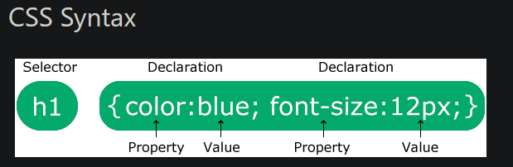
For example, all <p> elements will be center-aligned with a red text color:
p {
color: red;
text-align: center;
}

