Alex@CHUWI MINGW64 /C/Users/Alex/Desktop/Spire/myGit (master)

$ git status

On branch master

Your branch is up to date with 'origin/master'.

Untracked files:

(use "git add <file>..." to include in what will be committed)

1.txt

nothing added to commit but untracked files present (use "git add" to track)

Alex@CHUWI MINGW64 /C/Users/Alex/Desktop/Spire/myGit (master)

$ git add 1.html

fatal: pathspec '1.html' did not match any files

Alex@CHUWI MINGW64 /C/Users/Alex/Desktop/Spire/myGit (master)

$ git add 1.txt

Alex@CHUWI MINGW64 /C/Users/Alex/Desktop/Spire/myGit (master)

$ git status

On branch master

Your branch is up to date with 'origin/master'.

Changes to be committed:

(use "git reset HEAD <file>..." to unstage)

new file: 1.txt

Alex@CHUWI MINGW64 /C/Users/Alex/Desktop/Spire/myGit (master)

$ git commit -m "txt должен появиться в репозитории на сайте"

[master 0887c68] txt должен появиться в репозитории на сайте

1 file changed, 1 insertion(+)

create mode 100644 1.txt

Alex@CHUWI MINGW64 /C/Users/Alex/Desktop/Spire/myGit (master)

$ git push

Enumerating objects: 4, done.

Counting objects: 100% (4/4), done.

Delta compression using up to 4 threads

Compressing objects: 100% (2/2), done.

Writing objects: 100% (3/3), 352 bytes | 117.00 KiB/s, done.

Total 3 (delta 0), reused 0 (delta 0)

To https://github.com/Alester99/alesterproject.git

8b1cf49..0887c68 master -> master

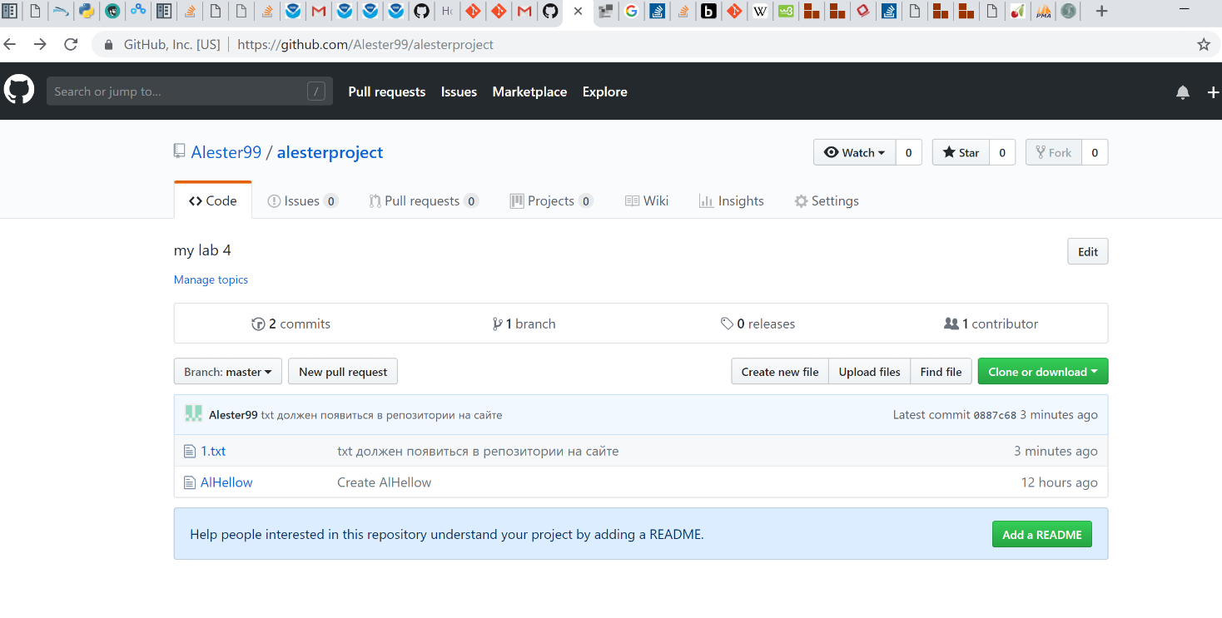

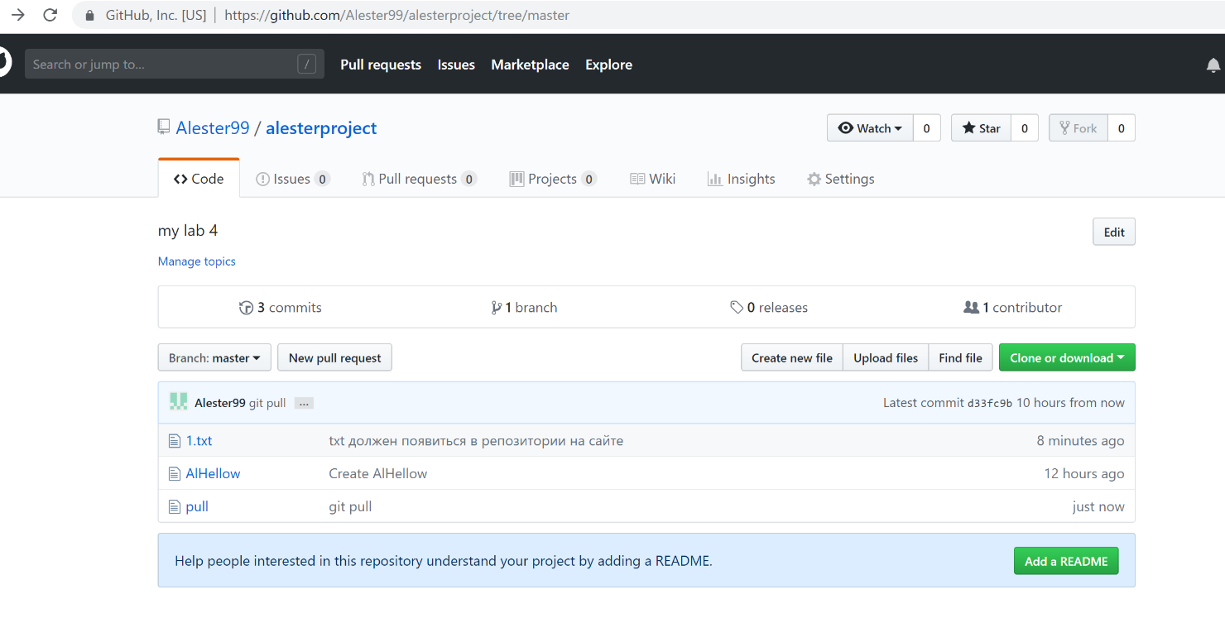

Alex@CHUWI MINGW64 /C/Users/Alex/Desktop/Spire/myGit (master)

$ git pull

remote: Enumerating objects: 4, done.

remote: Counting objects: 100% (4/4), done.

remote: Compressing objects: 100% (2/2), done.

remote: Total 3 (delta 0), reused 0 (delta 0), pack-reused 0

Unpacking objects: 100% (3/3), done.

From https://github.com/Alester99/alesterproject

0887c68..d33fc9b master -> origin/master

Updating 0887c68..d33fc9b

Fast-forward

pull | 1 +

1 file changed, 1 insertion(+)

create mode 100644 pull

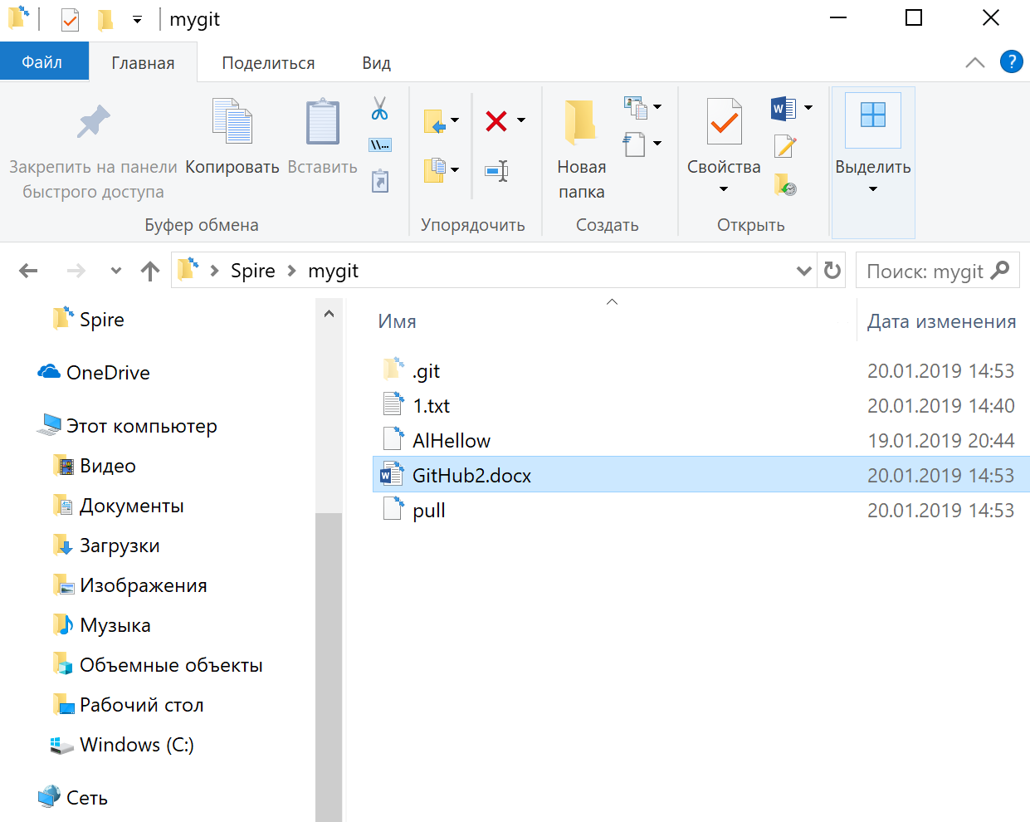

Alex@CHUWI MINGW64 /C/Users/Alex/Desktop/Spire/myGit (master)

$ git status

On branch master

Your branch is up to date with 'origin/master'.

Untracked files:

(use "git add <file>..." to include in what will be committed)

GitHub2.docx

~$itHub2.docx

nothing added to commit but untracked files present (use "git add" to track)

Alex@CHUWI MINGW64 /C/Users/Alex/Desktop/Spire/myGit (master)

$ git add -A

Alex@CHUWI MINGW64 /C/Users/Alex/Desktop/Spire/myGit (master)

$ git status

On branch master

Your branch is up to date with 'origin/master'.

Changes to be committed:

(use "git reset HEAD <file>..." to unstage)

new file: GitHub2.docx

new file: ~$itHub2.docx

Alex@CHUWI MINGW64 /C/Users/Alex/Desktop/Spire/myGit (master)

$ git commit -m "add word file"

[master 8b4a921] add word file

2 files changed, 0 insertions(+), 0 deletions(-)

create mode 100644 GitHub2.docx

create mode 100644 ~$itHub2.docx

Alex@CHUWI MINGW64 /C/Users/Alex/Desktop/Spire/myGit (master)

$ git push

Enumerating objects: 5, done.

Counting objects: 100% (5/5), done.

Delta compression using up to 4 threads

Compressing objects: 100% (4/4), done.

Writing objects: 100% (4/4), 385.42 KiB | 8.96 MiB/s, done.

Total 4 (delta 0), reused 0 (delta 0)

To https://github.com/Alester99/alesterproject.git

d33fc9b..8b4a921 master -> master

