Alexandra Anthony

- The GitHub URL: https://github.com/Alex-Anthony/SSW-567
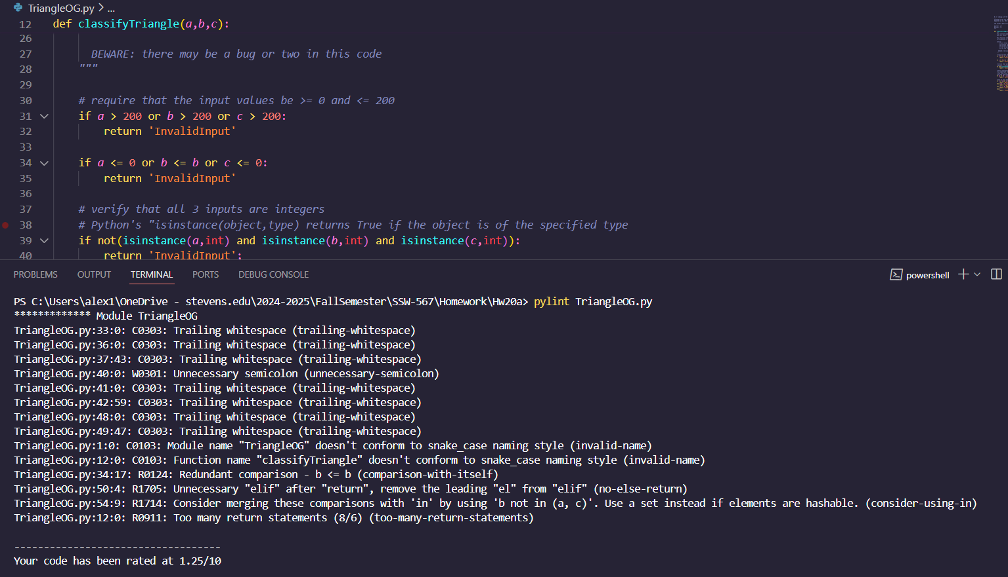
- Pylint
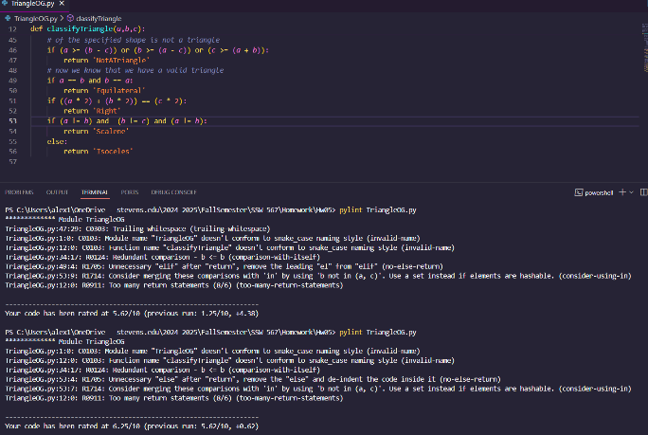

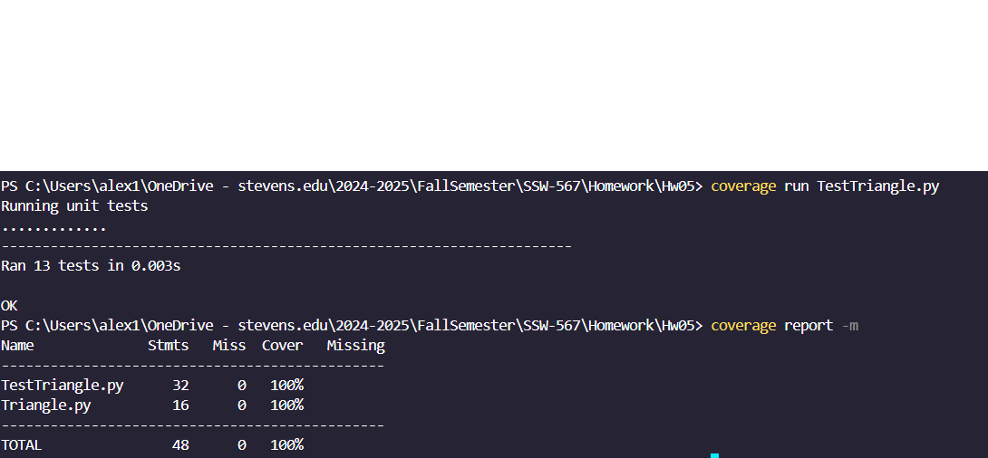
- Coverage.py

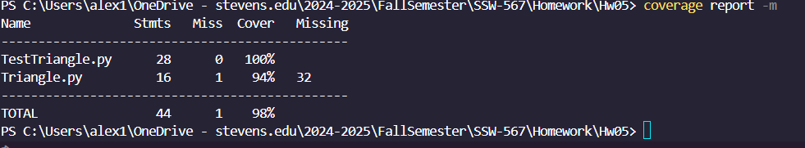

4. Identify both your original test cases and new test cases that you created to achieve at least 80% code coverage.
I took out and added these two tests to show it working as I was already at 100%
def testInvalidInputC(self):
self.assertEqual(classifyTriangle(-1, 5, 6), 'InvalidInput', '-1,5,6 should be InvalidInput')#ID10

def testInvalidInputD(self):
self.assertEqual(classifyTriangle(4.5, 5, 6), 'InvalidInput', '4.5,5,6 should be InvalidInput')#ID11

