Koha EDS Plugin

Setup Guide  
Version: 1.002 and above

System Requirements

This Koha_EDS Plugin requires a minimum Koha version 3.12.02 and should have plugins enabled.  
To learn more about plugins in Koha visit the below URLs  
Official Guide: <http://manual.koha-community.org/3.12/en/pluginsystem.html>  
Unofficial Guide: <http://kohageek.blogspot.com.au/2013/09/how-to-setup-plugin-system-in-koha.html>

Installation

The plugin contains the following folder/file structure

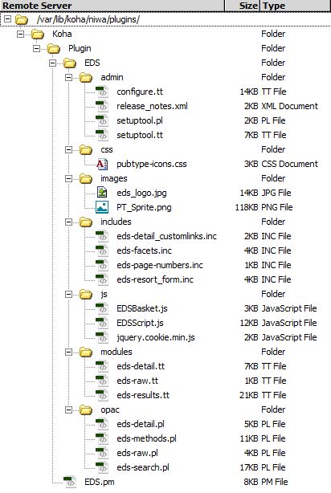

To install the plugin; download the .kpz file and login to Koha Admin

Go to http://<admin URL>/cgi-bin/koha/plugins/plugins-home.pl

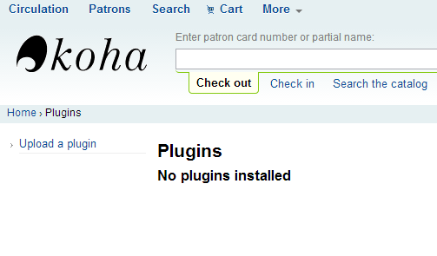

Click Upload a plugin. Select the Koha EDS Plugin file and click upload

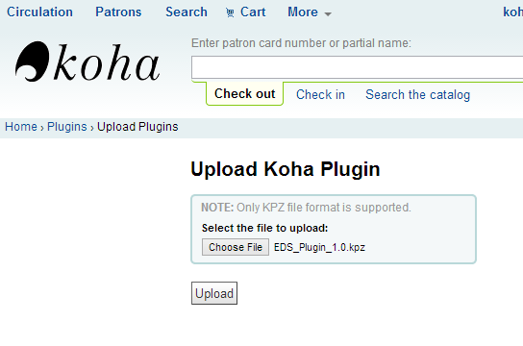

Click Configure to go to the configuration page

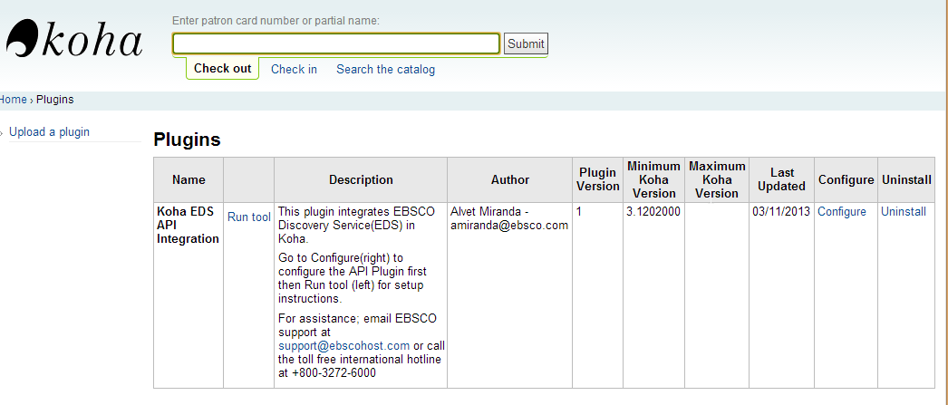

Enter EDS API details and click save configuration. Contact EBSCO to obtain API details.

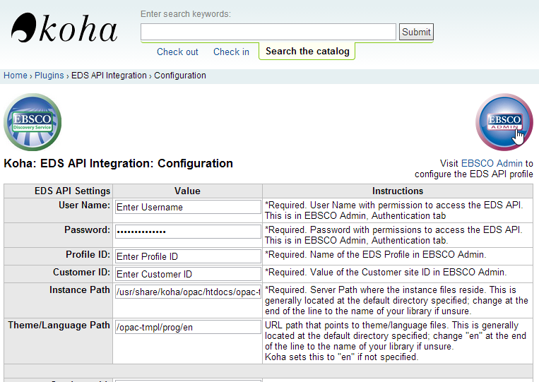

Click Run tool in the plugin home page to access the setup tool.

Login to the server and

1. Run chmod 755 eds-* in the opac directory of the plugin. This is where the perl files are executed from.
2. Patch the files specified in the run tool E.g.

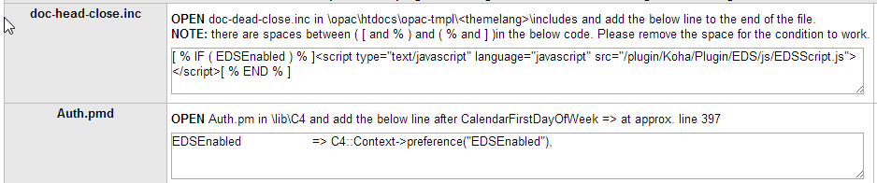

Please refer to the run tool for the latest instructions.

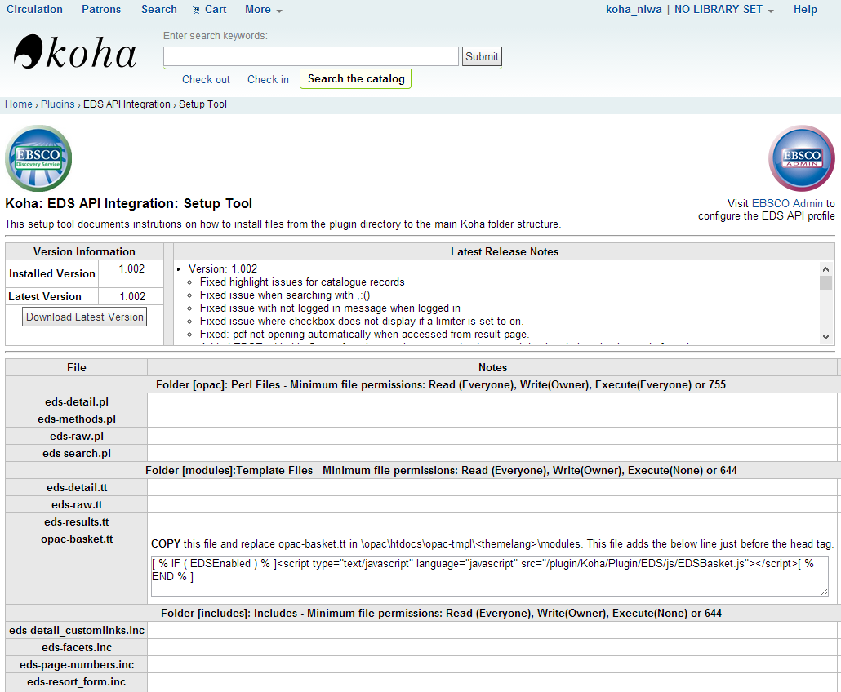

Return to the configure tool to test the plugin. Click Update Info Now to connect to EDS and get EBSCO Admin configuration settings to apply by default.

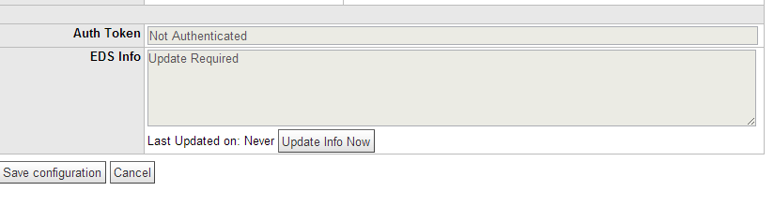

After update if the Auth Token and EDS Info look similar to the below screenshot – the connection was successful. If not; verify the login credentials, ensure files have the right permission and contact [support@ebscohost.com](mailto:support@ebscohost.com) for more information.

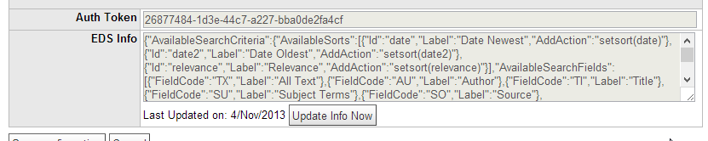

Using the EDS Plugin

Once the plugin is installed successfully, the option to search EDS will appear in the search dropdown. Use the dropdown to search the native catalogue or EDS by selecting the appropriate option.

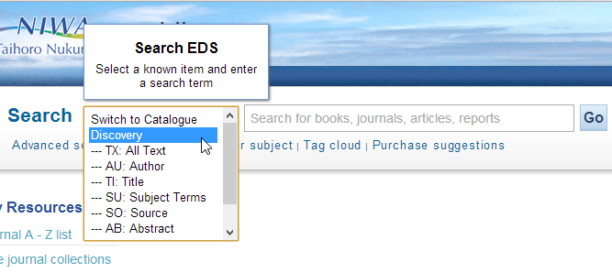

A screenshot of the results page is shown below.  
On the left you have features such as limiters, expanders and facets. At the top is search options such as results per page, sort by etc.

The results display with the title as a link to go to the details page. Add the features and settings on this page are configurable by updating the EDS API profile in EBSCO Admin.

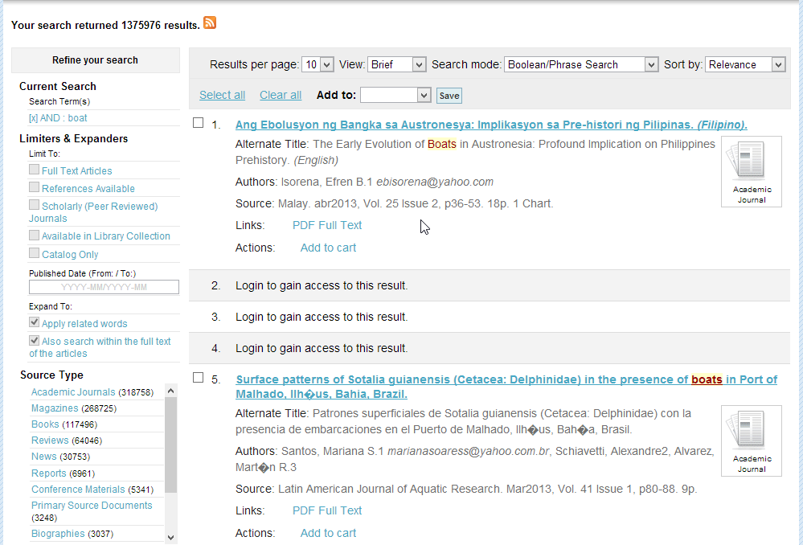

The detailed page displays details for a selected record. With custom links and Koha tools on the right. The feature also allows users to navigate between previous and next records while returning to the result list.

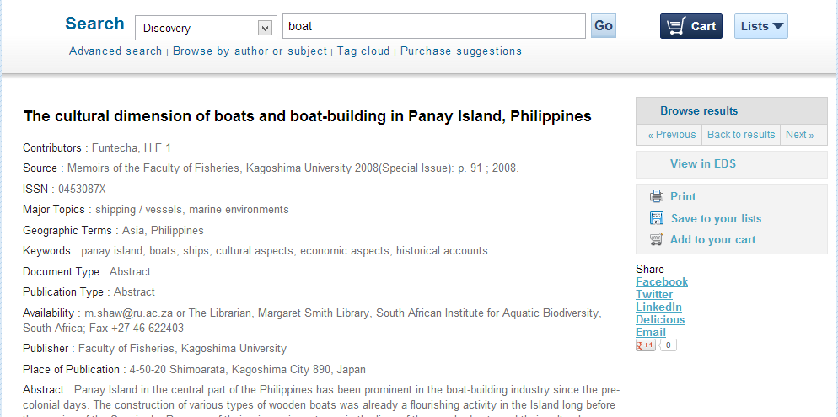

The browse results feature also allows users to browse the results without having to return to the results page. Click View More results will fetch and next page. Click on one of these links to go to the detailed page.

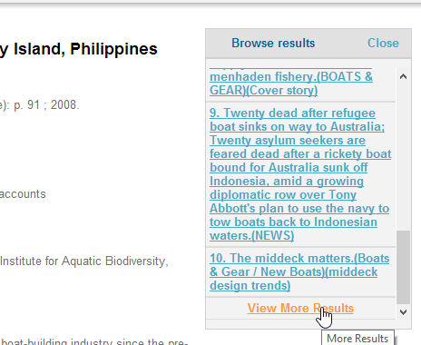

The Plugin also supports applying EDS items in the cart. Simply click the add to cart option in the result list of detailed page and then click the cart option to open a popup.

