The configure section of the EDS Plugin stores necessary information to connect to the EDS API and manage settings. Click on the configure link from the Koha plugins page after the EDS Plugin is installed and actions in the Run tool are executed.

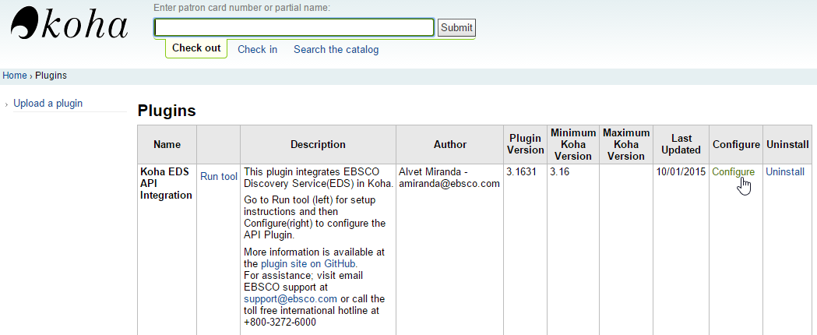

The following screenshot displays the various settings available.

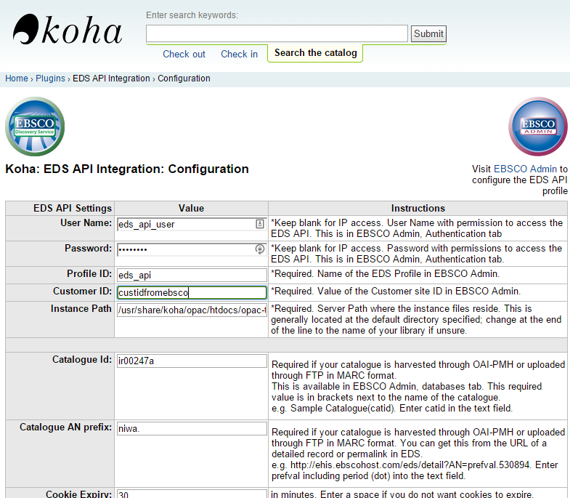

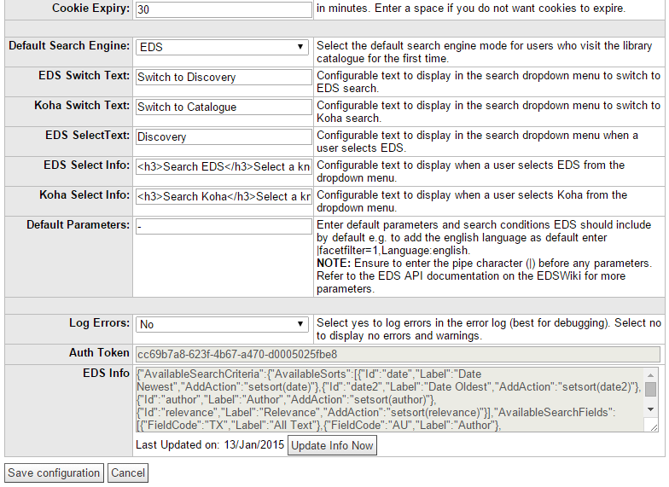

Once the form is populated click on the Save configuration button. This returns the use back to the plugin page. Click on configure again to return to this form and click the button Update Info Now. This attempts to contact the EDS API and establish a connection. It uses the baseurl setting Koha Admin so it is important to ensure that field is setup correctly too.

Update Info Now may need to be clicked twice when connecting the first time.