EBSCO Discovery Service (EDS) is a highly customisable platform that allows subscribers to add on features and functionalities through widgets available on the EDS Wiki.

The customisation manger (available from version 3.1630+) is a way for the Koha Plugin to implement widgets and customisations. A Koha administrator can implement additional features by going into the Run Tool from the plugins page.

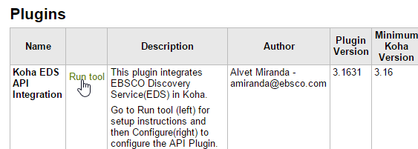

Scroll to the bottom of the page and click the manage button for the file custom.js



This opens a dialog with an editor.

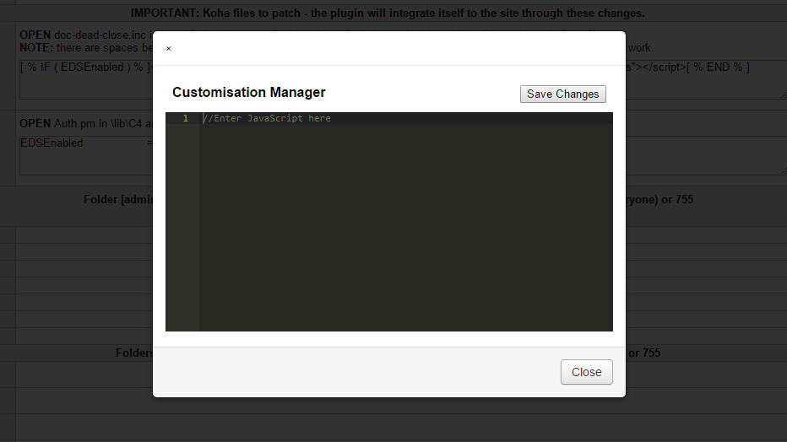

Enter some widget code – here is an example of a popular EHIS Widget. The snippet is modified slightly to accommodate the Koha environment. Once the script is in place; click on Save Changes.

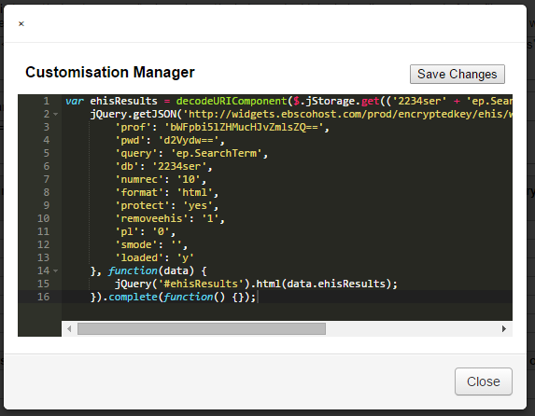

An alert appears to confirm the changes. Click OK and Close to exit the customisation manager.

