Koha EDS Plugin – Live Update

The Live Update feature in the plugin allows Koha administrators to upgrade and rollback the plugin to available versions. It is recommended that Live Update be run on a test environment first to ensure everything is operational and then run Live Update again on the production/live environment.

To access Live Update go to the plugins page and click on Run tool.

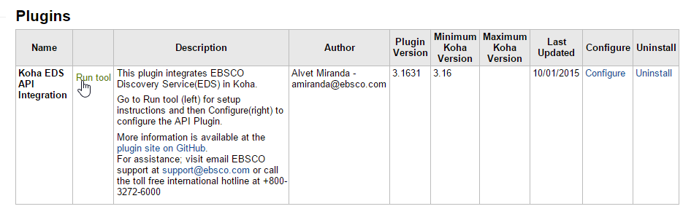

This section provide version information, release notes and lists all the files applicable to this version.

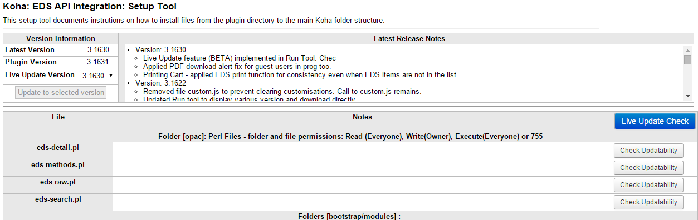

By default the update to selected version button is disabled to prevent Live Updates on the current version. Selecting a newer or older version of the plugin allows the Koha admin to click the button.

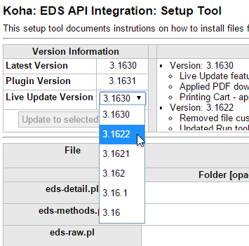

When the button is clicked it informs the administrator that the tool will run an updatability check which tests the permissions on the files.

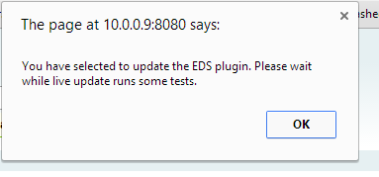

It does this by running the Live Update Check feature which can be initiated on its own by clicking on the Live Update Check button.

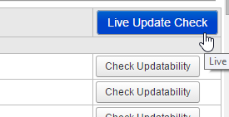

The tool then steps through each file and provides advises if a specified file is updatable or not.

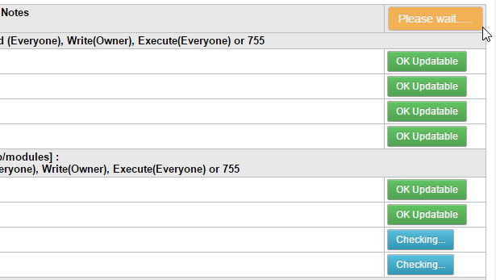

An admin can click on the button to initiate a check again if the updatability check fails.

Once the check passes it initiates the live update process which can take 2 to 3 minutes to execute.

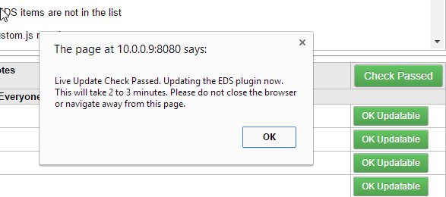

During this time screen the screen is disabled with a loading icon while the plugin fetches the files from rawgit.com for the plugin version specified and updates the existing files on the server.

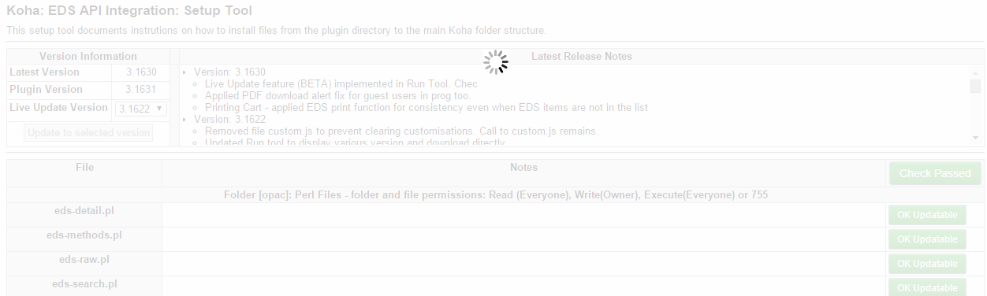

Once the update is complete status Log is provided so the administrator can copy and save. Click Close to return to the Run tool page and test the plugin on the front-end to ensure it works as expected.

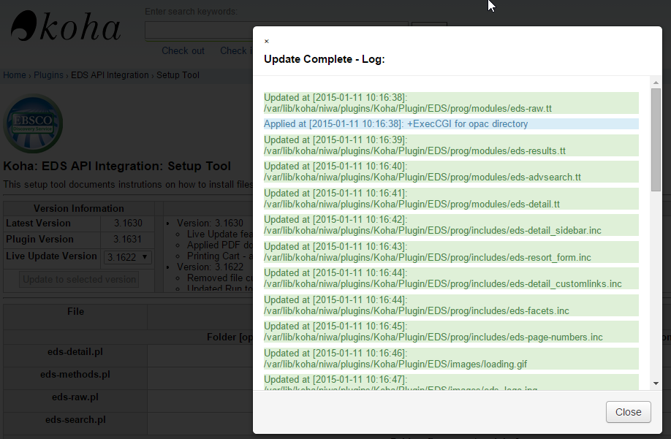

Please contact your server administrator if you find any issues with the Live Update or the plugin stops working. Functionality can be restored by uploading the plugin from Koha and running chmod 755 on the opac folder of the plugin.

A .htaccess file with the contents “Options +ExecCGI AddHandler cgi-script .cgi .pl” is created in the opac folder so .pl files are executed.

Also ensure the all files and folders in the EDS plugin folder have a permission setting of 755.