The Koha EDS Plugin allows users to select multiple facets as a part of their search.

When a facet I select an Update button appears top left of the screen. Once the various facet combinations are selected the user can click update to refresh the result list.

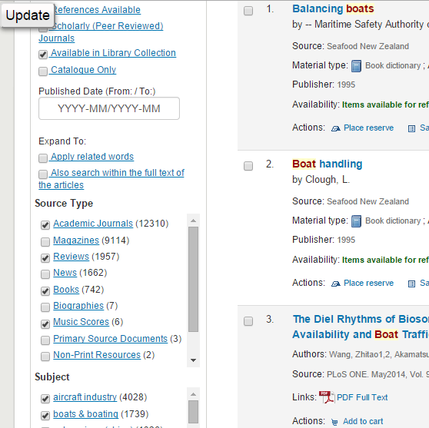

Facets can also be applied by clicking on the hyperlink however this applies one facet at a time.

Sometimes a combination of facets can lead to no results. In this case a screen with all the selected facets appears allowing users to unselect facets and search again.

