Research Starters is a feature in EBSCO Discovery Service (EDS) that provides links to citable, authoritative summary articles for thousands of popular topics. Designed to assist users with their research, this feature was developed based on extensive studies with undergraduate and graduate students.

When a user conducts a search in the Koha EDS plugin – a research starter may appear at the top of the result list. Users may have to login to Koha to see the full results.

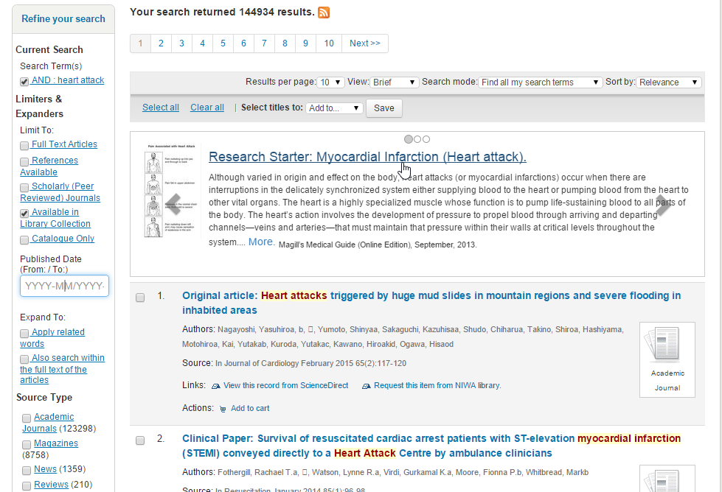

This feature is available in the form of a carousel allowing users to see the best match and scroll left or right depending on the number or items to view related topics.

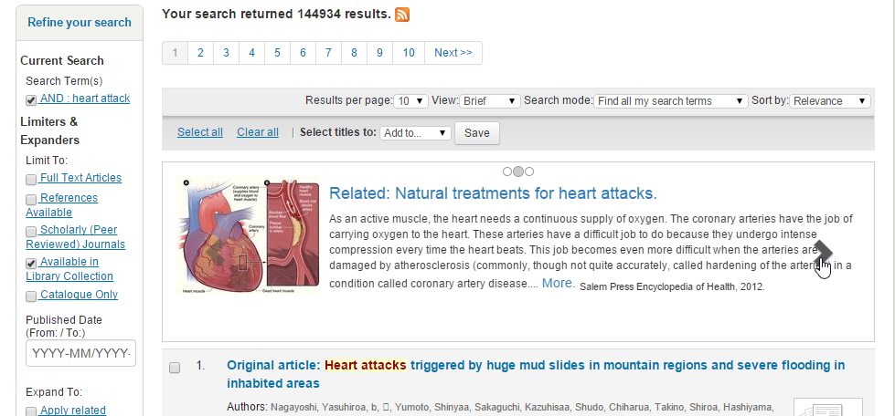

Visit the below URL to learn more about Research Starters.

<http://support.ebscohost.com/knowledge_base/detail.php?topic=996&id=6951&page=1>