Inspector Team: Bytes & Fabric Devs
Inspected Team: Infinite Loops
Code Observations

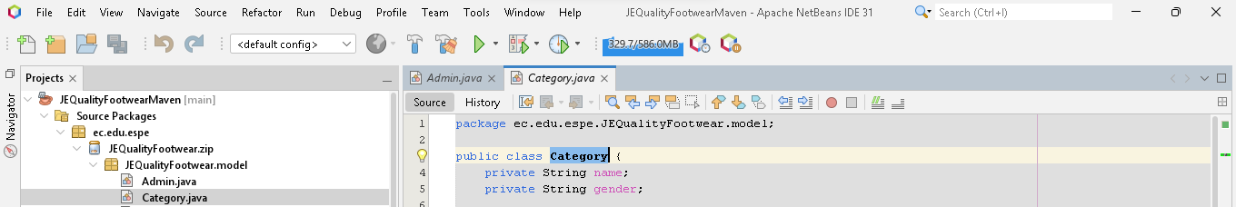
Category of what?

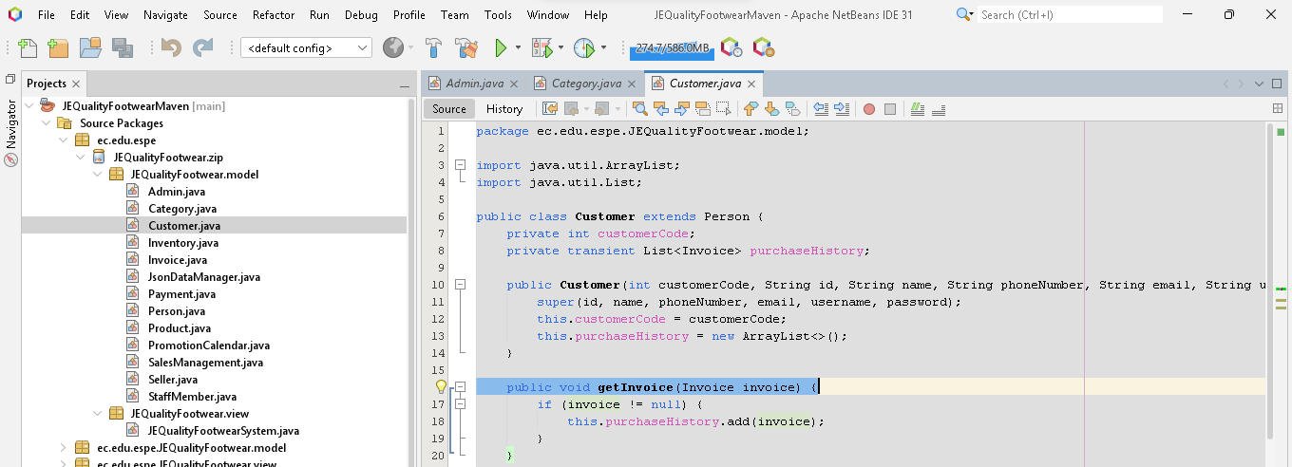
Bill could be better name in this case

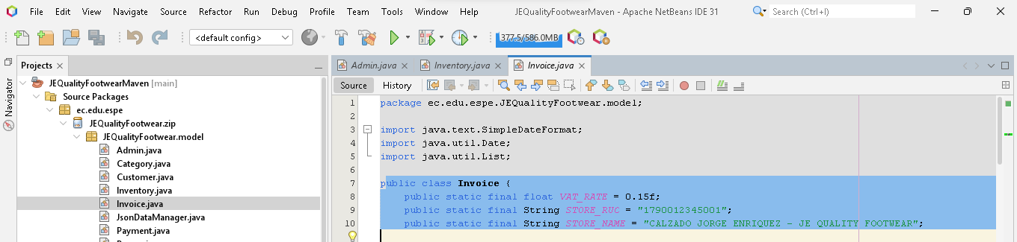
Bill could be a better and understandable name

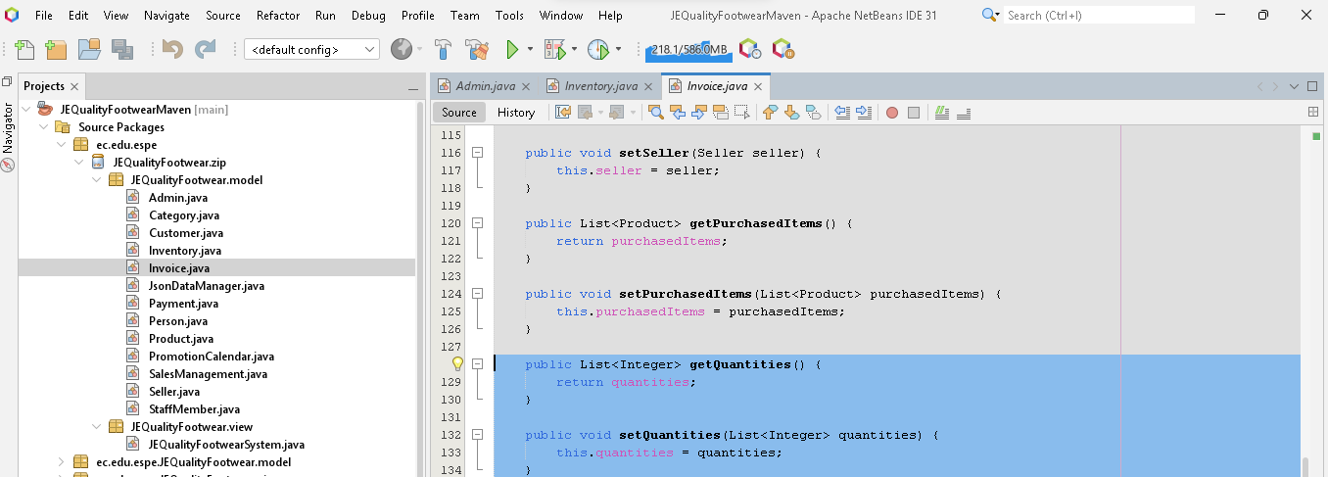
Quantity of what? please be more specific

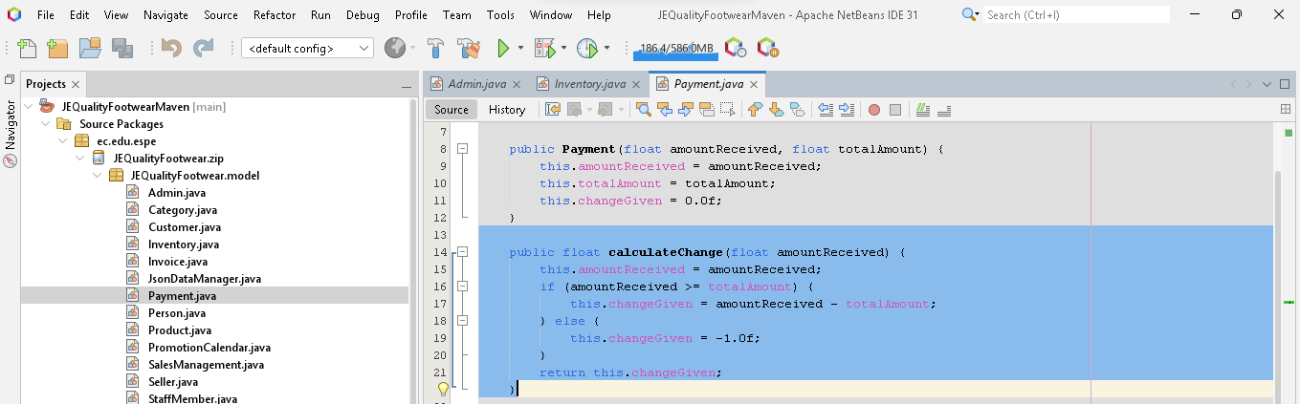
Change of what?

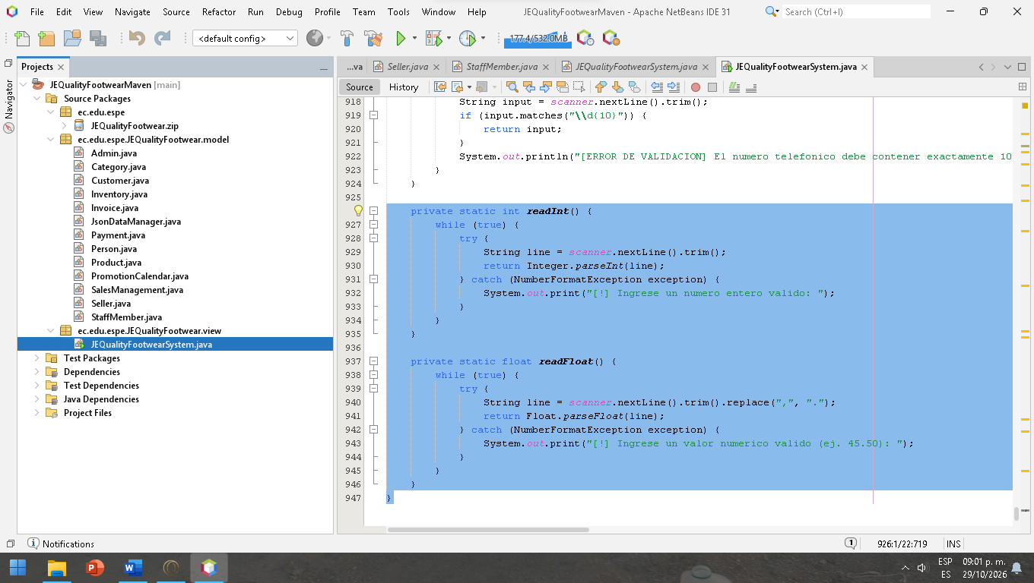
Too much lines in the main, we recommend to divide the main in subclasses

