

Universidad de las Fuerzas Armadas ESPE

DEPARTMENT OF COMPUTER SCIENCE

Object-Oriented Programming

Edison Lascano PhD

NRC: 36862

MEMBERS: Bonilla Alejandro, Chacualan Henry, Clavón David

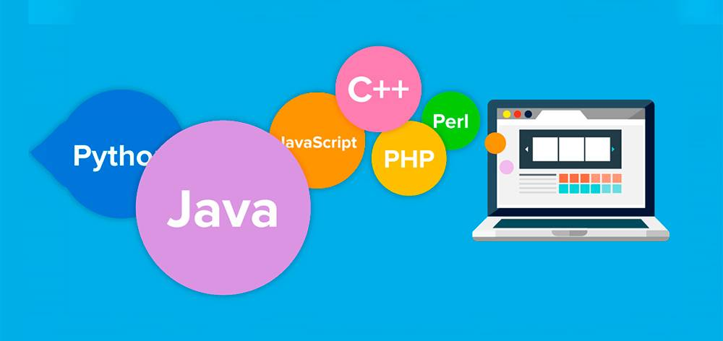
Problem
At Jorge Enríquez Footwear, business growth requires moving beyond manual work methods. Currently, the store operates without an integrated platform that connects customer service at the counter with central inventory control. This disconnect creates several operational challenges:
Lack of user profiles: There is no clear distinction or digital record of the staff members involved in the store’s operations
Uncategorized inventory: Although the variety of merchandise is known dress shoes, athletic shoes, children’s shoes, and leather goods, the products are not formally classified in the system. This prevents the generation of turnover metrics by model and complicates scheduled restocking with manufacturers or suppliers.
Error-prone checkout process: Since there is no automatic stock update at the point of sale, checkout is slow and requires manual verification.
Best-selling products: Production could be optimized by knowing which products are the best sellers in the market, so a way to correctly identify them is needed.
- Overview
The proposal involves implementing a Sales Management System tailored to Jorge Enríquez’s needs. The software will centralize business information in a single, user-friendly environment.
Its main features include:
Smart Cataloging: Categorize footwear and identify exactly which products sell best.
Direct Billing: Recording sales by linking the customer to the cashier on duty and immediately deducting the sold merchandise from inventory.
Payment Methods: Managing collections through “electronic” invoices.
With this approach, management gains full visibility into daily performance, and customers receive a more efficient and transparent service.
- Background
The heart of the system is the seamless transition from product selection to completing the sale:
Footwear/Accessories Selection: The user browses the catalog for items.
Invoice Generation: The system immediately checks stock availability and calculates the total amount.
Payment Method Selection:
Cash Payment: The customer enters the amount paid, and the system automatically calculates the exact change to be given.
Bank Transfer: The receipt number or reference number for the bank transaction is requested and stored.
Stock Write-Down and Closure: The system deducts the units sold from the total inventory and issues the final receipt/invoice.
- Analyst Comparison
To ensure clean, structured, and easy-to-maintain code, the system will be built using:
Base Structure (Person): We create a general Person class to store shared data (ID number/RUC, name, phone number). The Client class (with its purchase history) and the Cashier class (with its shift and employee ID) are derived from this class.
Dynamic Payment Handling (ProcessPayment): We define a generic payment method that changes its behavior:
If it receives an object of type CashPayment, it requests the amount handed over by the customer and returns the exact change.
If it receives an object of type BankTransfer, it requests and stores the bank reference code/number.
Inventory Protection (Product): Critical attributes such as currentStock or price are modified only through authorized methods, preventing the sale of out-of-stock products.
Relationship Organization (Invoice, Category, and Supplier):
Products are associated with a Category (e.g., Dress, Shoes, Boots)
The Invoice consists of the selected items and links the Customer to the Cashier who processed the transaction.

CLASS FOR OBJECTS – LIST OF POSSIBLE OBJECTS

- Person
- Customer
- staff members
- Cashier
- Admin
- inventory / stock
- Footwear
- Men Footwear
- Boots
- Sneakers
- Sandals
- Shoes
- Women Footwear
- Boots
- Ankle Boots
- Sneakers
- Sandals
- Sneakers
- Heels
- Shoes
- Children Footwear
- Shoes
- Accessories
- Wallets
- Purses
- Belts
- Straps
- Backpacks
- Payment Method / Payment
- Cash Payment
- Invoice
- Sales Management
- sale / sales

