

Universidad de las Fuerzas Armadas ESPE

DEPARTMENT OF COMPUTER SCIENCE

Object-Oriented Programming

Edison Lascano PhD

NRC: 36862

MEMBERS: Bonilla Alejandro, Chacualan Henry, Clavón David


- AdminTest.java
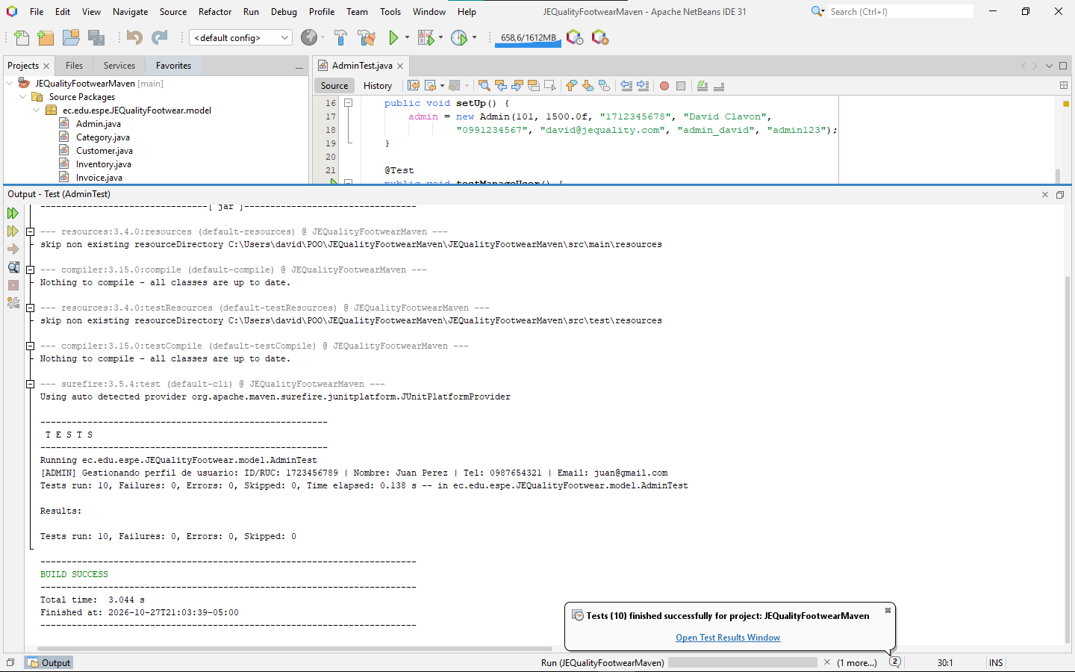

- CategoryTest.java
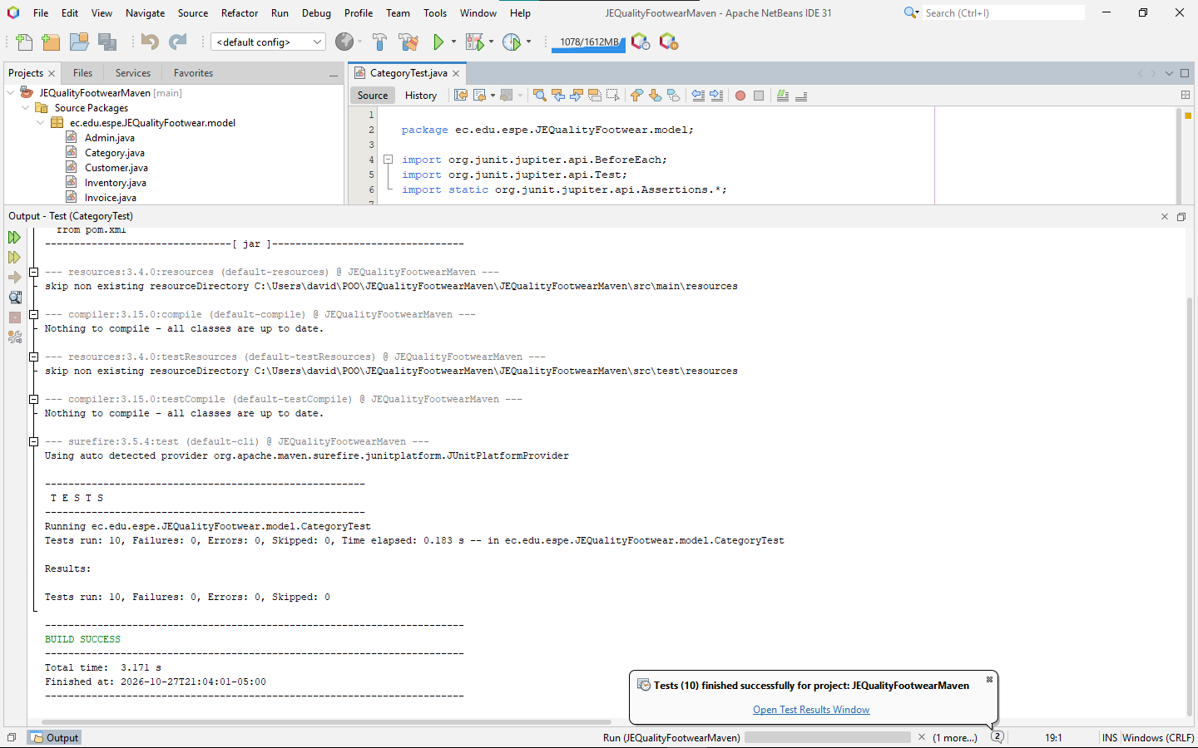

- CustomerTest.java
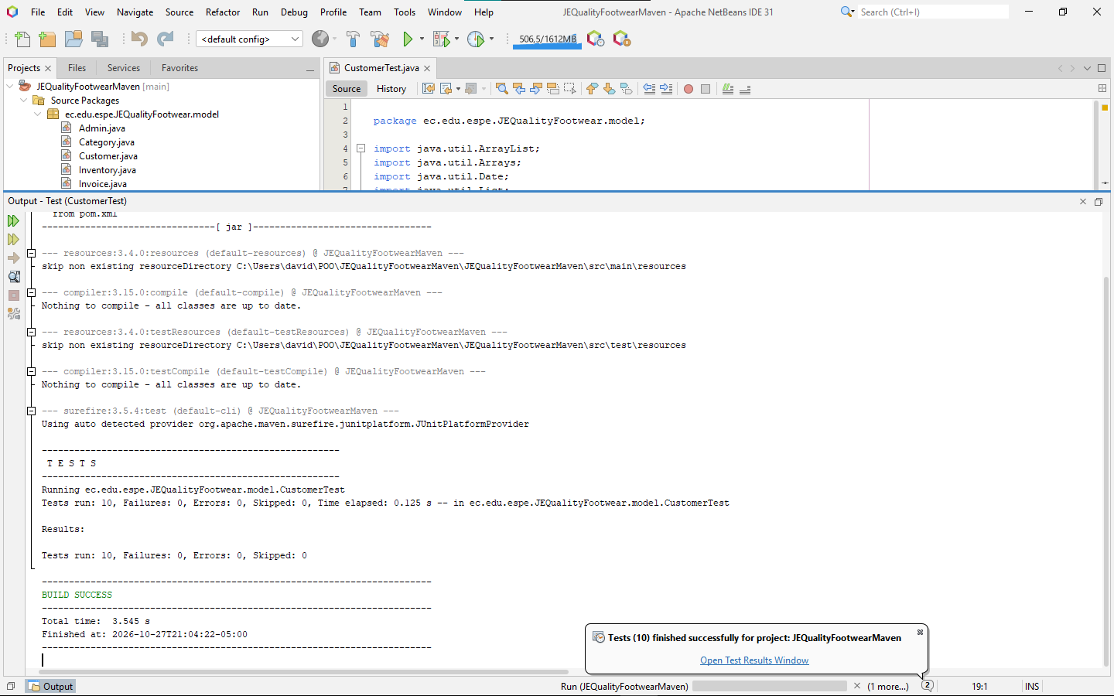

- InventoryTest.java
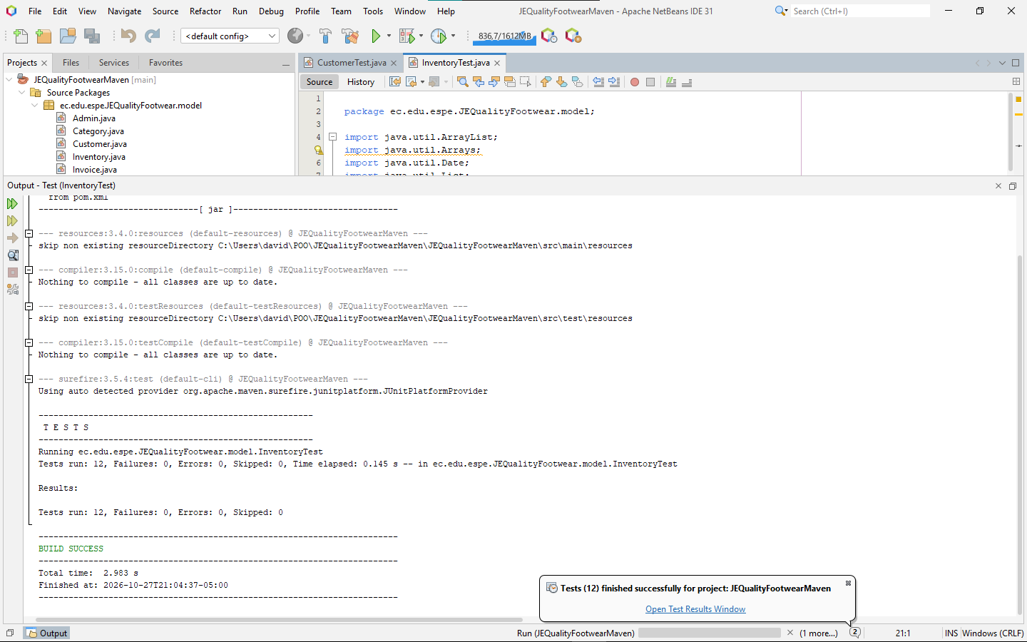

- InvoiceTest.java
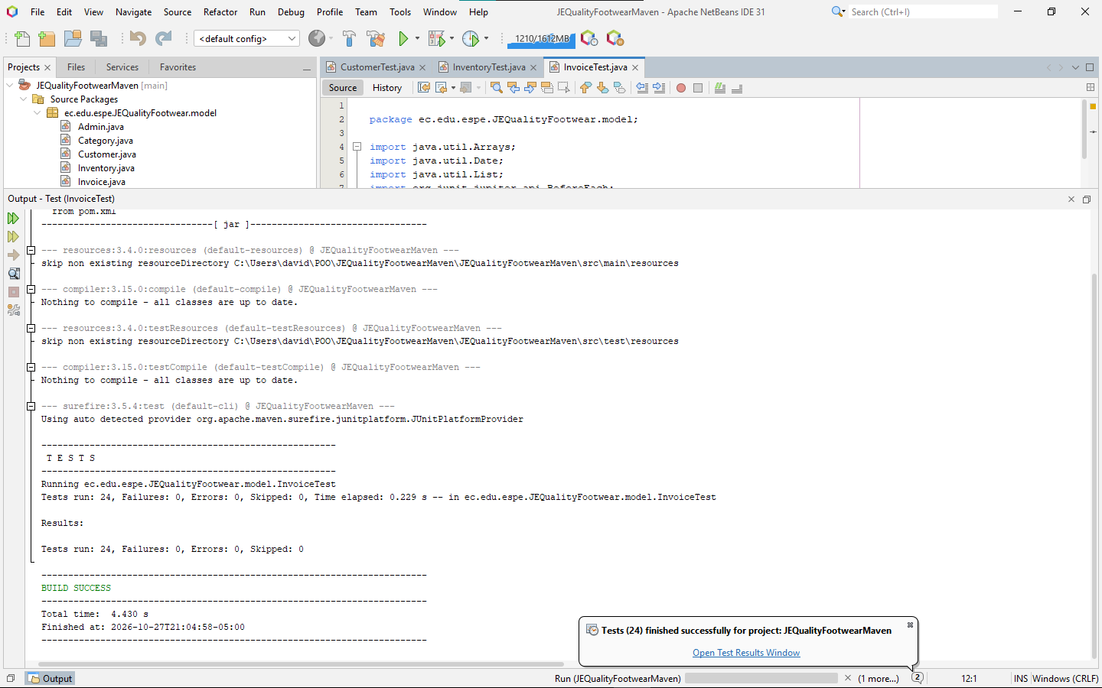

- PaymentTest.java
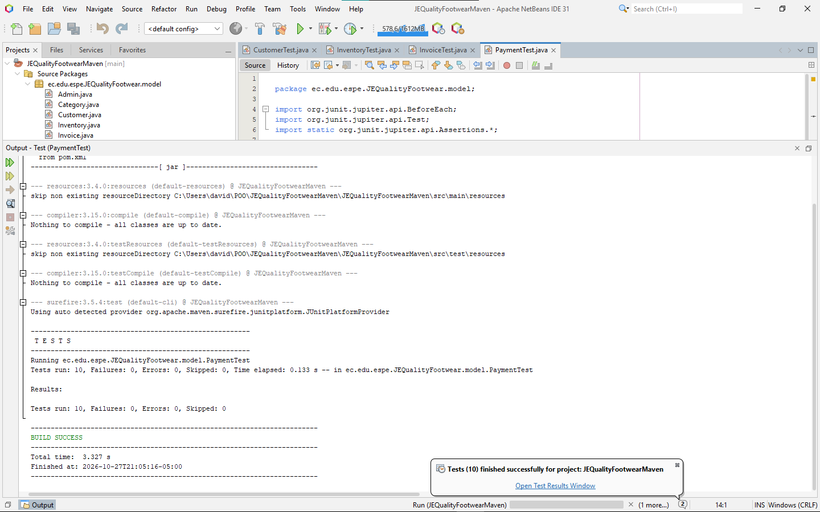

- PersonTest.java
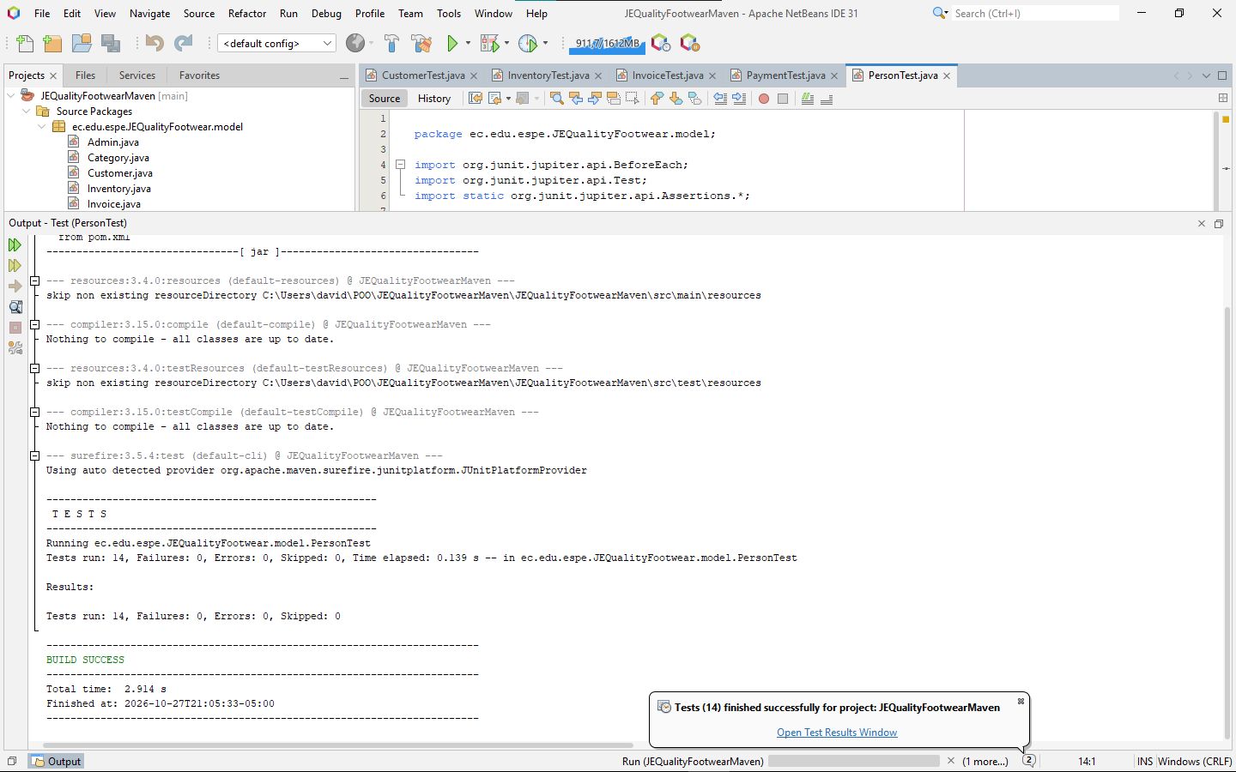

- ProductTest.java
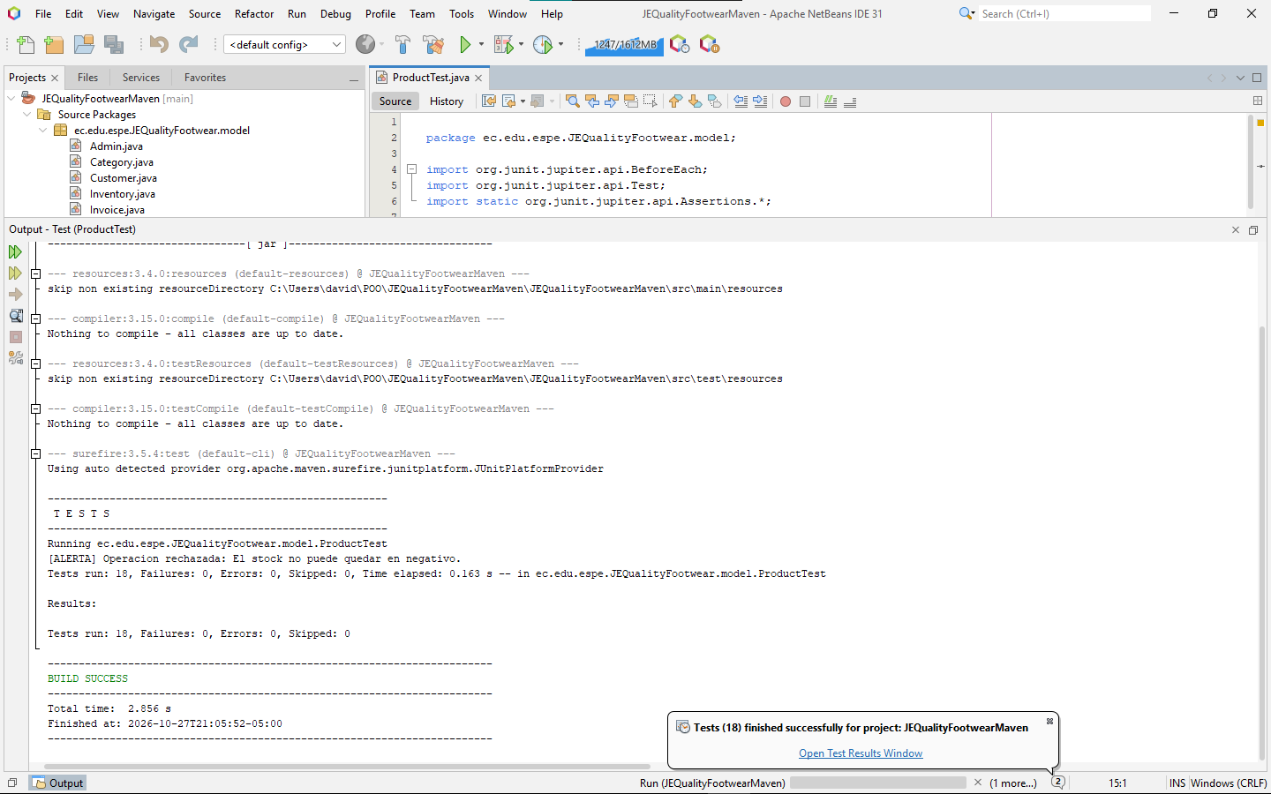

- PromotionCalendarTest.java
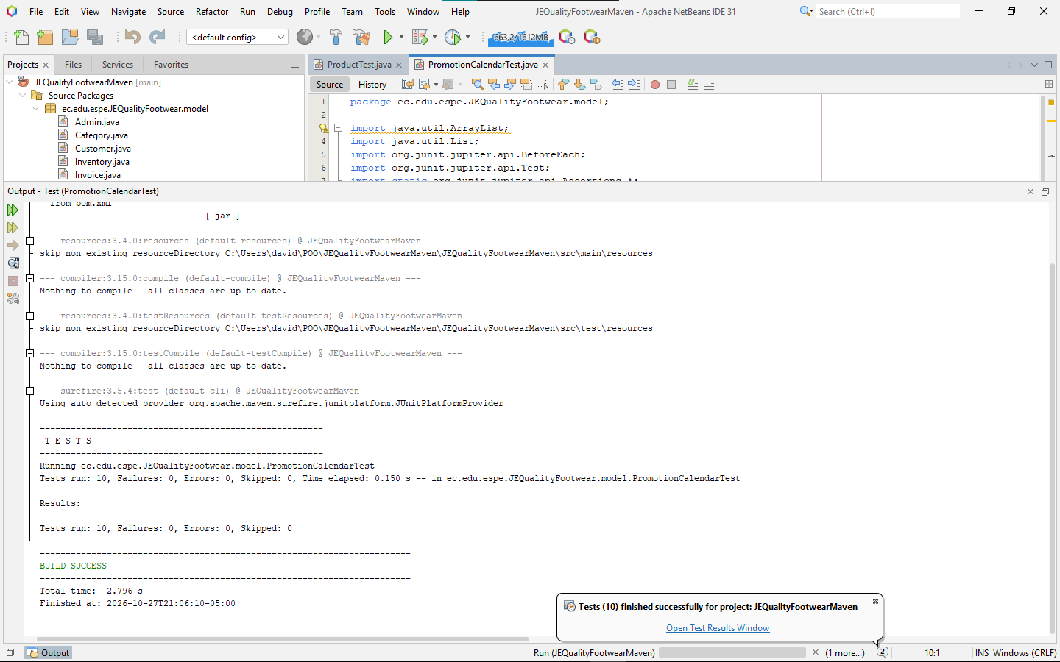

- SalesManagement.java
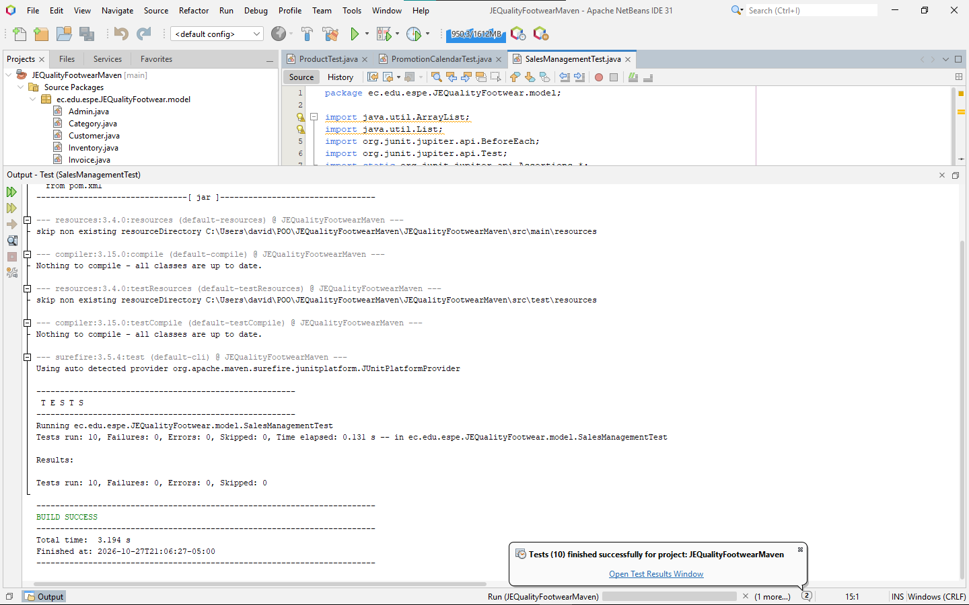

- SellerTest.java
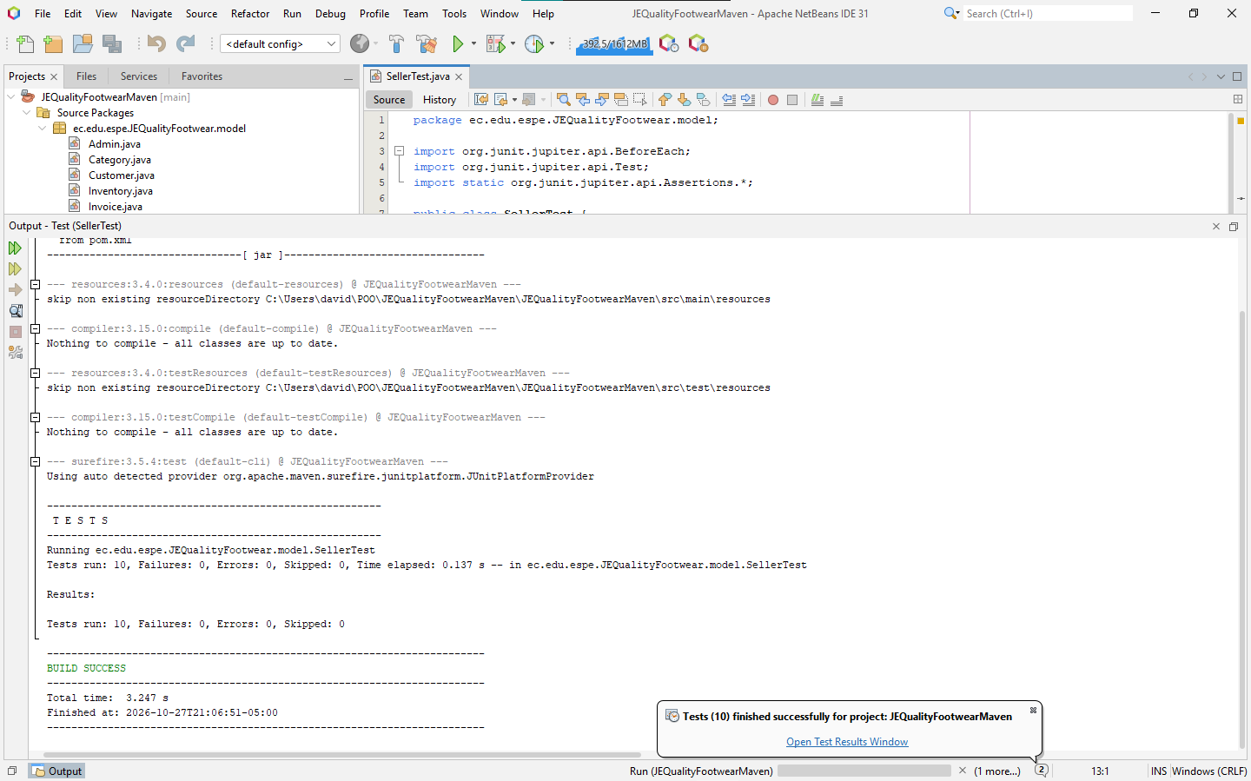

- StaffMemberTest.java
