**Meeting: 3 18/04/2021**

**Second Meeting**

**Agenda:**

**Project Report**

Rough ‘literature review’ and introduction formed this week, focusing on what are hurricanes and external information about the visualization of hurricanes from the nhc. Background on gis, what is it and how did it come to be?

* This week
  + What I aimed for
    - Literature review
      * Hurricanes
      * Basics of gis
      * Basics of uncertainty
    - Update gannt chart
  + What I did
    - Updated gannt chart
      * Added new events
      * Re organised events
    - Initial back ground reading on
      * Hurricanes
      * Gis
    - Initial writing on
      * Hurricanes 4 pages
      * Gis 1 page
      * Uncertainty – notes only
* Next week
  + Aims
    - Finifh of gis literature review
    - Concentrate upon uncertainty
    - Review material upon types of vizulization

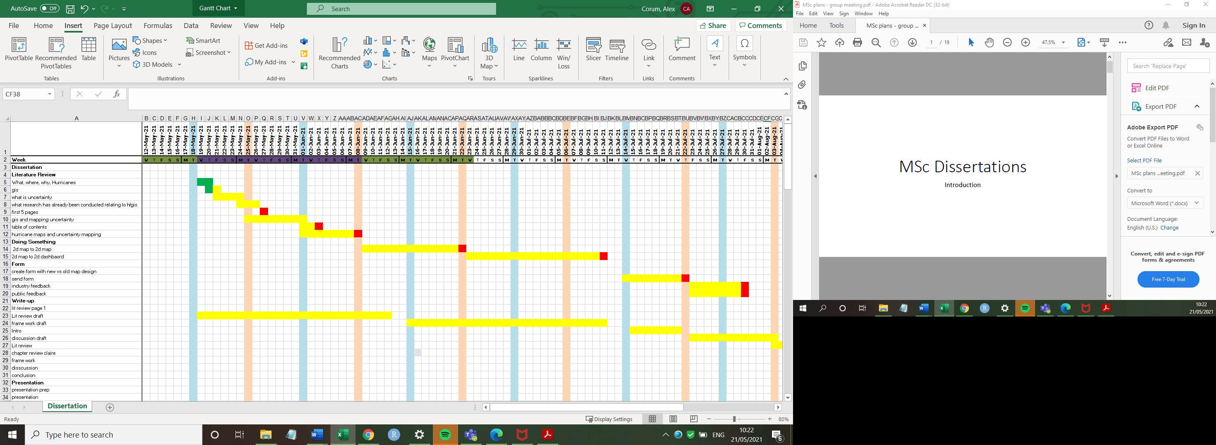**Example Gantt chart** updated v 2.0(21/05/21)