Ghghghg

In 2020, we were bombarded with maps—but maps can lie. When communicating an issue that is as complicated, as delicate, and as uncertain as COVID-19, data visualizations must be clearer than ever to ensure the right message is communicated to the audience. This project investigates the wider issue of communicating uncertainty through maps, from issues such as climate change to catastrophe modelling to modelling a global pandemic. The focus is on cartography and the visualisation of uncertain geographic phenomena.

RMS whislist

* Tom sabertelly?
  + Event response?
  + Uncertainty cone with event response cone, contentualze how rms communicate uncertainty. E.g. hurricane hurricane cone.
  + Taking text to dynamic image
  + Dynamic portal compared to pictue
  + Build a dynamic portal from static text to
  + Compare to current industry what is going on?
* Where do I position my research
  + Geospatial to solve something
    - Influences from congnative
  + Eliminated namesd users
  + How does RMS vizulize

Soooo

* Literature view on how vizulasion is used congativably to make it easier to understand
* Meat of the work – creating eh improved visualisation
* Final – get feedback from industry/public
* Bonus – extra hazards
* Bonus – how do other cultures.
* Picking the best hurricane?
  + Laura
  + Valadte for rms use cases ? nda?
* Supervision over the summer….. 30 min a week evey 2 weeks.
* Week of the 21th – dig into the literature and

Meeting

* Whats the outcome, what do we want to achive?
* Format … website? Set of visualised maps?
  + Creating a set of map visualizations
  + Web visualizations
* For what? Natural hazard? How broad? Volcanic eruptions? Earthquakes?
  + Ethics review for working with people?
  + Online questionnaire
    - Feedback through anonymous review.

Visualisation is very individual – each map is its own

#### How do you make that information useful for decision making? How do you make that information useful for actually informing a response?"

Uncertainty

‘uncertainty itself is an ill-defined

concept, with distinction between it and related

concepts such as data quality, reliability, accuracy,

and error often remaining ambiguous.’

we lack methods for measuring

and representing many aspects of uncertainty

in a GIS database.

* Unkonw error, e.g. we know its not wright, but we also don’t know hwo wrong it could be
* Accuracy positional and attribute
* Precision
* Report accuracy or report error (good or bad)
* Maps are not numerical

Project – ideal natural disasters – volcanic eruptions

Webmapping

Define

* Uncertainty
* Visualisation
* Singular topic e.g. natural hazards
  + Earthquakes

Out come

* Creatinga method to measure uncertainty
* Discovery of techqnuies or set of rules to follow to visualise uncertainty
* Feedback from populations – frame work to conduct a study into how to vizulize uncertainty
* List of risks and the ways that they are uncertain

vizulzation

* Maps can lie
  + Distance
  + Elevation
  + Scale
  + Cloropleth maps, sudden changes at boundaries
  + Point data is only point data – cant really be extrapolated
* Scientific knowledge it hard to understand
  + Correct language to use?
  + Colour schemes
    - Colour theory
    - Basic colour corolatation e.eg. red means danger
  + Explaining with images not words
* Standardizing symbolization techniques
* Dizasters are uncertain

Temporal vizulization

* Hazards at 4d changing rapidly through time,

#### We have to create a single suite of products that accurately addresses all their varied needs in a timely manner.

he clients would rather start working with imperfect information rather than waiting.

Decision making

* Needs to be clear
* Prevent actions being taken or not take due to uncertain data
* Protect your self from bad decision making

#### But the problem we have is the crying wolf and we are only as good as our last forecast. What do we do if we do it eight times and nothing happens? That’s the biggest challenge.

Books

Risk, Governance and Society

Visualizing Geospatial Information Uncertainty:

What We Know and What We Need to Know

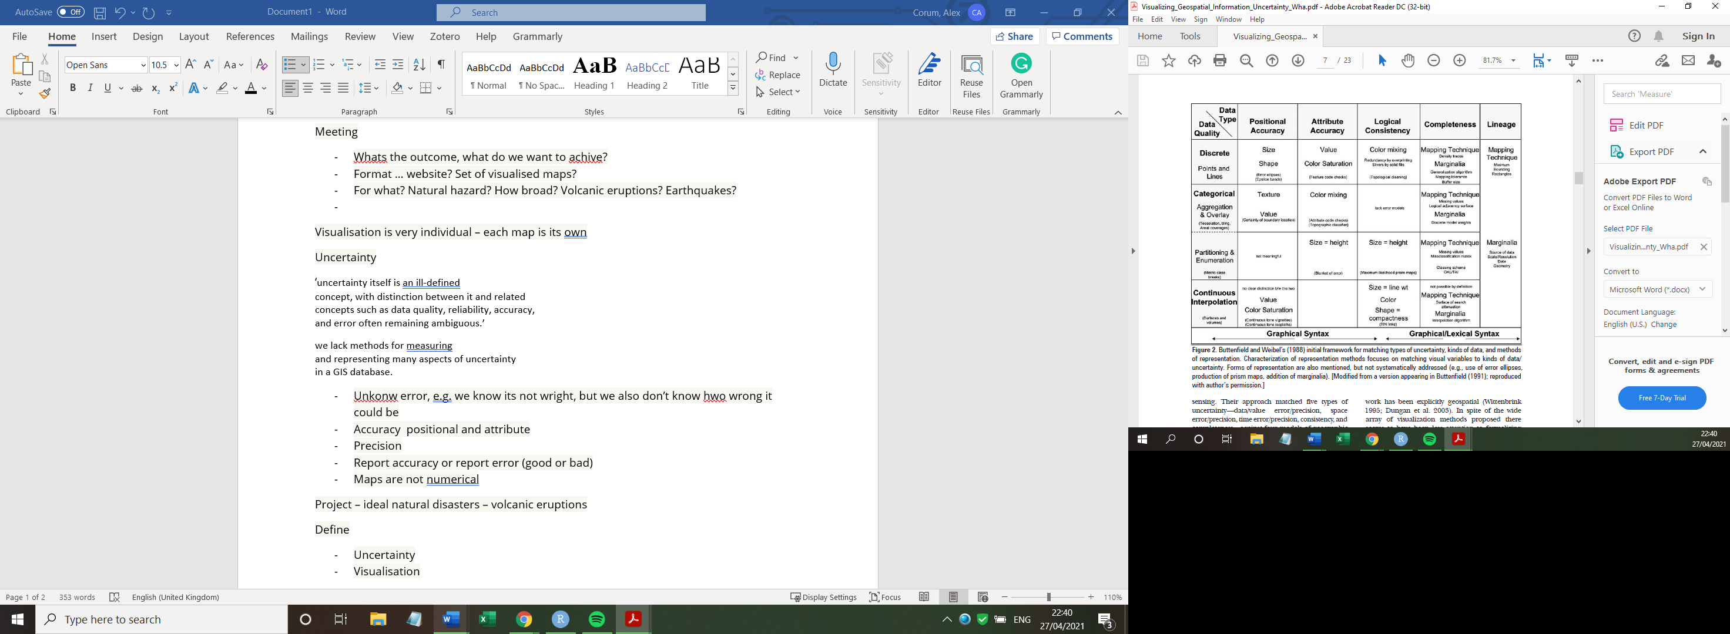

Bertin’s (1983) visual variables

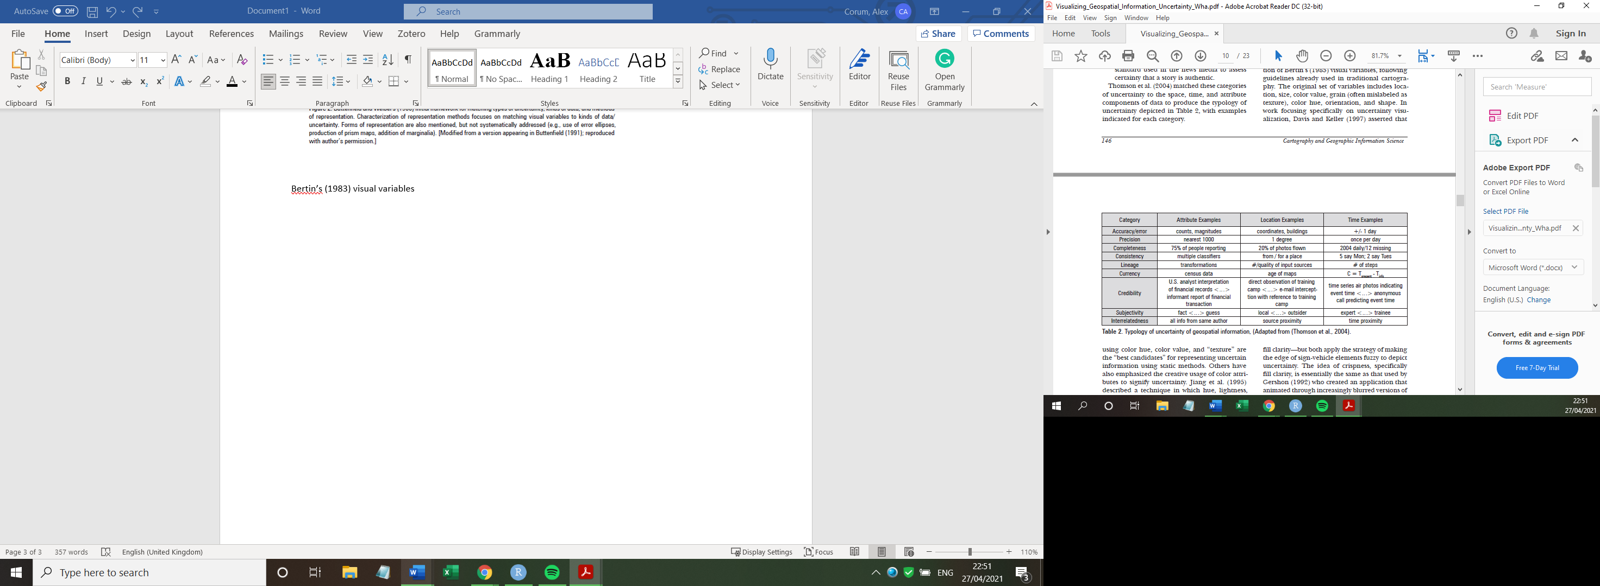

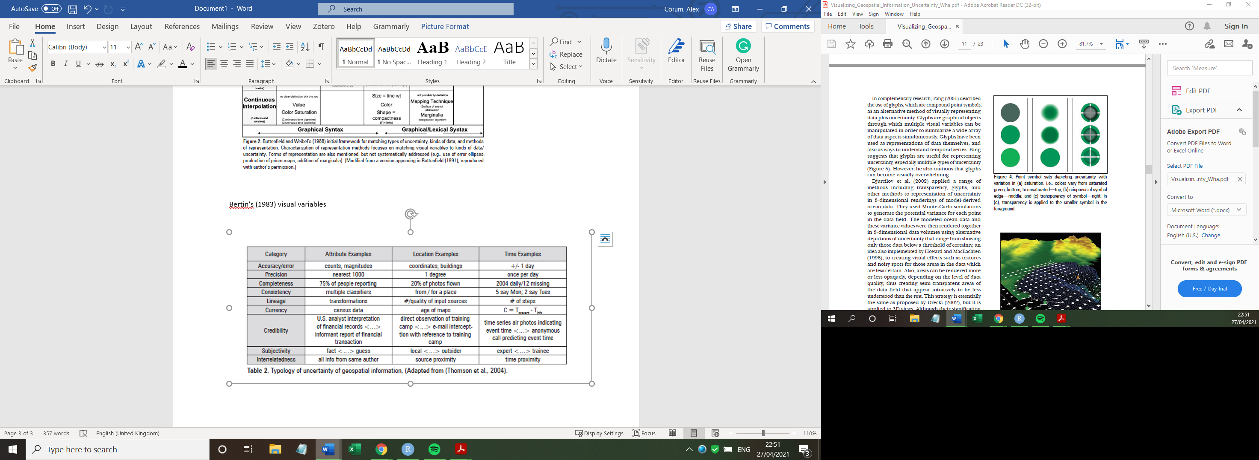

*Understanding the components of uncertainty and*

*their relationships to domains, users, and information*

1. *needs*—

*Understanding how knowledge of information*

*uncertainty influences information analysis, decision*

1. *making, and decision*

*Understanding how (or whether) uncertainty*

1. *visualization aids exploratory analysis*

*Developing methods for capturing and encoding*

1. *analysts’ or decision makers’ uncertainty*

*Developing representation methods for depicting*

1. *multiple kinds of uncertainty—*

*Developing methods and tools for interacting with*

1. *uncertainty depictions*

*Assessing the usability and utility of uncertainty*

*capture, representation, and interaction methods*

1. *and tools*—

<https://www.esri.com/arcgis-blog/products/story-maps/3d-gis/using-3d-data-to-understand-hurricane-patterns/>

<https://www.forbes.com/sites/marshallshepherd/2015/08/28/why-is-tracking-a-hurricane-easier-than-predicting-its-intensity/>