How to embed pyqtgraph in PyQt5 GUI
step 1:
Open PyQt5 Designer
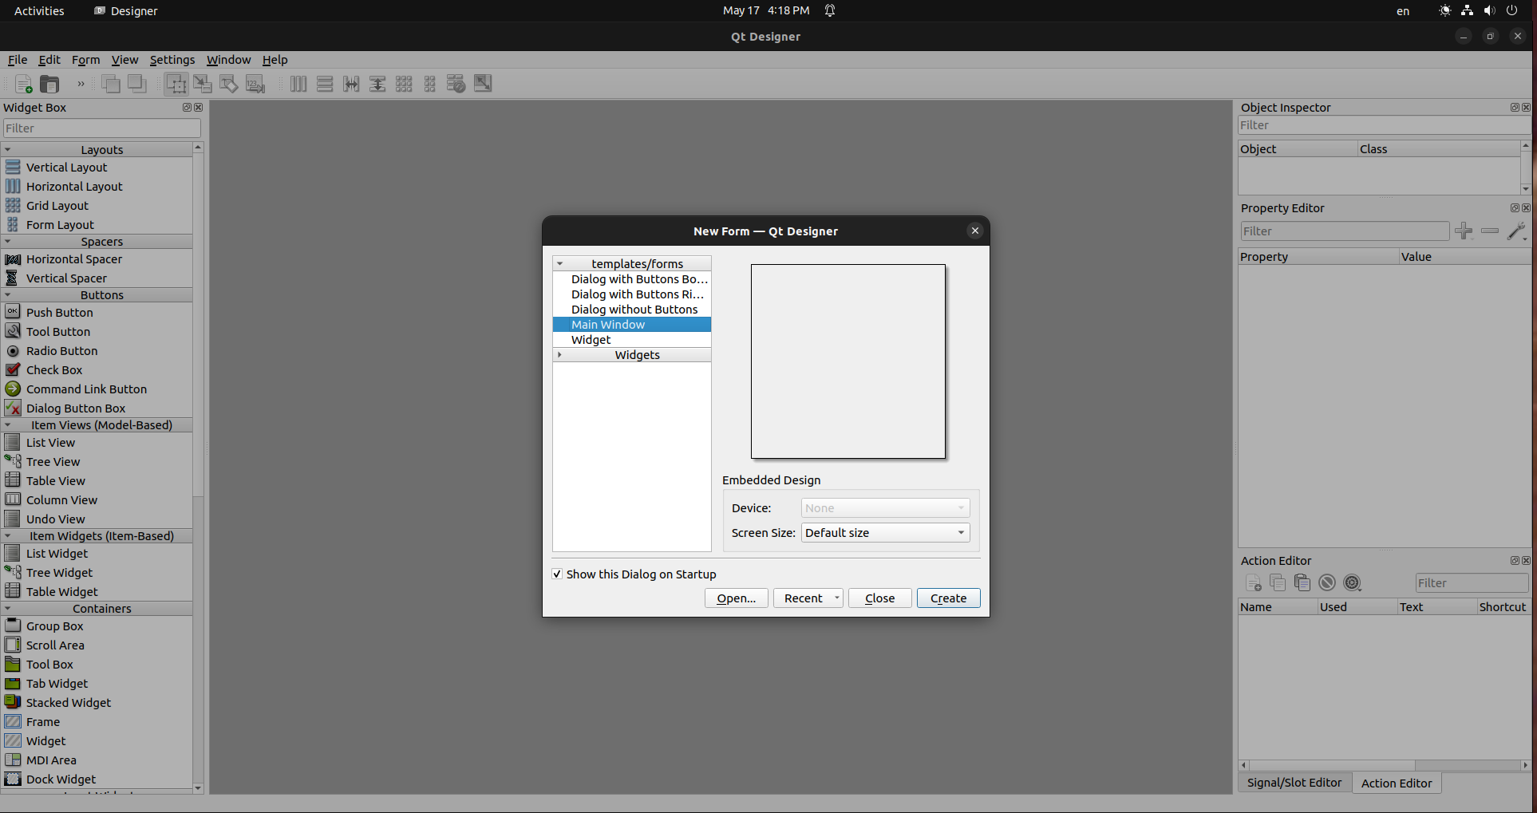

\

Choose Main Window, Then Press Create

step 2:
Choose A Widget

for this example I used a QGraphicsView

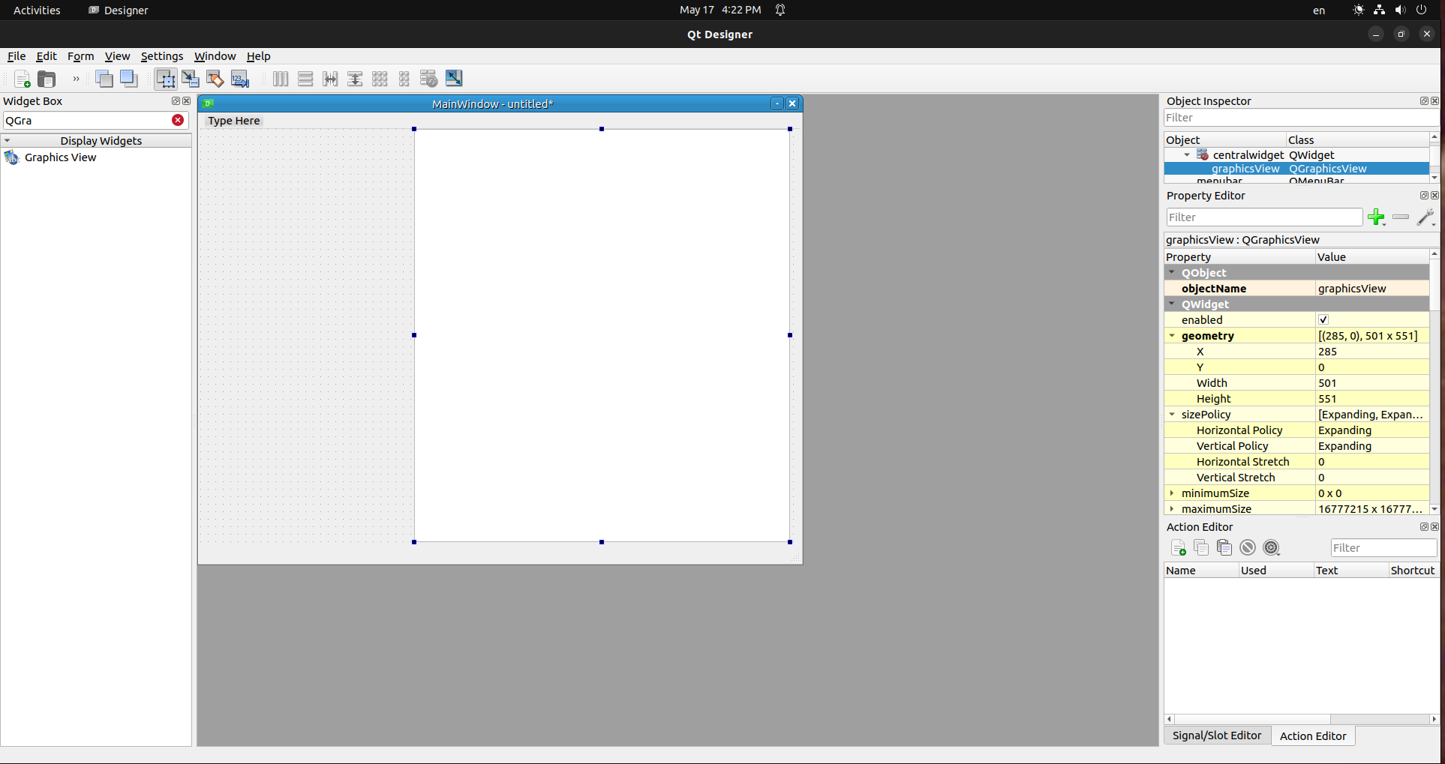
Drag it onto the GUI and expand it to your liking

step 3:
Promote the widget

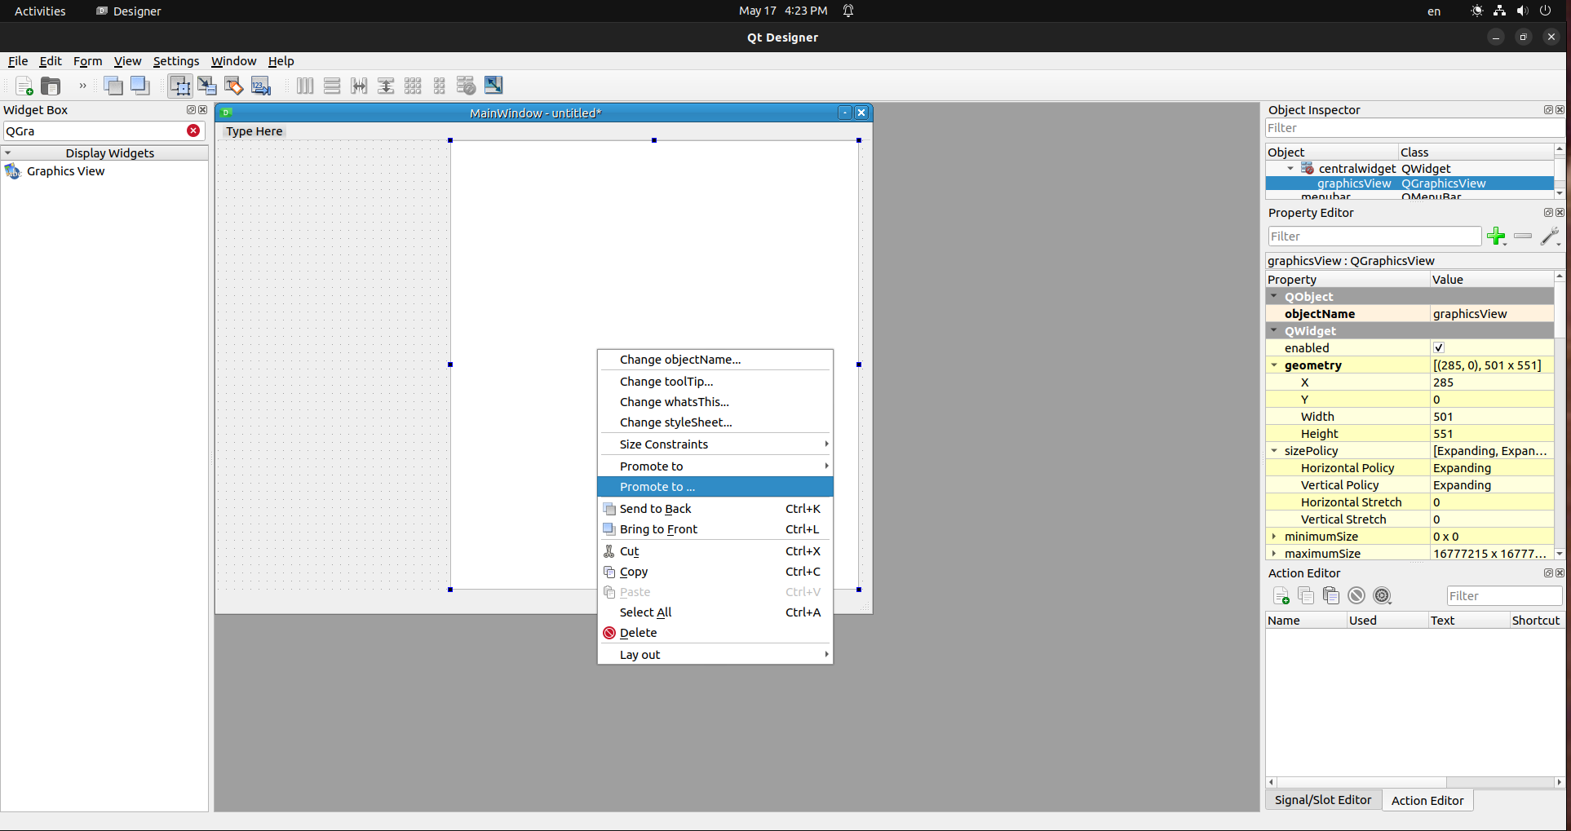
To promote the widget just right click on the widget and press “Promote to…”

step 4:
Promotion Settings
before all this you might want to rename the Widget to plotWidget

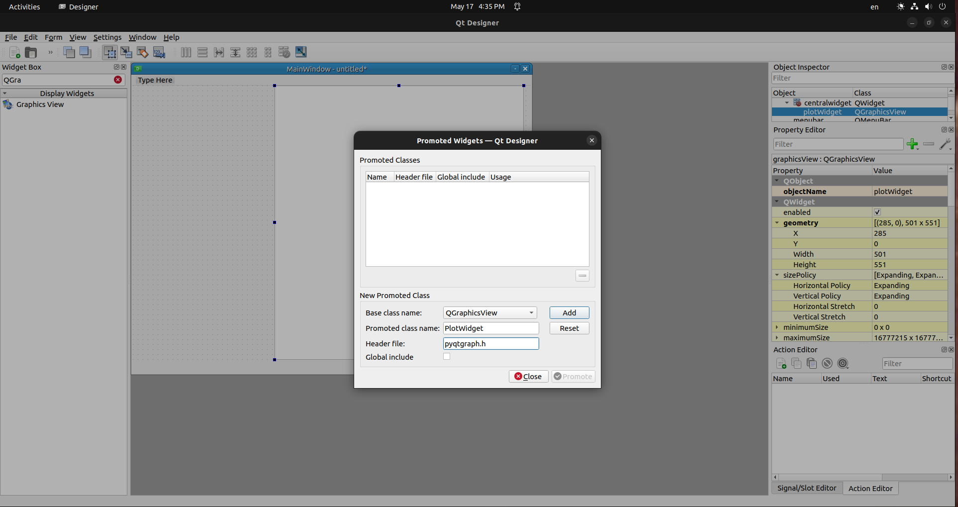
keep the base class name to WhateverTheWidgetis but I used QGraphicsView
set promoted class name to PlotWidget
and set the header file to pyqtgraph.h

then press add then promote

step 5:
Last Step
save it as whatever you want, but I will name it template.ui

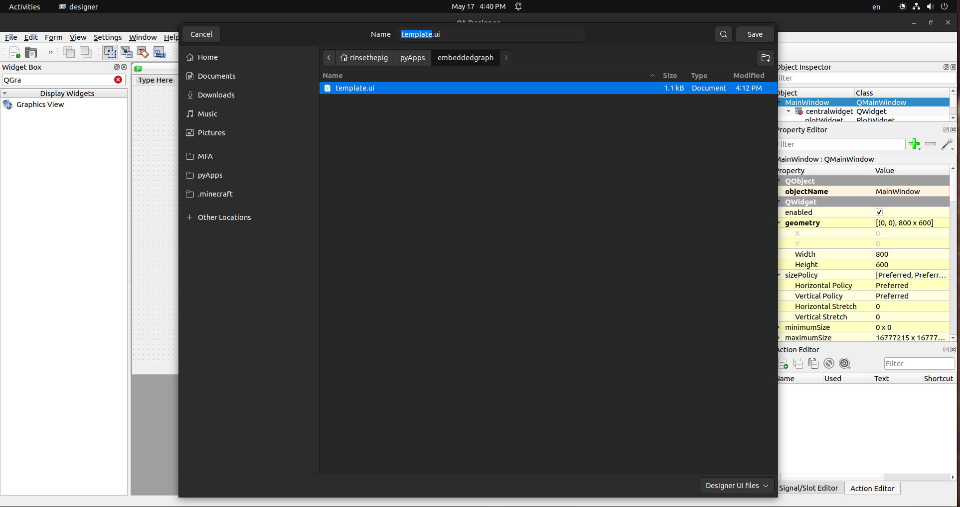
then locate the directory of the .ui and do
pyuic5 -x /yourdirectory/template.ui -o /yourdirectory/template.py

then you should see the file “whatyounamedyourui.py”
for me it is “template.py”
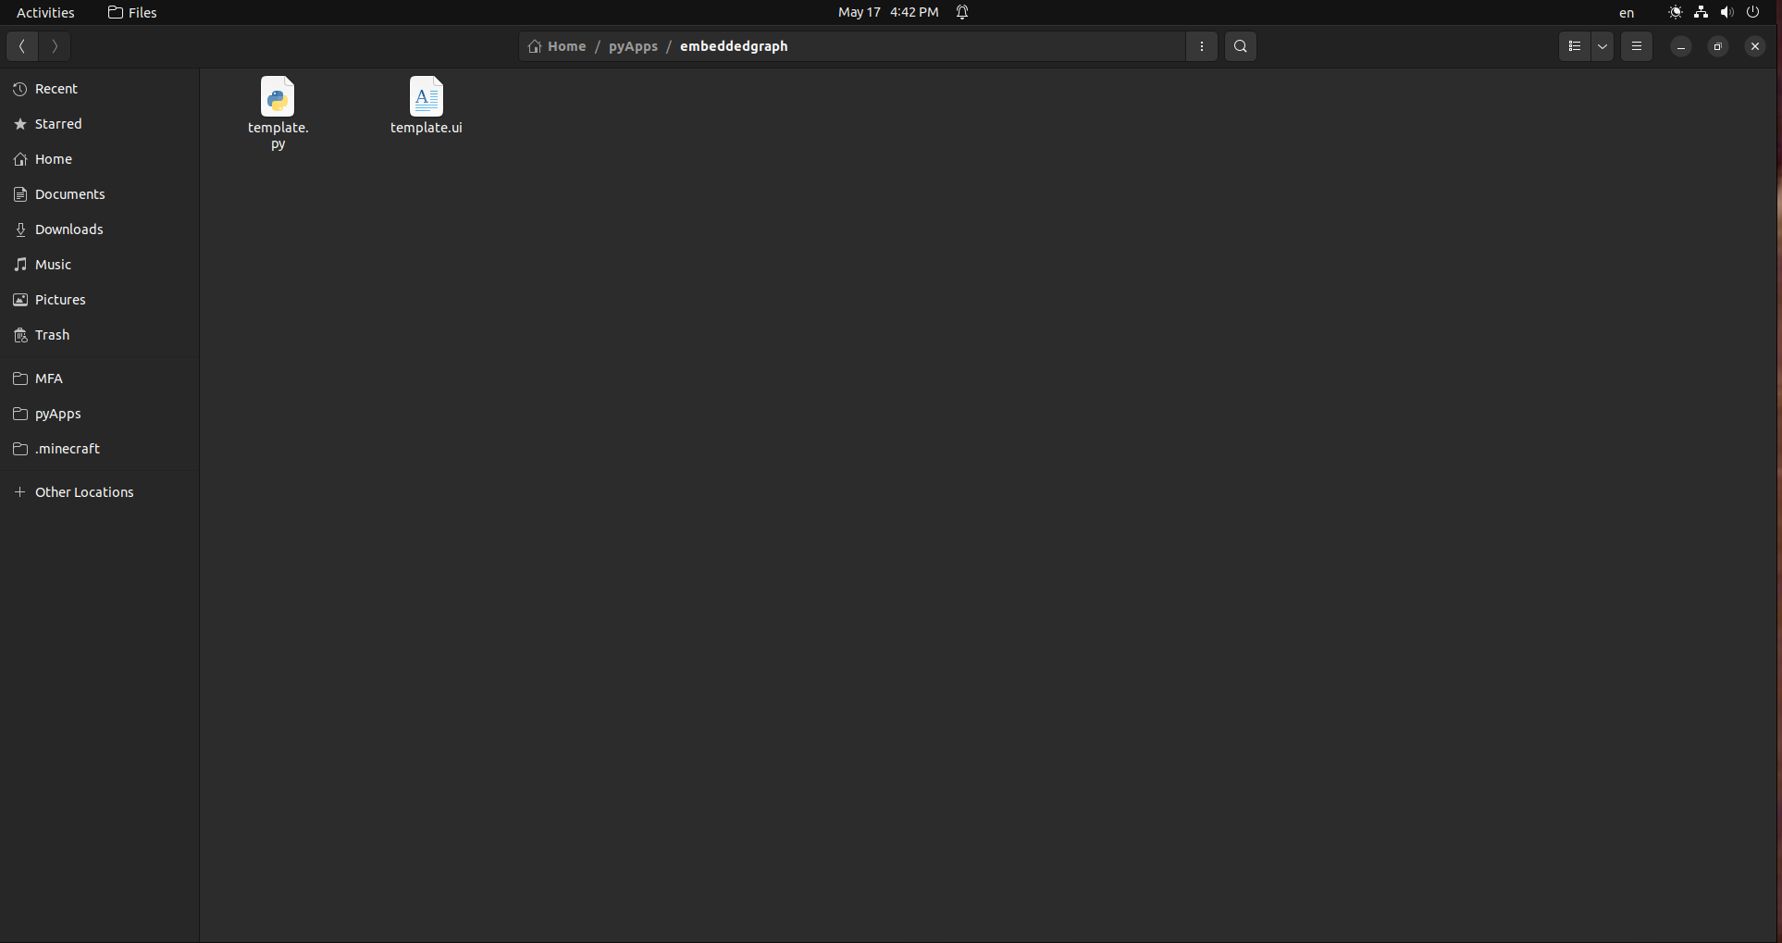

now open your IDE, im going to use spyder, and run the file, you should see an embedded graph in it

