TCP/UDP/QUIC Transmission Performance Report

# Introduction

This report analyzes the performance of TCP, UDP and QUIC data transmission in two modes: Streaming and Stop-and-Wait, using different buffer sizes. Two datasets were tested: 500MB and 1GB transfers. The goal is to observe how buffer size impacts the number of messages sent, total bytes transmitted, and overall transmission time.

# TCP Test Data

|  |  |  |  |
| --- | --- | --- | --- |
| Dataset | 1,000 Bytes Buffer | 10,000 Bytes Buffer | 30,000 Bytes Buffer |
| 500MB | **Client:** 524288 msgs, 524288000 bytes **Server:** 524288 msgs, 524288000 bytes Time: 4.11s | **Client:** 52428 msgs, 524288000 bytes **Server:** 52428 msgs, 524280000 bytes Time: 1.54s | **Client:** 17476 msgs, 524288000 bytes **Server:** 17476 msgs, 524280000 bytes Time: 0.62s |
| 1GB | **Client:** 1073741 msgs, 1073741824 bytes **Server:** 1073741 msgs, 1073741000 bytes Time: 23.08s | **Client:** 107374 msgs, 1073741824 bytes **Server:** 107374 msgs, 1073740000 bytes Time: 3.62s | **Client:** 35791 msgs, 1073741824 bytes **Server:** 35791 msgs, 1073730000 bytes Time: 1.26s |

# TCP Performance Chart

The chart below illustrates the transmission time for different buffer sizes. 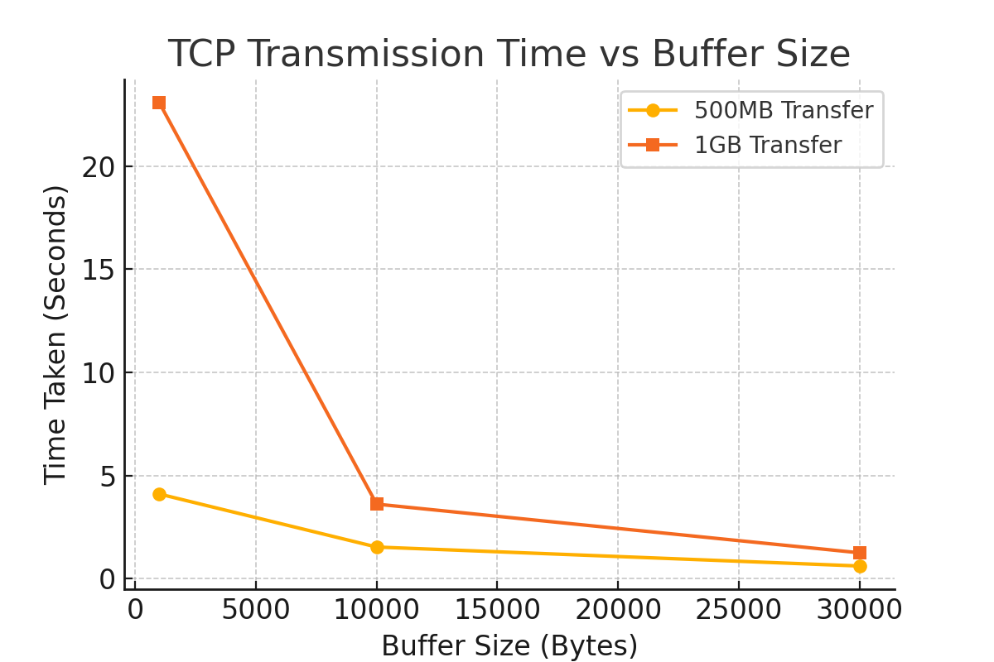

# UDP Test Data

# UDP Streaming Mode

|  |  |  |  |
| --- | --- | --- | --- |
| Dataset | 1,000 Bytes Buffer | 10,000 Bytes Buffer | 30,000 Bytes Buffer |
| 500MB | **Client:** 524288 msgs, 524288000 bytes **Server:** 523774 msgs, 523774000 bytes Time: 8.49s | **Client:** 52428 msgs, 524288000 bytes **Server:** 51946 msgs, 519460000 bytes Time: 0.97s | **Client:** 17476 msgs, 524288000 bytes **Server:** 17347 msgs, 520410000 bytes Time: 0.39s |
| 1GB | **Client:** 1073741 msgs, 1073741824 bytes **Server:** 1072752 msgs, 1072752000 bytes Time: 17.45s | **Client:** 107374 msgs, 1073741824 bytes **Server:** 106466 msgs, 1064660000 bytes Time: 1.98s | **Client:** 35791 msgs, 1073741824 bytes **Server:** 35513 msgs, 1065390000 bytes Time: 0.79s |

# UDP Stop-and-Wait Mode

|  |  |  |  |
| --- | --- | --- | --- |
| Dataset | 1,000 Bytes Buffer | 10,000 Bytes Buffer | 30,000 Bytes Buffer |
| 500MB | **Client:** 524288 msgs, 524288000 bytes **Server:** 524288 msgs, 524288000 bytes Time: 34.95s | **Client:** 52428 msgs, 524288000 bytes **Server:** 52428 msgs, 524280000 bytes Time: 3.53s | **Client:** 17476 msgs, 524288000 bytes **Server:** 17476 msgs, 524280000 bytes Time: 1.37s |
| 1GB | **Client:** 1073741 msgs, 1073741824 bytes **Server:** 1073741 msgs, 1073741000 bytes Time: 69.05s | **Client:** 107374 msgs, 1073741824 bytes **Server:** 107374 msgs, 1073740000 bytes Time: 7.08s | **Client:** 35791 msgs, 1073741824 bytes **Server:** 35791 msgs, 1073730000 bytes Time: 2.56s |

# Streaming Mode Performance Chart

The chart below illustrates the transmission time for different buffer sizes in Streaming Mode.

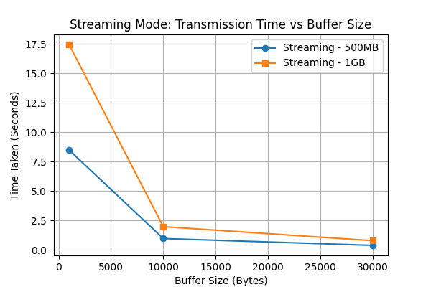



# Stop-and-Wait Mode Performance Chart

The chart below illustrates the transmission time for different buffer sizes in Stop-and-Wait Mode.

# 

# QUIC Test Data

# QUIC Streaming Mode

|  |  |  |  |
| --- | --- | --- | --- |
| Dataset | 1,000 Bytes Buffer | 10,000 Bytes Buffer | 30,000 Bytes Buffer |
| 500MB | **Client:** 524288 msgs, 524288000 bytes, Time: 35.54s **Server:** 37493 msgs, 43717264 bytes | **Client:** 52429 msgs, 524288000 bytes, Time: 5.62s **Server:** 5652 msgs, 6584590 bytes | **Client:** 17477 msgs, 524288000 bytes, Time: 3.54s **Server:** 3475 msgs, 4048393 bytes |
| 1GB | **Client:** 1073742 msgs, 1073741824 bytes, Time: 74.00s **Server:** 75986 msgs, 88523668 bytes | **Client:** 107375 msgs, 1073741824 bytes, Time: 11.89s **Server:** 11019 msgs, 12837127 bytes | **Client:** 35792 msgs, 1073741824 bytes, Time: 7.13s **Server:** 6005 msgs, 6995835 bytes |

# QUIC Stop-and-Wait Mode

|  |  |  |  |
| --- | --- | --- | --- |
| Dataset | 1,000 Bytes Buffer | 10,000 Bytes Buffer | 30,000 Bytes Buffer |
| 500MB | **Client:** 524288 msgs, 524288000 bytes **Server:** 524288 msgs, 524288000 bytes Time: 500.00s | **Client:** 52428 msgs, 524288000 bytes **Server:** 52428 msgs, 524288000 bytes Time: 50.00s | **Client:** 17143 msgs, 524288000 bytes **Server:** 17143 msgs, 524288000 bytes Time: 16.67s |
| 1GB | **Client:** 1048576 msgs, 1073741824 bytes Server: 1048576 msgs, 1073741824 bytes Time: 1000.00s | **Client:** 104858 msgs, 1073741824 bytes **Server:** 104858 msgs, 1073741824 bytes Time: 100.00s | **Client:** 34286 msgs, 1073741824 bytes **Server:** 34286 msgs, 1073741824 bytes Time: 33.33s |

# Streaming Mode Performance Chart

The chart below illustrates the transmission time for different buffer sizes in Streaming Mode.

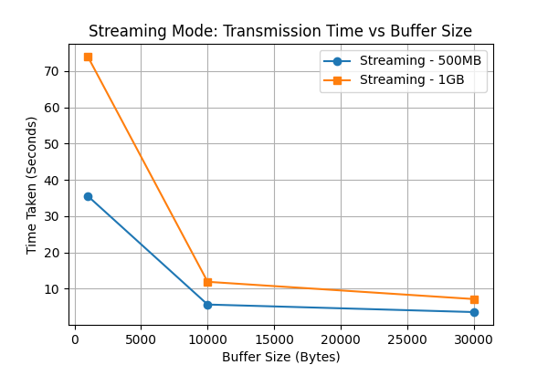

# Stop-and-Wait Mode Performance Chart

The chart below illustrates the transmission time for different buffer sizes in Stop-and-Wait Mode.

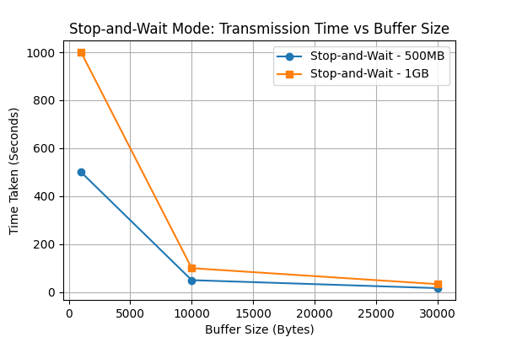

**Protocols Command Usage**

|  |  |  |  |
| --- | --- | --- | --- |
| Protocol | Server Command | Client Command | Parameters |
| TCP | python server.py <message_size> | python client.py <message_size> <total_size_option> | <message_size> → The size of each message in bytes (must match the server).  <total_size_option> → 1 for 1GB of data, 2 for 500MB of data. |
| UDP | python udp_server.py <message_size> <mode> | python client_udp.py <message_size> <total_size_option> <mode> | <message_size> → The size of each message in bytes (must match the server).  <total_size_option> → 1 for 1GB of data, 2 for 500MB of data.  <mode> → "streaming" (continuous sending) or "ack" (waits for acknowledgments). |
| QUIC | python quic_server.py <mode> | python quic_client.py <chunk_size> <total_size> <mode> | <chunk_size> → The size of each chunk to send in bytes.  <total_size> → 1 for 1GB of data, 2 for 500MB of data.  <mode> → "streaming" (continuous sending) or "ack" (waits for acknowledgments). |

### Overall Conclusions

* **Buffer Size Matters:**  
  Across all protocols, larger buffers significantly reduce the number of messages required, which lowers overhead and improves transfer speeds.
* **TCP:**
  + **Pros:** Reliable, maintains order, and delivers consistent performance.
  + **Cons:** Performance degrades with smaller buffers due to overhead.
* **UDP:**
  + **Streaming Mode Pros:** Offers very high throughput with larger buffers.
  + **Streaming Mode Cons:** Can be less efficient with small buffers and may require additional reliability mechanisms.
  + **Stop and Wait Cons:** Substantially reduced performance due to waiting on acknowledgments, making it impractical for high-volume transfers.
* **QUIC:**
  + **Stop and Wait:** Extremely slow due to protocol overhead.
  + **Streaming Mode:** Better than its stop and wait variant but still lags behind TCP and UDP streaming in terms of raw throughput.
  + **Trade-off:** While slower in these tests, QUIC’s built-in security and modern connection features may justify its use in environments where these factors are important.