**Correlation patterns between floristic and sea currents connectivity within oceanic archipelagos**

Alexandre Fuster-Calvo, Guillem Pocull, Javier Fajardo, Yurena Arjona, Pablo Vargas

ABSTRACT

Key words:

## INTRODUCTION

* The role of sea dispersal largely intrigued by scientists since __. Way of colonizing new lands, littoral ecosystems, etc.
* Trying to answer what is the role of dispersal traits and physiological adaptations, types of floras with more or less potential to disperse by the sea..
* Oceanic archipelagps suitable to study long distance dispersal by sea currents. Studies have shown that ____.
* However,we do0nt know much about within-archipelago dispersal. Arrivals from the continent may be punctual phenomena, and is within-archipelago dispersal in a key-stone manner what could play a larger role in explaining the distribution of species within the archipelago. In addition, within-island dispersal may influence the connectivity between populations.
* This has been difficult to study in part because of lack of data on dispersal capabilities of species (experiments), and most importantly, lack of oceanic current data. This is often available in larger grain resolution, which is valid for continent-archipelago analyses of currents connectivity, but too large for within.
* Oceanic islands to study ecol evol processes. Organisms arrive by dispersal, and then suitbale to study dispersal phenomenons and its role in the composition of communities and evolution of species.
* Some of the main questions concerning role of dispersal traits, whether adaptations confer more or less dispersal capabilities…
* Long distance dispersal from continent to islands most studied, showing ___.
* Within islands less studied, besides the fact that they may drive dynamics of populations

## METHODS

## *Sea currents data*

Given temporal and spatial constraints of each archipelago, we obtained sea water direction and speed data from the HYbrid Coordinate Ocean Model (HYCOM) (REF). To do this, we first modified the “get.hycom” function from “HMMoce” R package (version 1.0.0) to obtain data of 26 years (from 1992 to 2018) for the variables “u” (direction) and “v” (velocity) of oceanic currents at a resolution of 8km (details are provided in the code). Second, we selected a coordinate point (hereafter connection point) on each side of the islands to cover all orientations (North, South, West, East) from which we calculated the current connectivity paths to the rest of the islands of the archipelago. For large islands, we added one connection point every 40km (5 pixels of 8km). For instance, Isabela island in the Galápagos archipelago has a total of eight connection points  (one in the North and South, and three in the East and West sides). For small islands with an area that occupies less than a pixel of the raters (<8km), a single connection point was assigned.

## *Sea current connectivity between islands*

1. Extract the current data variables direction and velocity from HYCOM (2020).
2. The dates were between 02nd of October 1992 to 20th of November of 2018, where we extracted one of every two days. A few days had errors, so we jumped to the following day.
3. With the help of the netcdf4 package, u and v vectors were utilized to find direction and speed of oceanic currents.
4. Then direction and speed were extracted to finally display the conductivity in the space as if it was a physical field with the rWind package.
5. This mean conductivity was translated to the cost distances of an object (or seed/fruit in our case) to travel from each of the islands as origin and another island from the same archipelago as destination.
6. We replaced the ‘infinite’ values for NAs
7. Then, for each location, we find the median of the 5% minimum values of cost distances (or connectivity) because our data was non-parametric.
8. We created a symmetric matrix, so the cost from point 1 to 2 is different from 2 to 1.
9. Four points for each island were used to determine the mean connectivity between islands. Each point was located in each cardinal direction around the coast line. Some of the bigger islands had more than four points (Tenerife, _ points …) to compensate for the size bias.

## *Floristic data*

## *Floristic connectivity between islands*

1. We filtered the species depending on different requisites: species that live in the lowlands of the islands, species present on the littoral of the islands, species that only live in the littoral, native species from lowlands and species with thalassochoric syndrome.
2. Then we calculated the floristic distances between islands from the same archipelago depending on the species that commit the requisites from above.
3. We proceed with the measure of the Dissimilarity Index (DI). DI measures the relative separation (high dissimilarity) or closeness (low dissimilarity) of floristic composition between two islands (Castro-Urgal & Traveset, 2014). We used the Bray-Curtis DI because:
   * It is symmetrical (it takes into account double-zero attributes also called co-absences, which the absence of a specie is also indicative of the floristic composition of the island (Greenacre, 2008; Todeschini et al., 2012).
   * Ecological studies in oceanic islands have used Bray-Curtis index for that purpose (Castro-Urgal & Traveset, 2014; Florencio et al., 2013 and Thuesen et al., 2011).

## *Geographic, area and age distances between islands*

#### **Geographical distances**

We have downloaded the shapefile map from NOAA (2020) and then found the shortest distance between each island inside each archipelago with the QGIS software and the tool ‘geometry by expression’.

#### **Size of islands**

We have downloaded the shapefile map from NOAA (2020) and there it was the information of the area of each island.

#### **Age of islands**

We did the mean of the different ages extracted from different studies:

* Azores: Cardoso et al. (2010), França et al. (2005) y Fernández-Palacios & Dias (2001).
* Canary islands:
* Galapagos:

and used functions of the “rWind” package, which replicate the methods in Felicisimo et al. 2008, to obtain .

## *Correlation tests*

1. Transform the oceanic current matrices into distance matrices.
2. Transform the different types of distances (floristic dissimililarity, geographic distance, size and age of islands) into distance matrices.

3. NMDS

4. Procrustes superimposition and Protest

## *Degrees and % tha and littoral*

## RESULTS

* Island distances based on current connectivities are highly correlated with geographic distances and age, which makes sense (the more space between them the more cost for current connectivity, and islands are ordered in space in chronosequences with their age, being more obvious in the Canaries, then Azores, and then Galapagos, which coincides with the correlation with currents).

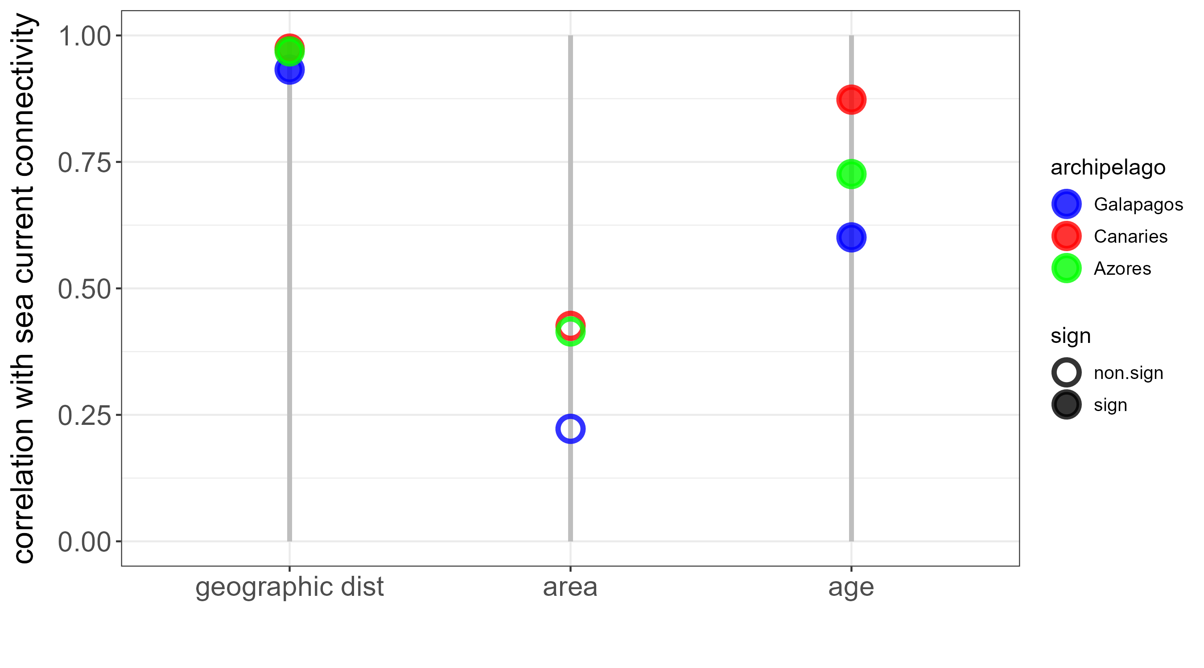

* Then, we cannot know if floristic distances respond to geographic or current distances. It might be obvious that will correlate with geographic distances, but maybe the main finding here is that they also do for currents.

NO, MAIN THING HERE IS THAT CURRENTS HAVE DIRECTIONS – SO IF I WANT TO DO SOMETHING WITH THIS ARTICLE, WILL BE TO SEPARATE THE GEOGRAPHIC DISTANCES FROM THE CURRENTS BY SEEING WHAT ISLANDS ARE SINKS (SO FROM AN ASYMMETRIC MATRIX OF CONNECTIVITIES), AND THEN SEEING THEIR DISTANCES AS SINKS TO COMPARE IT WITH FLORAS AND FOR THE ANALYSES OF DEGREES.

## DISCUSSION

## BIBLIOGRAPHY

## FIGURES