15/03/23

***Recap:

So far, I ran the model with facilitation and competition interactions as Mathilde’s original model, and the aspect that I developed is to compute the phylogenetic signal at each timestep by obtaining interaction and phylogenetic distances from networks and trees, and compare the distances with Procrustes test.

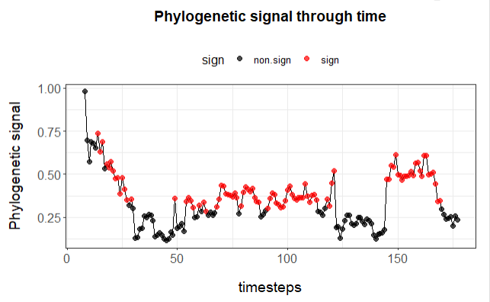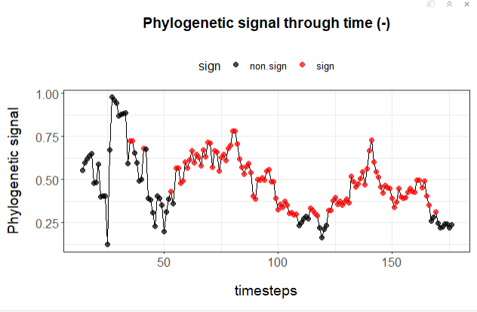

DOUBTS:

* Significant and non-significant -> what do I do here?

**Now, trying to do the same but for FOODWEBS**

Foodwebs, as facilitation and competition systems, are unipartite. The difference is that they are directed. So when computing interaction distances, I need to take into account the distances between species as predators and the distance between species as preys separately. Then, I can just take the mean of both distances to have the total distance (as I discussed with Massol).

Another thing that changes respect to the model with facilitation and competition are the establishment and extinction probabilities.

**P(Establishment)**

* How should they change as spp richness or interactions increase? I decided to just say P(Establishment) = 0.5, very arbitrary, for all species.

**Rule Establishment ->** at least one prey present. In the code:

if(I == 0){

estab_prob = 0

}

Because I is the vector of interactions for the new species. **BUT, I need to distinguish here preys and predators -> I just need to check the number of preys.**

**P(Extinction)**

* P(extinction) = 0.3 + (influence of the number of predators of a species)

**Rule Extinction ->** if last prey lost. In the code:

I see in Mathilde’s code this for the section of extinction:

# Test for extinction #---------------------- P(extinction)

if(int == 0) {

in_I = colSums(L) + **Bext**\*pres_vec

ext_prob = e_0neg * (1 - exp(-a_eneg*in_I))

}

**in_I** seems to me the number of interactions as it is summing the columns of the matrix L, which is supposed to be the matrix of interactions with spp x spp. So here she is summing this number to **Bext.** This is a parameter in the model:

pars$Bspe = 4 # Constant minimal number of interaction per species (extablishment prob)

pars$Bext = 4 # Constant minimal number of interaction per species (extinction prob)

So, she is not allowing species to lose all their interactions.

If I want to compute establishment and extinction rules in the foodweb, I’m going to need to change this.

**Dominique’s model:**

(Predator-prey)

We consider that successful speciation of a predator require to find at least one prey to establish. The speciation function should thus be increasing and saturating with species richness, as it is for mutualism. The extinction function is however more complicated, as it combines two different constraints. First, **there increasing benefit of having multiple preys since the likelihood of all preys going extinct should decrease with species richness**. **Second, predatory interactions could have a negative impact on the prey, reducing there density and potentially leading to extinctions**. Depending on the relative importance of these two functions, the final extinction probability could be a monotonic decreasing and asymptotic function of the expected number of interactions, or alterna- tivel it could have a fast decrease followed by an increase of the extinction rate (such as 188 illustrated at Fig. X).

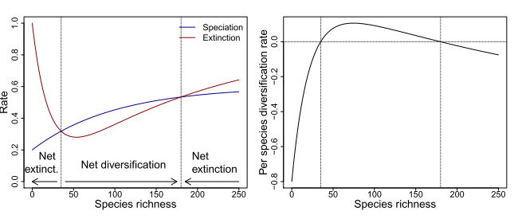

From this and from what I talked with Dominique, I could just make it factorial and not continuos, and say that if a species has no prey it goes extinct, and that the extinction probability of a species increases with the number of predators. But to do this, I need to first change the rule of Mathilde so that species can actually run out of preys.

So:

(1) Eliminate **Bext and Besp** parameter.

-> I just set Bext and Besp to zero.

(2) P(Establishment) = some number for all species (0.5)

(3) Rule of Establishment -> if no preys, can’t establish.

(4) P(Extinction) = some number for all species (0.5)

(5) Rule of Extinction -> if no preys, goes extinct.

* For competition interactions, P(extinction) is how I want for preys. Is the model taking into account interactions of any kind? Because for the foodweb this probability depends only on the number of predators, not others. In competition interactions they must take into account all interactions. I need to check this.

Establishment is tested only for the new species, so it is a single number for the probability, and the interactions are managed as vectors for that species.

But Extinctions are computed for the whole community, so the probability is a vector, and the interactions are managed from the L matrix.

17-03-23

FOODWEB

* Matrix of interactions and how it is computed doesn’t change, because in competitive and facilitation interactions they are non-simmetric too.
* Probabilities of speciation, establishment and extinction is what I need to change.

P(speciation)

DOUBTS FOR MATHILDE

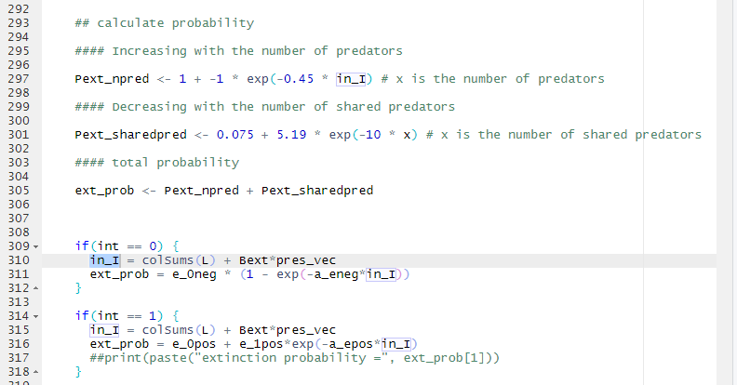

I don’t understand what is the in_I. I thought they were the number of interactions, because is colSums(L), but then why is it summing Bext*pres_vec?

Are the probabilities here vectors? If so, what are their dimensions?

In Mathilde’s code the p(extinction) is computed in general, only taking into account the number of interactions globally.

To compute the extinction probability that I want (as a function of n pred and shared pred), I need to do it individually so computing one P(extinction) per species (right? I don’t know if I just say that the more predators present in the community the higher the p(ext) and the mored they share preys the less p(ext) for EVERYONE. But I don’t even know what would this mean biologically. In the same way, Mathilde’s calculate a general extinction prob for all the species as a function of the n interactions, which dont know what it means biologically neither).

* How the matrix is not symmetric?? How to know which spp has or not interactions? To compute distances
* Speciation probability ????????????
* Basal species ???????????????
* Niche filling curve – how you get it??????????
* How you computed the confident intervals around the means for the simulation results?

----------------------------

So for now:

** Foodweb:

* Double-check with Mathilde the functioning of the matrices, and if there are species without interactions. Ask her also about filling the niche.
* Establishment and extinction curves could be as the functions that Dominique draws in the model. -> and I would add the rule that if no prey, get extinct.

----

Let’s try to measure more things, BUT ALWAYS WITH A QUESTION.

Network role – evolutionary estability (n extinctions and n diversification)

For this, I need to identify the clades of certain spp – How?

20 March 2023

Objectives

* make the model for foodwebs
* try to make the model for bipartite mutualisms
* Scheme how to make it for predator-prey

FOOWEBS

* P(establishment) as facilitation, with the rule of no interaction P = 0, but with the parameter Bext and Besp = 4, because if set at 0 the simulation doesn’t run.
* P(extinction) increases with the number of predators and decreases with the number of shared predators.

****PROBLEM -> number of shared predators not working. P(extinction) not working properly:

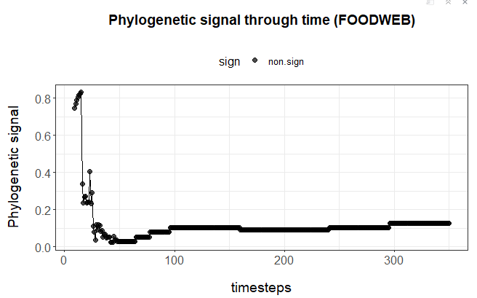

I didn’t save the graph for spp richness but looked like this:

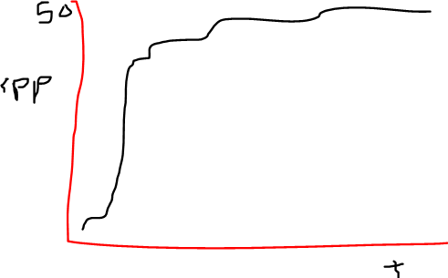

Yields 342 timesteps

Now trying with

P(extinction) = number of shared predators (working properly now)

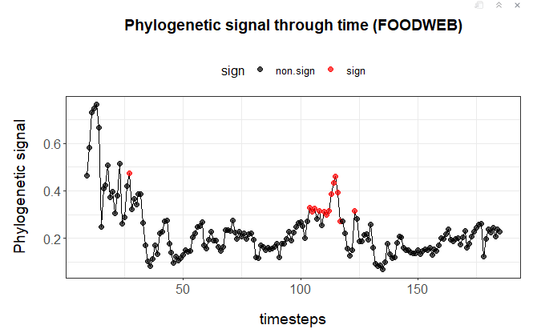

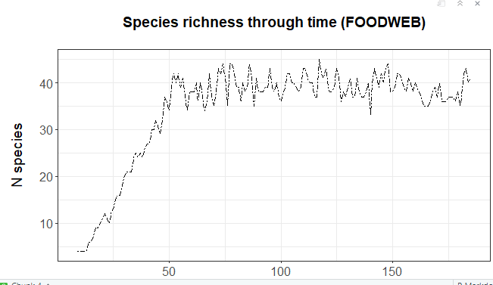

NOW I NEED TO DO IT GOOD AND TAKE THE CHISQ FOR PREDATORS AND PREYS SEPARATELY AND DO THE MEAN, BECAUSE SO FAR I JUST LOOKED AT THE CHISQ OF THE COLUMNS (e.g. as predators).

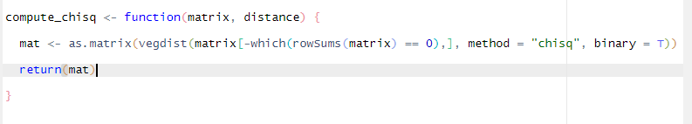

THIS IS PROBABLY WRONG FOR COMPETITION AND FACILITATION TOO, because I am selecting only those that are not 0 for the row, which doesn’t make sense.

I need to change the function to comoute chisq, and make one for computing chisq for spp as preys and one for spp as predators.

I need to know how to just take into account those species that are present. – or, I guess here it will be: for predators, only take into account those that have preys , and for preys, only take into account those species that have predators. (BUT, a top predator can be present and not have predators – so don’t know how to deal with this).

IMPORTANT DOUBTS

* For calculating Chisq, R warns me with the following message:



So I may have to not do it over the full matrix 1000x1000 but only with the present species.

And this message when running the protest



Chisq distances here must be as prey and as predator and then combine both.

Separating correlation, chisq as predators with phylog, and chisq as preys with phylog

If they are not predators (all 0 in the column) or not preys (all 0 in the row) they are not accounted for in neither the chisq dist matrix nor the phylogeny.

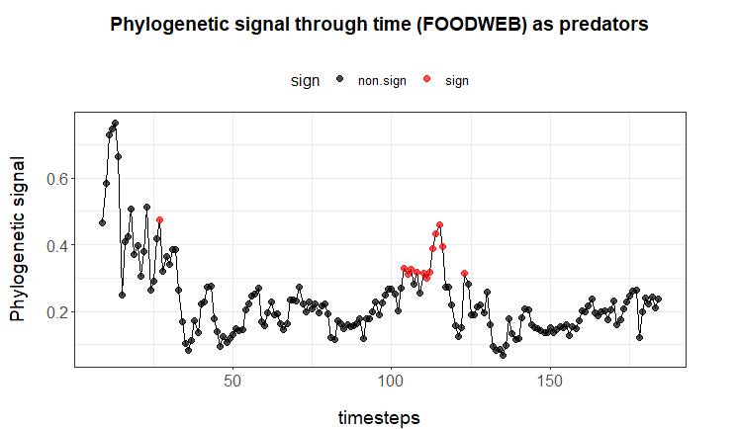

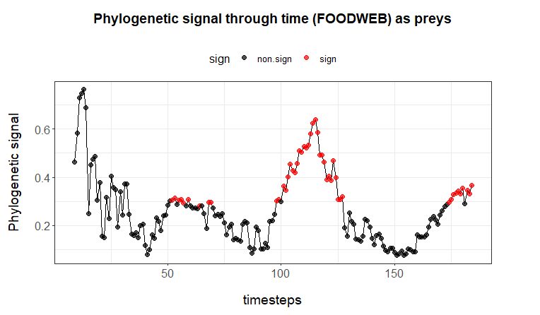

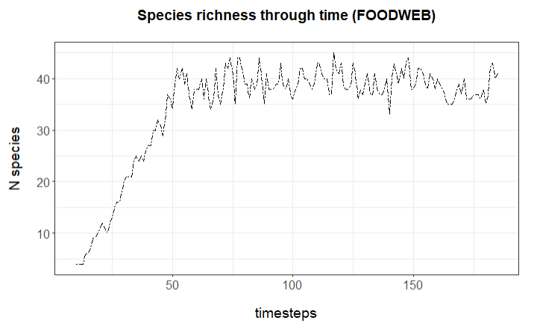

COMBINED:

PROBLEM:

* To compute Chisq, I get warnings that the results will be affected if I have empty species.
* To make the mean between the Chisq distance matrices I need that both have the same species, and this is not the case – sometimes a species doesn’t have preys and sometimes doesn’t have predators.

** spp without preys would correspond to basal species

** spp without predators would be top-predators

Both make sense to keep them..

ANYWAYS, I checked and there is only 1 basal species in timesteps (~160,161) and nothing else. And no top predators (spp without predators).

Meeting Mathilde

* Competition is not really competition (asymmetric)
* Species without interactions not possible (But I see it can happen) -> I can establish the rule to go extinct.
* Basal species -> when calculating number of interactions for probability of especiation and extinction (she doesn’t know how it is used).

********* MEETING FRANCOIS ********

* In my model, it can happen that some species don’t have preys (basals), and it can happen that some species don’t have predators (top predators).

Because of this, I can’t use the Chisq to compute distances, because it can’t handle the fact that a species don’t have interactions (if we see its formula, the denominator can’t be 0). This is because Chisq is what Francois called a “classifier” metric, that classifies the information according to two groups (0 and 1, interaction and no interaction) for all species and then computes the distance between the classifications, but can’t handle having only 0.

There is another metric that does handle this: Normalized Mutual Information Index (NMI), which measures the antropy between the two sets of preys (no prey, prey), and can handle comparisons between groups of 1 (no preys, only 0) and 2 (preys and no preys, 0 and 1.

NMI goes between 0 and 1 -> there is a non-normalized version but Francois has never used it. 0 is very dimsimilar and 1 very similar, so contrary than distance. If I use this I will need to do 1-NMI to get distance (dissimilarity).

Rand Index -> also quite famous classifier. Very used in networks for comparing modules.

Function “compare” in igraph package has actually both NMI and Rand Index.

The model should have basal spp – but I see that there are very few. It can be that

(1) the way I am looking at it (Colsums = 0 and rowsums > 0 for a given spp) is not correct, but I think it is, or

(2) the model contains a lot of loops

(3) In the model all species prey on something because I actually add the basals with the parameter Bexp and Bspe. I don’t underttsand completely how this works but I see that they are added when computing the number of interactions, summing 4 interactions to all spp. But actually the matrix of interactions don’t show these basal spp and these interactions. So maybe with the Bexp and Bspe what the model is saying is that there are basals that are implicit, and the species that I am modeling in the network are actually all preying on something (I don’t have plants or any other primary producer). – so All spp prey on a minimum of 4 basal spp, but this is not reflected in the matrix, in the foodweb.

* I think this (add 4 interactions with basals) should only happen with those spp that don’t prey on anything, so on herbivores, and not on all the spp.

I sayed I would apply a rule where if the last prey goes extinct then the species goes extinct, but this way I would not have basal species, which is not correct. I need basal species in the model.

Doing this of going extinct if you lose your last prey makes sense for Predator-Prey bipartite system, but not in a foodweb.

Francois talked about adding a trait that keeps basal species.

--

Probability of extinction depending on number of predators and shared predators.

|  |  |  |
| --- | --- | --- |
| ¼ | 1/2 |  |
| ¼ | 0 |  |
| 1/4 | 0 |  |
| 1/4 | 1/2 |  |

¼ : 4 is total of preys of the predator

Diversity measure -> hill number

Average abundance of predator (sum elements of rows / real predators)

Relative average -> ¼

Average abundance (5/8)

Number of predators H (1/4, 1)

(5/8) * H (1/4, 1)

Hill number is a diversity metric. There are many. The indexes go from 0 to infinite, and the smaller it is, the more rare spp affect, and the higher, the less they care. Shannon index is Hill number of 1, so is in between, and is an intermediate one where takes into account rare ones but not crazily.

So I could use the Shannon as diversity of predators and use this to compute my probability of extinction.

**

So far I am implementing only the basic basic niche model based on threshold trait, but if I want to approach a bit more to reality, I could use the Allesina model (threshold + interval) or another one that gives more realistic foodwebs.

How to check how much my networks resemble real ones? -> use motif-based comparisons. Paper of Daniel Stouffer where he explains this method. They have even a correction for bipartite networks.

TODO now

* Understand how basals work in my code and in Dominique’s code.
* Do I have basals? Do I only have implicit interactions with basals (all spp have) so I don’t have any basal spp in the interaction matrix?

If it’s all about theoretically not allowing species without interactions, then I am okay with that but to me it should only happen to herbivores – those species that don’t have preys (colsums 0). Changing this would affect only the P(ext) and P(esp), because they depend on the number of interactions, but would not change the fact that I can’t use Chisq, because even if spp have these interactions, they are not present in the matrix (and also we have the problem with the top predators).

Meeting with Francois (last day of the stay)

How to make this for a FOODWEB

1. Manage basal species problem

- What would be my initial idea

- How is this done in other models

- Ask Dominique

2. What kind of niche model / number of traits and more realism

2. Try something out

3. Add distance NMI

4. Probability of extinction

- Same for everyone +

Shannon index for accounting for the number of predators and shared predators for preys (the more predators, the more prob of extinction, and the more shared, the less prob)

* Rule of extinction for when no preys – goes extinct.

Meeting Dominique

Phylog model

* Try to do foodweb, bipartite pred-prey and mutualistic
* Foodweb: simple rule of extinctions + Shannon index for preys

Too many predators – higher probability of going extinct (predation dependent extinction)

Control evolution for generalist

I may never reach equilibrium this way

Struggle for extistance experession -> predation-dependent extinction rate for controlling for this – very corse but if we tweak it again we come back to the same problem.

* Predator-prey: no running out of preys? Basals implicid as Mathilde?
* Basals problem – HOW DOES THAT WORK IN GENERAL?
* Distance by NMI (Normalized Mutual Information index) to handle top-predators

🡪 Can we meet one day and reserve 2h to work on it, with the model in the screen?

Once I have this, I can do many things:

Signal through time

Signal in evolution vs invasion assembled webs

Signal in selection vs neutral

Evolutionary rate – trophic position, and species network role

Role of evolutionary processes in network structure – persistence

Keep in mind that I can explore C++ to run it – much faster.

Paulo

Go to Sao Paulo

Work on asymmetries

Why core network should favor speciation?

Effect of phylogeny on Networks (Mathias Pires) – the opposite not really clear

Meta-community models

Lucas Medeiras – 2 sites with different environments – connected through gene flow – environmental selection cancel out

How much the structure of the network contributes to that?

How evol. of diversification

Impact of diversification on the stability of network or high-level ptoperty of networks

How diversification dynamics affect network properties?

More modular, maybe less robuts, because more disparity in trait values. Redundancy/disparity

Francois student developed a model to trace back the group of species belonging to a certain clade.

* Phylog – model
* Heterogeneities

Naesiotus

Working group

Working Group Dom and me – 2 days – network level selection

Dom – Paulo

Evolution of Migration

Switch selection regimes between communities

Invite Paulo to come

How ecological speciation happens in a network

* Formaly invite Paulo
* Go there (with Dominique)

19-04-23

* Run the model normally for facilitation and competition (OK)
* Draw the functions for each model next to each other for comparing what’s different. Then decide which ones to go with.

4 april 2023

Foodweb:

|  |  |  |
| --- | --- | --- |
|  | Facilitation/competition | Foodweb |
| Speciation probability | = | = |
| Establishment probability | = | = |
| Extinction probability | Positive:  ext_prob = e_0pos + e_1pos*exp(-a_epos*in_I)  Negative;  ext_prob = e_0neg * (1 - exp(-a_eneg*in_I)) | ext_prob = e_0neg + e_1neg*exp(-a_eneg*out_I) +  e_0pos + e_1pos*exp(-a_epos*in_I) |

* The model doesn’t lead to a successful solution (>40spp in timestep X)
* I tried adding basal species as Dominique does, and I have the same problem.

17 May 2023

So the only difference between the foodweb model and the competition or facilitation one is the probability of extinction (table above).

With that Pext, the foodweb version do not produce a viable solution.

I will try several combinations of parameter values to see if any of them makes it work.

ext_prob = e_0neg + e_1neg*exp(-a_eneg*out_I) + e_0pos + e_1pos*exp(-a_epos*in_I)

e_0neg

1) Draw curves

2) Build script to run only foodweb, do not set the condition of not saving objects if S < 20 at timestep 150. Instead, save the objects and see what the simulation is doing.

3) Then, try with different parameter values while looking at the objects.

Changing the parameter e_Oneg from 0.5 to 0.1 allows to create communities for foodwebs:

```{r}

pars$e_0neg = 0.1 # Asymptotic extinction probability with infinite negative interactions

```

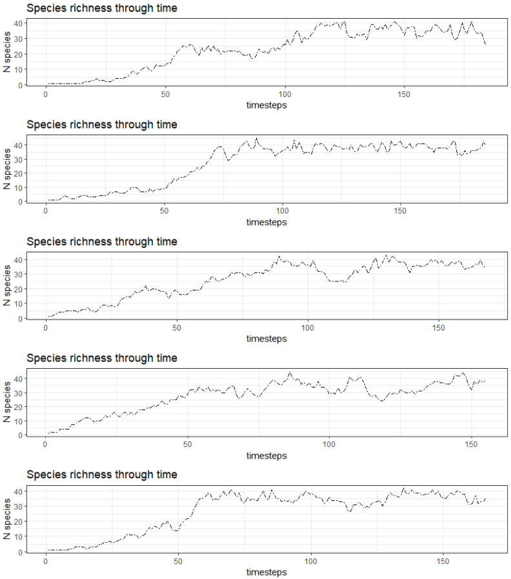

The figure above shows the spp richness in 5 different simulations with the foodweb version (i.e. extinction probability according to in or out links).

NEXT STEP:

1) Code for Normalized Mutual Information Index (NMI) -> distance as predators, distance as preys.

2) Sensitivity analysis to see how changing e_Oneg parameter affects the results, and think what this parameter means biologically and if setting this values makes sense.

3) Test if resulting networks resemble empirical ones -> Francois proposed to do this with an analyses of motifs. I could check this and also main network descriptors.

VERY CLEAR

PART 1

Phylogenetic signal ~ time

Phylogenetic signal ~ selection vs neutral

Phylogenetic signal ~ invasion vs evolution

~ interaction types

PART 2

Network role ~ evolutionary process (diversification rate)

Trophic position ~ evolutionary rate

Network role ~ evolutionary rate

PART 3 (PAULO?)

Network metrics ~ evolutionary processes

Network robustness ~ evolutionary processes

PART 4

Network stability ~ system-level selection vs species-level selection

Network resembling to empiricals ~ system-level selection vs species-level selection

----------------------------------------------------------------------------------------------------------------