Compute the analyses with species role similarity instead of interactions similarity. From Bramon Mora et al. 2018 (Dominique is in it)

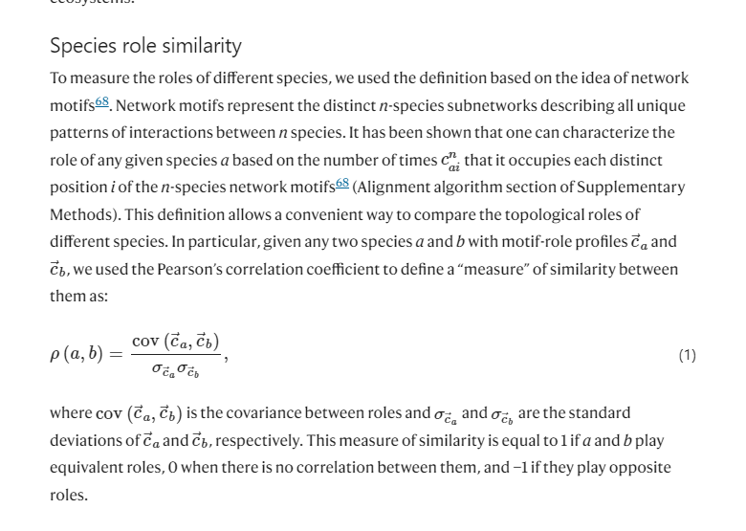

Doubts Dom

* How do I get empirical data foodwebs
* Metric motifs for computing dissimilarities
* RDPG for computing species importance