Brownian motion trait evol:



How to simulate brownian motion evolution (Dominique’s email):

In your case in particular, yes it could be simulated from a given phylogeny. But what you proposes seems ok, with a slight ajustment :

z_t1 ~ N(z_t0, sigma^2_t0)

In other words, the trait of the descendant is centered on the trait value of the ancestor.

The alternative would be :

z_t1 ~ z_t0 + d_t0

where

d_t0~N(0, sigma^2_t0)

Then,

For drawing traits from new mutants, use the Brownian motion formula.

Then the probability of establishment is fixed around a mean

Then there is no extinctions

The way I draw mutant traits is ALREADY like that (normal distribution centered in the ancestor, with a given sd).

Dominique: what matters is whether or not there is selection afterwards. You are right, it is in the probabilities of establishment and extinction it matters.

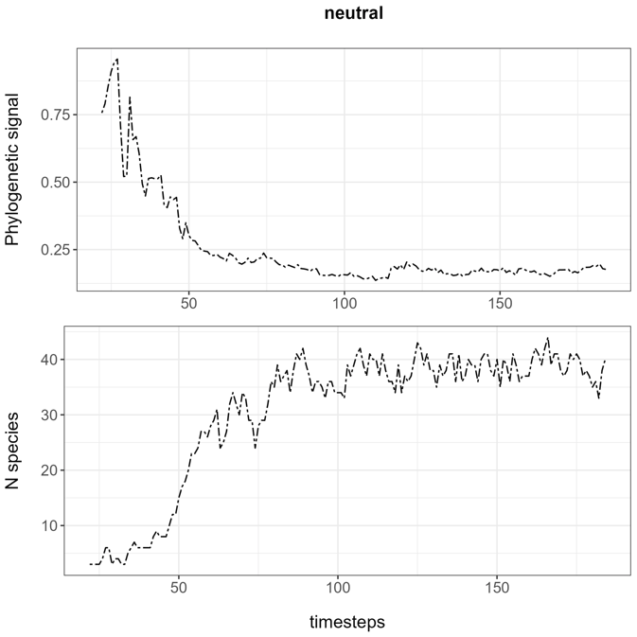

I tried with different options

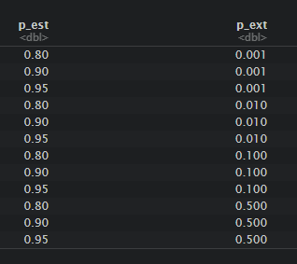

The highest value of p_ext and lowest of p_est that gives a successful simulation is

P_est = 0.80

P_ext = 0.1

Explore much more possibilities,

Find a way to save the results of each scenario

But for now, I see that it has the same effect with and without selection.