101

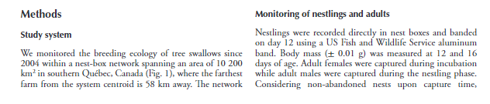

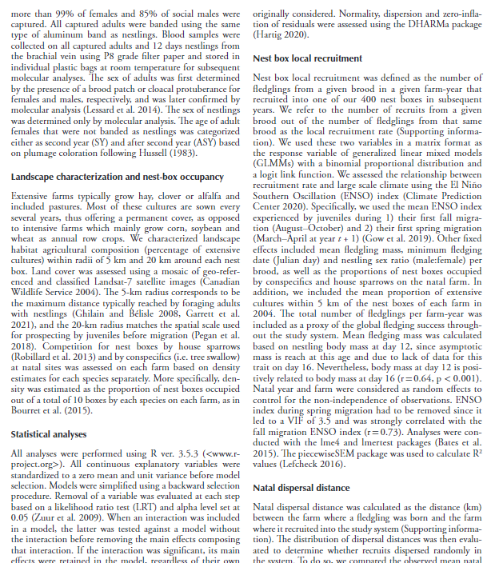

102

Data from: Disentangling woodland caribou movements in response to clearcuts and roads across temporal scales

**Beauchesne, David,**Concordia University

**Jaeger, Jochen A. G.,**Concordia University

**St-Laurent, Martin-Hugues,**Université du Québec à Rimouski

**Jaeger, Jochen AG.,**Concordia University

Published Nov 12, 2013 on Dryad. https://doi.org/10.5061/dryad.n3c2f

Cite this dataset

Beauchesne, David; Jaeger, Jochen A. G.; St-Laurent, Martin-Hugues; Jaeger, Jochen AG. (2013). Data from: Disentangling woodland caribou movements in response to clearcuts and roads across temporal scales [Dataset]. Dryad. <https://doi.org/10.5061/dryad.n3c2f>

Abstract

Although prey species typically respond to the most limiting factors at coarse spatiotemporal scales while addressing biological requirements at finer scales, such behaviour may become challenging for species inhabiting human altered landscapes. We investigated how woodland caribou, a threatened species inhabiting North-American boreal forests, modified their fine-scale movements when confronted with forest management features (i.e. clearcuts and roads). We used GPS telemetry data collected between 2004 and 2010 on 49 female caribou in a managed area in Québec, Canada. Movements were studied using a use – availability design contrasting observed steps (i.e. line connecting two consecutive locations) with random steps (i.e. proxy of immediate habitat availability). Although caribou mostly avoided disturbances, individuals nonetheless modulated their fine-scale response to disturbances on a daily and annual basis, potentially compromising between risk avoidance in periods of higher vulnerability (i.e. calving, early and late winter) during the day and foraging activities in periods of higher energy requirements (i.e. spring, summer and rut) during dusk/dawn and at night. The local context in which females moved was shown to influence their decision to cross clearcut edges and roads. Indeed, although females typically avoided crossing clearcut edges and roads at low densities, crossing rates were found to rapidly increase in greater disturbance densities. In some instance, however, females were less likely to cross edges and roads as densities increased. Females may then be trapped and forced to use disturbed habitats, known to be associated with higher predation risk. We believe that further increases in anthropogenic disturbances could exacerbate such behavioural responses and ultimately lead to population level consequences.

Usage notes

Beauchesne Jaeger and St-Laurent_PLoS ONE datasets

Characteristics of observed and random steps of female Woodland caribou inhabiting a highly disturbed landscape in eastern Canada.

Beauchesne et al_datasets PLoS ONE.zip

103

Variable strength of predator-mediated effects on species occurrence in an arctic terrestrial vertebrate community

**Duchesne, Éliane,**Université du Québec à Rimouski**,**[**https://orcid.org/0000-0003-2597-3442**](https://orcid.org/0000-0003-2597-3442)

**Lamarre, Jean-François,**Université du Québec à Rimouski

**Gauthier, Gilles,**Université Laval

**Berteaux, Dominique,**Université du Québec à Rimouski

**Gravel, Dominique,**Université de Sherbrooke

**Bêty, Joël,**Université du Québec à Rimouski

**eliane_duchesne@uqar.ca, joel_bety@uqar.ca**

Published May 26, 2021 on Dryad. https://doi.org/10.5061/dryad.pg4f4qrpf

Cite this dataset

Duchesne, Éliane et al. (2021). Variable strength of predator-mediated effects on species occurrence in an arctic terrestrial vertebrate community [Dataset]. Dryad. <https://doi.org/10.5061/dryad.pg4f4qrpf>

Abstract

Indirect effects resulting from species sharing the same enemy can shape spatio-temporal variations in species occurrence. The strength of such effects remains poorly known in natural communities composed of species from different trophic levels interacting in heterogeneous landscapes. Benefiting from a well-known arctic vertebrate community and marked spatio-temporal variations in the density of key prey species, we examined the effects of direct predator-prey and indirect predator-mediated effects on species occurrence in the landscape. We found both positive effects of one prey (lemmings), as well as negative indirect effects of another prey (colonial nesting snow geese) on the occurrence of species (ground-nesting birds) belonging to different guilds and trophic levels but sharing a common predator (arctic fox). However, species using prey refuges available in the landscape were not or less affected by predator-mediated effects. Similarly, the smallest (a passerine) and the largest and most dangerous species (an owl) for the shared predator were not affected by these effects. Our study provides one of the rare empirical evidence of predator-mediated effects ascending the food web (i.e., negative indirect effect of an herbivore on avian predators) and underlines how habitat structure and species traits can modulate the strength of indirect effects in natural communities.

Methods

The dataset provided here contains the data used in each of the models presented in the article "Variable strength of predator-mediated effects on species occurrence in an arctic terrestrial vertebrate community". These data are the processed values (as described in the method section and supporting information of the article) used to model the effects of lemming density and distance to a goose colony on the occurrence of various nesting birds. Mapped data is available in supporting information of the article.

Usage notes

The README file contains column descriptions and general information for the analyses.

116

Where to spend the winter? The role of intraspecific competition and climate in determining the selection of wintering areas by migratory caribou

**Le Corre, Mael,**Ciment Québec (Canada)**,**[**https://orcid.org/0000-0003-2374-2050**](https://orcid.org/0000-0003-2374-2050)

**Dussault, Christian,**Ministère des Forêts, de la Faune et des Parcs**,**Ciment Québec (Canada)

**Côté, Steeve D.,**Center for Northern Studies**,**Ciment Québec (Canada)**,**[**https://orcid.org/0000-0002-4875-1917**](https://orcid.org/0000-0002-4875-1917)

**mael.lecorre@abdn.ac.uk, Christian.Dussault@mffp.gouv.qc.ca, steeve.cote@bio.ulaval.ca**

Published Dec 17, 2019 on Dryad. https://doi.org/10.5061/dryad.pnvx0k6hq

Cite this dataset

Le Corre, Mael; Dussault, Christian; Côté, Steeve D. (2019). Where to spend the winter? The role of intraspecific competition and climate in determining the selection of wintering areas by migratory caribou [Dataset]. Dryad. <https://doi.org/10.5061/dryad.pnvx0k6hq>

Abstract

Depicted as predictable movements, migrations can, however, show important interannual variations, making the conservation of migratory species particularly challenging. Plasticity in migratory behaviour allows individuals to adjust their migratory tactics to maximize their fitness. Destination of migration, and therefore migration patterns, may vary according to climatic and environmental conditions encountered during migration or at the arrival site but also according to competition. In Northern-Québec and Labrador, Canada, fall migration patterns of caribou from the Rivière-George (RGH) and the Rivière-aux-Feuilles (RFH) herds have varied greatly during the last decades. Meanwhile, both herds have shown large fluctuations in abundance. We assessed the influence of environmental factors and changes in population size on wintering area selection. Based on 649 fall migrations of 284 females equipped with ARGOS collars, we used a machine-learning algorithm, the random forests, to assess how climate, resources and population size affected the selection of four different wintering areas. Individuals followed over several years switched to a different wintering area 45% of the time between consecutive years, and this probability increased at high population size. The main determinant of wintering area selection was the population size for both herds, suggesting intra- and inter-herd competition for wintering areas. The long migrations of RGH toward the western wintering areas, also used by RFH, were favoured when the herd was abundant and when the availability of resources was low at the departure. The migrations of RFH toward the south-western area increased as RGH declined, possibly because the past presence of RGH in this area reduced access for caribou from RFH. These results highlight the flexibility in the migratory behaviour of caribou in response to variation in competition. Our study is the first to suggest that wintering area selection can be determined by competition between populations of the same ungulate species.

Usage notes

Datasets and R scripts required to run the hierachical cluster analysis and the random forests analyses

141

Data from: History matters: contemporary versus historic population structure of bobcats in the New England region, USA

**Carroll, Rory P.,**University of New Hampshire at Manchester

**Litvaitis, Marian K.,**University of New Hampshire at Manchester

**Clements, Sarah J.,**University of New Hampshire at Manchester

**Stevens, Clark L.,**University of New Hampshire at Manchester

**Litvaitis, John A.,**University of New Hampshire at Manchester

Published Mar 29, 2019 on Dryad. https://doi.org/10.5061/dryad.t77f1p4

Cite this dataset

Carroll, Rory P. et al. (2019). Data from: History matters: contemporary versus historic population structure of bobcats in the New England region, USA [Dataset]. Dryad. <https://doi.org/10.5061/dryad.t77f1p4>

Abstract

Habitat fragmentation and genetic bottlenecks can have substantial impacts on the health and management of wildlife species by lowering diversity and subdividing populations. Population genetic comparisons across time periods can help elucidate temporal changes in populations and the processes responsible for the changes. Bobcats (Lynx rufus) are wide-ranging carnivores and are currently increasing in abundance across an expanding range. Bobcat populations in New England have fluctuated in the past century in response to changes in their prey base, harvest pressure, and landscape development. We genotyped contemporary (2010–2017) and historic (1952–1964) bobcats from New England and Quebec, Canada at a suite of microsatellite loci and tested for differences in diversity, effective population size, and gene flow. Over 20 generations separated the sampling periods, and the intervening years were marked by drastic changes in land use and species management regimes. We found a general decrease in genetic diversity and differing population genetic structure through time. Effective population size decreased at the end of the historic period, coincident with a spike in harvest, but rebounded to greater numbers in the contemporary period. Our results suggest that bobcat populations in the region are robust, but development and range dynamics may play a significant role in population structure. Our study also highlights the benefits of a historical perspective in interpreting contemporary population genetic data.

Usage notes

Microsatellite data for contemporary (2009-2017) and historic (1952-1964) bobcats

Each row contains a unique individual ID, sex, year of collection, state and town of capture, XY coordinates for the town centroid (NH state plane coordinate system), and genetic data formatted as allele1_allele2. Column names are microsatellite loci.

BobcatData.xlsx

150

Data set for combined influence of food availability and agricultural intensification on a declining aerial insectivore

**Garrett, Daniel,**Université de Sherbrooke**,**[**https://orcid.org/0000-0002-8000-0582**](https://orcid.org/0000-0002-8000-0582)

**daniel.garrett88@gmail.com**

Published Feb 07, 2022 on Dryad. https://doi.org/10.5061/dryad.xd2547dj8

Cite this dataset

Garrett, Daniel (2022). Data set for combined influence of food availability and agricultural intensification on a declining aerial insectivore [Dataset]. Dryad. <https://doi.org/10.5061/dryad.xd2547dj8>

Abstract

Aerial insectivores show worldwide population declines coinciding with shifts in agricultural practices. Increasing reliance on certain agricultural practices is thought to have led to an overall reduction in insect abundance that negatively affects aerial insectivore fitness. The relationship between prey availability and the fitness of insectivores may thus vary with the extent of agricultural intensity. It is therefore imperative to quantify the strength and direction of these associations. Here we used data from an 11-year study monitoring the breeding of Tree Swallows (*Tachycineta bicolor*) and the availability of Diptera (their main prey) across a gradient of agricultural intensification in southern Québec, Canada. This gradient was characterized by a shift in agricultural production, whereby landscapes composed of forage and pastures represented less agro-intensive landscapes and those focusing on large-scale arable row crop monocultures, such as corn (*Zea mays*) or soybean (*Glycine max*) that are innately associated with significant mechanization and agro-chemical inputs, represented more agro-intensive landscapes. We evaluated the landscape characteristics affecting prey availability, and how this relationship influences the fledging success, duration of the nestling period, fledgling body mass, and wing length as these variables are known to influence the population dynamics of this species. Diptera availability was greatest within predominately forested landscapes, while within landscapes dominated by agriculture, it was marginally greater in less agro-intensive areas. Of the measured fitness and body condition proxies, both fledging success and nestling body mass were positively related to prey availability. The impact of prey availability varied across the agricultural gradient as fledging success improved with increasing prey levels within forage landscapes yet declined in more agro-intensive landscapes. Finally, after accounting for prey availability, fledging success was lowest, nestling periods were the longest, and wing length of fledglings were shortest within more agro-intensive landscapes. Our results highlight the interacting roles that aerial insect availability and agricultural intensification have on the fitness of aerial insectivores, and by extension how food availability may interact with other aspects of breeding habitats to influence the population dynamics of predators.