*Summary*

In this study, we describe the presence of a recently discovered snail’s immune response to nematodes by means of shell encapsulations across the Naesiotus genus radiation of the Galapagos islands. We qualitatively quantify the nematode loads found in the shells, and show that we can measure the nematode diversity found in each host species using DNA sequencing. We discuss the implications of these findings in light of the potential unparalleled advantages of this host-parasite system to investigate the interplay between biogeographic, evolutionary, and ecological processes.

*Motivation*

We currently lack a mechanistic understanding of the interplay between macroevolution and species interactions in the formation and dynamics of ecological communities. While theory and predictions need to be developed, empirical data that allows for both testing and inspiring these predictions is very scarce.

The characteristics of island radiations made them ideal systems for this and have already shown to provide insights on how evolution and ecological processes act in forming species and communities. Few studies gathered both evolutionary and interactions data from radiations, and showed to provide groundbreaking insights to understanding the evolution of communities (e.g. competition interactions in the Caribbean Anolis system, frugivory interactions in the Galapagos finches-plants and Hawaiian honeycreepers-plants system). Arguably the main reason is that sampling interactions across numerous species across radiations is very complex and costly compared to other ecosystems, as this implies expeditions to remote islands. Furthermore, it is needed to sample interactions in different seasons and through time to get a complete picture of them.

Recently, a new immune defense mechanism has been discovered in land snails to kill potential parasitic nematodes which consist on trapping and encapsulating them in their shell. These remain in the snail’s shell, which allows to observe the interaction time after (even 300 years after as observed by Rae et al). Furthermore, it is possible to extract and analyze the DNA of the encapsulated nematodes. We think this defense mechanism could offer unique advantages for sampling interactions and evolutionary data. In addition, given that the snail’s shell often evolves in response to biotic and abiotic pressures, it could also allow for investigating the role of adaptation to certain environments in the evolution and interaction within host and parasites.

Snails radiation in islands are actually reported globally and are some of the most numerous in species. Here, we investigate the largest described radiation in the Galapagos islands, which is the one by the genus of land snails Naesiotus. We found that (1) the mechanism is present throughout the group and (2) we can amplify and analyze the nematode’s DNA.

*Results*

* Encapsulations present in the 38 analyzed species, out of the total 47 spp of the radiation. (present in the 11 islands analyzed) (Figure 1)
* Species showed differing nematode loads (TODO - does island identity, isolation, area, or phylogeny explains these difference?) (Figure 2)
* We can amplify and analyze the DNA of encapsulated nematodes. (Figure 3)
* There is a high taxonomic diversity among the encapsulated nematodes (given that we sampled only 2-3 individuals of 2-3 species). (Figure 3)

*Discussion*

Potential of the system to investigate questions on:

* Macroevolutionary imprints on interactions
* Biogeographic influence on macroevolution and interactions
* Diversification rates and network roles
* Impact of abiotic and biotic adaptation on evolution and networks
* Codiversification

Caveats:

* Nature of the interaction (what exactly means the encapsulation)
* Observations (potential limitations to observe nematodes)
* DNA analyses (amplification process)

Motivate further research in this and other island radiations of snails.

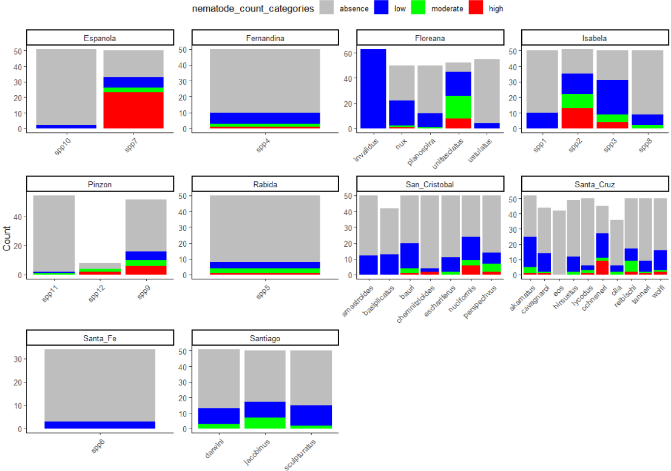

Figure 2. Nematode counts by species and island. Categories: absence = 0, low = 1-10, moderate = 10-30, high = 30->100)