Changing extinction and establishment probabilities in the absence of interactions

# Extinction probability parameters

pars$e_1pos <- 5 # Slightly decrease the extinction probability in the absence of positive interactions

# Establishment probability parameters

pars$u_1 <- -1 # Increase the establishment probability in the absence of positive interactions

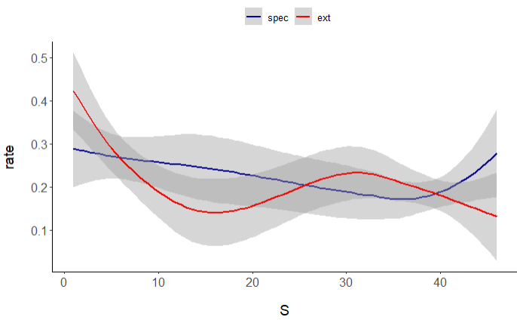

**Decreased u_1 from -1 to -2:**

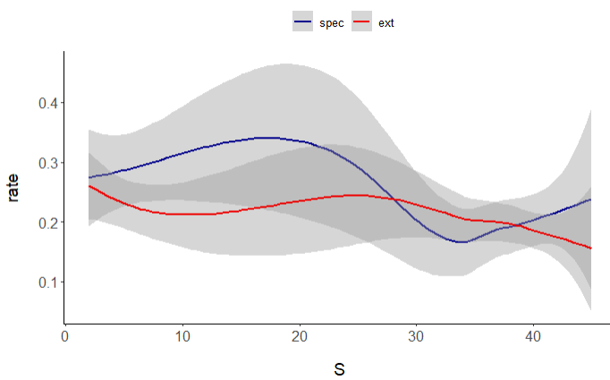

Increased u_1 from -1 to -0.3

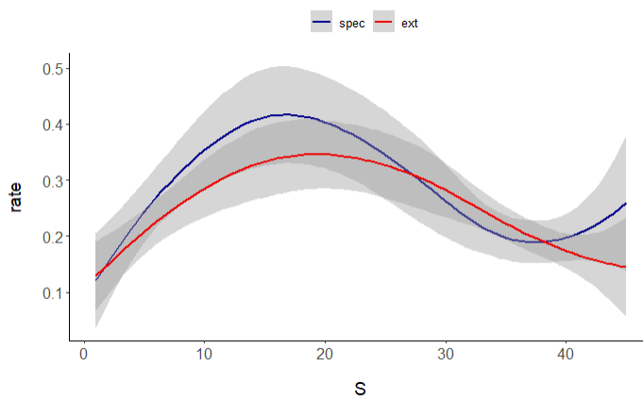

Decreased u_1 from -1 to -1.2

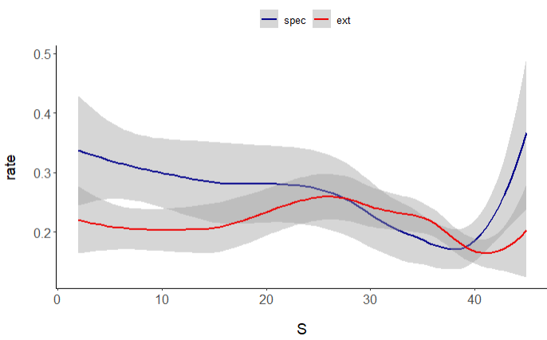

Increased a_epos from 1 to 1.5

