I made simulations with I_max = 40. I just saw that when I reduce the sd, the correlation decreases more strongly with S, and when having like S = 20, it already shows a correlation of 0.25 and then stays there until the end. Whereas for higher sd, it decreases more gradually (starting from even higher correlation values), and also stabilizes around S = 20 but for correlation = 0.35 more or less, a bit higher than the scenario with the lower sd. Why this can be

**Explanation:**

1. **Lower sd: Rapid Trait Saturation and Stronger Competition Early On**:
   * With lower sd, new species have traits that are closer to their ancestors. This means that species tend to cluster in similar areas of trait space. When the community size (S) is small, the initial correlation between phylogenetic and interaction distances may be relatively high because new species have traits that are strongly conserved.
   * However, because the traits are not diverging much, the niche space becomes saturated more quickly. This leads to stronger competition among species with similar traits, causing some to go extinct or to differentiate their interactions more dramatically to survive. As a result, the correlation between interaction and phylogenetic distances decreases rapidly, as species interactions are no longer strongly aligned with their phylogenetic relationships.
   * By the time S = 20, the trait space is already quite saturated, and the correlation stabilizes at a lower level (~0.25) because the community has diverged in terms of interactions, even though the underlying traits are still relatively conserved.
2. **Higher sd: Gradual Divergence and More Distributed Competition**:
   * With higher sd, new species exhibit greater trait divergence from their ancestors. This allows species to explore more of the niche space without directly competing with closely related species, leading to a slower saturation of niche space.
   * The initial correlation between interaction and phylogenetic distances is higher because the new species are still relatively close to their ancestors in trait space, but as the niche space fills up more gradually, the correlation decreases more slowly. The trait divergence allows species to establish in different parts of the niche space, preserving the alignment between phylogenetic and interaction distances for a longer period.
   * By the time S = 20, the niche space is more fully occupied, but because the species are more divergent in traits, the correlation stabilizes at a higher level (~0.35). This reflects a balance between phylogenetic divergence and interaction differentiation, with species still showing some alignment between their traits and interactions.

**Plots for sd = 0.1 (low) (reference value was 0.5)**

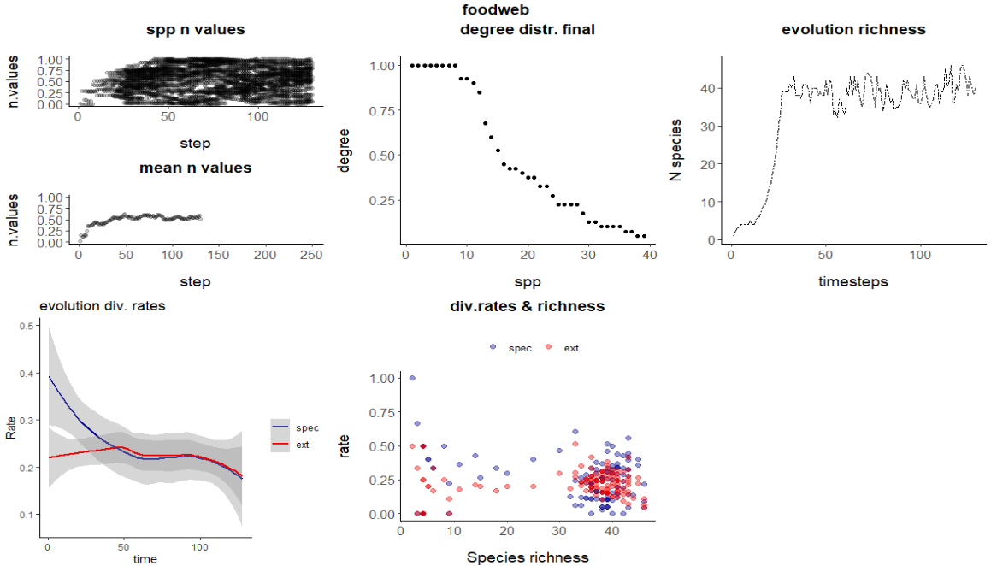

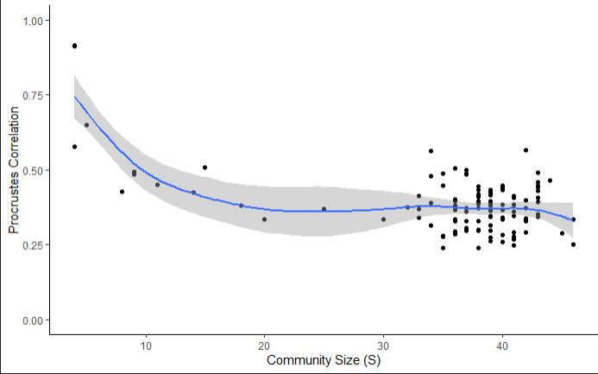

**Same but neutral:**  
  
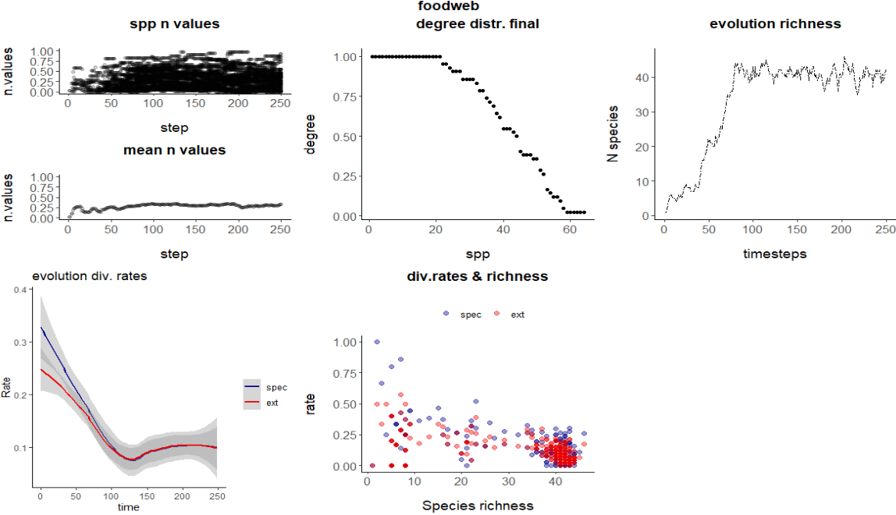

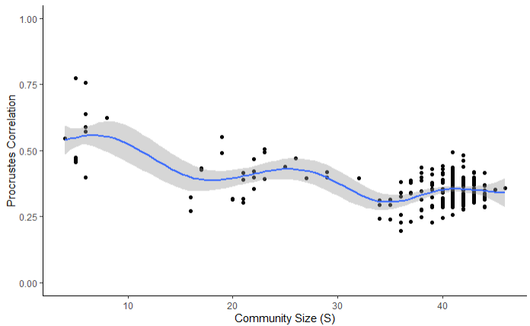

I think that, when saturating the niche space, both selection and neutral scenarios should show similar dynamics. That was indeed in my hypothesis. But, in my hypothesis was also that there would be a difference in the process until saturating the niche, where selection would impose higher signal than neutral

Your hypothesis makes sense and aligns with ecological theory: selection should lead to stronger trait conservation and phylogenetic signal during the early stages of community assembly, before niche space becomes fully saturated. In contrast, neutral processes would allow for more random trait divergence, which should result in a weaker phylogenetic signal early on.

**Why the Difference Might Not Be Apparent:**

1. **Rapid Saturation in Both Scenarios**:
   * If niche space is filling up relatively quickly in both scenarios, the early-stage difference between selection and neutral-driven evolution might not have enough time to manifest clearly. The rapid progression toward saturation might compress the window during which selection-driven processes could impose a stronger signal. As a result, both processes could appear to behave similarly in terms of phylogenetic signal, even though the underlying mechanisms differ.

I think rapid saturation is something worth modifying to allow more time for differences to manifest in the time when communities are not saturated. How would you suggest to do this? how should I change the parameters?

Slowing down niche saturation to allow more time for differences between selection and neutral-driven evolution to manifest can be approached by adjusting a few key parameters. Here are some suggestions on how you might modify the parameters:

### Key Parameters to Adjust:

1. **Increase I_max**:
   * **Rationale**: Since I_max controls the maximum number of species that can coexist based on interactions, increasing I_max will delay saturation by allowing more species to establish before the community becomes fully saturated.
   * **Suggested Change**: Try increasing I_max to a higher value (e.g., 80 or 100). This will slow the progression toward niche saturation by allowing more species to interact before the system reaches its carrying capacity.
2. **Decrease speciation_prob (via u_max or d)**:
   * **Rationale**: Slowing down the rate of speciation will reduce the speed at which new species fill the available niche space. Lowering the overall speciation probability will prolong the period during which the community is expanding, giving more time for selection to influence trait divergence.
   * **Suggested Change**: Decrease u_max, which controls the upper bound of the speciation probability. Alternatively, increasing the value of d would make the speciation probability decrease more slowly as the number of species (ActualS) approaches I_max.
3. **Increase Trait Variability (sd)**:
   * **Rationale**: By increasing sd, you allow for greater trait divergence during speciation. This can reduce competition between species and delay niche saturation, as species will be more likely to occupy distinct parts of the niche space. The greater the trait variability, the less rapidly species will fill overlapping niches, allowing more time for selection to drive trait divergence before saturation.
   * **Suggested Change**: Increase sd to create greater trait divergence, which should reduce competition and delay saturation.

```{r}

pars$I_max <- 100 # Increase the maximum number of species allowed to interact

pars$u_max <- 0.15 # Decrease the upper bound on speciation probability

pars$d <- 0.75 # Decrease the rate at which speciation probability drops with increasing S

pars$sd <- 0.5 * pars$av_r + 0.001 # Increase the trait variability during speciation

pars$competition_coefficient <- 0.025 # Reduce the impact of competition

```

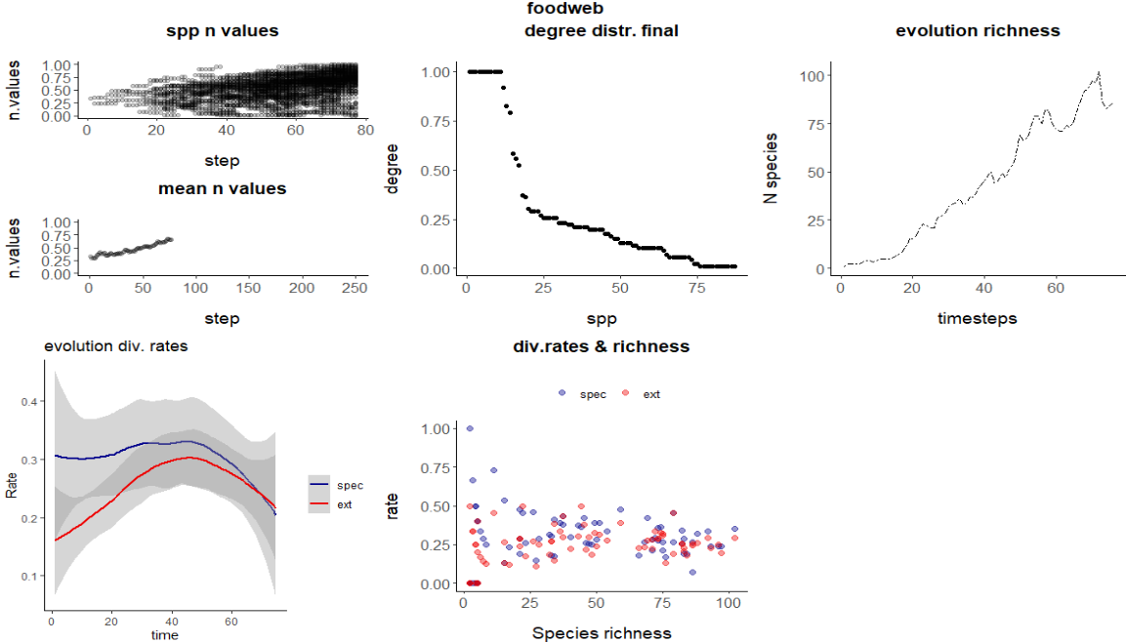

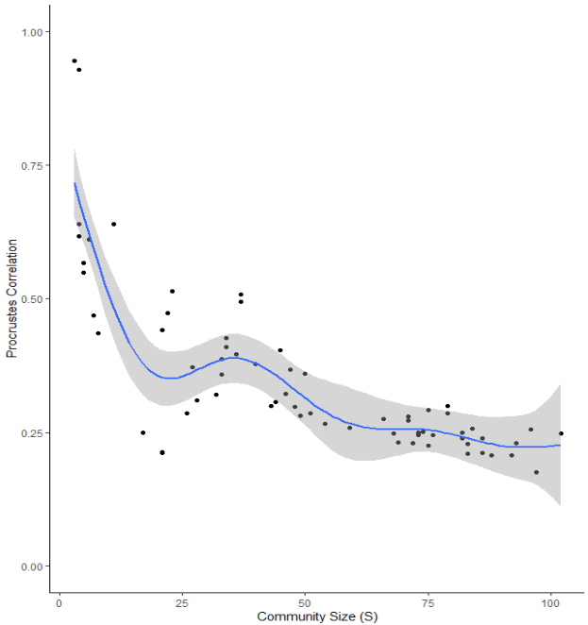

**Now neutral:**

