The best values for *d* are 100 to 160, 180, and 190. All values of *d* are above 90% accuracy, but these numbers have an accuracy of 100% on the test data using “scrambled_mnist10000.bin” for training.

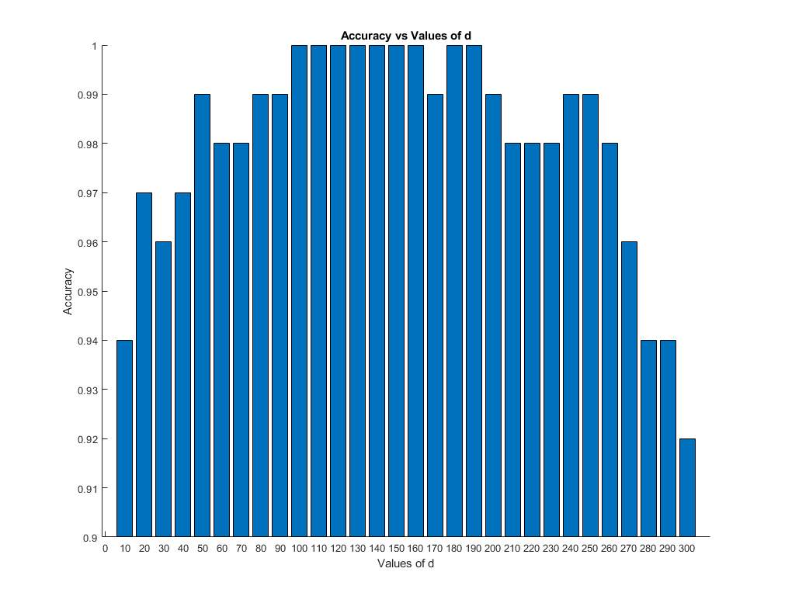Among all, 130 is likely the best value for d, as ± 30 still maintains a 100% accuracy rate.