  
Rockwell License Scrubber Version 1.0

User Manual

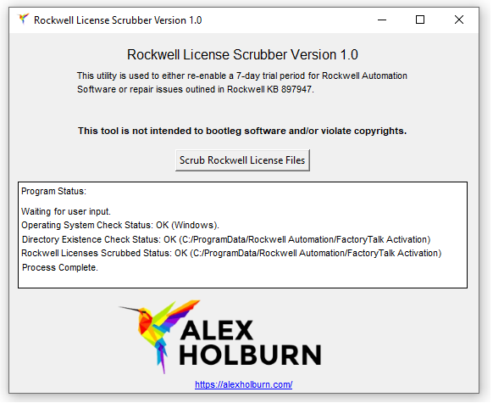

# Table of Contents:

## About / Contact

## Utility Purpose and Intent

## Using the Utility

## Status Messages

# About / Contact

Special Thanks To:   
  
Alicia Gilpin for convincing me to start publishing some of my tools and tolerating my shenanigans after being onsite for extended periods.   
  
About:  
  
This utility was written in Python 3.9 and leverages the following libraries:

-platform  
-system  
-os  
-sys  
-shutil  
-tkinter  
-PIL  
-ImageTK  
-webbrowser

An executable, Scrub_Rockwell_Licenses.exe is included with the release for users that don’t want to install Python or any associated libraries, at the expenses of taking approximately 10 seconds to run vs instantaneously. The source code, Scrub_Rockwell_Licenses.py is also included in the release for those that want to run the utility with Python or examine the code.

### Contact: Alex Holburn alex.holburn@alexholburn.com

# License

Copyright 2020 Alex Holburn, https://www.alexholburn.com

Permission is hereby granted, free of charge, to any person obtaining a copy of this software and associated documentation files (the "Software"), to deal in the Software without restriction, including without limitation the rights to use, copy, modify, merge, publish, distribute, sublicense, and/or sell copies of the Software, and to permit persons to whom the Software is furnished to do so, subject to the following conditions:

The above copyright notice and this permission notice shall be included in all copies or substantial portions of the Software.

THE SOFTWARE IS PROVIDED "AS IS", WITHOUT WARRANTY OF ANY KIND, EXPRESS OR IMPLIED, INCLUDING BUT NOT LIMITED TO THE WARRANTIES OF MERCHANTABILITY, FITNESS FOR A PARTICULAR PURPOSE AND NONINFRINGEMENT. IN NO EVENT SHALL THE AUTHORS OR COPYRIGHT HOLDERS BE LIABLE FOR ANY CLAIM, DAMAGES OR OTHER LIABILITY, WHETHER IN AN ACTION OF CONTRACT, TORT OR OTHERWISE, ARISING FROM, OUT OF OR IN CONNECTION WITH THE SOFTWARE OR THE USE OR OTHER DEALINGS IN THE SOFTWARE.

# Utility Purpose and Intent

The purpose of the Rockwell License Scrubber is to remove all Rockwell license files from a system in the event that FactoryTalk Activation Manager causes issues and prevents a user from running Rockwell Automation Software. This can facilitate the option for a user to scrub the licenses files and re-check out a license immediately or allow for a 7-day trial period until the user can get access to check out a valid license file.  
  
What this utility is NOT intended to facilitate is flagrant violation of software copyrights in the form of pirating Rockwell Automation software by repeatedly scrubbing 7-day trial licenses.

# Using the Utility

1) Run ScrubRockwellLicenses.exe. The utility packages a python interpreter with the executable, so the load time may take approximately ten seconds. After opening, the following will be displayed:  
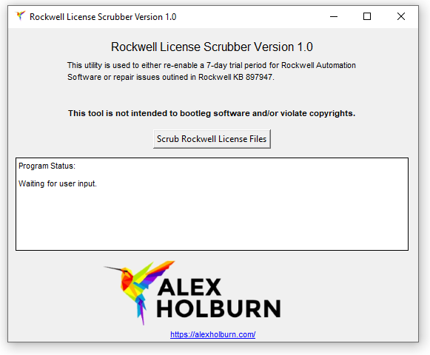

Using the Utility [Continued]:  
  
2) Click “Scrub Rockwell License Files”. After clicking and a successful run, the following will be displayed: 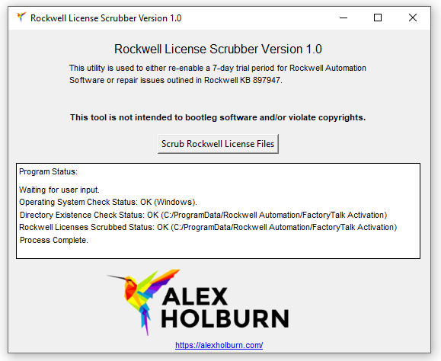  
  
3) Close the Application.

Status Messages  
  
Waiting for User Input:  
  
When “Waiting for User Input” is displayed in the status window, the program is waiting for the user to click the “Scrub Rockwell License Files” button.  
  
Operating System Check Status: OK (Windows)

When “Operating System Check Status: OK (Windows)” is displayed in the status window, the program is indicating that the check that the OS the program is running on is Windows passed. No user interaction is required with this message.   
  
Operating System Check Status: FAIL (Not Windows)

When “Operating System Check Status: OK (Windows)” is displayed in the status window, the program is indicating that the check that the OS the program is running on is Windows failed. This message displays when the user is trying to run the application on an OS other than Windows. The solution is to run the software on a Windows OS.

### Directory Existence Check Status: OK (<FilePath>)

When “Directory Existence Check Status: OK (<FilePath>)” is displayed in the status window, the program is indicating that the check that the Rockwell license directory exists passed. No user intervention is required.

### Directory Existence Check Status: FAIL (<FilePath>)

When “Directory Existence Check Status: FAIL (<FilePath>)” is displayed in the status window, the program is indicating that the check that the Rockwell license directory exists passed. No user intervention is required.

### Rockwell Licenses Scrubbed Status: OK (<FilePath>)

When “Rockwell Licenses Scrubbed Status: OK (<FilePath>)” is displayed in the status window, the program is indicating that the check that the Rockwell licenses have been scrubbed and what directory they have been saved to if they need to be sent to Rockwell Tech Support for further assistance. No user intervention is required.

# Status Messages [Continued]

### Rockwell Licenses Scrubbed Status: FAIL (<FilePath>)

When “Rockwell Licenses Scrubbed Status: FAIL (<FilePath>)”is displayed in the status window, the program is indicating that the check that the Rockwell licenses have been scrubbed. No user intervention is required.

### Process Aborted

When a status check fails, the process aborts. When this happens, close the program and rectify the issue that caused the status check failure.

### Process Completed

This status message displays when the program has successfully scrubbed all Rockwell Software licenses.